**WOT - ECM1004**

**Client Server Communication using Contiki OS**

Name: Nagharjun M

Registration Number: 18BLC1129

Date: 17/03/2021

**Totally 1 UDP Server connected with 4 UDP Clients**

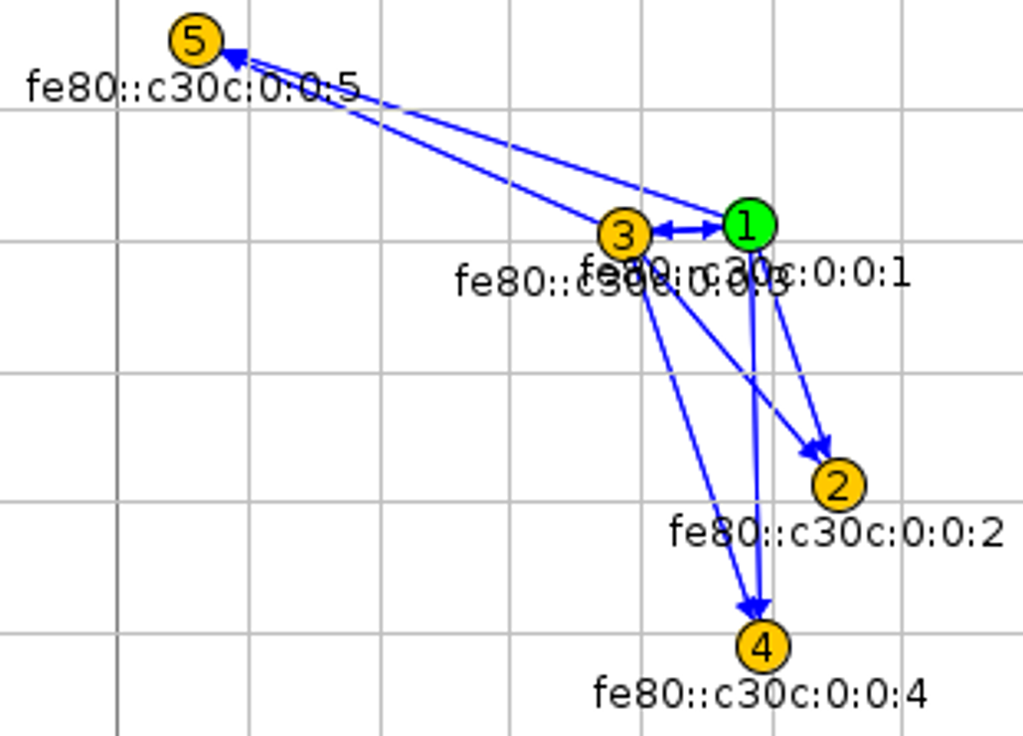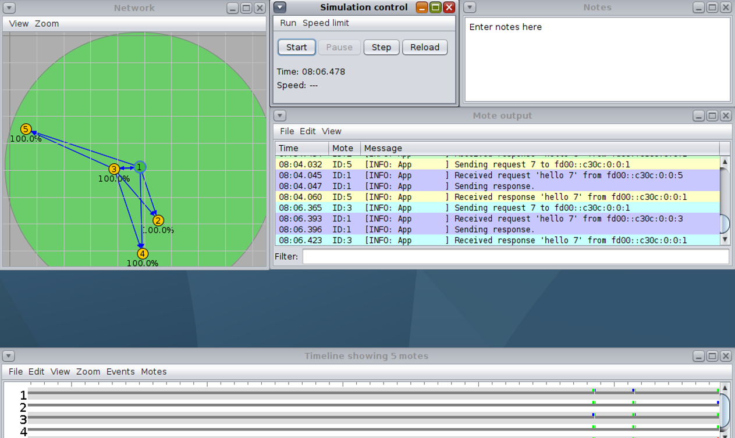

**Mote Output:**

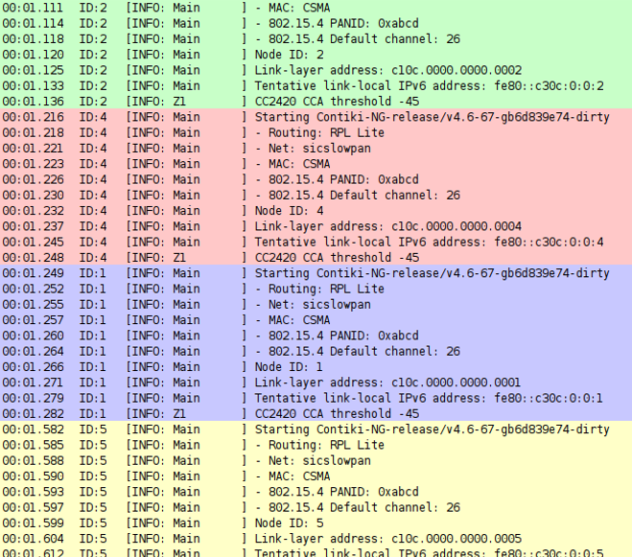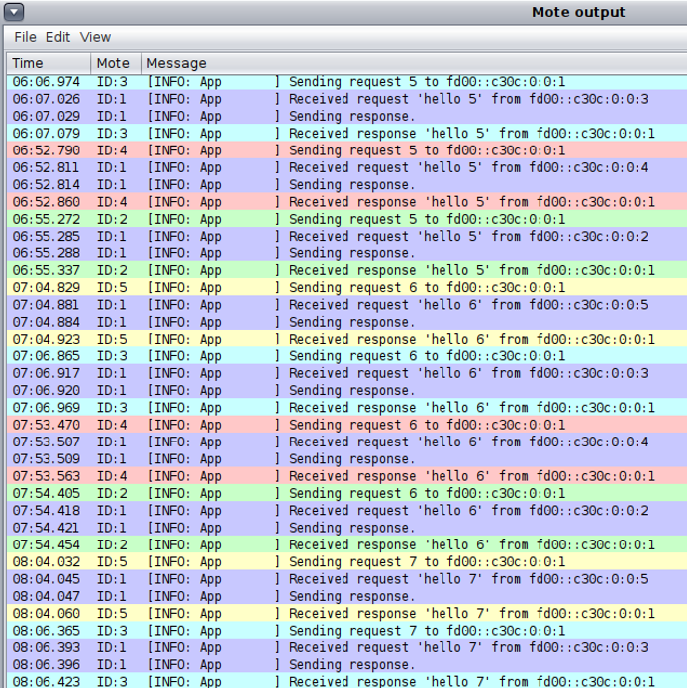

**Radio Messages:**

