**WOT LAB Virtual sensor using Contiki-ng and Cooja**

**ECM1004**

Name: Nagharjun M

Registration Number: 18BLC1129

Date: 17/04/2021

**Code:**

**Mytemp.h**

#ifndef MYTEMP_H

#define MYTEMP_H

struct Sensor {

char name[15];

float value;

};

struct Sensor read_temperature();

struct Sensor read_humidity();

struct Sensor read_carbonmonoxide();

#endif

**Mytemp.c**

#include "mytemp.h"

#include <string.h>

#include <stdlib.h>

float random_value(float min, float max)

{

float scale = rand() / (float) RAND_MAX;

return min + scale * (max - min);

}

struct Sensor read_temperature()

{

struct Sensor temp;

strncpy(temp.name, "Temperature", 15);

temp.value = random_value(0, 45);

return temp;

}

struct Sensor read_humidity()

{

struct Sensor humdidty;

strncpy(humdidty.name, "Humidity", 15);

humdidty.value = random_value(30, 80);

return humdidty;

}

struct Sensor read_carbonmonoxide()

{

struct Sensor carbonmonoxide;

strncpy(carbonmonoxide.name, "Carbonmonoxide", 15);

carbonmonoxide.value = random_value(0 ,99);

return carbonmonoxide;

}

**Demo.c**

#include "contiki.h"

#include "sys/etimer.h" //etimer Event Timer

#include "mytemp.h"

#include <stdio.h>

PROCESS(sensor_process, "Sensor process");

AUTOSTART_PROCESSES(&sensor_process);

static struct etimer timer;

PROCESS_THREAD(sensor_process, ev, data)

{

PROCESS_BEGIN();

printf("Native Sensor\n");

while(1) {

etimer_set(&timer, CLOCK_SECOND*2);

PROCESS_WAIT_EVENT_UNTIL(etimer_expired(&timer));

struct Sensor temp = read_temperature();

printf("%s: %.2f\n", temp.name, (double)temp.value);

struct Sensor hum = read_humidity();

printf("%s: %.2f\n", hum.name, (double)hum.value);

struct Sensor carbonmonoxide = read_carbonmonoxide();

printf("%s: %.2f\n", carbonmonoxide.name, (double)carbonmonoxide.value);

printf("------------\n");

}

PROCESS_END();

}

**Makefile:**

CONTIKI_PROJECT = demo

all: $(CONTIKI_PROJECT)

PROJECT_SOURCEFILES += mytemp.c

CONTIKI = ../../

include $(CONTIKI)/Makefile.include

**OUTPUT:**

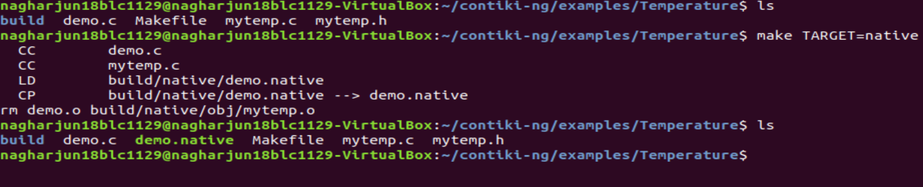

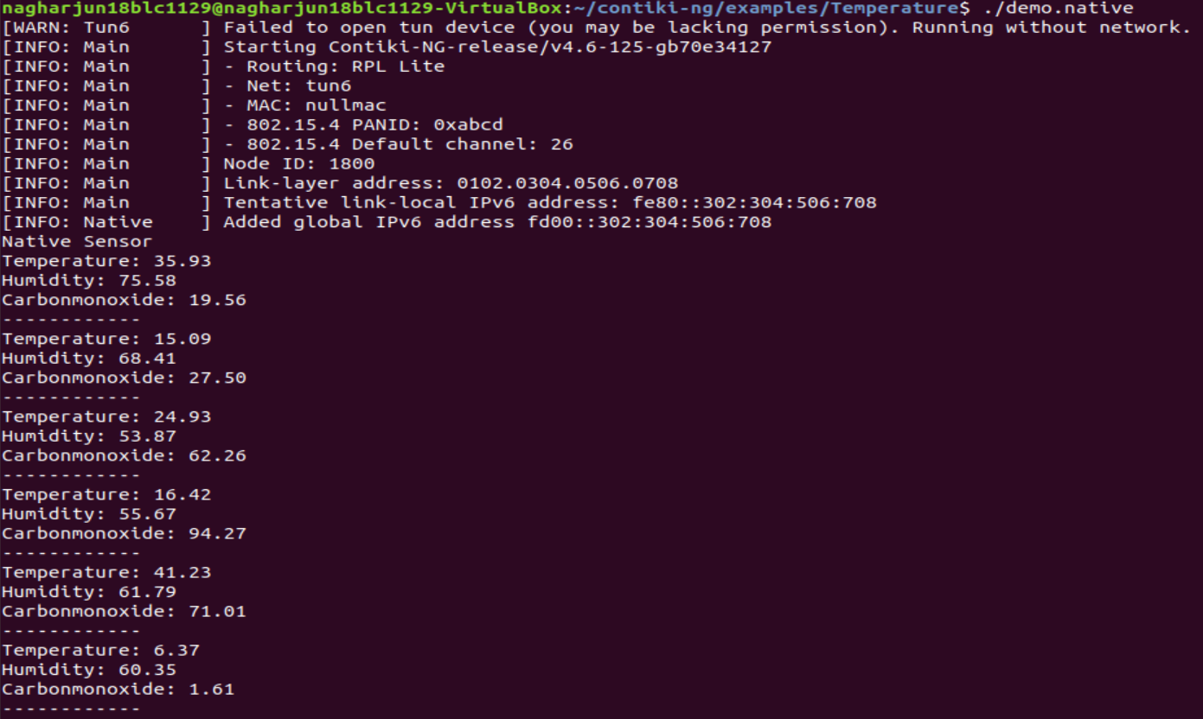

**COOJA Simulator:**

