**ANALYSE THE PERFORMANCE OF VARIOUS PACKET SCHEDULING ALGORITHMS**

by

NAGHARJUN M 18BLC1129

GUGAN S KATHIRESAN 18BLC1089

A project report submitted to

**Dr. C. HEMANTH**

**SCHOOL OF ELECTRONICS ENGINEERING**

in partial fulfilment of the requirements for the course of

**ECM2001 – DATA COMMUNICATION NETWORKS**

in

**B. Tech. ELECTRONICS AND COMPUTER ENGINEERING**



**Vandalur – Kelambakkam Road**

**Chennai – 600127**

**NOVEMBER 2020**

**BONAFIDE CERTIFICATE**

Certified that this project report entitled “**ANALYSE THE PERFORMANCE OF VARIOUS PACKET SCHEDULING ALGORITHMS”** is a bonafide work of **NAGHARJUN M - 18BLC1129 and GUGAN S KATHIRESAN - 18BLC1089** who carried out the Project work under my supervision and guidance for **ECM2001 – DATA COMMUNICATION NETWORKS.**

**Dr. C. HEMANTH**

Associate Professor

School of Electronics Engineering (SENSE),

VIT University, Chennai

Chennai – 600 127.

**ABSTRACT**

With the rapid transformation of the Internet into a commercial infrastructure, demands for service quality have rapidly developed. This project gives a comparative analysis different queuing systems like DROPTAIL, SFQ, FIFO, PQ, RR, WFQ, MM1, GG1, MG1 and MD1 with different traffic distribution. Different traffic distribution includes constant, uniform and exponential traffic distribution. Packet end to end delay, traffic drop and packet delay variation is evaluated through simulation. Results have been evaluated for uniform and exponential traffic distribution.

**ACKNOWLEDGEMENT**

We wish to express our sincere thanks and deep sense of gratitude to our project guide, **Dr. Hemanth C,** Associate Professor, School of Electronics Engineering, for his consistent encouragement and valuable guidance offered to us in a pleasant manner throughout the course of the project work.

We are extremely grateful to **Dr. Sivasubramanian. A,** Dean of School of Electronics Engineering, VIT Chennai, for extending the facilities of the School towards our project and for his unstinting support.

We express our thanks to our Head of the Department **Dr. Thiripurasundari. D** for her support throughout the course of this project.

We also take this opportunity to thank all the faculty of the School for their support and their wisdom imparted to us throughout the course.

We thank our parents, family, and friends for bearing with us throughout the course of our project and for the opportunity they provided us in undergoing this course in such a prestigious institution.

NAGHARJUN M 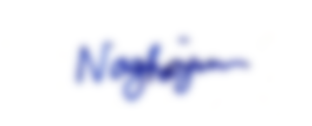GUGAN S KATHIRESAN

**NAME WITH SIGNATURE NAME WITH SIGNATURE**

**TABLE OF CONTENTS**

|  |  |  |  |
| --- | --- | --- | --- |
| **SERIAL NO.** |  | **TITLE** | **PAGE NO.** |
|  |  | ABSTRACT |  |
|  |  | ACKNOWLEDGEMENT |  |
|  |  |  |  |
| 1 |  | INTRODUCTION |  |
|  |  |  |  |
|  | 1.1 | OBJECTIVES AND GOALS |  |
|  | 1.2 | APPLICATIONS |  |
|  |  |  |  |
| 2 |  | DESIGN |  |
|  | 2.1 | DIFFERENT QUEUING TECHNIQUES |  |
| 3 |  | PERFORMANCE ANALYSIS AND OUTPUT |  |
|  |  |  |  |
| 4 |  | CONCLUSION AND FUTURE WORK |  |
|  | 4.1 | RESULT, CONCLUSION AND INFERENCE |  |
|  | 4.2 | FUTURE WORK |  |

5 REFERENCES

6 PHOTO GRAPH OF THE PROJECT ALONG WITH THE TEAM MEMBERS

1. **INTRODUCTION**
   1. **OBJECTIVES AND GOALS**

The aim of the project is to analyse the performance of various scheduling algorithms and their performance. Upon analysing the way the packets are buffered under different scheduling and queuing algorithms, we can better understand how the packets are transmitted and dropped different. We can also see how each algorithm changes the delays of the transmission, which including with the transmission-drop analysis we can establish which algorithms are more efficient in comparison.

The buffering policies take place over the transport layer of the network communication model. The different types of algorithms affect the performance metrics like latency, throughput, etc of the model as well

* 1. **APPLICATIONS**

Queueing theory is commonly used to modelling service centres, to performance evaluation of computer systems, production and flexible manufacturing systems and communication networks.

Some of the applications are:

* Model of chemotherapy unit.
* Performance evaluation of the information systems.
* Modelling of human performance.

1. **DESIGN**
   1. **DIFFERENT QUEUING TECHNIQUES**
      1. **DROPTAIL**

* A simple queue management algorithm used by network schedulers.
* When the queue is filled to its maximum capacity, the newly arriving packets are dropped until the queue has enough room to accept incoming traffic.
  + 1. **SFQ**
* Stochastic Fairness Queuing is based on the well known fair queuing algorithm.
* SFQ uses a hashing algorithm which divides the traffic over a limited number of queues. It is not so efficient than other queues mechanisms but it also requires less calculation while being almost perfectly fair.
  + 1. **FIFO**
* Packets arriving to the link output queue are queued for transmission if the link is currently busy transmitting another packet.
* If there is not sufficient buffering space to hold the arriving packet, the queue's packet discarding policy then determines whether the packet will be dropped ("lost") or whether other packets will be removed from the queue to make space for the arriving packet.
  + 1. **FQ**
* Fair queuing is a family of scheduling algorithms used in some process and network schedulers.
* The algorithm is designed to achieve fairness when a limited resource is shared, for example to prevent flows with large packets or processes that generate small jobs from consuming more throughput or CPU time than other flows or processes.
* Fair queuing is implemented in some advanced network switches and routers.
  + 1. **WFQ**
* WFQ is a natural extension of fair queuing (FQ)
* In WFQ, the priority given to network traffic is inversely proportional to the signal bandwidth.
* Thus, narrowband signals are passed along first, and broadband signals are buffered.
  + 1. **RR**
* Round-robin (RR) is one of the algorithms employed by process and network schedulers in computing.
* As the term is generally used, time slices (also known as time quanta) are assigned to each process in equal portions and in circular order, handling all processes without priority (also known as cyclic executive).
* Round-robin scheduling is simple, easy to implement, and starvation-free.
* Round-robin scheduling can be applied to other scheduling problems, such as data packet scheduling in computer networks. It is an operating system concept.
  + 1. **M/M/1**
* In queueing theory, a discipline within the mathematical theory of probability, an M/M/1 queue represents the queue length in a system having a single server, where arrivals are determined by a Poisson process and job service times have an exponential distribution.
* The model is the most elementary of queuing modelsand an attractive object of study as closed-form expressions can be obtained for many metrics of interest in this model.
  + 1. **M/G/1**
* In queueing theory, a discipline within the mathematical theory of probability, an M/G/1 queue is a queue model where arrivals are Markovian (modulated by a Poisson process), service times have a General distribution and there is a single server.
* The model name is written in Kendall's notation, and is an extension of the M/M/1 queue, where service times must be exponentially distributed. The classic application of the M/G/1 queue is to model performance of a fixed head hard disk.
  + 1. **M/D/1**
* In queueing theory, a discipline within the mathematical theory of probability, an M/D/1 queue represents the queue length in a system having a single server, where arrivals are determined by a Poisson process and job service times are fixed (deterministic). The model name is written in Kendall's notation.
* Agner Krarup Erlang first published on this model in 1909, starting the subject of queueing theory.
* An extension of this model with more than one server is the M/D/c queue.
  + 1. **G/G/1**
* In queueing theory, a discipline within the mathematical theory of probability, the G/G/1 queue represents the queue length in a system with a single server where interarrival times have a general (meaning arbitrary) distribution and service times have a (different) general distribution.
* The evolution of the queue can be described by the Lindley equation.
* The system is described in Kendall's notation where the G denotes a general distribution for both interarrival times and service times and the 1 that the model has a single server.
* Different interarrival and service times are considered to be independent, and sometimes the model is denoted GI/GI/1 to emphasise this.

1. **PERFORMANCE ANALYSIS AND OUTPUT**

**NS2 RESULTS:**

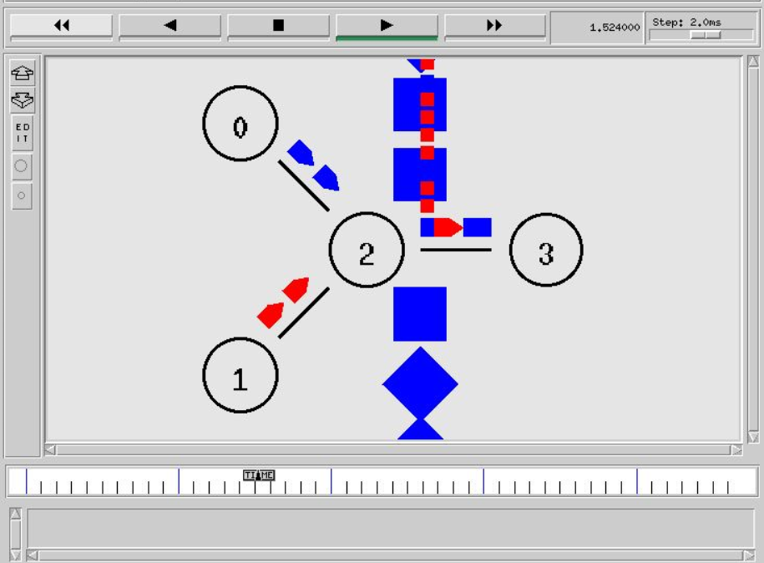

**DROPTAIL**

CASE 1: FLOW FROM NODE 0 STARTS AT 0.5 SEC ENDS AT 4.5 SEC WHEREAS THE FLOW FROM NODE 1 STARTS AT 1 SEC AND ENDS AT 4 SEC

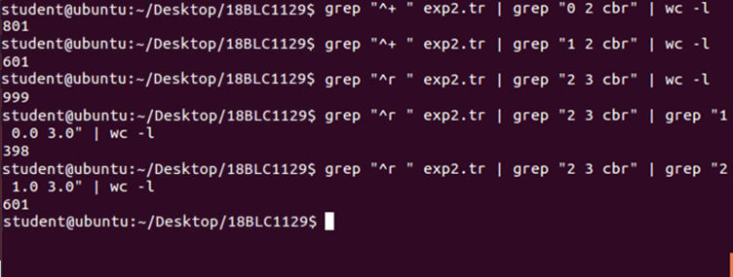

PDR OF FLOW 1: 398/801 = 0.497

PDR OF FLOW 2: 601/601 = 1

CASE 2: BOTH THE NODES START SENDING THEIR PACKETS AT 0.5 SEC AND END AT 4.5 SEC

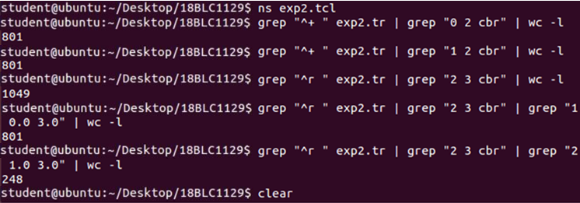

PDR OF FLOW 1: 801/801 = 1

PDR OF FLOW 2: 248/801 = 0.309

**SFQ**

CASE 1: FLOW FROM NODE 0 STARTS AT 0.5 SEC ENDS AT 4.5 SEC WHEREAS THE FLOW FROM NODE 1 STARTS AT 1 SEC AND ENDS AT 4 SEC

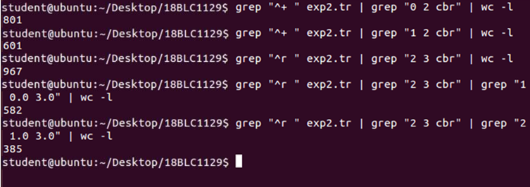

* PDR OF FLOW 1: 582/801 = 0.727
* PDR OF FLOW 2: 385/601 = 0.641

CASE 2: BOTH THE NODES START SENDING THEIR PACKETS AT 0.5 SEC AND END AT 4.5 SEC

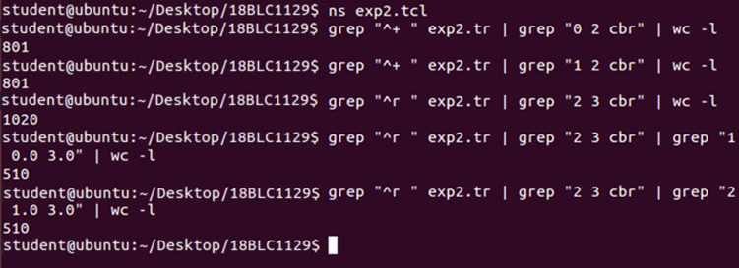

* PDR OF FLOW 1: 510/801 = 0.637
* PDR OF FLOW 2: 510/801 = 0.637

MM1

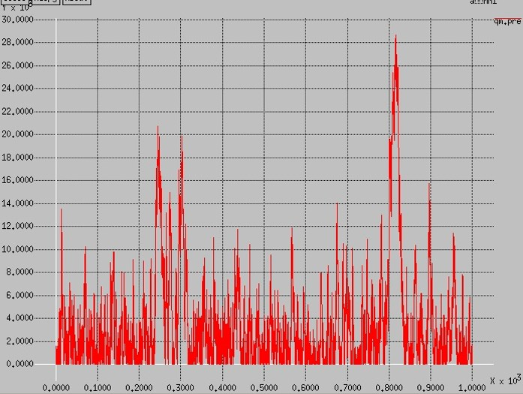

MG1 Uniform Distribution packet size.

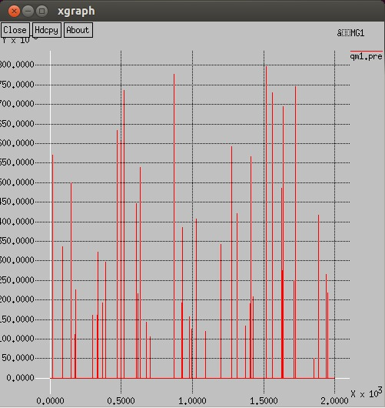

GG1

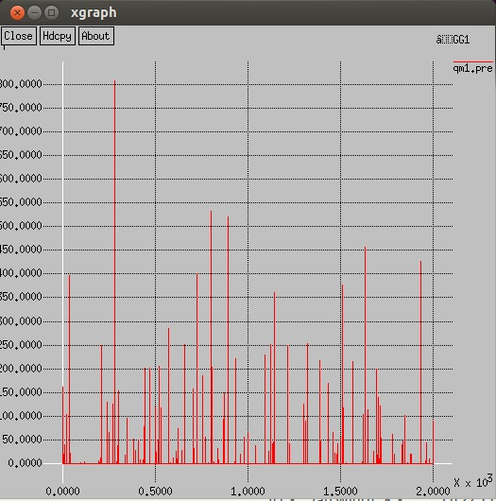

MD1

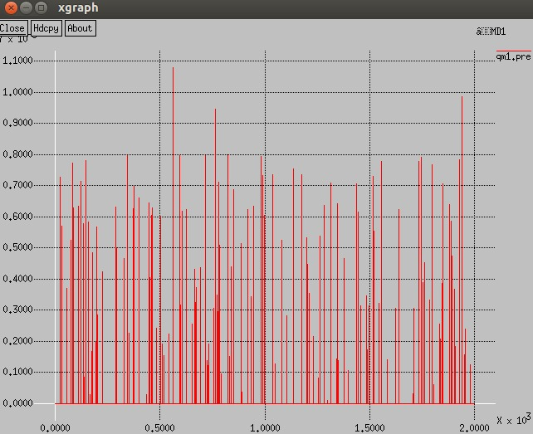

**NETSIM RESULTS:**

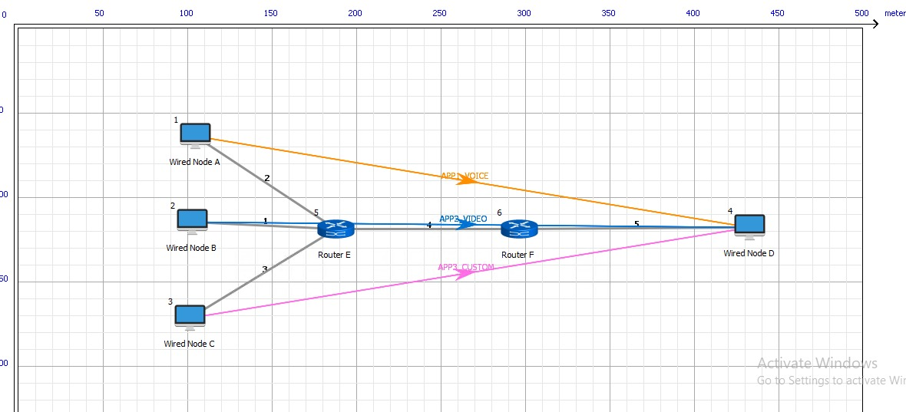

**FIFO**

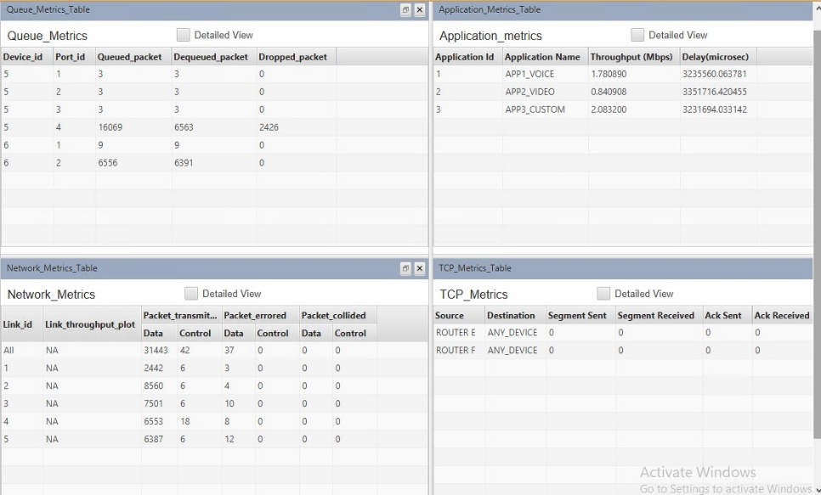

**PRIORITY**

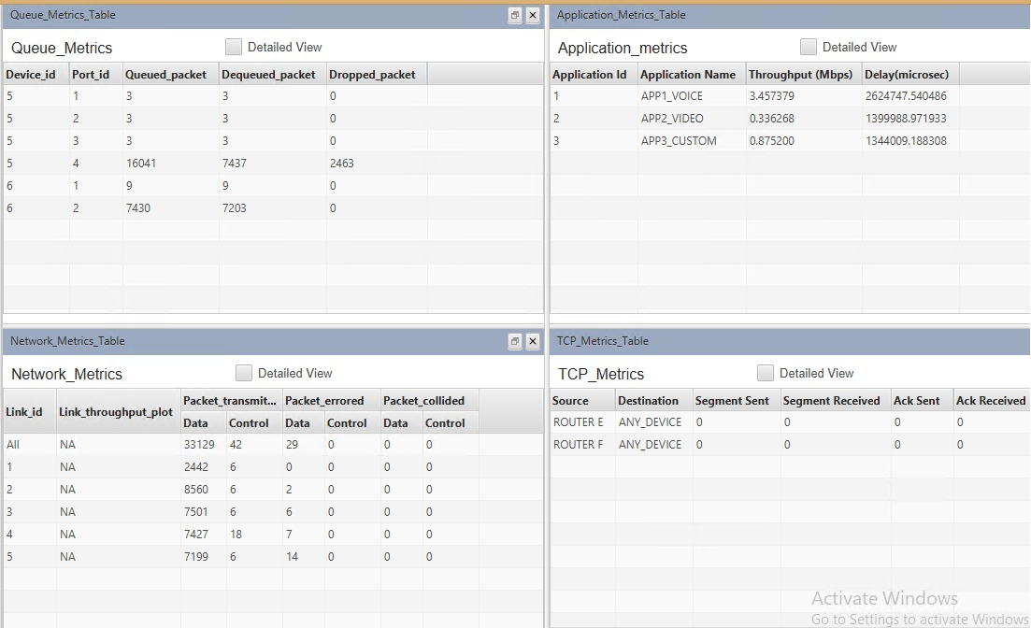

**ROUND ROBIN**

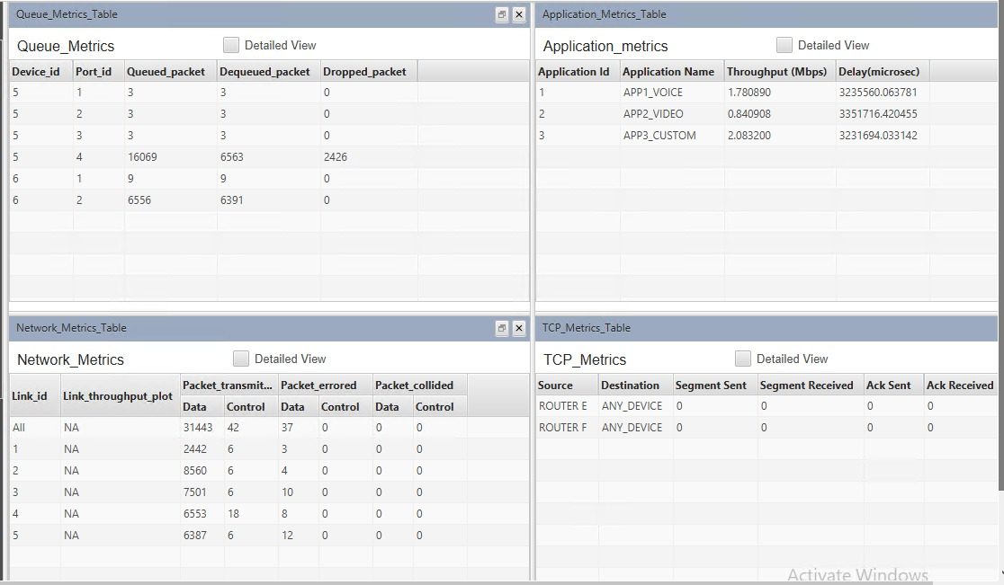

**WFQ**

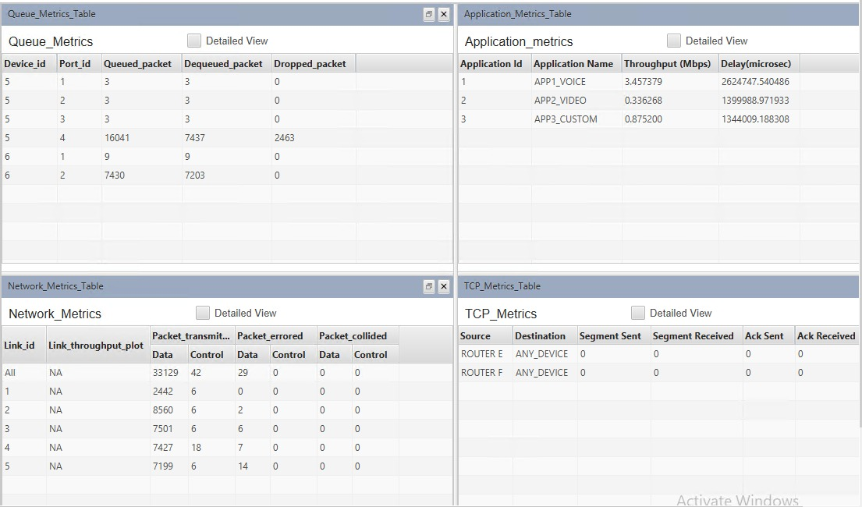

|  |  |  |  |  |  |  |
| --- | --- | --- | --- | --- | --- | --- |
| **QUEUE** | **VOICE DATA** | | **VIDEO DATA** | | **CUSTOM DATA** | |
| **THROUGHPUT**  **(MBPS)** | **DELAY**  **(Secs)** | **THROUGHPUT**  **(MBPS)** | **DELAY**  **(Secs)** | **THROUGHPUT**  **(MBPS)** | **DELAY**  **(Secs)** |
| **FIFO** | 1.780890 | 3.2356 | 0.840908 | 3.3517 | 2.083200 | 3.2317 |
| **PRIORITY** | 3.457379 | 2.6247 | 0.336268 | 1.4000 | 0.875200 | 1.3440 |
| **RR** | 1.780890 | 3.2356 | 0.840908 | 3.3517 | 2.083200 | 3.2317 |
| **WFQ** | 3.457379 | 2.6247 | 0.336268 | 1.4000 | 0.875200 | 1.3440 |

1. **CONCLUSION AND FUTURE WORK**
   1. **RESULTS, CONCLUSION AND INFERENCE**

Generally internet traffic is bursty in nature. Due to this reason in this current research work two distributions uniform and exponential has been consider which generate bursty data. It has been observed after comparing the detail statistics of the result that packet end to end delay, traffic drop and packet delay variation is always higher in case of FIFO scheme for both voice and video based content delivery over network. For voice application PQ, RR and WFQ schemes produces acceptable results whereas for video application PQ and RR scheme proves to be better.

* 1. **FUTURE WORKS**

We can try to implement and analyse the performance in the case of wireless networks as everything is becoming wireless day by day.

**REFERENCES**

1. Kang, Sang H., and Avideh Zakhor. "Packet scheduling algorithm for wireless video streaming." *International Packet Video Workshop*. Vol. 2002. 2002.

2. Ramli, Huda Adibah Mohd, et al. "Performance of well known packet scheduling algorithms in the downlink 3GPP LTE system." *2009 IEEE 9th Malaysia international conference on communications (MICC)*. IEEE, 2009.

3. Ryu, Seungwan, et al. "Urgency and efficiency based packet scheduling algorithm for OFDMA wireless system." *IEEE International Conference on Communications, 2005. ICC 2005. 2005*. Vol. 4. IEEE, 2005.

4. Wang, Jinggang, and Binoy Ravindran. "Time-utility function-driven switched ethernet: Packet scheduling algorithm, implementation, and feasibility analysis." *IEEE Transactions on Parallel and Distributed Systems* 15.2 (2004): 119-133.

5. Wang, Yuanye, et al. "Carrier load balancing and packet scheduling for multi-carrier systems." *IEEE transactions on wireless communications* 9.5 (2010): 1780-1789.

6. Lu, Songwu, Vaduvur Bharghavan, and Rayadurgam Srikant. "Fair scheduling in wireless packet networks." *IEEE/ACM Transactions on networking* 7.4 (1999): 473-489.

7. Liu, Bin, Hui Tian, and Lingling Xu. "An efficient downlink packet scheduling algorithm for real time traffics in LTE systems." *2013 IEEE 10th Consumer Communications and Networking Conference (CCNC)*. IEEE, 2013.

8. Liu, Peijuan, Randall Berry, and Michael L. Honig. "Delay-sensitive packet scheduling in wireless networks." *2003 IEEE Wireless Communications and Networking, 2003. WCNC 2003.*. Vol. 3. IEEE, 2003.

9. Guo, Jiani, Jingnan Yao, and Laxmi Bhuyan. "An efficient packet scheduling algorithm in network processors." *Proceedings IEEE 24th Annual Joint Conference of the IEEE Computer and Communications Societies.*. Vol. 2. IEEE, 2005.

10. Goyal, Pawan, Harrick M. Vin, and Haichen Chen. "Start-time fair queueing: A scheduling algorithm for integrated services packet switching networks." *Conference proceedings on Applications, technologies, architectures, and protocols for computer communications*. 1996.

11. Karim, Lutful, et al. "An efficient priority packet scheduling algorithm for wireless sensor network." *2012 IEEE international conference on communications (ICC)*. IEEE, 2012.

12. Kim, Hoon, et al. "An efficient scheduling algorithm for QoS in wireless packet data transmission." *The 13th IEEE International Symposium on Personal, Indoor and Mobile Radio Communications*. Vol. 5. IEEE, 2002.

**BIODATA**

Name :

Mobile Number :

E-mail :

Permanent Address:

Name :

Mobile Number :

E-mail :

Permanent Address:

Name :

Mobile Number :

E-mail :

Permanent Address: