

**Software Requirements**

**Specification**

**for**

**Virtual Motor Parts Shop**

**Version 1.1**

**Prepared by Cojocaru Ionut**

**24.03.2017**

# Table of Contents

Table of Contents 1

Revision History 2

1. Introduction 2

1.1 Purpose 2

1.2 Product Scope 2

1.3 Intended Audience and Reading Suggestions 2

1.4 Definitions, Acronyms, and Abbreviations 2

1.5 References 2

2. Overall Description 3

2.1 Product Perspective 3

2.2 Product Functions 3

2.3 User Classes and Characteristics 4

2.4 Operating Environment 5

2.5 Design and Implementation Constraints 5

2.6 User Documentation 5

2.7 Assumptions and Dependencies 5

3. External Interface Requirements 6

3.1 User Interfaces 6

3.2 Hardware Interfaces 6

3.3 Software Interfaces 6

3.4 Communications Interfaces 6

4. System Features 15

4.1 Authorization 15

4.2 Update account information 15

4.3 Browse inventory 15

4.4 Manage shopping cart 15

4.5 Comment 15

4.6 Manage inventory 15

5. Other Nonfunctional Requirements 17

5.1 Performance Requirements 17

5.2 Safety Requirements 17

5.3 Security Requirements 17

5.4 Software Quality Attributes 17

5.5 Business Rules 17

6. Other Requirements 18

Appendix A: Glossary 18

Appendix B: Analysis Models 18

# Revision History

|  |  |  |  |
| --- | --- | --- | --- |
| **Name** | **Date** | **Comments** | **Version** |
|  |  |  |  |
| Cojocaru Ionut | 20.03.2017 | First Revision | 1.0 |
| Cojocaru Ionut | 24.03.2017 | Small Revision | 1.1 |
|  |  |  |  |

# 

# Introduction

## Purpose

The purpose of the document is to serve as a guide to designers, developers and testers who are responsible for the engineering of the **Virtual Motor Parts Shop** project. It should give the engineers all of the information necessary to design, develop and test the software. Basic issues addressed in the SRS include functionality, external interfaces, performance requirements, attributes and design constraints.

## Product Scope

The objective of this project is to create and implement a web-application for an online Motor Parts shop. The website will be used primarily by online shoppers. The website will allow users to create and maintain individual accounts, search the Virtual Motor Parts Shop database for products, and make online purchases. The website makes purchasing motor parts quicker, easier, and more convenient.

A small automobile spare parts shop sells the spare parts for vehicles of several models. Also each part is typically manufactured by several small industries. To stream line the sales and supply ordering, the shop owner has asked us to develop the following motor part shop software.

The motor part shop deals with large no. of motor parts of various manufacturers and various vehicle types. Some of the motor parts are very small and some are very large. The owner maintains different parts in wall mounted and numbered racks. The shop owner maintains as few inventory for each item as reasonable, to reduce inventory overheads after being inspired by "just in time (JIT) philosophy".

The system can be accessed by:

* Customers (normal users)
* Shop owner(with unlimited access)

Both the user and shop owner are authorised before using the software.

## Intended Audience and Reading Suggestions

This document is intended for developers, shop owner, testers, and documentation writers. Start with the purpose, followed by the product scope and the functional and non-functional requirements of the system and also contains the contextual and data flow diagrams.

## Definitions, Acronyms, and Abbreviations

|  |  |
| --- | --- |
| **Acronym, Abbreviations** | **Description** |
| SRS | Software Requirement Specification |
| IEEE | Institute of Electrical and Electronics Engineers |
| LAN | Local Area Network |
| HTML | Hyper Text Markup Language |
| CSS | Cascading Style Sheet |
| PHP | PHP Hypertext Preprocessor |

## References

GitHub project link: https://github.com/Naginn/WAD_Project

# Overall Description

## Product Perspective

The **Motor Part Shop** system will be a newly developed and self-contained product.

The Virtual Motor Parts Shop application enables the customers to browse through a virtual Motor Parts shop, and a system administrator to manage the items in the shop. The application will interact with the Virtual Motor Parts Shop’s inventory database.

## Product Functions

The following list of function descriptions explains the major features of the Virtual Motor Parts Shop:

* Allow the customer to register
* Allow the customer to login
* Allow the customer to easily browse through the products
* Allow the customer to manage a shopping cart
* Allow the customer to manage account
* Allow the customer to leave a comment
* Allow the shopkeeper to manage the shop inventory

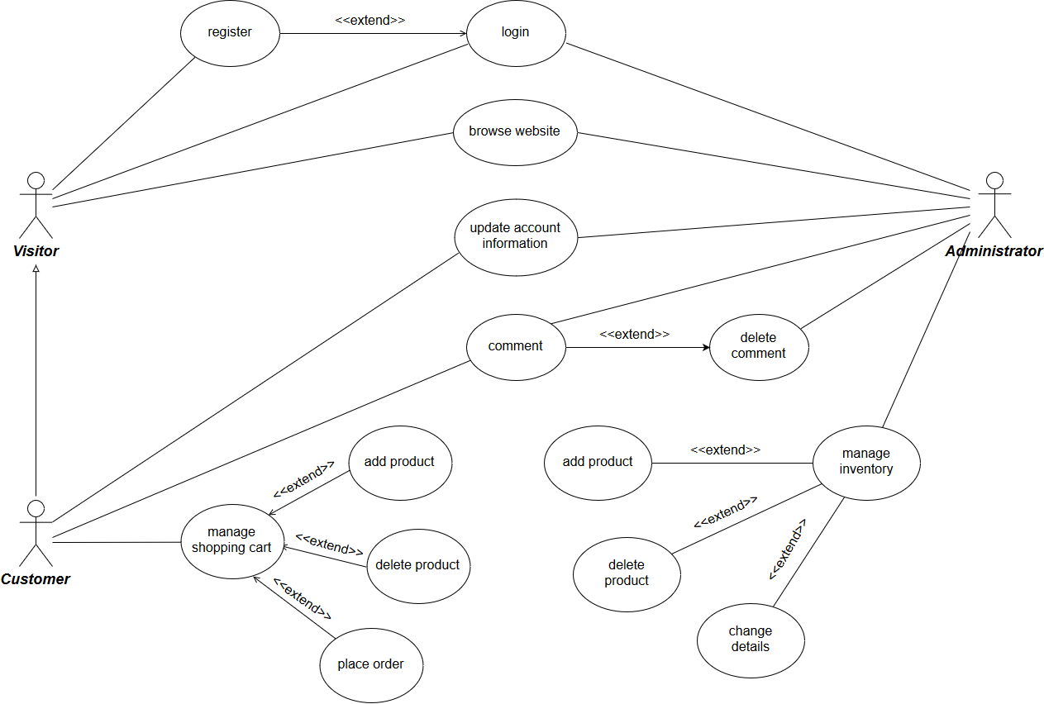**Use case diagram**

**Activity diagram**

**Class diagram**

## User Classes and Characteristics

There are 3 user classes for the aforementioned application:

* Visitor: does not have an account, can browse the website;
* Customer: has an account, can manage the account, can buy products and can leave comments;
* Store management (administrator): manages the shop inventory.

## Operating Environment

This application will be developed in: Microsoft Visual Studio IDE.

The software will operate in any environment, including the hardware platform, operating system and versions, and any other software components or applications. This product is web based and can be viewed by any browser and has been tested for compliance with Google Chrome and Mozilla Firefox.

## Design and Implementation Constraints

The application will be displayed only in English.

The developed system should run under any platform (Windows, Linux, Mac etc.) that contains a web browser which supports JavaScript.

This application is distributed with a proprietary software license.

The design and implementation constraints of this system are:

* Its front end should be implemented using HTML5, CSS3 and JavaScript.
* The back end should be managed by the PHP & SQL.

## User Documentation

System Requirements Specifications document, System Design Specifications document and testing documents.

## Assumptions and Dependencies

Since the Virtual Motor Parts Shop is only accessible through the Internet, it is assumed that the end user has a connection to the Internet. It is also assumed that the user has a web browser able to display the website. (I.E. Google Chrome, Mozilla Firefox or compatible browser).

All the inputs should be checked for validation and messages should be given for the improper data. The invalid data is to be ignored and error messages should be given.

# External Interface Requirements

## User Interfaces

The interface between the system and the users mainly include the PHP page that is loaded using a web browser like Internet Explorer, Mozilla Firefox, or Chrome. The PHP page includes a form in which the user can enter the Username (unique to a user), Password and motor parts. You can choose the products which you would want to purchase and will be added to the cart. At the end an invoice is generated in order to make payment.

Each part of the user interface intends to be as user friendly as possible. The fonts and buttons used will be intended to be very fast and easy to load on web pages. The pages will be kept light in space so that it won’t take a long time for the page to load.

There will be 3 different user interfaces:

* The visitor interface will consist of a menu which will list the available products, a registration form and a login page.
* The customer interface will extend the aforementioned interface by adding a shopping cart and allowing the user to leave a comment on a product page.
* The administrator interface will consist of a login page and form for adding/modifying product pages.

## Hardware Interfaces

Not applicable.

## Software Interfaces

The application is connected to a database which stores details about the client accounts and the products. There will be a communication interface between the server and the database (functions to read from and write into the database) and another one between the server and the client application (get input text and display data).

## Communications Interfaces

This application uses the HTTP protocol.









# System Features

## Authorization

* + - **Account registration**

The registration function shall allow users to create secure accounts. The account will track the user’s name, address, username and password.

* + - **Account login**

The account login function shall allow account members to enter their username and password. Once verified, users will be able to access the shopping cart, purchase products online, and update their account information.

* + - **Password reset**

The password reset function shall allow the users to receive a new password for their account.

## Update account information

The update account information function shall give account members access to edit their stored information.

## Browse inventory

The user can search for a specific product in the database (by name or category). The main menu will have sections for each category of parts. The user will be able to order the listed products by price and name and see details about any product from the database. He will select the desired version to see the exact price.

## Manage shopping cart

* + - **Add product to shopping cart**

The add to shopping cart function shall allow users to temporarily save products in a list that are being considered for purchase.

* + - **Delete product from shopping cart**

The delete from shopping cart function shall remove any unwanted products from the cart.

## Comment

Logged in users can leave comments on a product’s page. Administrators will be able to delete comments.

## Manage inventory

* + - **Add product**

The add product function will allow administrators to add a new product to the shop inventory.

* + - **Delete product**

The delete product function will allow administrators to delete a product from the shop inventory.

* + - **Edit product**

The edit product function will allow administrators to edit the details of a product (such as name, description, picture and price).

# Other Nonfunctional Requirements

## Performance Requirements

There is no performance requirement in this system because the server request and response is depended on the end user internet connection.

## Safety Requirements

Not applicable.

## Security Requirements

The system’s back-end servers shall only be accessible to authenticated administrators.

Sensitive data will be encrypted before being sent over insecure connections like the internet.

## Software Quality Attributes

**Flexibility:** The system should be flexible enough to handle several additions and deletions of users/parts and support extensions in the functionalities if required.

**Maintainability:** The software will be maintainable enough so that extra features can be added or modified at any time.

**Testability:** Web site can be tested with a number of users using it at a time.

**Reliability:** It will be reliable and will send the correct information to the correct user who have registered to the site.

**Usability and portability:** Software will be easy to use and will be portable enough to transfer from one server machine to another.

## Business Rules

There is no warranty or representation, expressed or implied, as to the accuracy, completeness or appropriateness of the information on this website. Therefore the user must assume full responsibility for using the information and agree that developers are not responsible or liable for any claim, loss, damage or inconvenience caused as a result of reliance on such information.

All rights reserved.

Images and copy on this website are for personal use only and cannot be reproduced commercially without permission.

# Other Requirements

# Appendix A: Glossary

# Appendix B: Analysis Models

The development of the application is based on the Agile strategy.