KUNAAL.S. SHINDAGI
Full Stack Software Developer


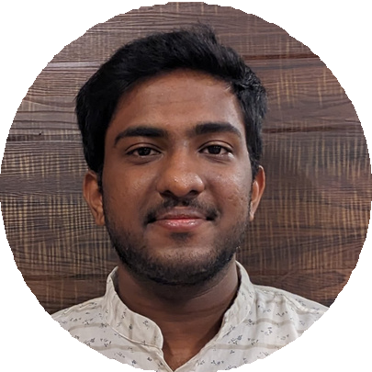



About Me
Full stack software developer with strong leadership qualities. Skilled in developing end-to-end solutions and adept at leading cross-functional teams to success

 +91 8105188413

kunaalshindagi@gmail.com


Ho NO 26 Wada Compound NO 2 Nazar Camp 3 Cross Vadgaon Belagavi Karnataka India, 590005
LANGUAGE
- English
- Hindi
- Kannada
- Marathi
EXPERTISE
- Leadership
- Management Skills
- Creativity
- Negotiation Critical Thinking Strategist
Software Developement
EXPERIENCE
CoachEd
Belagavi, Karnataka Nov 2022 - Dec 2022
One-month internship at Coached in Belagavi, Karnataka, focused on Python and Data Science. Hands-on experience in data manipulation, visualization, and analysis. Collaborated with mentors on real-world projects, enhancing Python coding and data analysis skills. Recognized for dedication and teamwork.
Dlithe
Belagavi, Karnataka Nov 2023 - Dec 2023
At Dlithe in Belagavi, Karnataka, I was honored as the top intern in IoT, demonstrating strong leadership qualities alongside technical expertise. I excelled in applying IoT technologies to project success, showcasing dedication and proactive problem-solving. My leadership and technical skills were recognized by the team, solidifying my position as the standout intern in the IoT program.

B.K.Model PU College Belagavi, Karnataka April 2023 - April 2024
As a full-time Computer Science and Business Management teacher at B.K. Model PU College in Belagavi, Karnataka, I dedicated myself to nurturing student learning and academic growth. Through engaging curriculum delivery and effective teaching methodologies, I facilitated understanding of complex computer science concepts. My leadership in the classroom fostered a positive learning environment, encouraging student participation and academic excellence. I am proud to have contributed to the success of my students and to have been recognized for my commitment to excellence in education.

EDUCATION
Jain College of Engineering and Research Bachelor of Computer Science and Engineering 2021 - 2025 6 sem with 8.6 cgpa

Gogte College of Commerce and Science
With PCM-CSE 2019-2021 with 68%

Arion Data Securtiy System
Arion Dss is a multi-language, emoji-based data encryption, and decryption system that can generate up to 10000 combinations for each encryption

PUBLICATIONS



St Marys High School
2008-2019 with 68.9%
SKILLS

Data Science, Data Analysis
Machine learning
Cloud Computing
HTML, CSS, Java Script, React js
UI/UX
IOT
Cyber Security
Cryptography
PROJECTS

Engineers Matrimony
- Implementation of Frontend, Backend, and Database management. Using HTML, CSS, JavaScript, and Mangodb Database.

Dhavani
- Implement a Smart solution for Hands-free interaction with the center console for multipurpose interaction and drowsiness detection using face recognition, Jason, and machine learning.

Encryption and Decryption of data
  - Implementation of Cryptography. Using XROT and XPLUS.

Ev Charging Station
  - Ionexa is a next-gen EV charging station that was made to address the challenges of EV charging facilities by making it connect to the internet and reducing the size of the charging station so that it can easily be mounted any where

Clear View
Clear View is a Website that allows users to anonymously post problems they face in their locality.
- A Comprehensive Survey of Cybercrime and CybersecurityA Comprehensive Survey of Cybercrime and Cybersecurity at ICAECC conference Reva University IEEE (Institute of Electrical and Electronics Engineers) · Sep 7, 2023. Doi:10.1109/ICAECC59324.2023.10560320
- Analysis and Implementation of IoT-Enabled Electric Vehicle Charging Station at Jain University Springer - International Publisher.
ACHIVEMENTS
- 1st position in Ai/Ml Hackthon at IIT Roorkie
- 3rd position in Ideathon at Jain College of Engineering.
- 3rd position in 12hr Hackathon at TCE college Ghadhag
- Best Intern Award by Dlithe with a British gold coin from 2007 as a token of appreciation.
- 2nd position in photography at SDMCET.
- Elected as the Chairman of the CSE department Student chapter.
- Elected as the commander of the Naval wing at NCC camp Dharawada
- Certified as an exemplary cadet by the 25 Kar Naval battalion
- Archived A grade Certificate at the NCC
CERTFICATIONS
  - Certified Full Stack Software Developer Assessment by IBM https://coursera.org/verify/T6DPCVDVKHH9
  - Certified In Cloud Computing by IBM https://coursera.org/verify/ZTHH9NVDK863
EVENTS ORGANIZED
  - Savishkar 2k23 at Jcer Belagavi as the head of the cultural committee.
  - Quiz Competition at Jcer Belagavi as the head of the Event and anchor.
  - Savishkar 2k24 at Jcer Belagavi as the head of the CSE department.
  - Inter-department 8 hours hackathon at Jcer
Belagavi, as the head of the event.

