**CVG 2020 ASSIGNMENT-1**

CANNY EDGE DETECTION

NAME : NAGRAJ PAWAR

USN : 01FE18BEC357.

DIV : E

CONTENT :

1. Introduction
2. Algorithm
3. Padding the input image
4. Comparison between Sobel and Canny
5. Sample output
6. Applications
7. Conclusion

# Introduction

EDGES:

Edges characterizes boundaries and are therefore a problem of fundamental importance in image processing. edges in an image are areas with a strong intensity count or a jump in the intensity from one pixel to next. Edge detection of an image reduces the amount data and filters out the unwanted data.

Canny edge detection is also known as optimal edge detection. Based on this canny edge detection has steps to follow. Canny first smoothens the image to eliminate the noise, then finds the image gradient to find the regions with high spatial derivatives. Than carrying out the laplacian filtering to thin the edges, and final it is subjected to hysteresis thresholding.

# Algorithm

STEPS :

* Denoising of Image by using Gaussian Filter

The first step of canny edge detection is to filter out any noise in the original image before trying to locate and detect any edges. The Gaussian filter is used to blur and remove unwanted detail and noise. A convolution mask is much smaller than the actual image. As a result, the mask slides over the image, calculating every square of pixels at a time.

Gaussian filter uses 2D convolution. The larger the width of the Gaussian mask, the lower is the detector's sensitivity to noise. The weight of the matrix is concentrated at the centre, therefore any noise appearing in the outside columns and rows will be eliminated, as the weight decreases outward from the centre value.

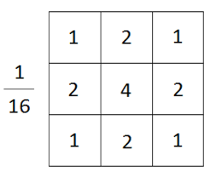

Figure 1 : Gaussian Filter

* Computing Image Derivatives

After smoothing the image and eliminating the noise, the next step is to find the edge strength by taking the gradient of the image. The Sobel operator performs a 2-D gradient measurement on an image.

The Sobel operator uses a pair of 3x3 convolution masks, one estimating the gradient in the x-direction (columns) and the other estimating the gradient in the y-direction (rows).

Sobel Gx and Gy masks shown below each one estimates gradient x direction and y direction respectively:

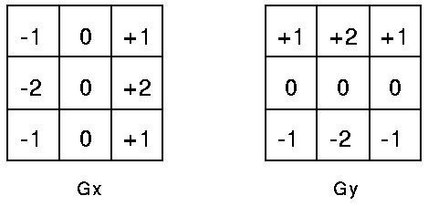

Figure 2

The gradient magnitude is given by:



* Finding Laplacian

The Laplacian is a 2-D  measure of the 2nd spatial derivative of an image (Alternative for finding image derivatives). The Laplacian of an image highlights regions of rapid intensity change and is therefore often used for https://homepages.inf.ed.ac.uk/rbf/HIPR2/mote.gifedge detection The Laplacian is often applied to an image that has first been smoothed with something approximating a Gaussian smoothing filter in order to reduce its sensitivity to noise, and hence the two variants will be described together here. The operator normally takes a single gray level image as input and produces another gray level image as output.

The Laplacian L(x,y) of an image with pixel intensity values I(x,y) is given by:

Eqn:eqnlog1

The commonlu used Laplacian filters are :

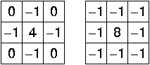

* Hysteresis

Finally, hysteresis is used as a means of eliminating streaking. Streaking is the breaking up of an edge contour caused by the operator output fluctuating above and below the threshold. If a single threshold, T1 is applied to an image, and an edge has an average strength equal to T1, then noise will be present there will be instances where the edge decreases below the threshold. Equally it will also extend above the threshold making an edge look like a dashed line. To avoid this, hysteresis uses 2 thresholds, a high and a low. Any pixel in the image that has a value greater than T1 is presumed to be an edge pixel, and is marked as such immediately. Then, any pixels that are connected to this edge pixel and that have a value greater than T2 are also selected as edge pixels.

# Padding

For every step where we perform convolution , the image size shrinks. If our input image if of shape (mxn) and we convolve it with a filter (fxf) the image size reduces to (m-f+1) x (n-f+1).

Therefore we apply zero padding to our input image to ensure that the output

image remains the same size(mxn).

If p is the value of padding then the size of output image will be

*(m+2p-f+1) x (m+2p-f+1)*

The padding technique in which the size of the input image is equal to size of output is called “*Same Padding”.*

For same padding the value of p should be : p = (f-1)/2

When the input image is convolved with filter then the corner pixels will overlap with the filter only once, and the centre pixel overlaps with filter more than one time, this implies that we are not giving importance to the information near the corners of the image.

Padding ensures that every pixel in the image is given equal importance.

# Comparision between Sobel and Canny

|  |  |  |
| --- | --- | --- |
| Algorithm | Pros | Cons |
| Sobel | Simple. Detects edges and their orientation | Inaccurate and sensitive to nosie |
| Canny | Smoothing effect to remove noise. Good localization and response. Enhances signal to noise ratio. Immune to noisy environment. | Difficult to implement to reach real time response. Time consuming |

# Sample Output

## 

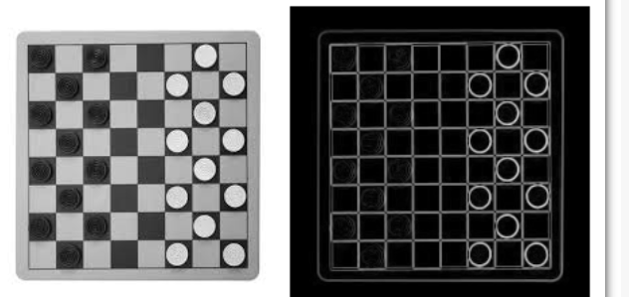

Figure 3

# Applications

1. Edge detection techniques enhance the quality of image and cause the improvement in the image recognition.
2. Finger Print Recognition .
3. Used in Lane Detection for Automated Vehicles.
4. Used in medical applications like to find tumors in Brain.

# Conclusion

Canny edge detector has many favorable features such as smoothing effect to remove noise, and improving signal to noise ratio through a process known as non-maximal suppression. Complex algorithms used in Canny method makes it time consuming and difficult to implement to reach real time response speeds. Despite its disadvantage, however, it is recommended to use Canny method over Sobel method.