**CVG 2020 ASSIGNMENT-2**

HOUGH TRANSFORM

NAME : NAGRAJ PAWAR

USN : 01FE18BEC357.

DIV : E

CONTENT :

1. Introduction
2. Line Detection
3. Hough Transform
4. Algorithm
5. Sample Output
6. Cons

# Introduction

The Hough Transform is an algorithm patented by Paul V. C. Hough and was originally invented to recognize complex lines in photographs . Since its inception, the algorithm has been modified and enhanced to be able to recognize other shapes such as circles and quadrilaterals of specific types whose parametric equations are known to us.

# Line Detection

Line Detection is an algorithm that takes a collection of n edge points and finds all the lines on which these edge points lie.

By detecting the lines in the image we will be able to segment out the region of interest from the image for various applications like Facial Recognition, lane detection for automated vehicles etc.

The most widely used algorithm for Line detection is the Hough Transform .

# Hough Transform

## Naive Algorithm :

1. Find the edges of the given image by Canny Edge detection Algorithm or with image derivatives.
2. Consider a edge point of known coordinates (x,y) , draw lines through this edge point by varing the angle theta (0-180) .
3. Then check how many of the lines L1,L2,….L180 passes through the edges or edge pixels .
4. The line which passes more number of edges is considered as a straight line.
5. Among 180 lines, the lines whose score(edges) is above a particular threshold value are preserved and the rest are rejected.

Cons : Here for every edge point we will have 180 lines and computing scores for these many lines would be computationally expensive.

## Modification

Instead of choosing a single edge point we can choose a pair of points such that only one line passes through them and we can easily find the equation of the line that passes through the two edge points by projecting the line in (xy) space as a point in (ab) or Hough space.

The Hough Space is a 2D plane that has a horizontal axis representing the slope and the vertical axis representing the intercept of a line on the edge image.

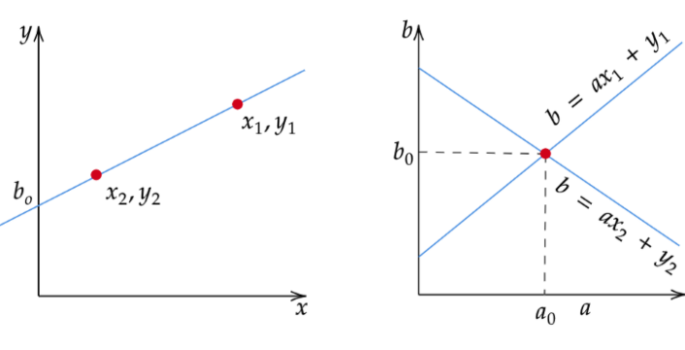

Figure Mapping of edge points to Hough space

But there are few drawbacks with representing lines in the form of y=ax+band the Hough Space with the slope and intercept. In this form, the algorithm won’t be able to detect vertical lines because the slope *a* is undefined/infinity for vertical lines and clubbing the lines with almost similar values of parameters a and b could result in loss of information about edges as edges are more sensitive to parameters a and b.

Therefore we go for Paramertic representaion of the line  ρ*= x cos(*θ*) + y sin(*θ*)* where ρis the length of the normal line and θ is the angle between the normal line and the x axis.

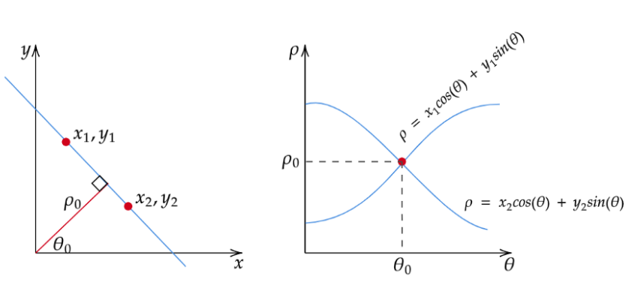

Figure An alternate representaion of straight lines and its correspomding Hough space

# Algorithm

1. Perform Edge detection on the original image by suitable edge detection technique.
2. Decide on the range of ρ and θ. Often, the range of θ is [ 0, 180 ] degrees and *ρ* is [ -d,d] where d is the length of the edge image’s diagonal.
3. Create a 2D array called the accumulator representing the Hough Space with dimension (num_rhos, num_thetas) and initialize all its values to zero.
4. For every pixel on the edge image, check whether the pixel is an edge pixel. If it is an edge pixel, loop through all possible values of θ, calculate the corresponding ρ, find the θ and ρ index in the accumulator, and increment the accumulator base on those index pairs.
5. Loop through all the values in the accumulator. If the value is larger than a certain threshold, get the ρ and θ index, get the value of ρ and θ from the index pair which can then be converted back to the form of y=ax+b.

# Sample output

# 

Figure .1 Final Output

# 

Figure 3.0 The Accumulator

# Cons

* Hough Tranform can detect structures only whose parametric equations are known.
* The length and position of line segment cannot be determined.

# Conclusion

Hough Transform is a simple and efficient way to only only detect Lines but the advancement in this algorithm allows it to detect other structures like circles , triangles and quadrilaterals of specific shapes.

This resulted in many useful real world applications ranging from document scanning to lane detection in self-driving cars.