A Report on
CampusBridge: Surana College Alumni Management System
submitted in partial fulfillment of the Degree of Master of Computer Applications (MCA)
By
Nagabhushana N
(Reg No. P03ME24S126001)
Under the guidance of
[Guide Name]
([Designation], MCA Department)
SURANA COLLEGE (AUTONOMOUS)
Re-Accredited by NAAC with 'A+' Grade, ISO 9001:2015 & IAO Certified Institution
Affiliated to Bangalore University & Approved by AICTE
#17, Kengeri Satellite Town, Bangalore-560060
2025-2026

DEPARTMENT OF MCA
(NBA Accredited)

CERTIFICATE
This is to certify that Mr./Mrs. Nagabhushana N [Reg.no: P03ME24S126001] is a bonafide student of MCA 4th semester, Surana College (Autonomous), has successfully completed the project work entitled 'CampusBridge: Surana College Alumni Management System' for the partial fulfilment of the requirements for the award of the degree of MCA Fourth semester. The matter embodied in this project work has not been submitted to any other university for the award of any other degree.

Internal Guide | Director - MCA
[Guide Name] | Dr. K Balaji
Signature | Signature

Examiners:
1. ________________________________
2. ________________________________

ACKNOWLEDGEMENT
I take this opportunity to sincerely thank all those who have encouraged me either directly or indirectly in completing the project.
I am thankful to Dr. K Balaji, Director - MCA, Surana College (Autonomous), for giving me this opportunity to undertake the project and apply software engineering concepts to a real institutional problem.
I am extremely grateful to our guide [Guide Name] for valuable guidance, suggestions, review, and constant support during the development of CampusBridge.
I also thank the Department of MCA, Surana College, faculty members, friends, and alumni respondents whose feedback helped shape the scope of the application.

Nagabhushana N
P03ME24S126001

DECLARATION
I hereby declare that the project on 'CampusBridge: Surana College Alumni Management System' embodies project affirmation carried out for the completion of the Fourth Semester MCA curriculum at the Department of MCA, Surana College, Bangalore, under the supervision of [Guide Name].
The project has been developed as an end-to-end web application using React.js, Node.js, Express.js, and MongoDB. The report describes the objective, scope, modules, database design, workflows, output screens, conclusions, and future enhancements of the developed system.

Place | Bangalore | Student Name | Nagabhushana N
Date | ________________ | Register Number | P03ME24S126001

ABSTRACT
CampusBridge is a web-based alumni management and engagement platform developed for Surana College. The application is designed to collect alumni details every year through a public form and make those records useful for department-level academic and placement activities.
The main idea is simple: a college should not only store alumni contact details, but should be able to activate the alumni network when students need referrals, departments need expert talks, or faculty members require support for Faculty Development Programmes. The platform therefore includes department-based admin login, alumni search, referral request tracking, secure alumni response links, Expert Talk/FDP requests, resume upload support, automatic email delivery, and Jenkins-based continuous integration.
The system follows a practical MERN architecture. React provides the user interface, Express.js exposes REST APIs, MongoDB stores alumni and request data, and Nodemailer supports email communication. The implementation is intentionally scoped for a college deployment while leaving room for future enhancements such as alumni self-service accounts, analytics, WhatsApp reminders, and production-grade authentication.

CONTENTS
Sl. No | Particulars | Page No
1 | INTRODUCTION | 7
2 | OBJECTIVE OF THE PROJECT | 8
3 | SCOPE OF THE PROJECT | 9
4 | MODULES OF THE PROJECT | 10
5 | BACKEND DATABASE DETAILS | 12
6 | ER DIAGRAM | 15
7 | OUTPUT SCREENSHOTS OF THE PROJECT | 16
8 | CONCLUSION | 18
9 | FUTURE ENHANCEMENTS | 19
10 | BIBLIOGRAPHY | 20

1. INTRODUCTION
Educational institutions maintain relationships with alumni for placements, mentoring, guest lectures, industry connect, accreditation evidence, and institutional branding. However, in many colleges the alumni data is scattered across spreadsheets, faculty contacts, WhatsApp groups, and outdated forms. This makes it difficult to identify the right alumnus when a department needs a speaker, a faculty member needs FDP support, or a current student needs a referral.
CampusBridge was developed to solve this operational gap for Surana College. The platform works as a centralized alumni intelligence system where passed-out students can submit their details through a public link. Department administrators can then search alumni based on batch, department, sector, skills, company, job role, and willingness to support expert talks or FDPs.
The project has evolved beyond a basic CRUD system. It now includes department-based admin access, secure no-login response links for alumni, request tracking, resume file upload, email notification, and Jenkins CI. This makes it suitable as a realistic college application rather than only an academic prototype.

1.1 Problem Context
- Departments need alumni search based on batch and department without exposing all college records to every admin.
- Students often need alumni guidance, referrals, resume review, or interview direction for companies where alumni are already working.
- Faculty members need industry practitioners or teaching-sector alumni for Expert Talks and Faculty Development Programmes.
- Manual tracking does not show whether an alumnus opened a request, accepted it, declined it, or contacted the student.

2. OBJECTIVE OF THE PROJECT
The objective of CampusBridge is to design and implement an end-to-end alumni management and engagement application for Surana College. The system should help the college collect alumni records continuously, search them intelligently, and convert alumni relationships into measurable academic and career support activities.
The platform specifically addresses the requirement that each department admin should see only their own department's alumni records after login. This prevents accidental exposure of unrelated department data and creates a realistic access-control model.

2.1 Primary Objectives
- Provide a public alumni registration form that can be shared with every passed-out batch.
- Enable department admins to search alumni only within their registered department.
- Support referral requests where college staff can connect a current student with a selected alumnus.
- Generate secure alumni response links so alumni can accept, decline, or ask for more details without creating an account.
- Allow the college to track whether requests were emailed, viewed, responded to, and completed.
- Support Expert Talk and FDP request workflows for student and faculty engagement.
- Build a maintainable MERN stack application with seed data, file upload, email configuration, and Jenkins CI.

2.2 Critical Evaluation
The key strength of the idea is its practical institutional value. The main risk is alumni response fatigue: if the college sends too many unstructured requests, alumni may stop responding. Therefore the platform keeps requests specific, traceable, and respectful of alumni choice.

3. SCOPE OF THE PROJECT
The scope of CampusBridge covers the alumni engagement lifecycle from data collection to request tracking. It is focused on Surana College and assumes multiple departments such as MCA, Computer Science, Commerce, and Business Administration.

3.1 In Scope
- Alumni registration and profile storage.
- Department admin login and department-scoped dashboard.
- Advanced alumni search based on batch, sector, company, skills, and availability.
- Referral request creation with optional resume upload.
- Automatic email attempt using SMTP configuration.
- Secure public response page for alumni decisions.
- Expert Talk and FDP request creation and tracking.
- Demo data for Surana College to understand the system quickly.
- Jenkins pipeline for dependency installation, build validation, and artifact archiving.

3.2 Out of Scope for Current Version
- Full alumni login portal with password management.
- Payment, donation, and event ticketing workflows.
- Production single sign-on with college identity provider.
- Automated WhatsApp/SMS integration.
- AI-based alumni recommendation engine.
These features are intentionally deferred to keep the first deployable version focused, testable, and suitable for academic demonstration.

4. MODULES OF THE PROJECT
Module | Description
Public Alumni Form | Allows alumni to submit name, email, phone, batch, department, company, role, skills, LinkedIn profile, location, sector, topic expertise, and availability for Expert Talk/FDP.
Admin Login | Authenticates department administrators and automatically applies department-level access control.
Dashboard | Displays summary counts and quick insight cards for the logged-in admin's department only.
Alumni Search | Provides department-scoped filtering by graduation year, skills, sector, company, availability, and expertise topics.
Referral Request | Allows an admin to create a student-alumni referral request with target company, role, reason, student skills, and resume file.

Module | Description
Alumni Response Link | Creates a private token-based link where the alumnus can accept, decline, ask for more details, or mark that the student was contacted.
Expert Talk/FDP | Allows departments to invite alumni for guest sessions, faculty development support, online/offline mode, audience, date, and remarks.
Email Service | Uses Nodemailer and environment variables to send request links while recording sent, failed, pending, or not configured status.
Jenkins CI | Validates the project through npm ci, syntax checks, build generation, and artifact archiving.

4.1 User Roles
- Department Admin: logs in and manages dashboard, search, referrals, Expert Talk, and FDP requests for the registered department.
- Alumnus: fills the public form and responds to private request links without maintaining a password-based account.
- Current Student: is represented inside referral requests and may be connected to alumni for guidance or referral.
- College/Placement Cell: can use the platform to coordinate alumni engagement and measure outcomes.

4.2 Key Workflows

4.2.1 Alumni Registration Workflow
- College shares public form link with passed-out students.
- Alumnus fills profile, department, batch, job, skills, and availability details.
- Backend validates and stores the record in MongoDB.
- Department admin can later discover that alumnus through department-scoped search.

4.2.2 Referral Workflow
- Admin searches alumni based on department, company, skills, and target role.
- Admin creates a request for a current student and optionally uploads a resume file.
- System generates a private response token and sends the alumni link by email if SMTP is configured.
- Alumnus opens the link and chooses accept, decline, need more details, or student contacted.
- Admin tracks the complete timeline from the request tracker cards.

4.2.3 Expert Talk/FDP Workflow
- Admin identifies an alumnus who is willing to support expert sessions or FDPs.
- Admin creates request type, title, topic, audience, mode, duration, and proposed date.
- System sends a secure response link to the alumnus.
- Alumnus responds with decision and remarks.
- Admin updates the request as scheduled, completed, closed, or requiring follow-up.

5. BACKEND DATABASE DETAILS
CampusBridge uses MongoDB with Mongoose schemas. MongoDB is suitable for this project because alumni profiles and request records contain semi-structured fields such as skills, remarks, topics, availability notes, and status history dates. Mongoose provides validation, indexes, references, and timestamp handling.

5.1 Collections
Collection | Purpose | Important Fields
alumnis | Stores alumni profiles submitted through public form. | fullName, email, phone, graduationYear, department, companyName, jobRole, skills, currentSector, availability flags
adminusers | Stores department admin accounts. | fullName, email, passwordHash, department, role, status
referralrequests | Tracks student referral requests sent to alumni. | student details, alumni ObjectId, responseToken, status, resume metadata, timestamps
expertrequests | Tracks Expert Talk and FDP invitations. | requestType, title, department, alumni ObjectId, responseToken, proposedDate, status, remarks

5.2 Alumni Schema
The Alumni collection is the core master data table. Email is unique because one alumnus should not create multiple duplicate profiles with the same email address. Department and graduation year allow batch-wise and department-wise search.
Field | Type | Purpose
fullName | String, required | Name of alumnus.
email | String, unique | Primary contact and unique identity.
graduationYear | Number | Batch-wise filtering.
department | String | Department scope for admins.
companyName/jobRole | String | Career and referral discovery.
skills/expertiseTopics | String | Searchable knowledge and topic areas.
availableForExpertTalk/availableForFdp | Boolean | Indicates willingness for academic engagement.

5.3 Referral Request Schema
ReferralRequest stores the complete lifecycle of connecting a current student with an alumnus. It keeps student details, target company/role, skills, resume file metadata, selected alumnus reference, response token, email status, alumni decision, and tracking dates.
Field Group | Fields | Design Reason
Student Data | studentName, studentEmail, studentPhone, studentDepartment, studentBatch | Allows admin to track the student without requiring a student account.
Referral Target | targetCompany, targetRole, studentSkills, requestReason | Gives alumnus enough context to decide whether to support.
Resume | resumeFileName, resumeOriginalName, resumeMimeType, resumeSize | Stores upload metadata while the physical file is handled separately.
Alumni Link | alumni, responseToken | Connects request to alumnus and protects public response page.
Tracking | status, emailDeliveryStatus, viewed/responded/contacted timestamps | Allows college to know what happened after the request was sent.

5.4 Expert Request Schema
ExpertRequest uses a similar token-based response model but is optimized for institutional events. It stores request type, title, audience, date, duration, mode, topic, selected alumnus, and the response lifecycle.
Index | Collection | Reason
{ department: 1, status: 1, createdAt: -1 } | expertrequests | Fast tracker view per department and status.
{ studentDepartment: 1, status: 1, createdAt: -1 } | referralrequests | Fast referral tracker for logged-in department admin.
{ alumni: 1, status: 1 } | referralrequests/expertrequests | Find active requests assigned to an alumnus.
{ department: 1, status: 1 } | adminusers | Filter active admins by department.

5.5 Security and Data Design Considerations
- Department filtering is enforced in backend routes, not only in the frontend UI.
- Admin passwords are stored as hashes instead of plain text.
- Referral and Expert/FDP response links use unique tokens so alumni can respond without a login account.
- Resume upload accepts limited file types and should be restricted to safe maximum size in production.
- SMTP secrets are stored in environment variables and should not be committed to Git.
- Production deployment should add HTTPS, rate limiting, audit logs, token expiry, backup policy, and role-based administration.

5.6 Trade-Offs
The no-login alumni response link is easier for alumni and improves response rate, but it creates a security trade-off: anyone with the private link can respond. For the current college workflow this is acceptable because links are random and sent to alumni email, but future production versions should add expiry, one-time-use confirmation, and optional OTP for sensitive actions.
MongoDB keeps the implementation flexible, but reporting across years and departments may later require aggregation pipelines, indexed normalized fields, or a data warehouse export. The current design is appropriate for a departmental application and can scale gradually.

6. ER DIAGRAM
The ER model below shows the main data entities and their relationships. Admin users are associated with departments. Alumni records are referenced by referral requests and Expert Talk/FDP requests. Both request types use response tokens for secure public alumni actions.
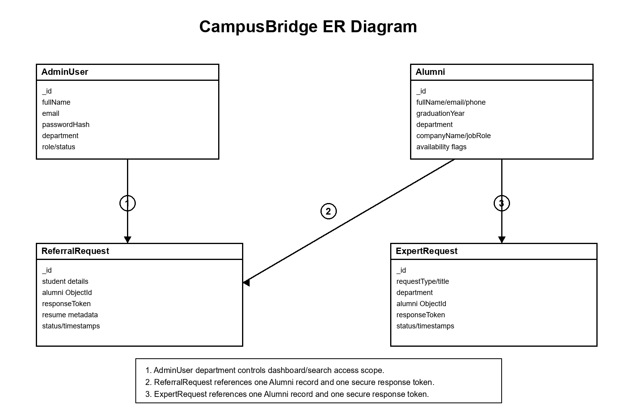
Figure 1: ER diagram of CampusBridge core entities.

7. OUTPUT SCREENSHOTS OF THE PROJECT
The following black-and-white output plates summarize the important screens developed in CampusBridge. They are included in compact form so the report remains readable and suitable for monochrome printing.
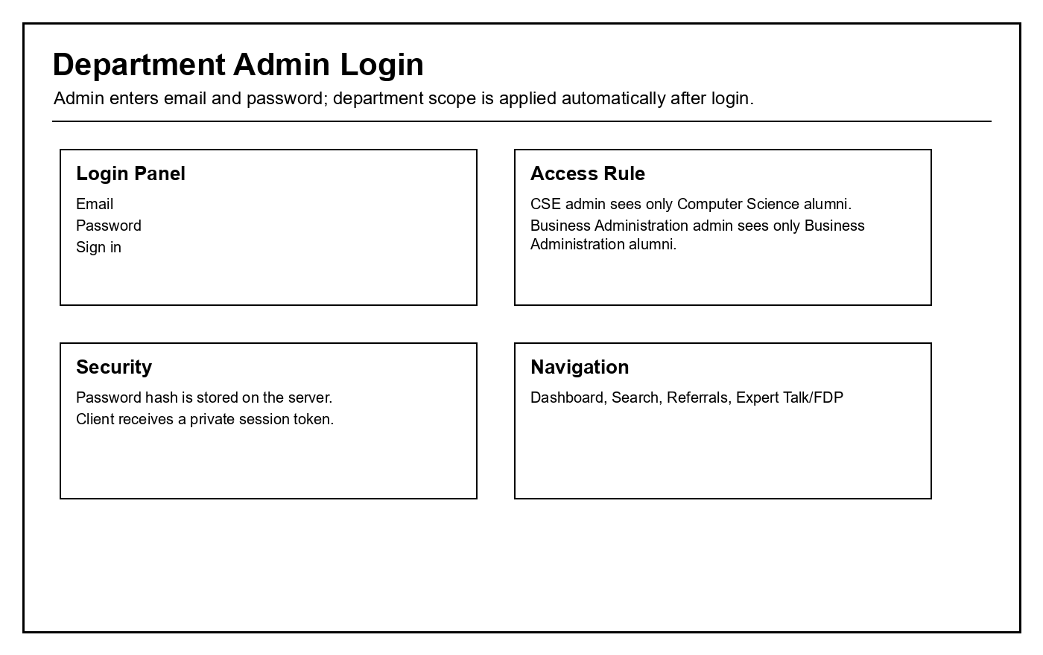
Screen 1: Department Admin Login
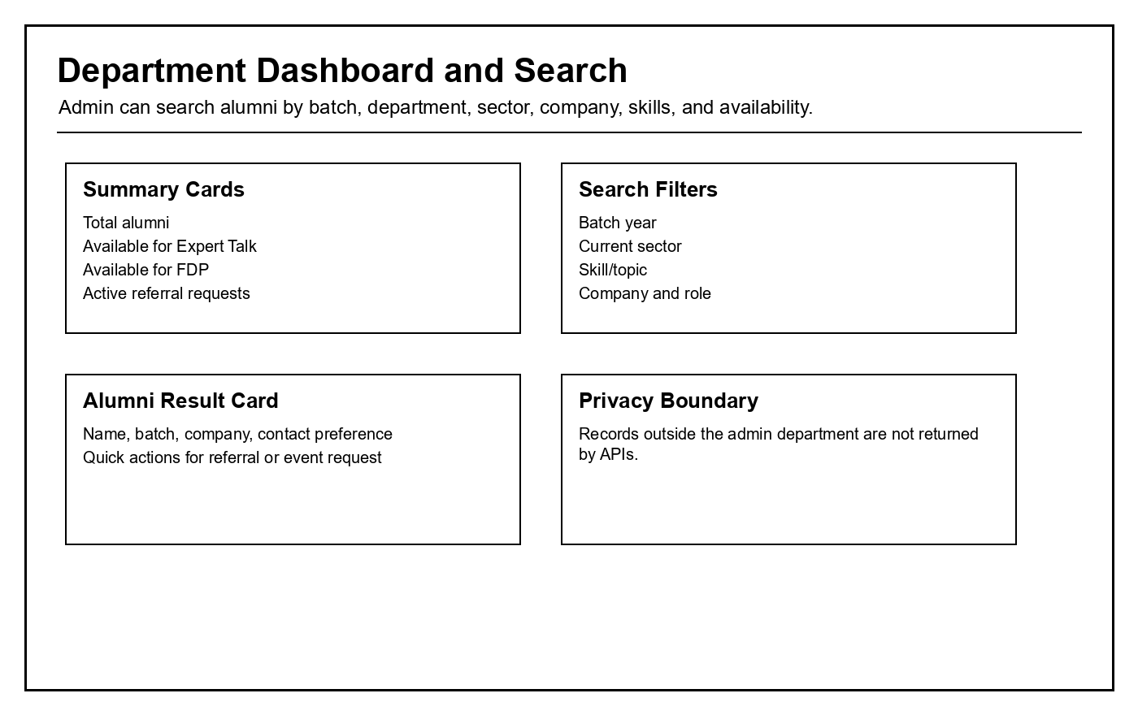
Screen 2: Department Dashboard and Search

7.1 Referral and Event Outputs
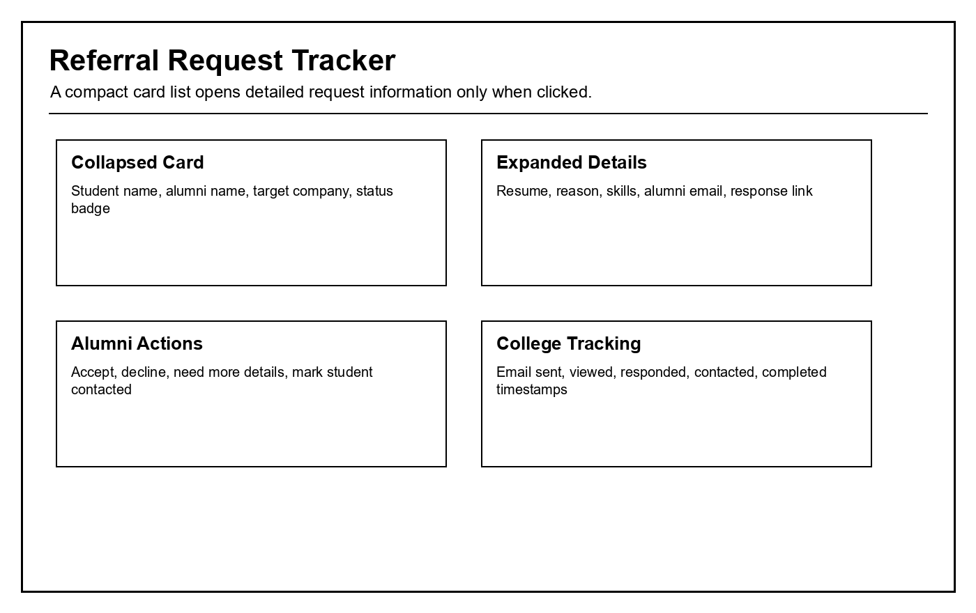
Screen 3: Referral Request Tracker
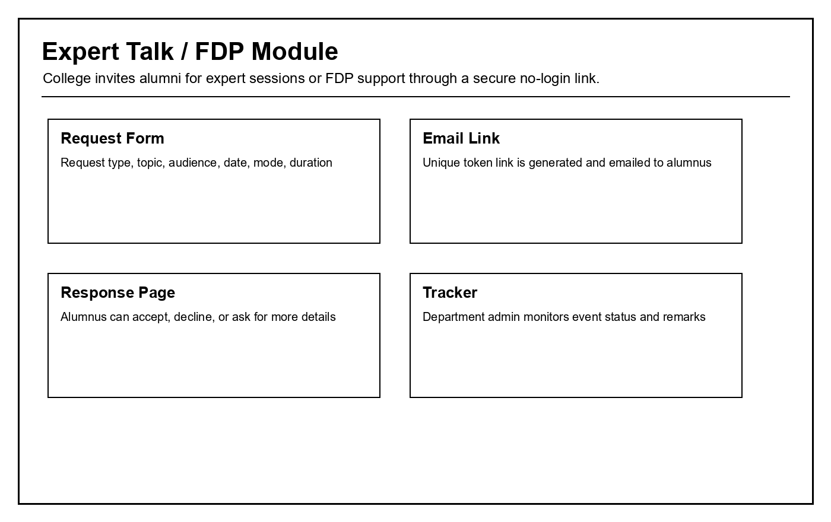
Screen 4: Expert Talk / FDP Module

8. CONCLUSION
CampusBridge successfully implements a practical alumni management and engagement system for Surana College. It solves the main problem of scattered alumni data by collecting alumni profiles through a public form and making them searchable by department admins.
The application also goes beyond record keeping. It converts alumni data into useful action through referral requests, Expert Talk invitations, FDP requests, response links, email delivery tracking, and request status timelines. This directly supports students, faculty, departments, and the placement ecosystem.
From a software engineering perspective, the project demonstrates full-stack development using React, Express, Node.js, MongoDB, Mongoose, Multer, Nodemailer, and Jenkins. The current implementation is deployable for controlled college usage and can be extended into a larger campus relationship platform.

8.1 Learning Outcome
The project gave practical exposure to backend API design, schema modelling, frontend state management, access control, file upload handling, email integration, and CI pipeline configuration.

9. FUTURE ENHANCEMENTS
- Add alumni self-service accounts where alumni can update profile, company, skills, and availability without repeatedly filling a new form.
- Add OTP verification or token expiry for referral and event response links.
- Add analytics dashboards showing alumni engagement rate, department-wise response rate, top companies, popular skills, and event completion history.
- Integrate WhatsApp or SMS reminders for high-priority requests while respecting alumni consent.
- Add AI-based alumni recommendations based on student goal, target company, skills, batch, and alumni response history.
- Add placement-cell super admin role for cross-department reporting and governance.
- Add calendar integration for Expert Talk/FDP scheduling.
- Deploy on a cloud platform with HTTPS, managed MongoDB, daily backups, monitoring, and CI/CD deployment from Jenkins.
- Add export features for accreditation reports, alumni participation evidence, and department activity summaries.
The most valuable next enhancement is not simply adding more screens. It is building alumni engagement quality: fewer but better requests, proper consent, automated reminders, and measurable outcomes.

10. BIBLIOGRAPHY
- MongoDB Documentation - Schema Design and Indexing Concepts.
- Mongoose Documentation - Schemas, Models, Validation, and Population.
- Express.js Documentation - Routing and Middleware.
- React Documentation - Component-Based UI Development.
- Vite Documentation - Frontend Build Tooling.
- Nodemailer Documentation - SMTP Email Sending in Node.js.
- Jenkins Documentation - Pipeline as Code and Build Artifacts.
- OWASP Web Security Guidelines - Authentication, File Upload, and Access Control Practices.
- Project Source Code - CampusBridge Alumni Management System, Surana College.

