AWS SNS, SQS & CloudWatch Monitoring
EC2 Monitoring with Email and SQS Notifications
Project Documentation
1. Project Overview
This project demonstrates an AWS monitoring and notification workflow using Amazon SNS, Amazon SQS, Amazon EC2, and Amazon CloudWatch. An SNS topic named NK-Topic is configured with two subscribers: an email subscriber using the Email-JSON protocol and an Amazon SQS queue. The same SNS topic is later used as the notification target for a CloudWatch alarm that monitors CPU Utilization on an EC2 instance.
2. Objective
To understand how Amazon SNS can distribute messages to multiple subscribers and how Amazon CloudWatch alarms can trigger notifications for an EC2 monitoring event. The project validates message delivery to both Email and SQS and confirms that a CloudWatch alarm can use the same SNS topic for alert delivery.
3. Technology Stack
• Amazon Simple Notification Service (Amazon SNS)
• Amazon Simple Queue Service (Amazon SQS)
• Amazon Elastic Compute Cloud (Amazon EC2)
• Amazon CloudWatch
• AWS Identity and Access Management (IAM)
• Email subscription using Email-JSON format
• CloudWatch Classic Metrics and CloudWatch Alarms

4. Architecture
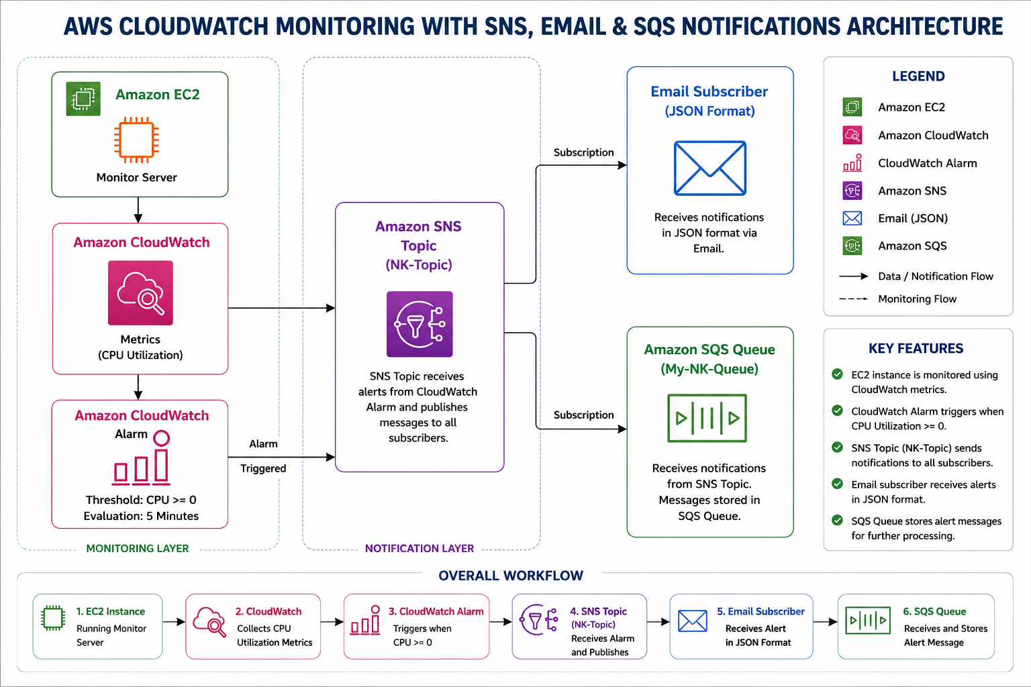
The architecture uses Amazon SNS as the central notification service. Test messages can be published to NK-Topic and delivered to the configured Email and SQS subscribers. For monitoring, the EC2 Monitor Server sends CPU Utilization metrics to CloudWatch. When the configured alarm enters the ALARM state, the alarm notification is sent to NK-Topic and distributed to both Email and Amazon SQS.
5. Implementation Workflow
1. Create the Amazon SNS topic named NK-Topic.
2. Create an Email-JSON subscription and confirm the email subscription through the SubscribeURL.
3. Create the Amazon SQS queue named My-NK-Queue.
4. Configure the required SNS-to-SQS access settings and create the SQS subscription.
5. Publish a test message to NK-Topic and validate delivery in both SQS and Gmail.
6. Launch an EC2 instance named Monitor Server for monitoring.
7. Open CloudWatch Classic Metrics and select the EC2 CPU Utilization metric for the instance.
8. Create a CloudWatch alarm using the Average statistic and a 5-minute period.
9. Use a static threshold with CPU Utilization greater than or equal to 0 for the lab task.
10. Configure the alarm action to notify the existing NK-Topic when the alarm is in the ALARM state.
11. Validate that the alarm notification is delivered to both Gmail and the SQS queue.

Implementation Screenshots
1. Topic Created
Created the SNS topic NK-Topic for centralized notifications.
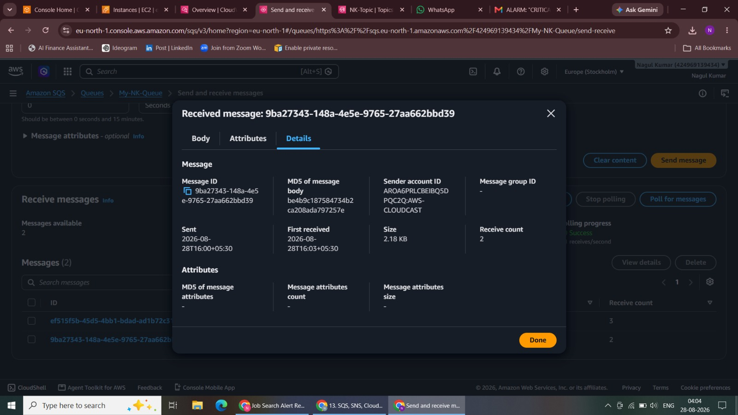
Figure 1. Topic Created
2. Adding Subscription Gmail - Email JSON Format
Configured the first subscriber using the Email-JSON protocol.
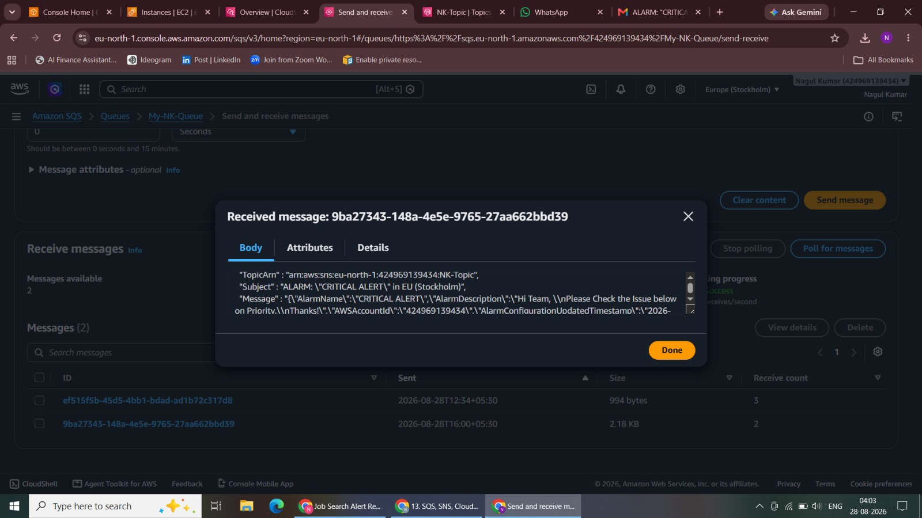
Figure 2. Adding Subscription Gmail - Email JSON Format

3. Subscription created
Created the email subscription for the SNS topic.
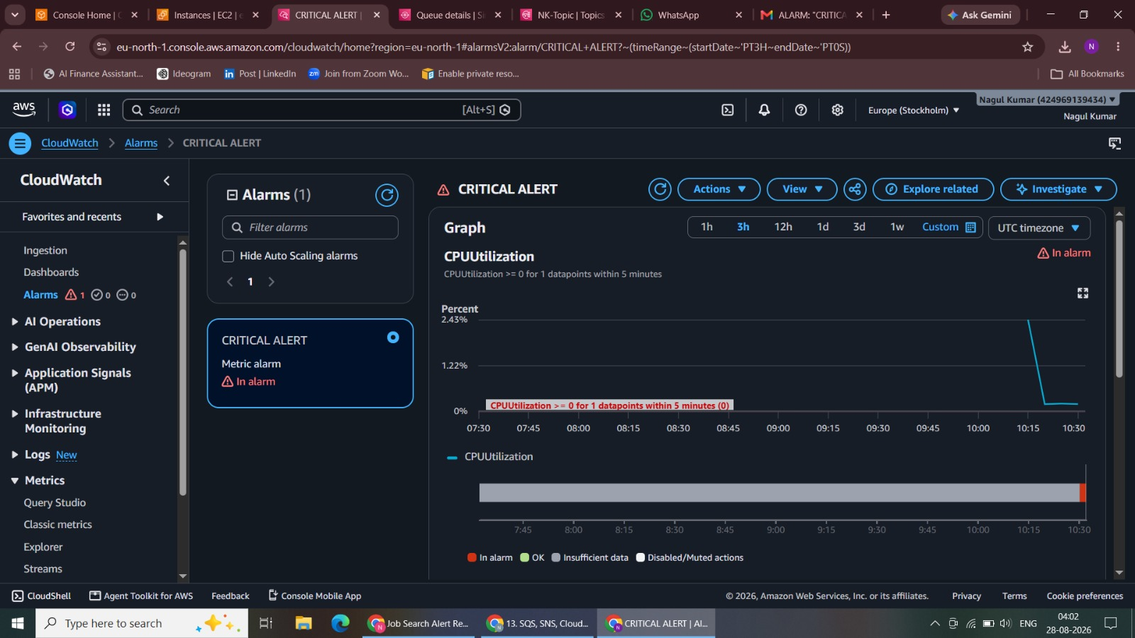
Figure 3. Subscription created
4. Email received in JSON format
Received the SNS notification in the configured Gmail account.
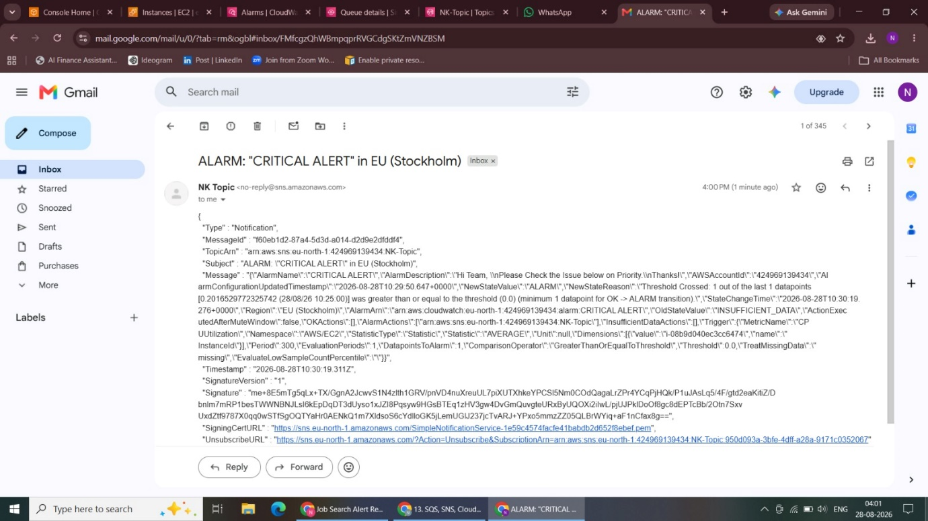
Figure 4. Email received in JSON format

5. Subscription confirmed after clicking the Subscribe URL
Confirmed the subscription through the AWS SubscribeURL.
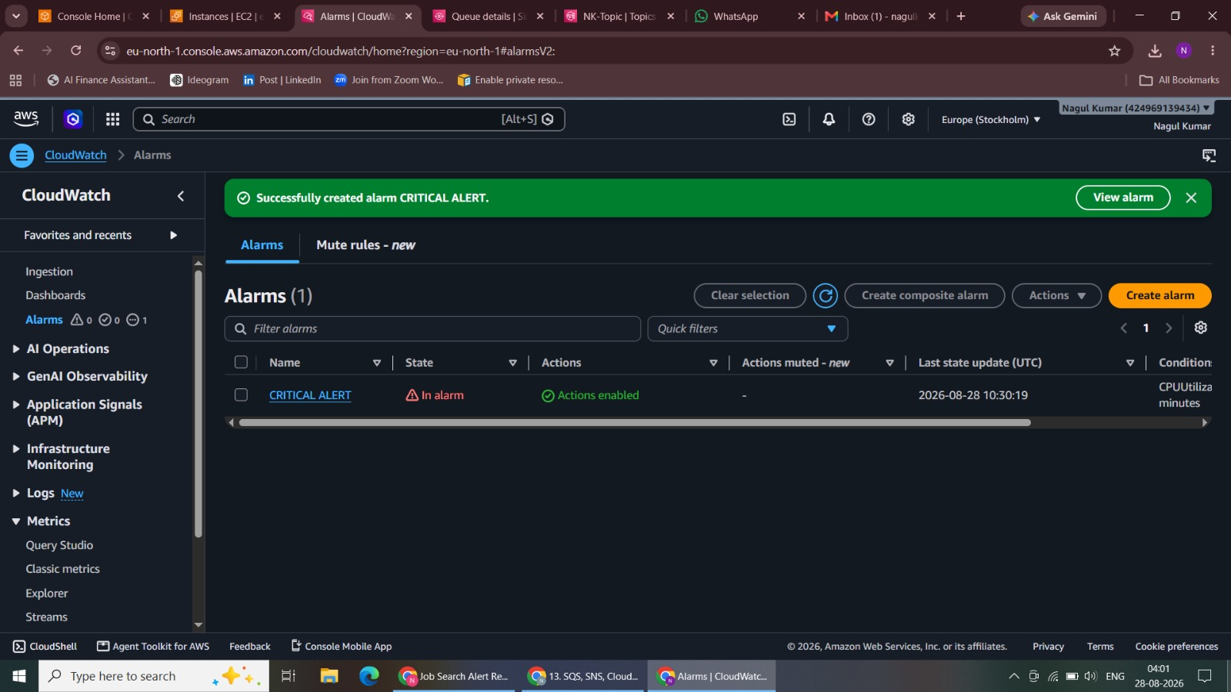
Figure 5. Subscription confirmed after clicking the Subscribe URL
6. Subscriber Confirmed
Verified that the email subscription status was Confirmed.
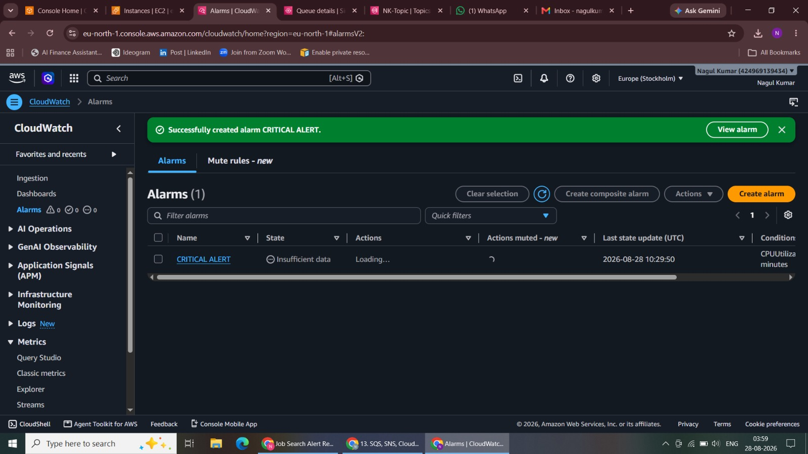
Figure 6. Subscriber Confirmed

7. Queue creation using Amazon SQS
Started creation of the SQS queue My-NK-Queue.
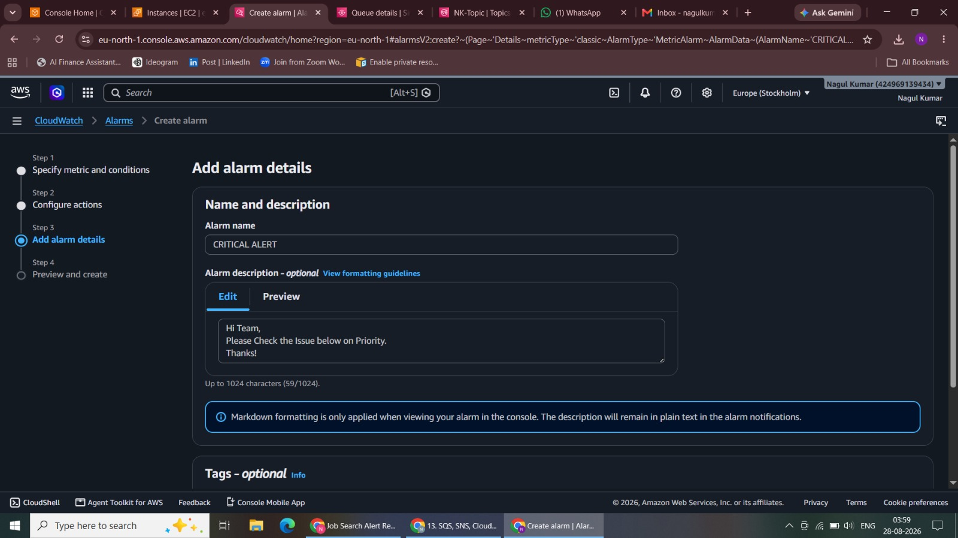
Figure 7. Queue creation using Amazon SQS
8. Adding role for SNS
Started the IAM configuration used in the SNS-to-SQS lab workflow.
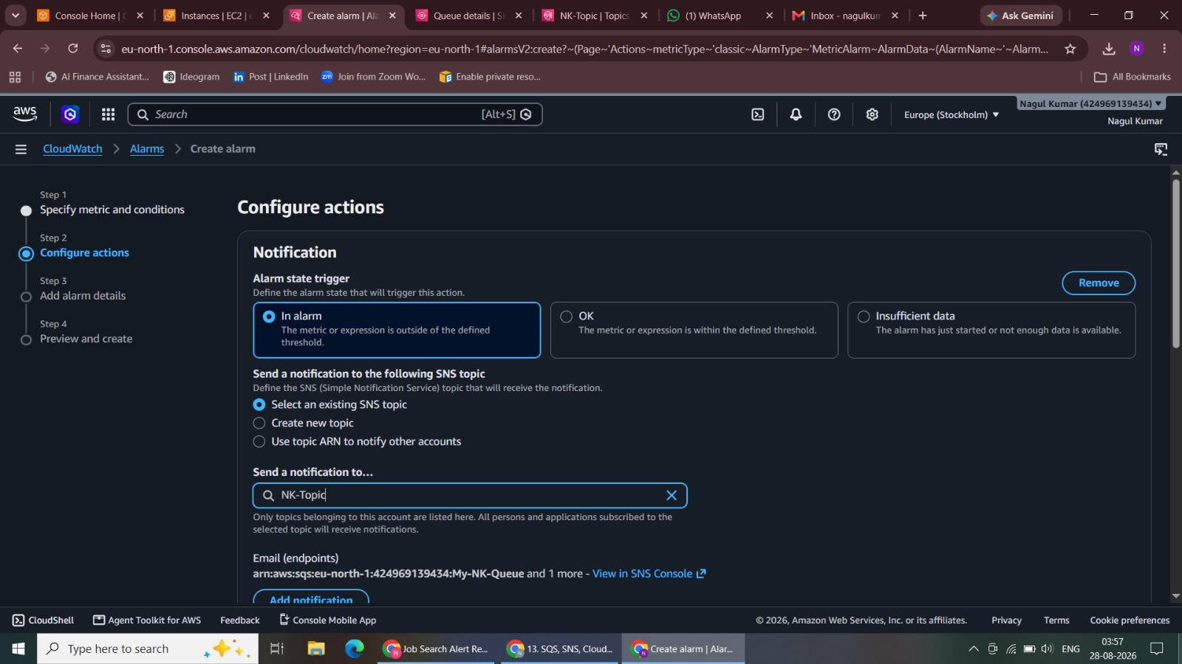
Figure 8. Adding role for SNS

9. Policy
Reviewed the required permission policy.
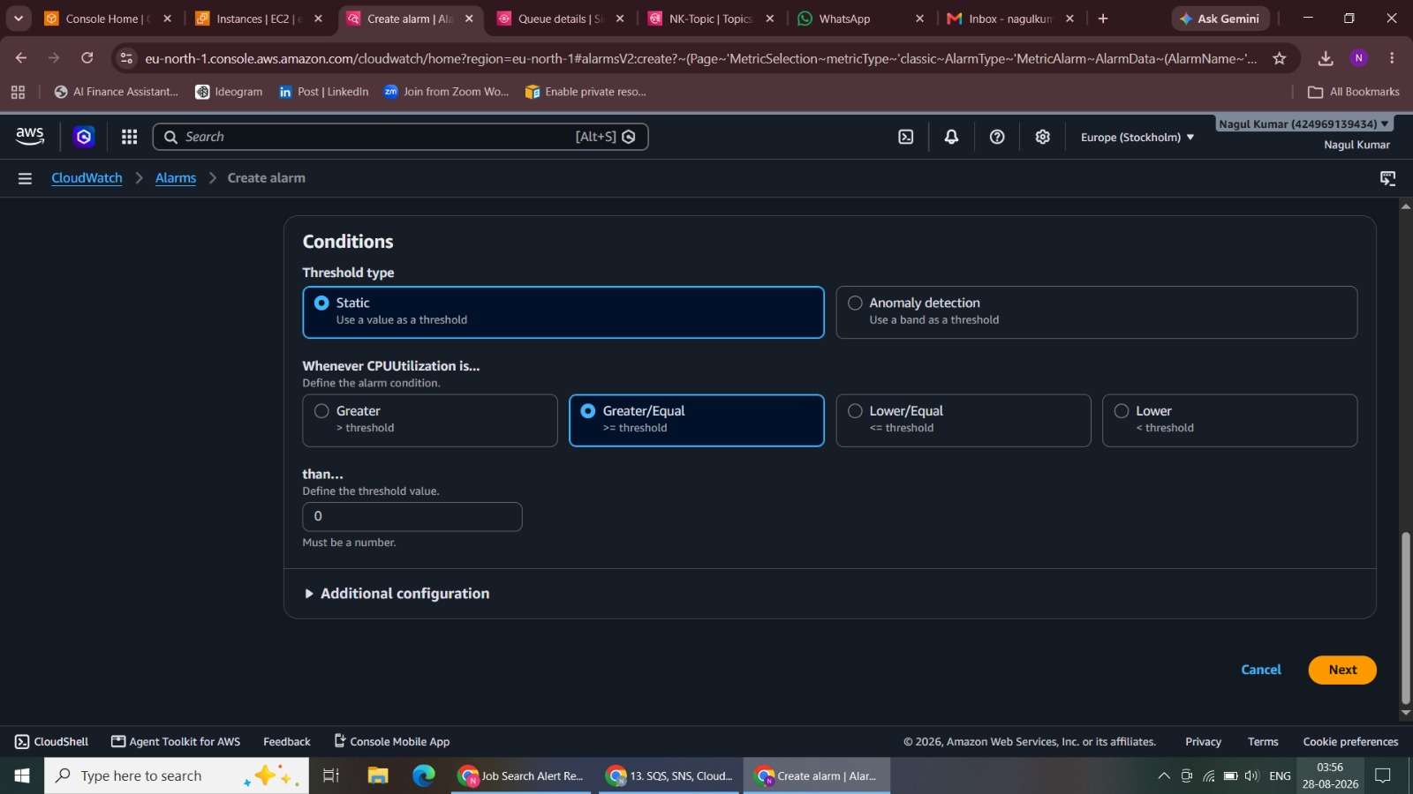
Figure 9. Policy
10. Adding name
Configured the IAM role name before creation.
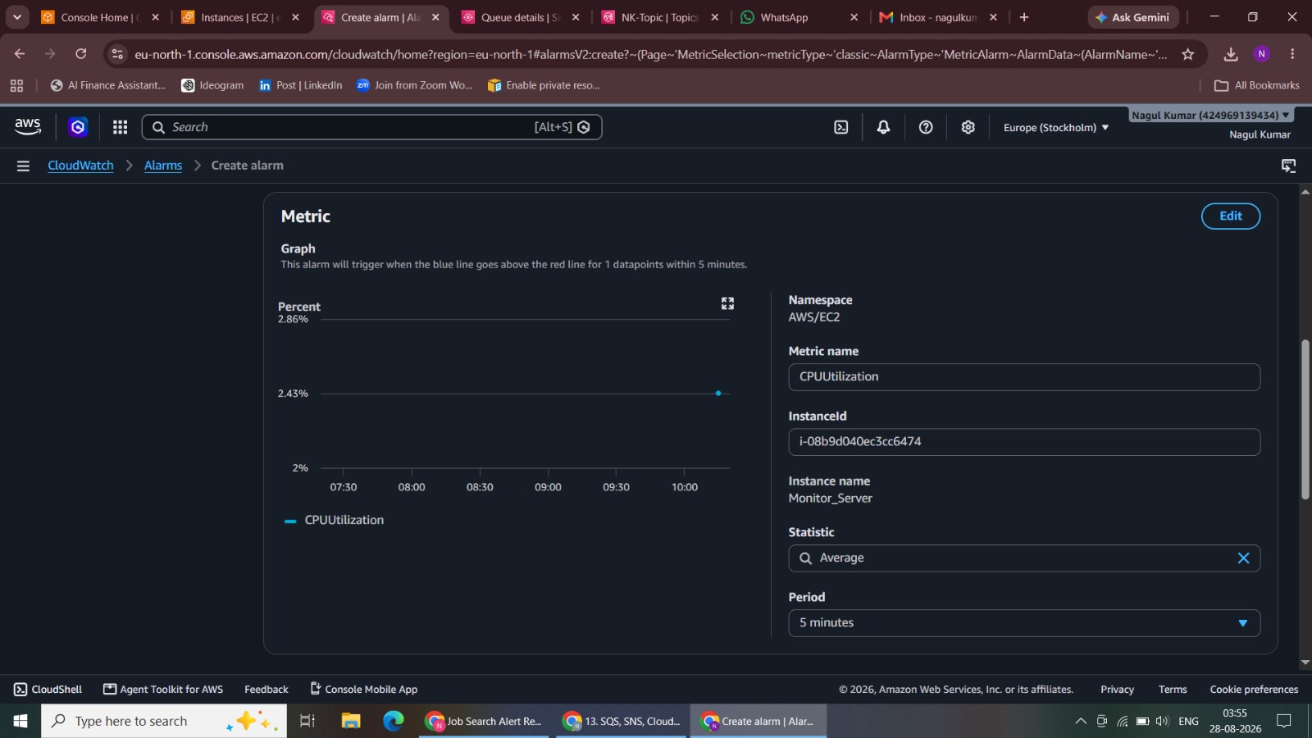
Figure 10. Adding name

11. IAM Role has been created
Verified that the IAM role was created.
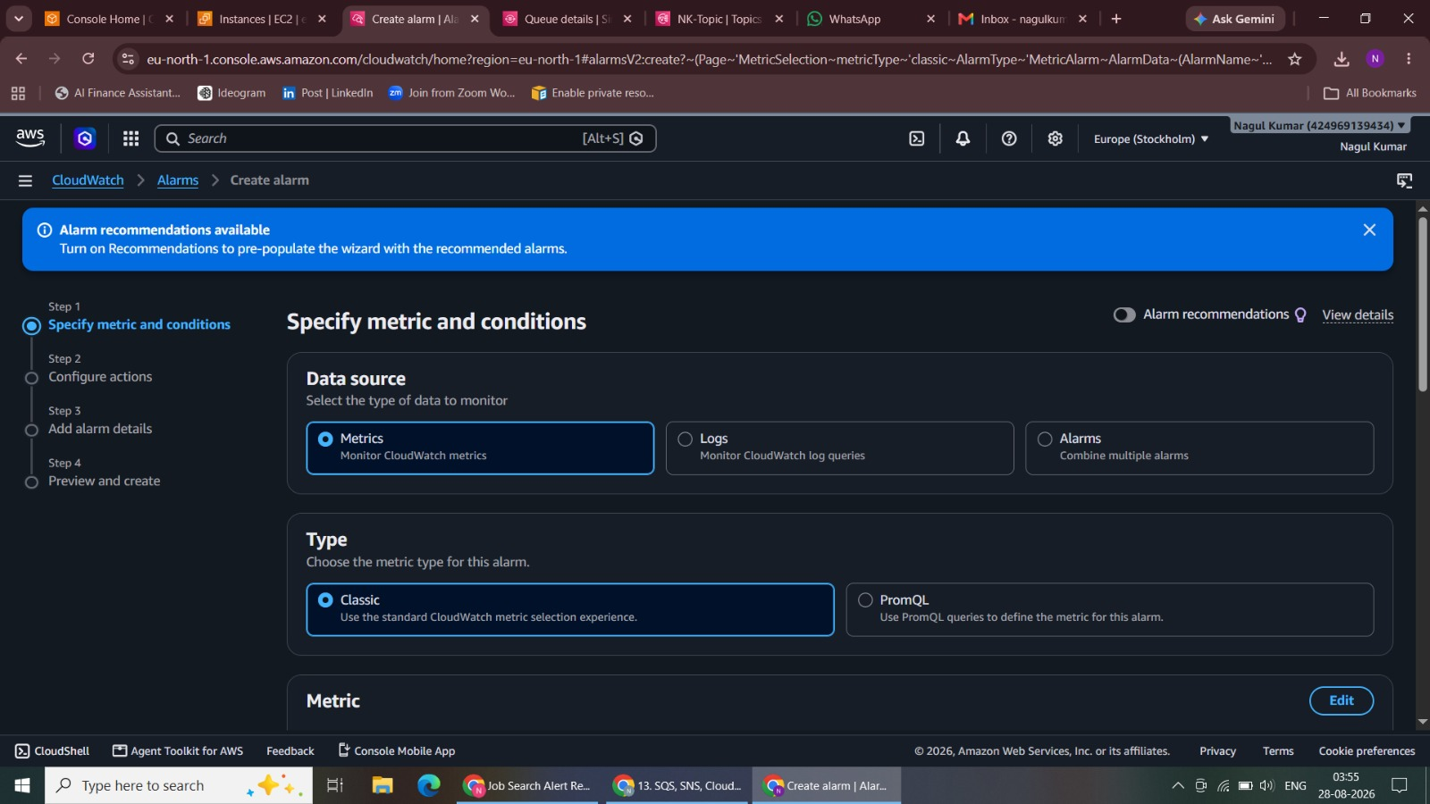
Figure 11. IAM Role has been created
12. Copy the Role ARN to the SQS TAB
Copied the role ARN for the queue access configuration.
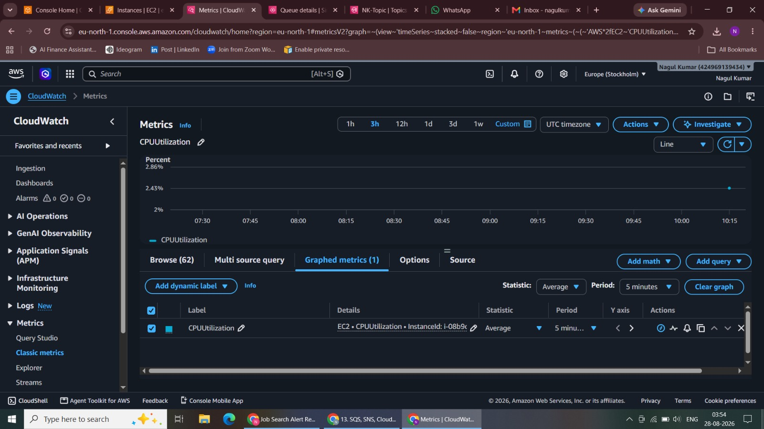
Figure 12. Copy the Role ARN to the SQS TAB

13. Access Policy
Configured the SQS queue access policy settings.
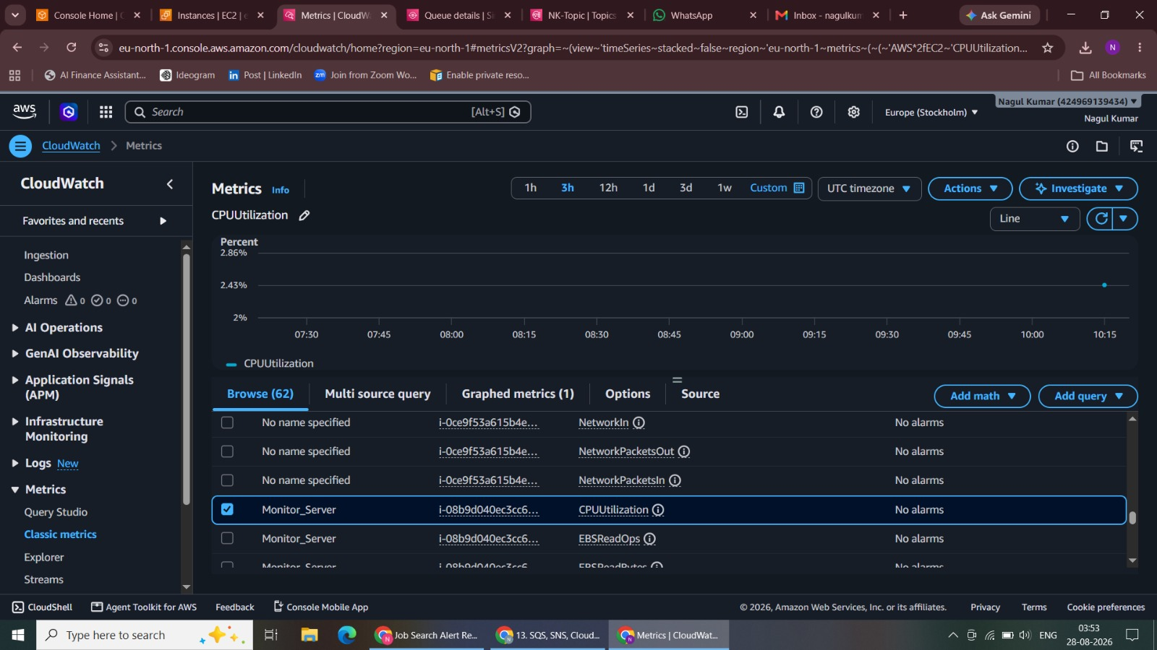
Figure 13. Access Policy
14. Public Queue Created
Created the SQS queue successfully.
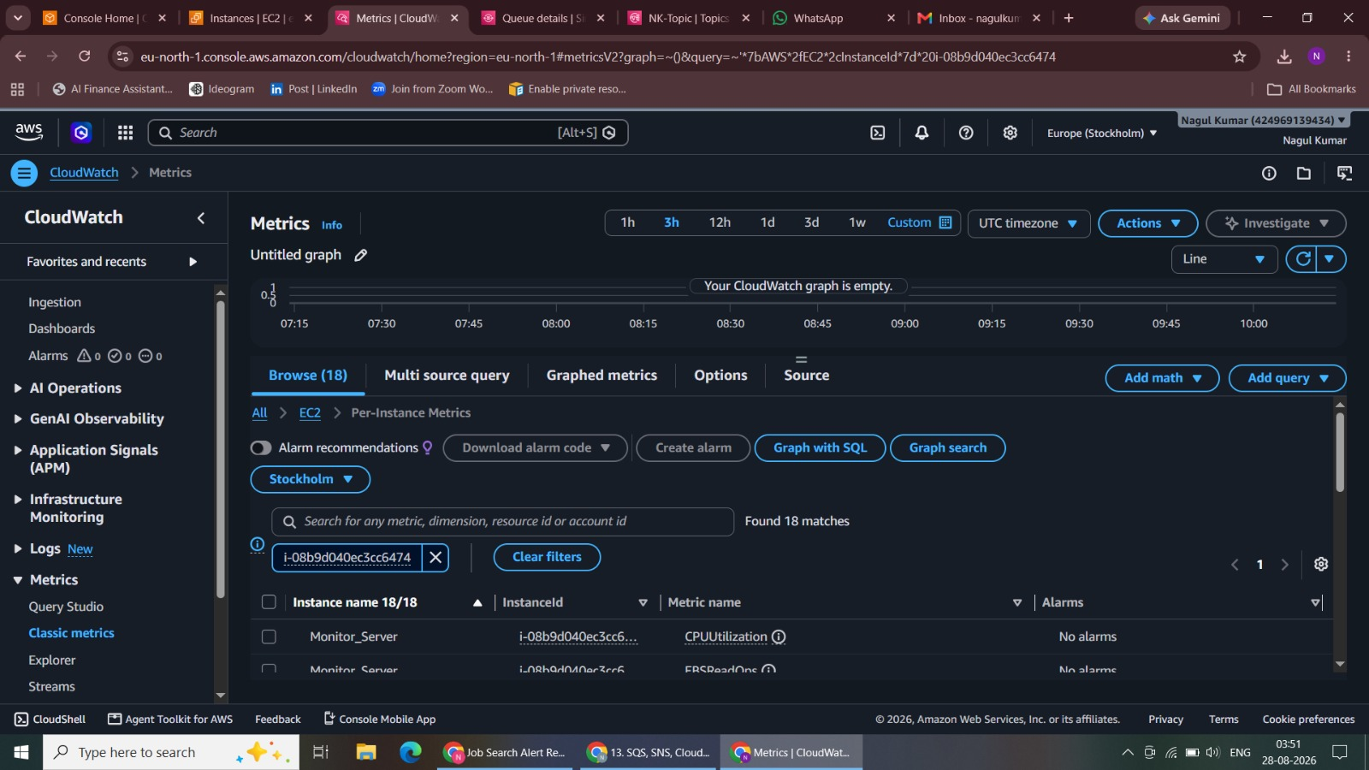
Figure 14. Public Queue Created

15. Creating Subscription - Amazon SQS And Endpoint
Added Amazon SQS as the second SNS subscription endpoint.
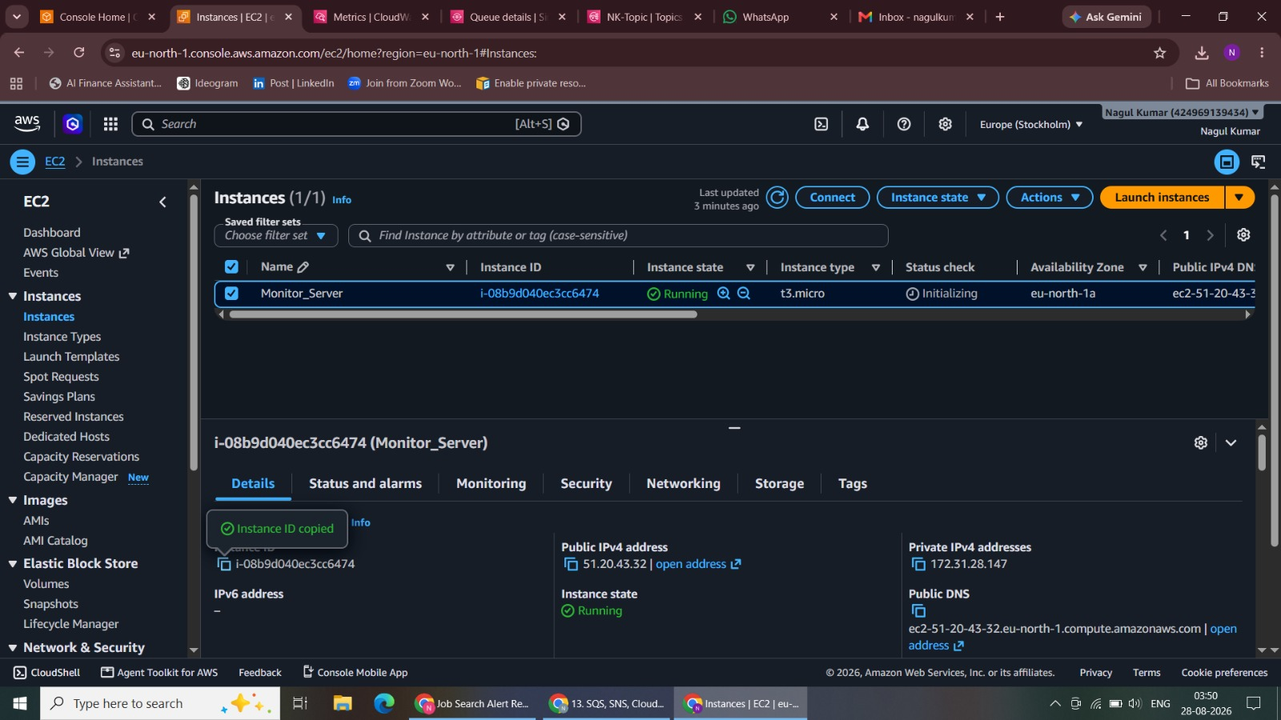
Figure 15. Creating Subscription - Amazon SQS And Endpoint
16. SQS Subscription Created
Created and verified the SNS-to-SQS subscription.
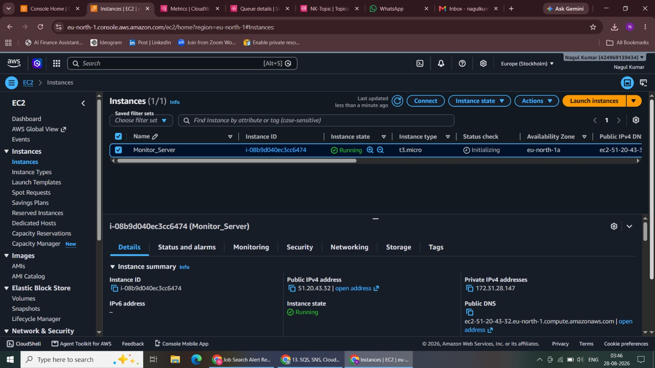
Figure 16. SQS Subscription Created

17. SNS Subscription automatically Added to the SQS Queue
Verified the SNS subscription in the SQS queue configuration.
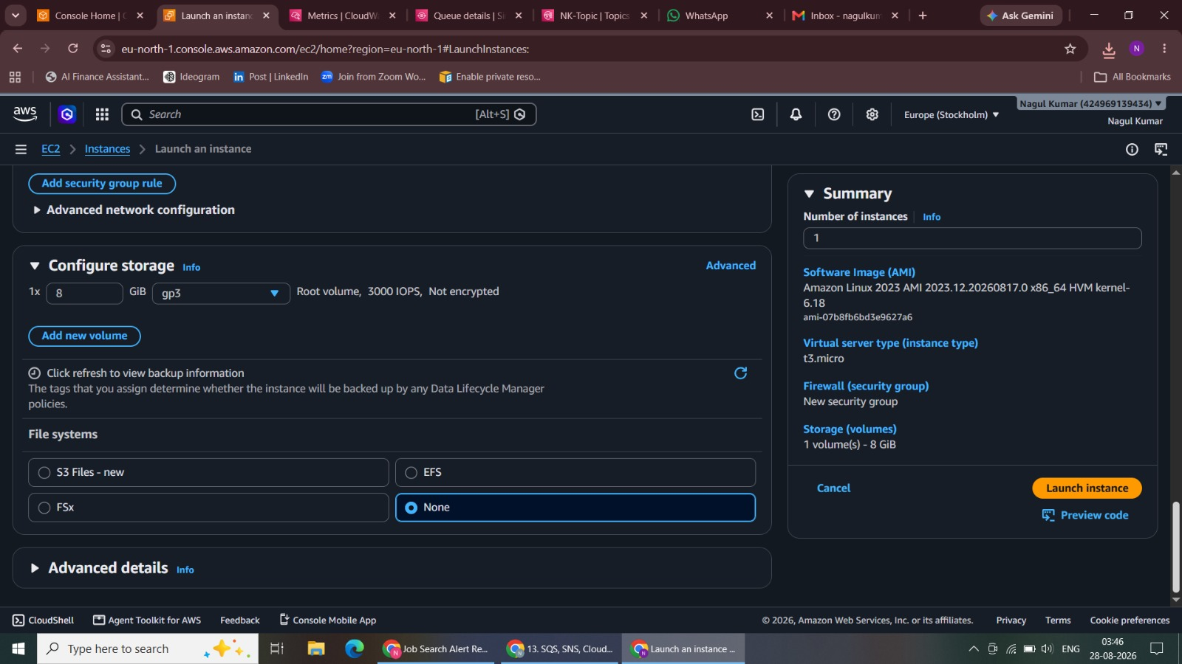
Figure 17. SNS Subscription automatically Added to the SQS Queue
18. Message Publishing
Opened the SNS publish-message workflow.
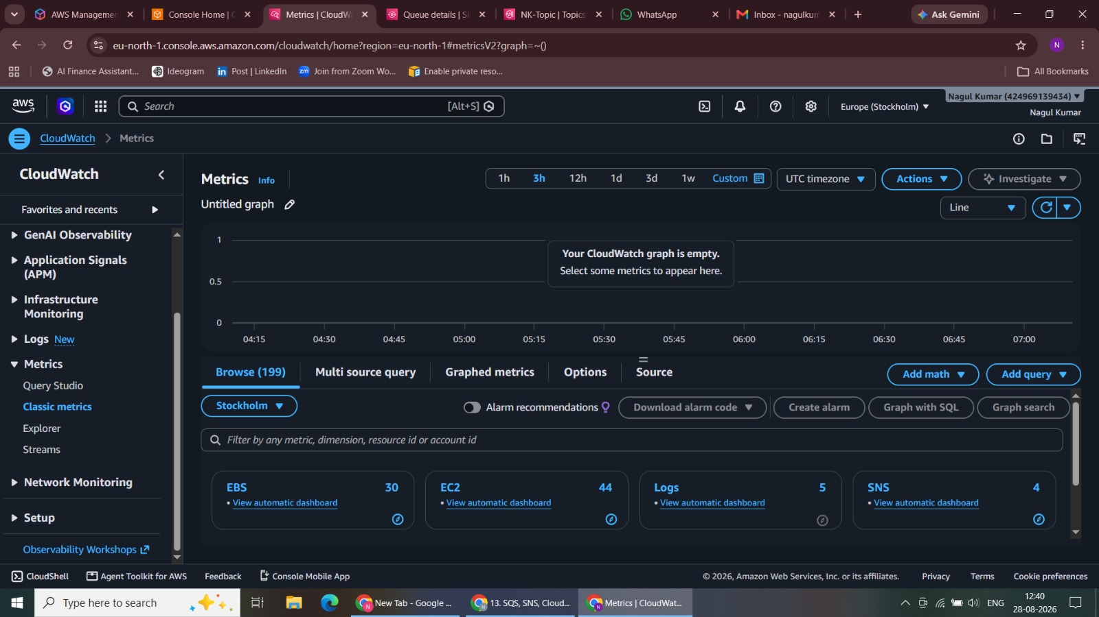
Figure 18. Message Publishing

19. Message Published
Published a test message to NK-Topic.
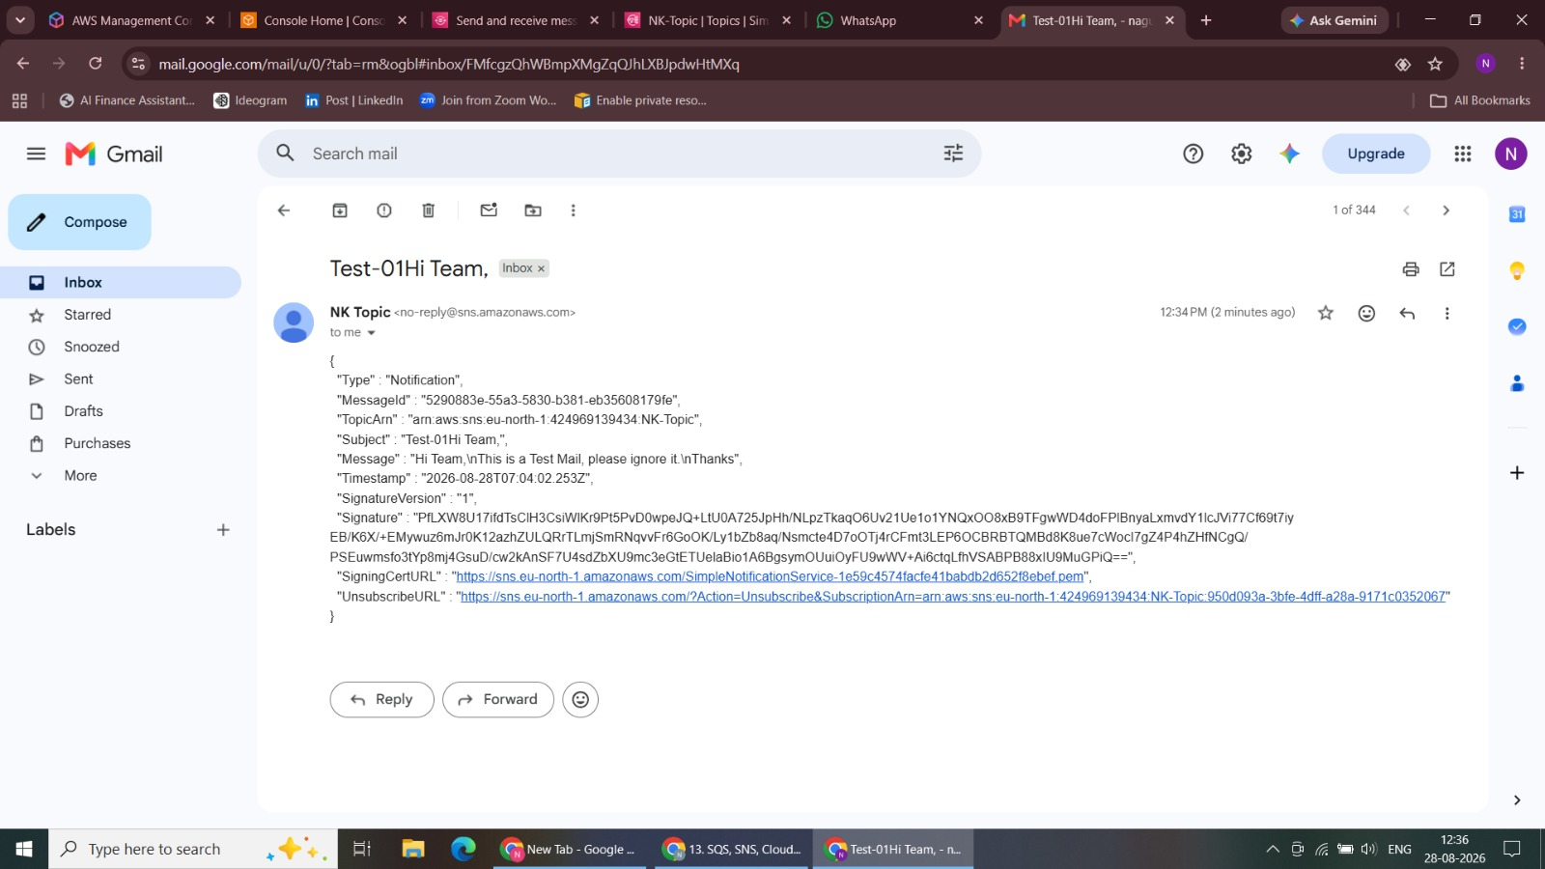
Figure 19. Message Published
20. Message Received in Amazon SQS
Polled the SQS queue and verified message delivery.
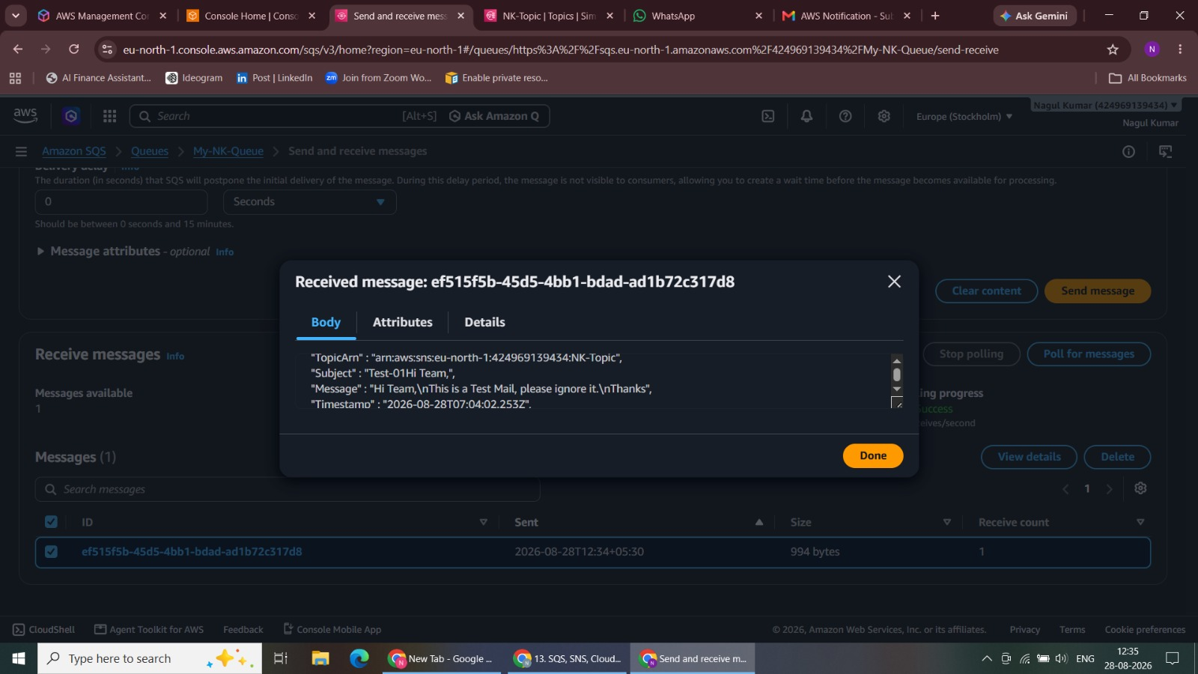
Figure 20. Message Received in Amazon SQS

21. Message Received in Gmail
Verified the same published message in Gmail.
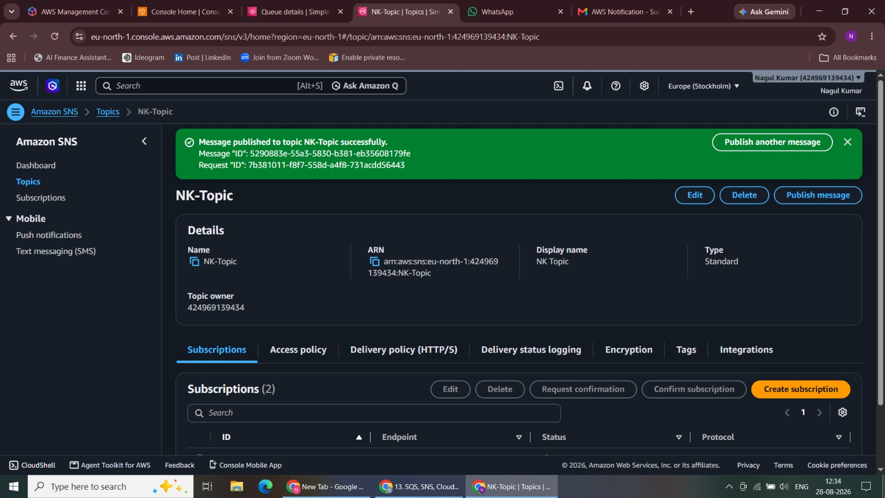
Figure 21. Message Received in Gmail
22. CloudWatch Classic Metrics Dashboard
Opened CloudWatch Classic Metrics.
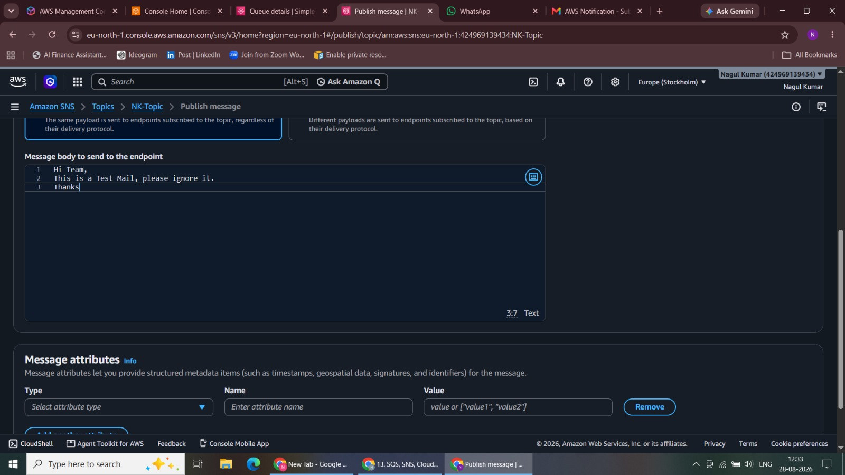
Figure 22. CloudWatch Classic Metrics Dashboard

23. Instance Launching
Started the EC2 instance launch workflow for monitoring.
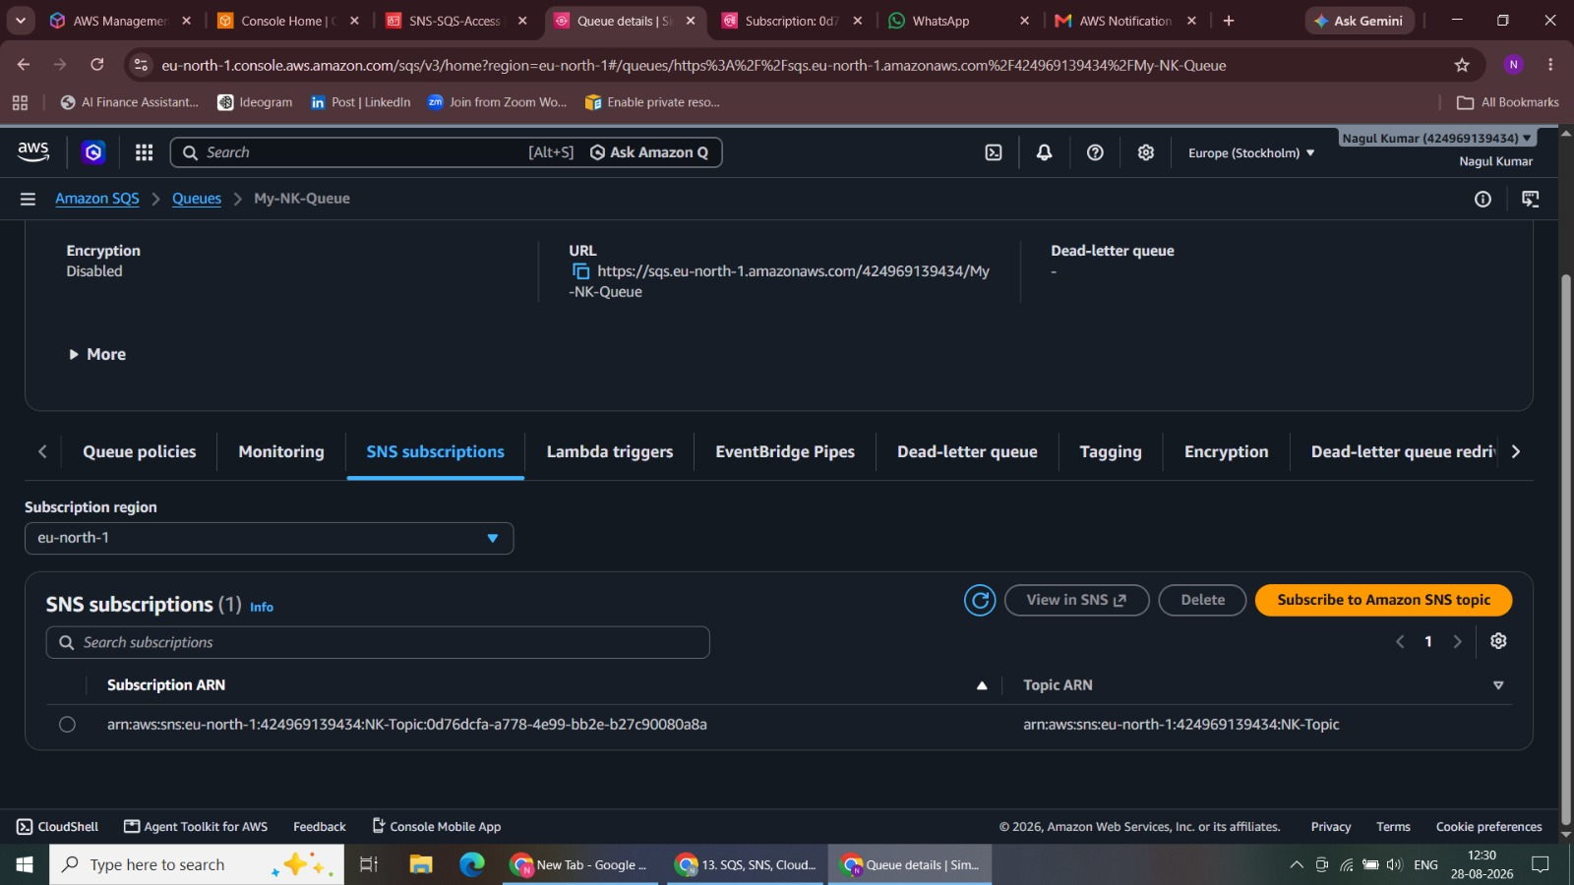
Figure 23. Instance Launching
24. Instance Launched
Verified that the Monitor Server instance was running.
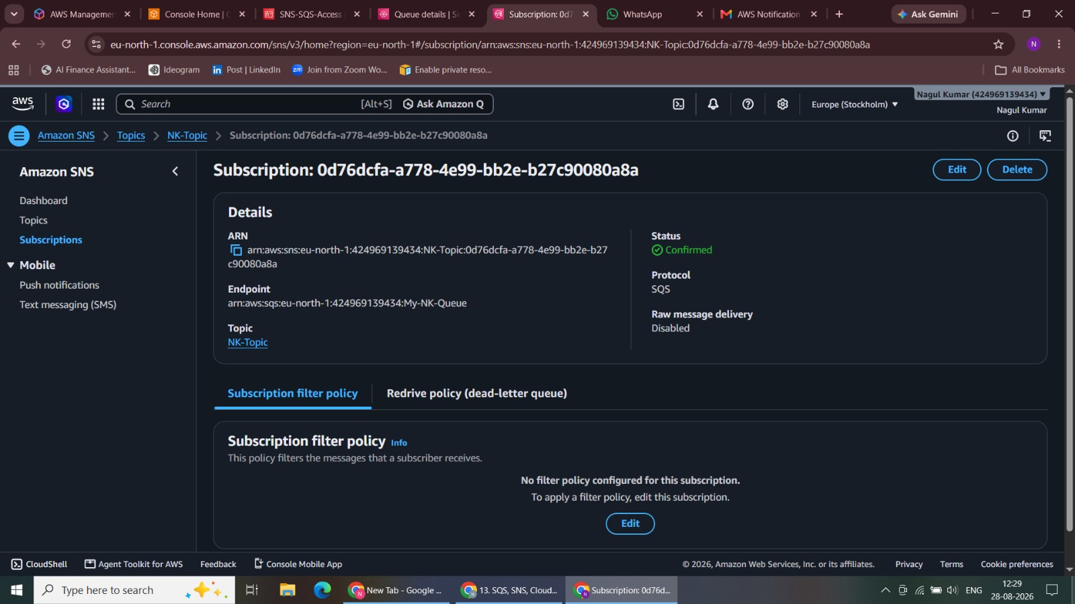
Figure 24. Instance Launched

25. Copy Instance ID
Copied the EC2 instance ID.
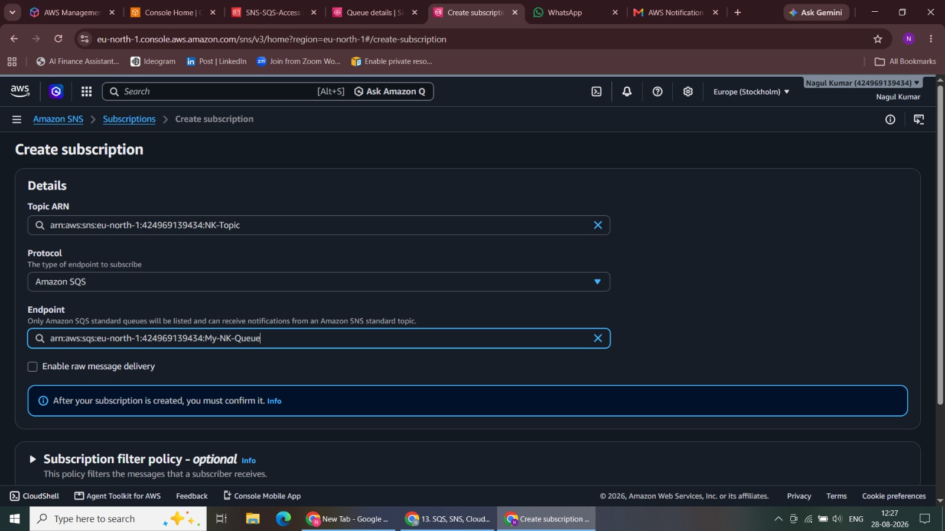
Figure 25. Copy Instance ID
26. Paste the Instance ID in Classic Metrics
Used the instance ID to locate the correct CloudWatch metric.
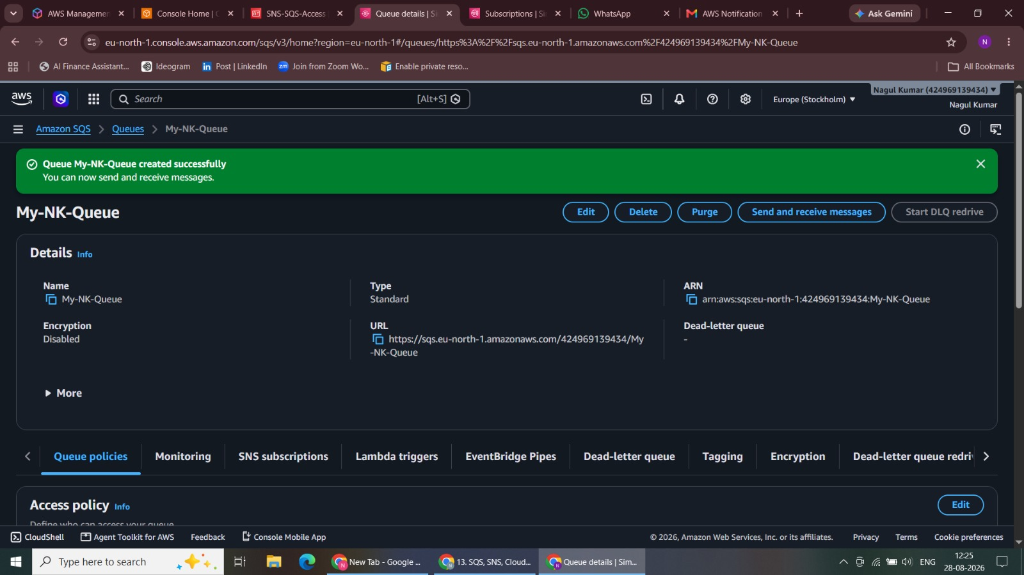
Figure 26. Paste the Instance ID in Classic Metrics

27. Select CPU Utilization Metric
Selected the EC2 CPU Utilization metric.
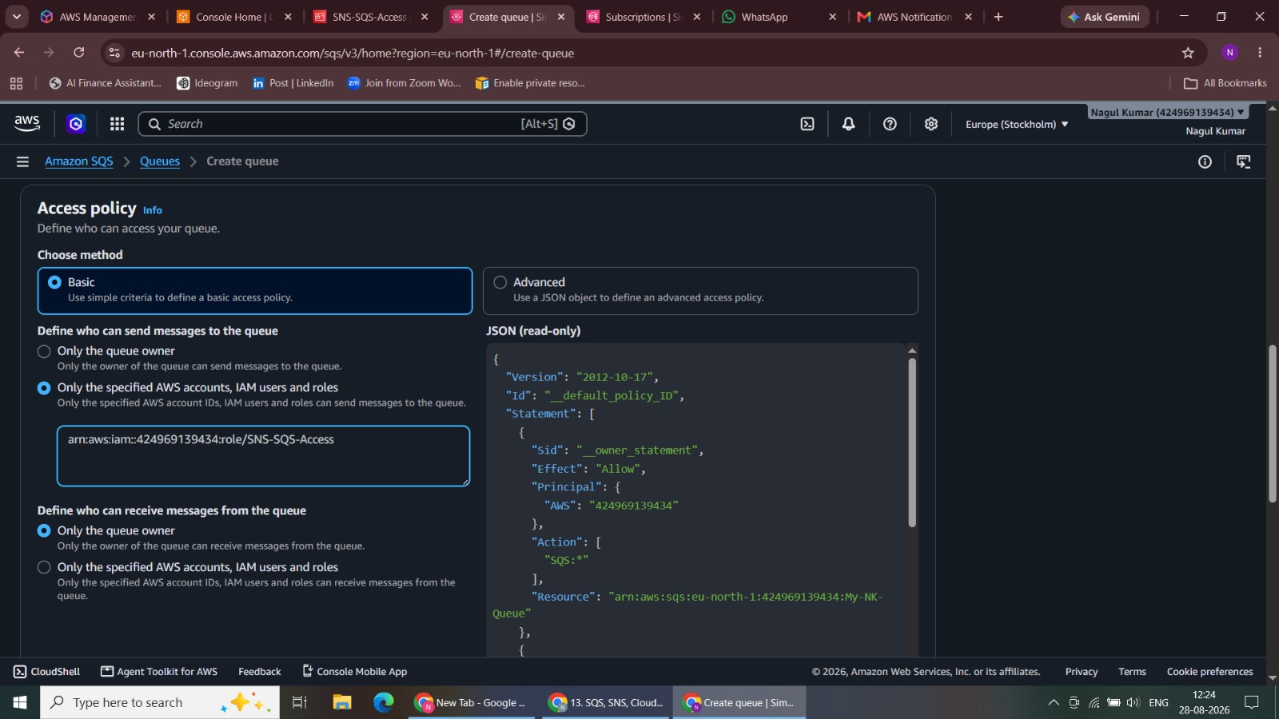
Figure 27. Select CPU Utilization Metric
28. Switch to Graphed Metrics
Reviewed the selected metric in the Graphed Metrics view.
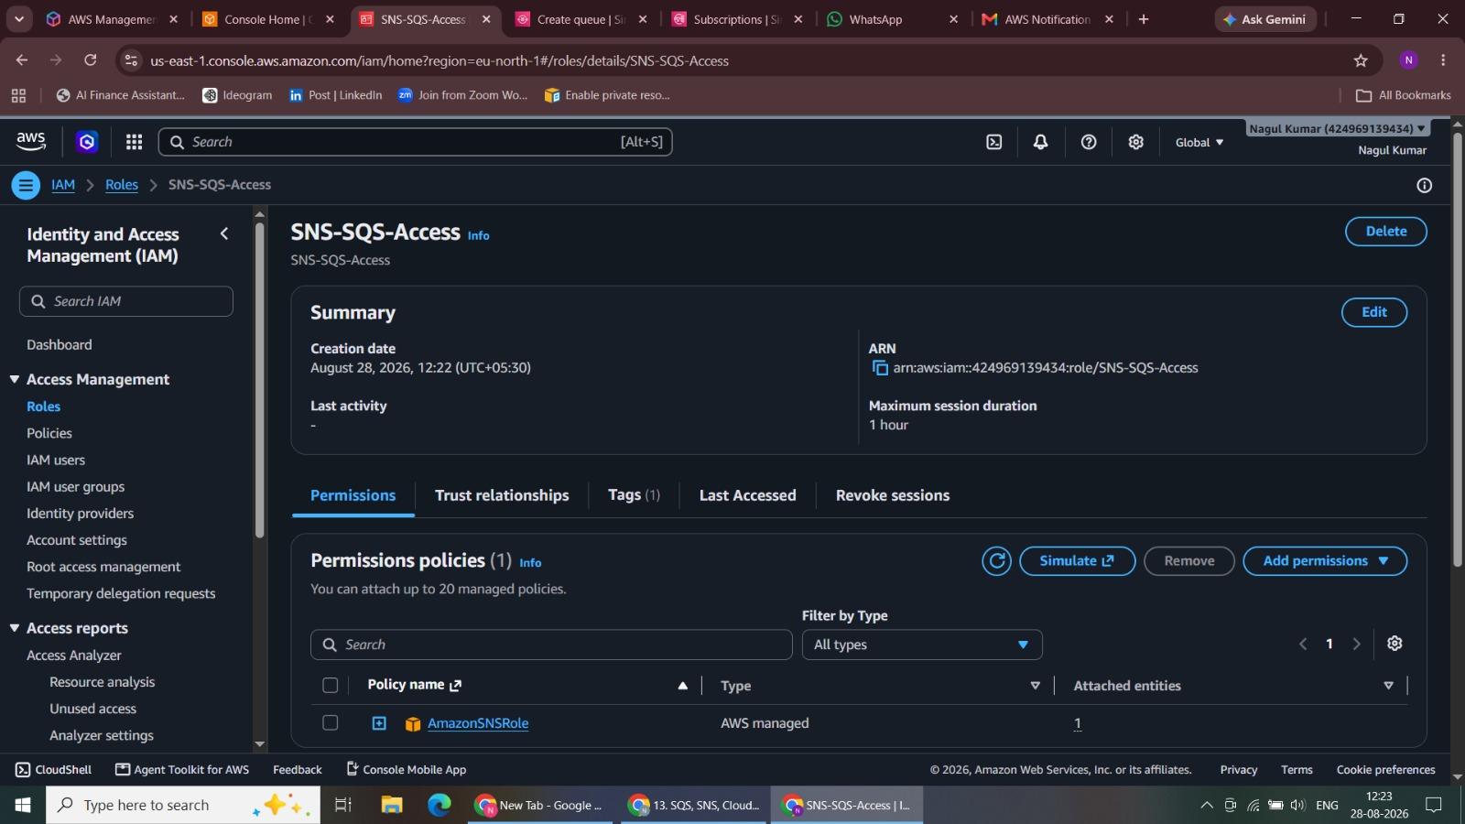
Figure 28. Switch to Graphed Metrics

29. Alarm Creation
Started the CloudWatch alarm creation workflow.
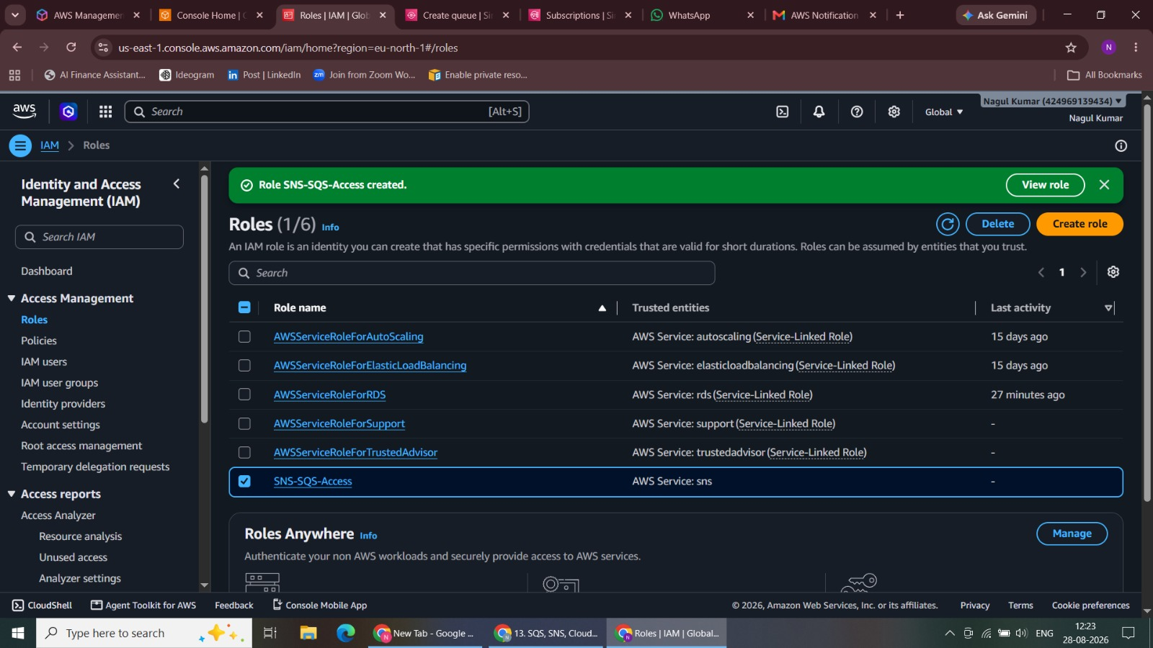
Figure 29. Alarm Creation
30. Metric
Configured the alarm metric and monitoring settings.
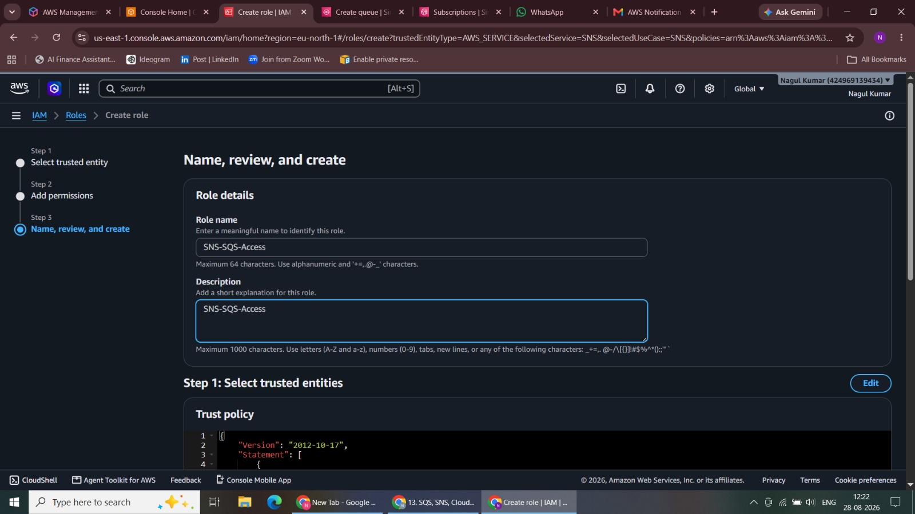
Figure 30. Metric

31. Conditions - Threshold Type
Configured the static threshold for the lab task.
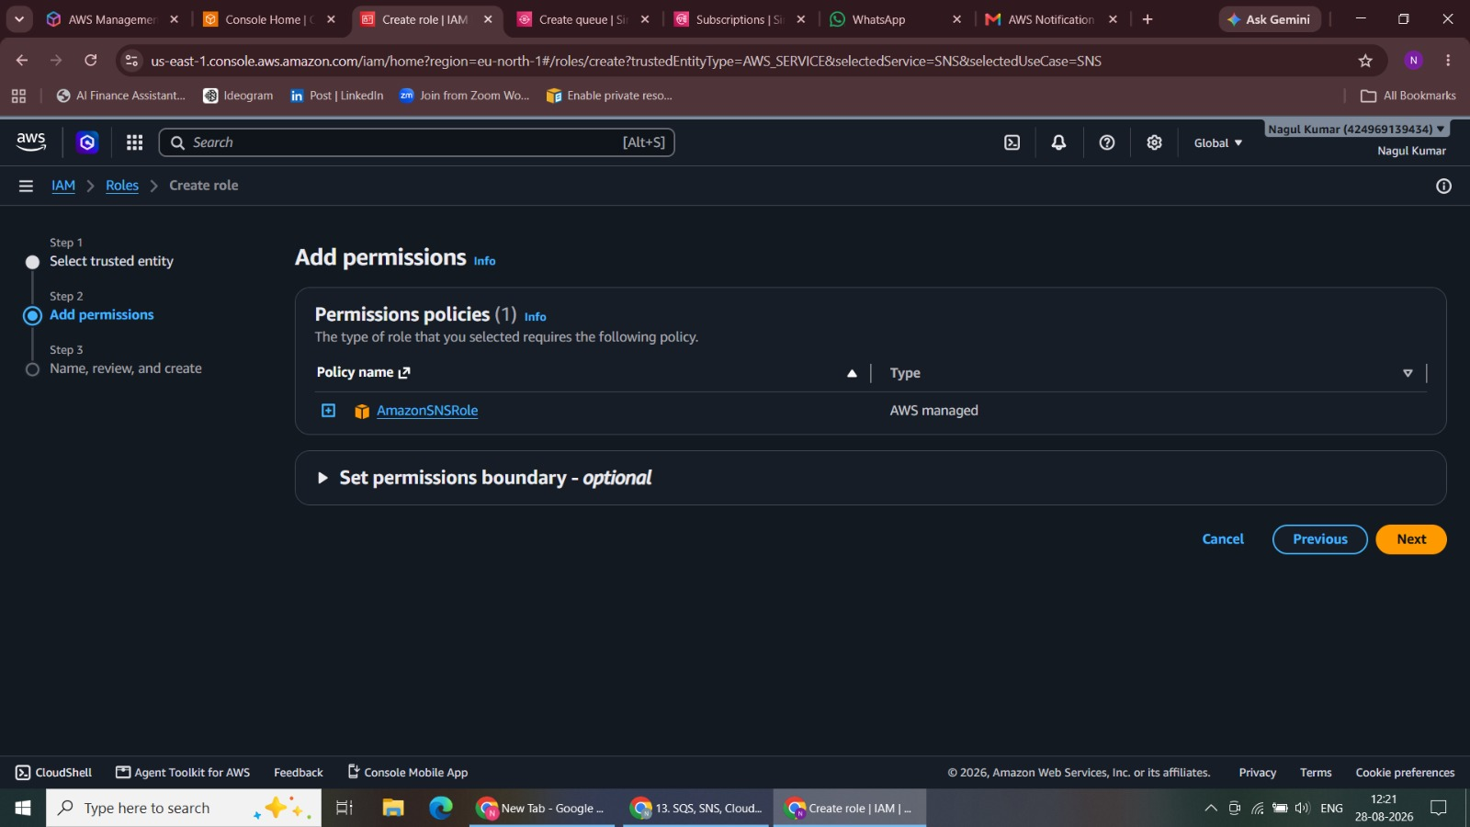
Figure 31. Conditions - Threshold Type
32. Notification and Selection of sns topics
Configured the IN ALARM action to notify NK-Topic.
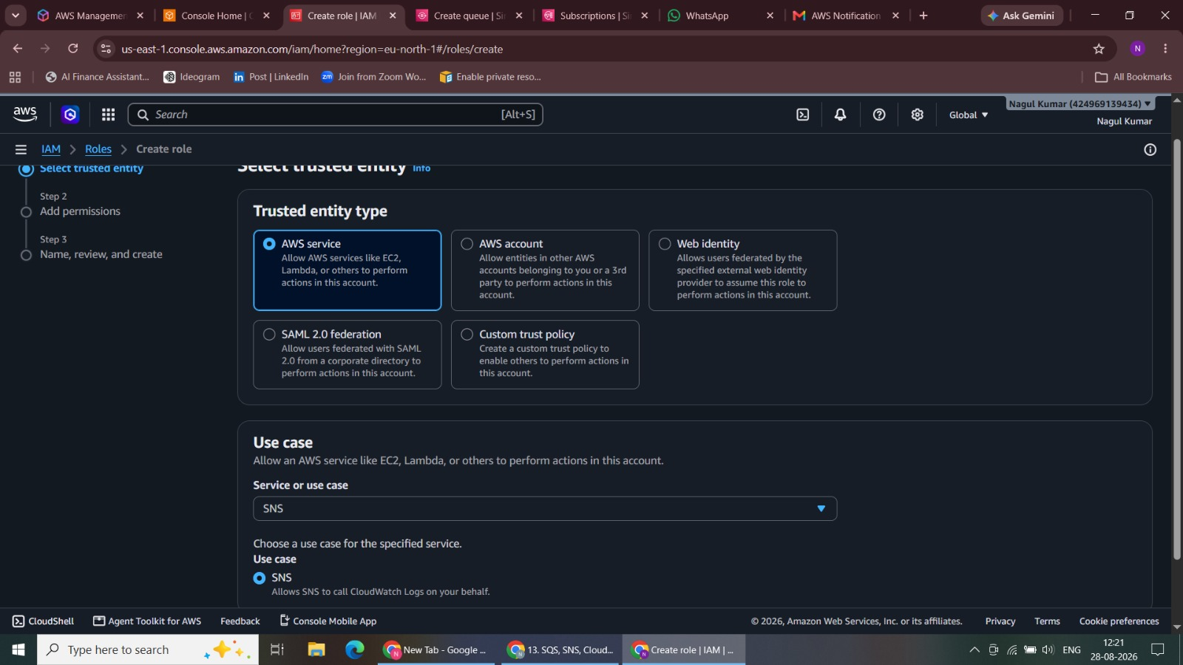
Figure 32. Notification and Selection of sns topics

33. Alarm Details
Added the alarm name and description.
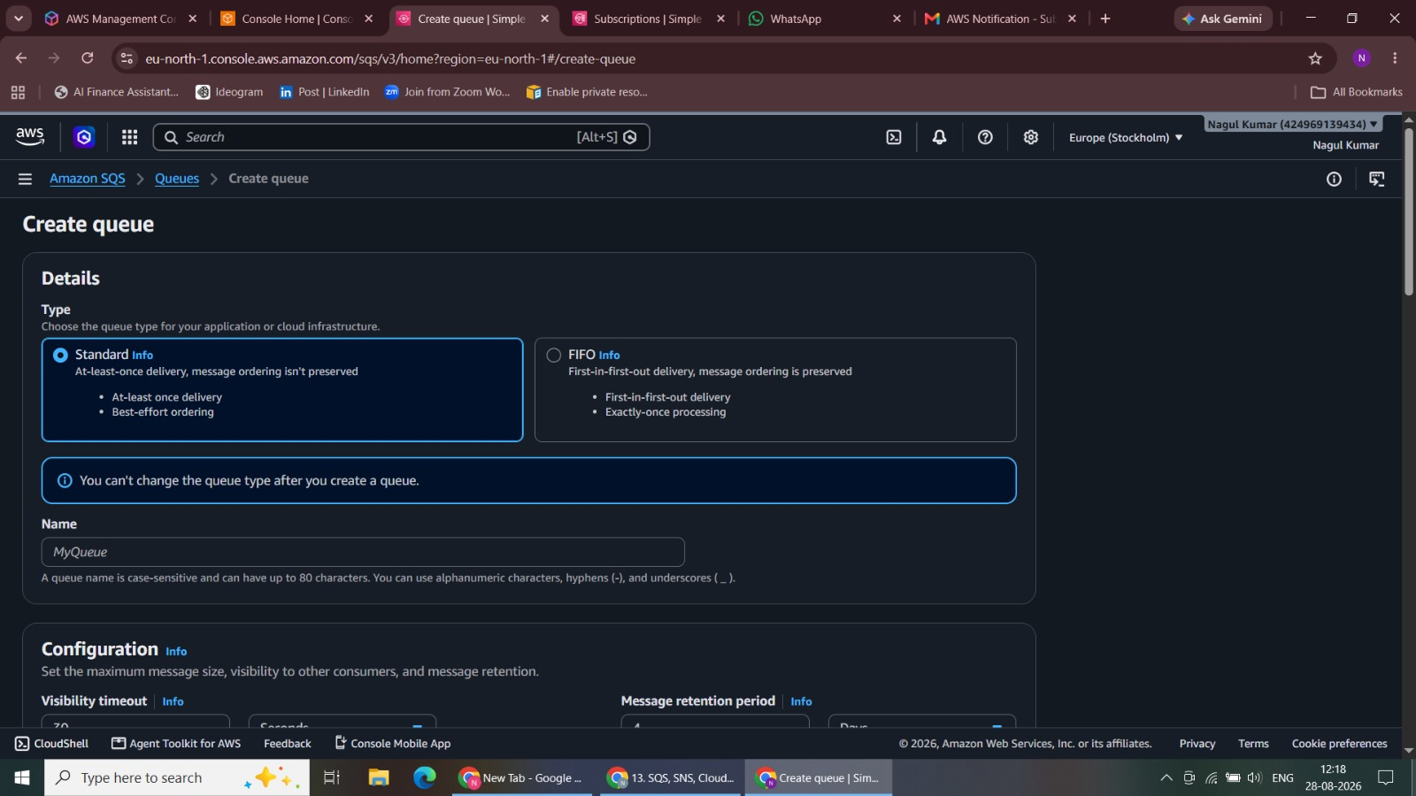
Figure 33. Alarm Details
34. Alarm Created
Created the CRITICAL ALARM.
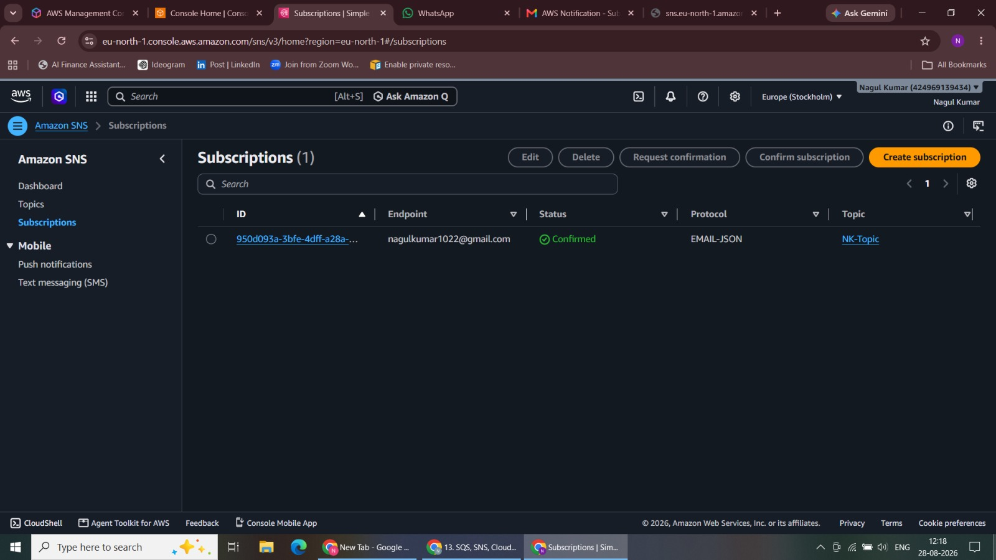
Figure 34. Alarm Created

35. Shows In alarm state
Verified that the alarm entered the IN ALARM state.
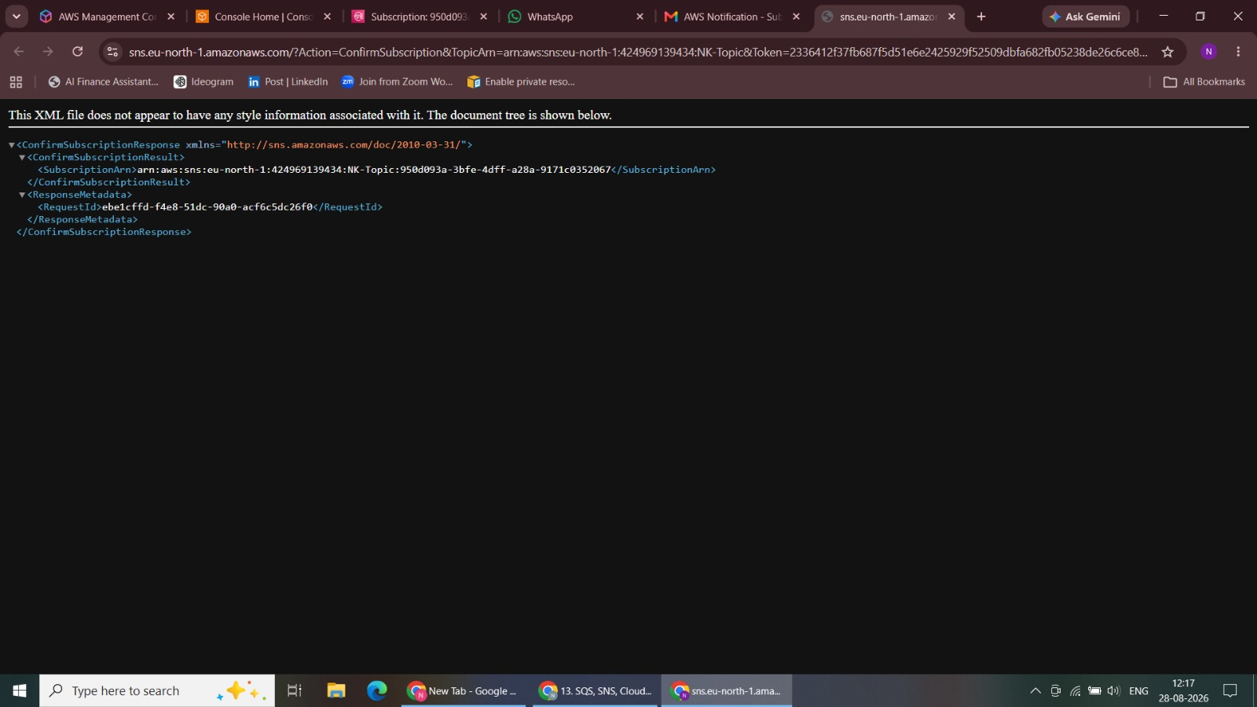
Figure 35. Shows In alarm state
36. Mail received - Alarm
Received the alarm notification in Gmail.
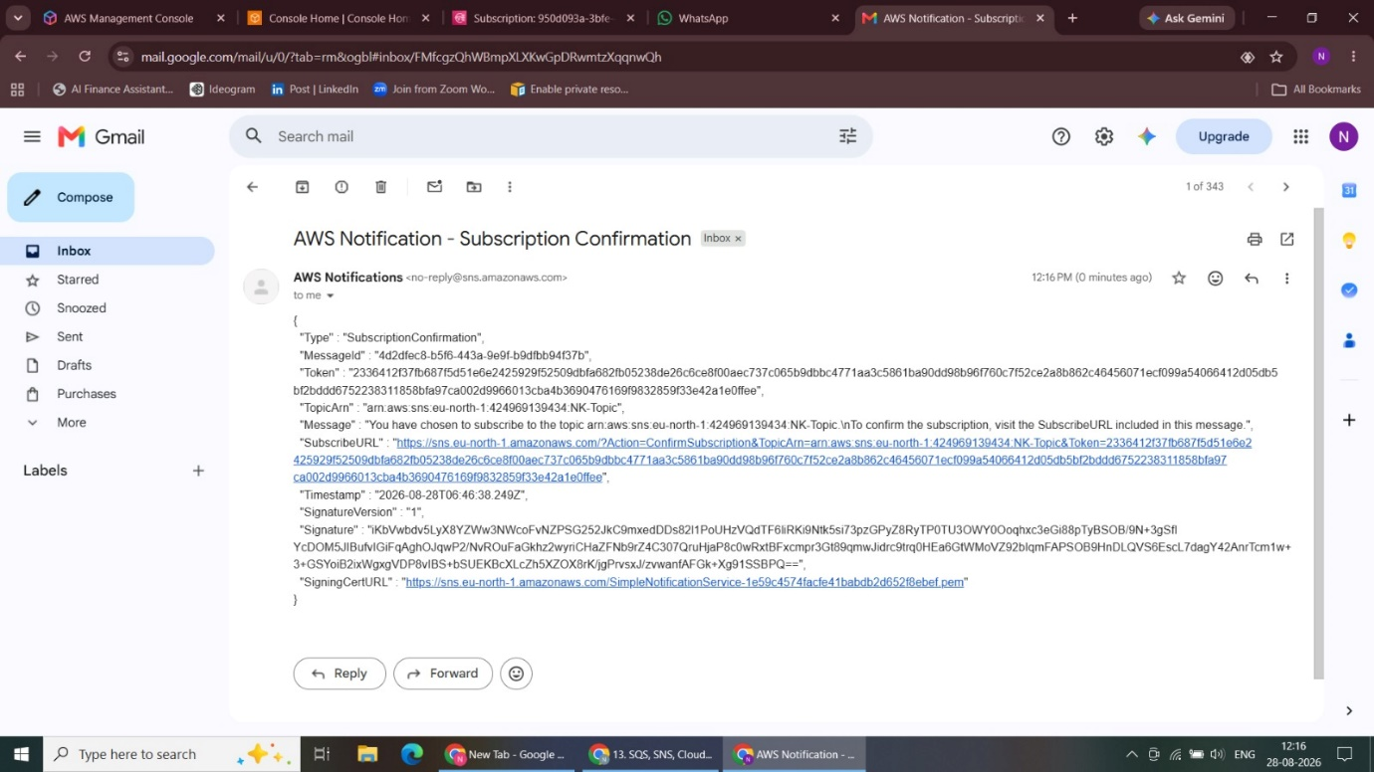
Figure 36. Mail received - Alarm

37. Graph
Reviewed the monitored metric and alarm state.
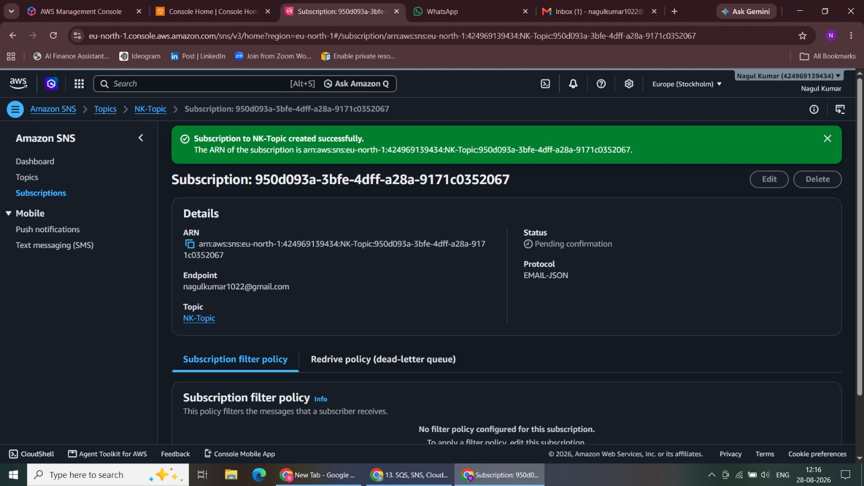
Figure 37. Graph
38. Message received in SQS
Verified the alarm notification in the SQS queue.
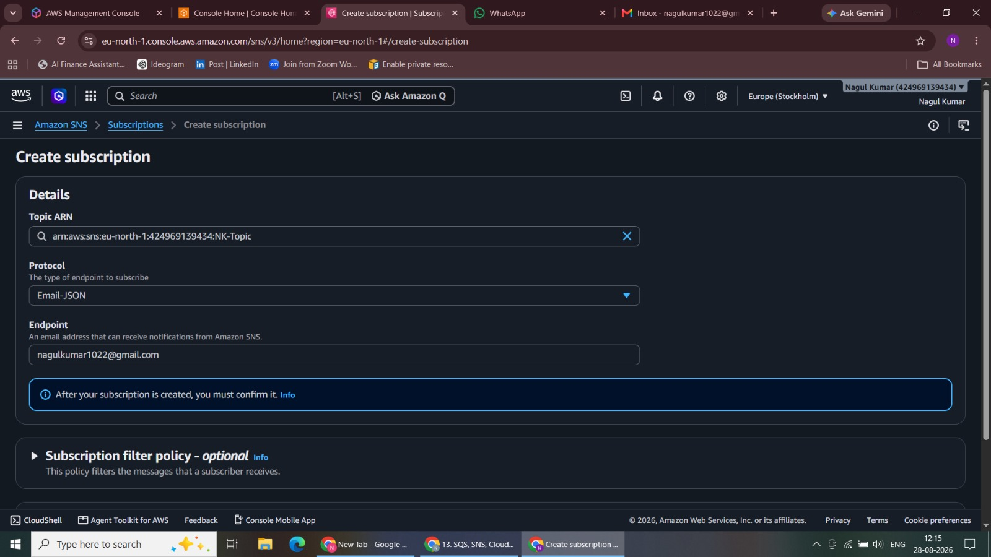
Figure 38. Message received in SQS

39. SQS Received Messages Details
Reviewed the received SQS message details.
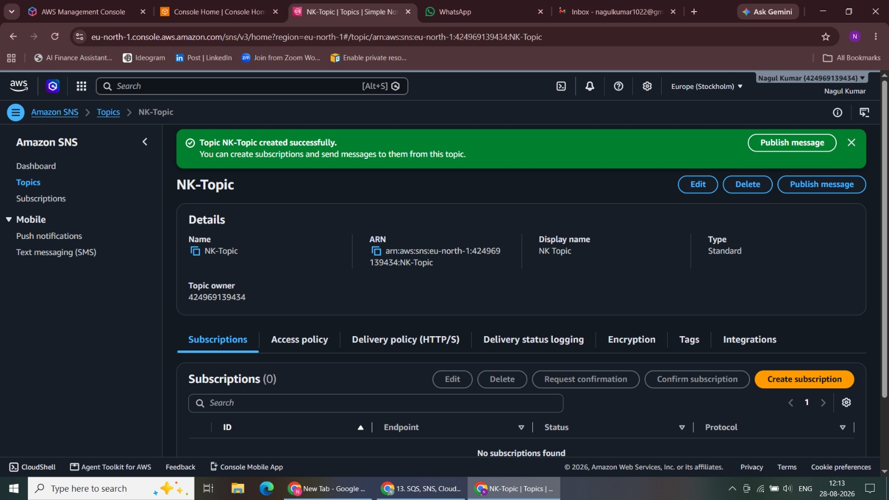
Figure 39. SQS Received Messages Details

Validation Summary
• SNS message delivery validated through Email and Amazon SQS.
• EC2 CPU Utilization successfully monitored in CloudWatch.
• CRITICAL ALARM entered the IN ALARM state using the lab threshold.
• CloudWatch alarm notifications successfully delivered to both endpoints.
Key Learning Outcomes
• Amazon SNS publish/subscribe workflow with multiple subscriber types.
• Amazon SQS as an SNS subscription endpoint.
• EC2 monitoring with CloudWatch metrics and alarms.
• CloudWatch alarm integration with SNS notifications.
• End-to-end validation of Email and SQS alert delivery.
Conclusion
The project successfully demonstrates a complete AWS monitoring and alerting workflow using EC2, CloudWatch, SNS, Email, and SQS.

