HOME
SITENAME
REVIEWS, POST, ABOUT US (Navbar)

Find reviews about your favourite Comics and Manga
Reviews (Button)

Write a review about your favourite Comic or Manga
Post(Button)

SITENAME,
IG(Instagram link), X(X/Twitter link), FB(Facebook link)

DASHBOARD
SITENAME
REVIEWS, POST, ABOUT US (Navbar)
TOP COMICS/MANGA THIS MONTH
Jujutsu Kaisen | Ultimate Spider-Man | Chainsaw Man | TRANSFORMERS | Kagurabachi
 | 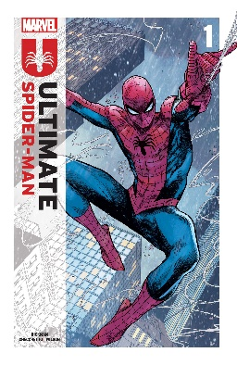 |  | 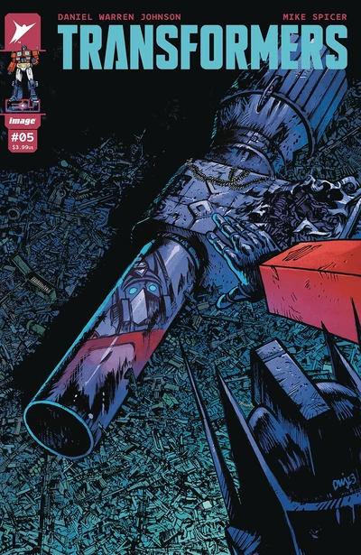 | 
Shueshia | Marvel Comics | Shueshia | Image Comics | Shueshia
2K+ Reviews | 500+ Reviews | 1K+ Reviews | 1K+ Reviews | 500+ Reviews

PFP(Profile picture) John Doe
Jujutsu Kaisen first thoughts
Jujutsu Kaisen is an electrifying rollercoaster of supernatural action and emotional depth! With its dynamic characters, intense battles, and a plot that keeps you on the edge of your seat, it's a must-watch for any anime enthusiast. From the stunning animation to the intricate world-building, every aspect of this series is crafted with care. Prepare to be spellbound by its gripping storytelling and unforgettable moments!
Read more...

PFP(Profile picture) Charlie White
Chainsaw Man fan review
Chainsaw Man delivers a wild and exhilarating ride through a twisted world of demons and mayhem! With its gritty aesthetic, bold characters, and jaw-dropping action sequences, this anime is a relentless thrill from start to finish. From the absurd premise to the unexpected twists, Chainsaw Man constantly defies expectations, keeping viewers hooked with its blend of dark humor and heart-wrenching moments...
Read more...

PFP(Profile picture) Ludwig Ahgren
One Piece review again...  One Piece is a timeless adventure that sails beyond the boundaries of imagination! With its vast world, colorful characters, and epic storytelling, this anime stands as a testament to the power of friendship, courage, and the pursuit of dreams. From the high seas to exotic islands, every episode is a treasure trove of excitement and discovery, filled with exhilarating battles, heartwarming camaraderie, and moments that tug at the heartstrings...  Read more... | 
Load more reviews…
SITENAME,
IG(Instagram link), X(X/Twitter link), FB(Facebook link)

