1-

2. What is the difference between cat and more command?

Cat 🡪to read file content.

More 🡪display file content based on screen size.

3. What is the difference between rm and rmdir using man?

rm 🡪 To remove files.

Rmdir 🡪To remove directory.

4. Create the following hierarchy under your home directory?

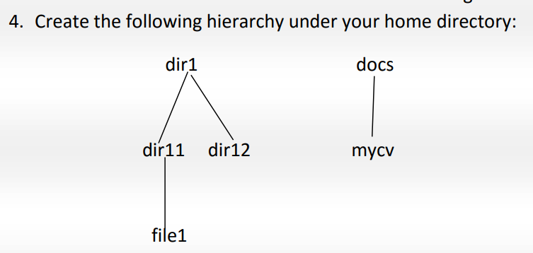

a-Remove dir11 in one-step. What did you notice? And how did you overcome that?



b. Then remove dir11 using rmdir –p command. State what happened to the hierarchy (Note: you are in your home directory.

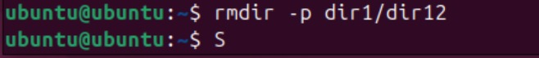

The parent deleted

c. The output of the command pwd was /home/user. Write the absolute and relative path for the file mycv



5. Copy the /etc/passwd file to your home directory making its name is mypasswd

6-Rename this new file to be oldpasswd

7-You are in /usr/bin, list four ways to go to your home directory



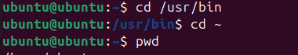

8-List Linux commands in /usr/bin that start with letter w

9-Display the first 4 lines of /etc/passwd 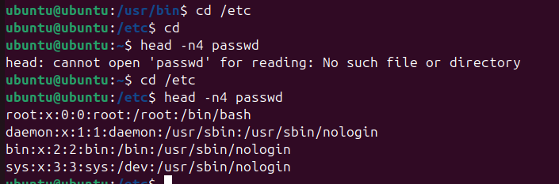

10-Display the last 7 lines of /etc/passwd

11.Display the man pages of passwd the command and the file sequentially in one command.

12-Display the man page of the passwd file.

13-.Display a list of all the commands that contain the keyword passwd in their man page.

