1. Create a user account with the following attribute

• username: islam

• Fullname/comment: Islam Askar

• Password: islam

2. Create a user account with the following attribute • Username: baduser • Full name/comment: Bad User • Password: baduser

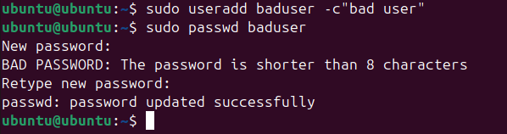

3. Create a supplementary (Secondary) group called pgroup with group ID of 30000

4. Create a supplementary group called badgroup

5. Add islam user to the pgroup group as a supplementary group

6. Modify the password of islam's account to password

7. Modify islam's account so the password expires after 30 days



8. Lock bad user account so he can't log in

9. Delete bad user account



10. Delete the supplementary group called badgroup.



13. Create a folder called myteam in your home directory and change its permissions to

read only for the owner.

14. Log out and log in by another user

15. Try to access (by cd command) the folder (myteam)

16. Using the command Line • Change the permissions of oldpasswd file to give owner read and write permissions and for group write and execute and execute only for the others (using chmod in 2 different ways)

**1-**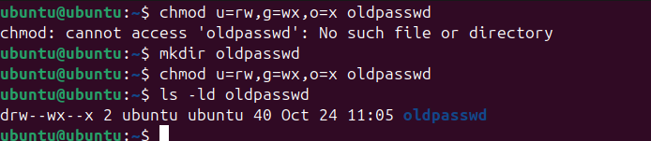

**2-**

**3-**maximum permissions for folder &file are 3 .

4-

**17-**

* **Source : rx des: wx**
* **R w-x**
* **Delete a file 🡪none depends on parent permission**
* **Cd🡪x**
* **Ls🡪r**
* **View a file content 🡪r**
* **Modify a file content🡪w**

**18- Create a file with permission 444. Try to edit in it and to remove it? Note what happened**.





**19. What is the difference between the “x” permission for a file and for a directory?**

X for a file 🡪 does not found else if itell the terminal to execute it .

X for a directory 🡪 exist. Cd >>