1. Compress a file by compress, gzip, zip commands and decompress it again. State the differences between compress and gzip commands.

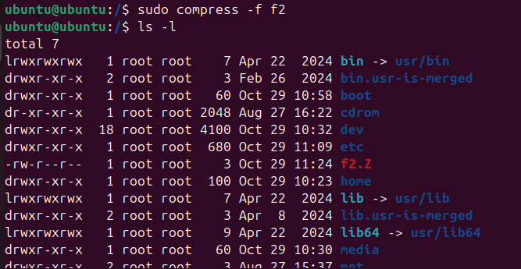

1. **What is the command used to view the content of a compressed file.**

-zcat commnd

zcat compressed file.

1. **Backup /etc directory using tar utility.**

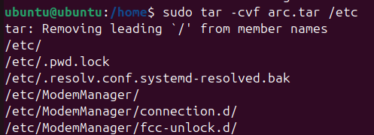

1. **Starting from your home directory, find all files that were modified in the last two day.**

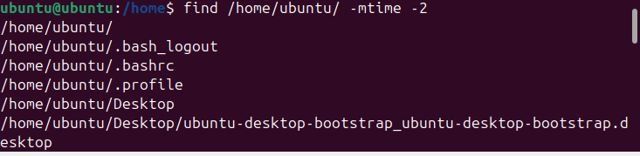

1. **Starting from /etc, find files owned by root user.**

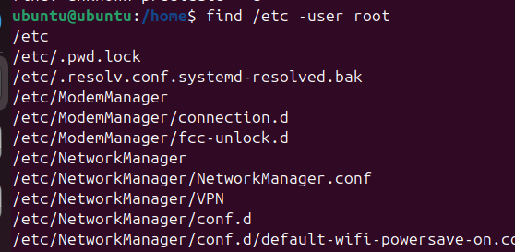

**6. Find all directories in your home directory.**

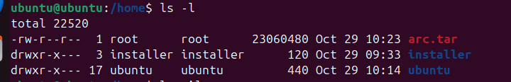

**7.Write a command to search for all files on the system that, its name is “.profile”**

**8.Identify the file types of the following: /etc/passwd, /dev/pts/0, /etc, /dev/sda**

**9. List the inode numbers of /, /etc, /etc/hosts.**



**10. Copy /etc/passwd to your home directory, use the commands diff and cmp, and Edit in the file you copied, and then use these commands again, and check the output.**



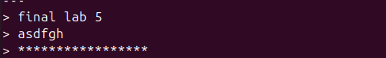



**11. Create a symbolic link of /etc/passwd in /boot.**

**12. Create a hard link of /etc/passwd in /boot. Could you? Why?** 