MyTunes - Compulsory Assignment #4

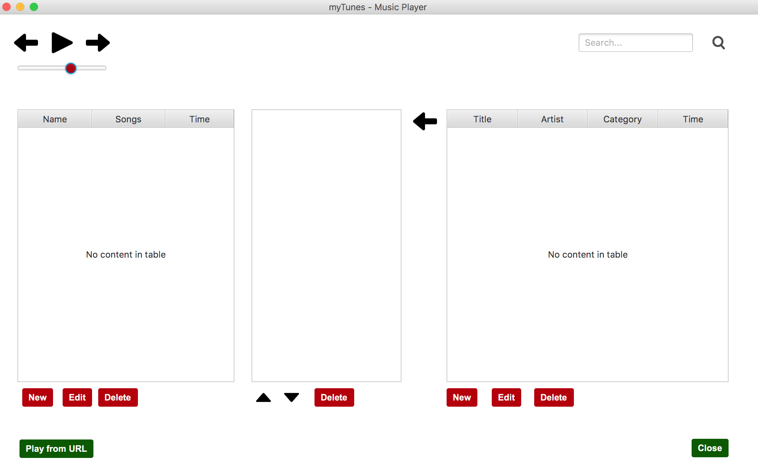

**Source code:** [**https://github.com/MapeSVK/myTunes**](https://github.com/MapeSVK/myTunes)

**Handed-in by**

1. **Dominik Nagy**
2. **Péter Sebők**
3. **Bence Mátyási**
4. **Michal Moravik**

**Date: 10.12.2017**

1. **State of delivery**

We were tasked with designing and constructing a java desktop application that could be used for playing music and storing its information to a database.

We needed to create an application that is backed up with a database that stores all the information about the imported music and the playlists. We had to make it so that the user can Add, Edit and Delete the imported music, their information, and the playlists. There are also options for playing and pausing music, adjusting the playback volume, filtering the music that we added, changing the order of playing in the playlists, adding and deleting music from the playlists and the option to open links from the internet.

The architecture of our application follows the three-layer model, so the GUI layer handles the interactions with the user, the Business Logic layer contains the business logic, the Data Access layer that controls the access to the database and the information stored in the music files and the Business Entities package that contains all our business entities.

1. **Application structure**
2. **Data Storage**

Our application stores its data to a database located on the school’s server, so it can only be accessed from the school network (as far as we know).

The database has three tables:

* The “Music” table for the music information, like the id, the name of the artist, the title of the song, its genre, the song length in seconds and the path of the file.
* The “Playlist” table for the playlist information, like its id and name.
* The “MusicInList” table that connects to previous two. It stores the songs which were put into playlists by storing the music’s id and the list’s id.

The ids in our tables are automatically generated and stored as an integer.

We opted not to store the music files themselves in the database, as it would create an unnecessary amount of network traffic, and would led to long loading times. Therefore, songs can only be played on the computers they were added from, even though they show up in the list.



1. **Implementation details**
2. **Source Control**

In this project we had a chance to use the GitHub as we must. We create a repository which called myTunes and we attached its link to the frontpage. In this repository we can find the source code, the image and a .zip file which contains all the java libraries what we used. During the project it turned out that the GitHub is a well-constructed software and it contributed to our collaborative work. Even though we experienced the benefits of GitHub, we had an opportunity to get to know its drawback. This drawback is the merge conflict what we didn’t know before. As we know it occurs when the same part of the code exit in two different way but the same name. We had to solve all the merge conflicts during the project which improved our problem-solving skills.