Midterm CS201

20125071 _ Bùi Lê Gia Cát _ 20CTT2

Problem 1:

|  |  |  |  |
| --- | --- | --- | --- |
| Description | 1’s complement | 2’complement | Bias 10 |
| 0 | 0x00 | 0x00 | 0x0B |
| ‒10 | 0x15 | 0x16 | 0x00 |
| 12 | 0x0C | 0x0C | 0x16 |
| ‒17 |  |  |  |
| 25 |  |  |  |

Explanation: Can not convert -17 and 25to binary because we can only represent a number from ‒15 to +15 in 1’s complement, from ‒15 to +16 in 2’s complement and from ‒10 to 21 with 5 bit

Problem 2:

a/

The exponent is: 5

The value of the fraction (without implicit 1.) is $\frac{51}{64}$

Final decimal value: $\frac{115}{2}$

Explaination: the value of exponent is 16 and the bias is 15.

b/

The 2-base normal notation: 1 10100 000010

The 5-bit encoding of exponent is: 10100

The 6-bit encoding of the fraction is: 000010

Explaination: ‒32.8 in binary is 100000,1100(1100). Then we normalize this to 1,000001100(1100) then round to nearest, half to even to obtain 1,000010

c/

Hex encoding of positive infinity: 0x7C0

Hex encoding of smallest positive, normalized number: 0x040

Explaination: The infinity number has the bit pattern of exponent is 11111, frac and sign part are 0s. The smallest positvie, normalized number has the exponent part is 00001, the frac and sign part is 0s.

Problem 3

1

2e

3

4f

5d

Explaination:

Problem 4:

|  |  |  |
| --- | --- | --- |
| Instruction | Destination | Value |
| addl %edx, %eax | %eax | 0x103 |
| Subl %edx, -1(%eax,%edx,2) |  |  |
|  |  |  |
|  |  |  |
|  |  |  |

Problem 5:

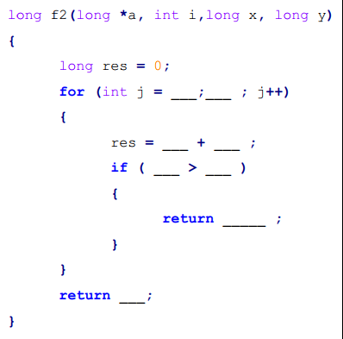

x+r10

1 i<=j

x+r10

i r8d

y