Background and Specification Progress Report

6CCS3PRJ – Individual Project

Argupedia

**Name: A K M Naharul Hayat**

**Student Number: 1750583**

**K Number: K1764014**

**Supervisor: Dr. Sanjay Modgil**

**Background and Context**

Being one of the oldest internet services, online discussion forums to this day continue to stand out in terms of popularity. This is evident from the fact that popular online discussion platforms such as Reddit and Quora have over 300 million active user bases [1, 2] with the former ranking in top 20 in terms of popular sites on the internet [3].

The user generated content nature of such platforms allows its users to not only have discussions about a topic, but also have debates about pressing issues around the world and exchange idea and opinions by posting and replying to critique each other’s comments/posts.

Debates at its core involve critiquing and presenting reasoning behind a proposed action or view, in order to justify it. Observing debates from this point of view enables us to consider its potential outside of mere online discussions. As noted by researchers in the field [4], debates can be evaluated and used by political leaders as a method for gathering public opinion and their reasoning - for and against a particular proposed policy or an issue. In addition, it has the potential to enable general public to observe a debate and have a well-informed educated opinion about a topic or an issue they lack knowledge about. Furthermore, it encourages them to analyse a proposed argument critically.

**Defining the problem:**

However, despite all of the potentials discussed above, there exists some issues which prevents the use of debates in online platforms to its full potential. These are discussed below:

1. It is often the case that debates end up having a lot of arguments. For example, one of the popular sub-forums in Reddit known as ‘Change my View’, which is strictly debate based, average close to 100 comments per topic [5]. In such long and complicated debates, it is difficult to make sense of which argument is critiquing which argument and reason through the debate and trying to extract **the current accepted argument/position in a debate.** As a result, making it difficult for individuals to have an informed opinion about a topic or an issue. This could discourage further participant from joining in on debates, because they may feel they do not know enough about the current state of the debate.
2. Existing debate platforms allow people to engage in debates by claiming a fact without backing it up with accepted ways of reasoning to reach the claim as the conclusion. This further adds to the difficulty of reasoning through a debate to a conclusion as it involves jumping through arguments which do not truly contribute to debate (i.e. arguments which are not backed by facts/reasoning/justification).
3. Existing online debate platforms focus on popularity of arguments/comments and favours them in terms of visibility, hence are generally considered as accepted argument in the debate. However, this has the potential of introducing bias in a debate. As noted by Scott in his book [7], people often tend to fall victim to confirmation bias, which is the tendency to favour information in a manner which tends to support one’s previous belief. Participants in a particular forum, may be biased towards a particular area, therefore, only voting positively for arguments which confirm their bias and negatively to the ones which do not. This in turn diminishes the chance of arguments which are against the bias to be noticed by public, despite being perfectly valid. Therefore, individuals exploring a debate topic to form an informed opinion, may only notice the arguments which favour bias and interpret them as accepted. Furthermore, perfectly valid arguments may not get the recognition it deserves just because it was posted at an inopportune time (later in the debate) as a result failing to get votes.
4. Online debates do often times get a bit heated. In such situations, it is observed people often ridicule contributions proposed by opposition, thus negatively affecting the overall debate as well as the motivation of participants. A study in the field regarding experiences of people participating in online forum and communities [6] suggests that close to 4% of participants encounter bullying. Although the figure may seem quite small, however, it is worth noting that public forums are a community as a whole, this could have an impact on other participants indirectly and dissuade them from engaging in debates in a healthy manner. However, the impact of this is yet to be evaluated.

**Closer look at existing platforms:**

There however exists online platforms such as ‘Debatepedia (<www.debatepedia.com>)’ and ‘Kialo (<www.kialo.com>)’, which although less popular than the ones mentioned before, attempts to address some of the problems mentioned above. Both of these platforms groups arguments in the form of pros and cons which allows users to easily weigh both sides of an issue/topic. In addition to this, ‘Debatepedia’ allows users access to detailed background information about a topic. ‘Kialo’ on the other hand also allows users to dive into sub-debates regarding a main topic in order to enable user to focus on targeted discussion. Furthermore, it allows visual representation of a debate in the form of a tree, with the main initial argument being represented as the root node of the tree and arguments which support or attacks it, being represented as child nodes.

However, both of the platforms mentioned allows users to engage in debate without following an accepted reasoning pattern, which opens doors to users engaging in debate by simply stating their claims without reasoning behind how they are reached their conclusion. In addition, ‘Kialo’ for instance, judges the strongest argument and ranks visibility by user votes alone, which, as discussed previously, gives rise to problems such as low visibility of perfectly valid counter-arguments, due to the majority of members having bias themselves or due to the argument being posted very late in the debate leading to lower votes. Furthermore, the platforms do not have a clear concise way of identifying arguments which are currently at an accepting position in the debate.

Taking into account the points discussed above, we can conclude that problems do exist which prevents debates being useful to the full extent of their potential. The aim of this project is to research, develop and evaluate a solution which attempts to address the problems discussed above.

**Literature Review**

As defined in the problems, an exploration towards identifying accepted arguments/positions at a given state of a debate is needed, which does not solely rely on votes..

**Abstract argumentation theory of Dung:**

A lot of research on the subject of argumentation is focused on Dung’s abstract argumentation framework [9]. It is abstract [10] in the sense that its core fundamental is only concerned with a set of atomic arguments coupled with a binary relation of the arguments representing which argument is criticizing/attacking which argument. It does not concern itself with the structure of the arguments or the core meaning behind how it is. However, it is widely used because it is very powerful in the sense that it can be used to deduce and identify set of logically accepted arguments from a knowledge base consisting of simply atomic arguments coupled with binary relation of their attack/criticism relation.

**A short background of dung’s argumentation framework:**

The concept of argumentation framework can be represented visually [11] in the form of a directed graph, with the nodes, depicting the atomic arguments, and the binary attack/criticism relation set being represented as arrows between the nodes. This is represented in an example, inspired by [13], demonstrated below:

*Atomic argument A1:*The cheapest option is to go to the park; therefore, we should go to the park tomorrow.

*Atomic argument A2:*But it is cold tomorrow, therefore we should go to café instead.

*Atomic argument A3:*Forecast says it will be hot tomorrow, so you won’t be cold tomorrow.

This can be represented visually as follows:

Node that an arrow from an argument node, say for instance X to an argument node Y conveys that, X is attacking argument Y [11]. In the example above, A1 is attacking A2 and A2 is attacking back as well. This is because A2 is criticizing A1 [13], backed by the reasoning that “it is going to be cold tomorrow”, however, A1 is attacking back as well because it is claiming the opposite of A2, and is also backed by the reasoning that “it is the cheapest option”. Note that A3 is attacking A2 on its claim that it is going to be cold, backed by reasoning of weather forecast, however, A2 is not attacking back [13] in this case because its claim – ‘it is going to be cold tomorrow’, which is being attacked, is not backed by any reasoning. Hence in this case it is a one directional arrow.

The argumentation framework for the example above can be formally defined as:

Atomic Arguments= {A1, A2, A3}, Attack Relation= {(A1, A2), (A2, A1), (A3, A2)}.

**Important notions of argument framework theory:**

***Argument Defence:***

The concept of argument defence is illustrated below [13]:

Argument set Y (blue) defends argument X (green) as it attacks every attacker of X (orange). It is worth noting that if an argument is not attacked, it is defended by all sets [13].

***Conflict free sets:***

An argument set is said to be conflict free [11] if none of the arguments in the set attack each other. I.e.: they are not conflicting. For instance argument set {a,b,c} is considered conflict free if there are no arrows between a, b, or c (no attack between each other each other or no bad blood in the set of arguments).

***Admissible sets:***

In essence, admissible sets [14] are sets of argument subsets, which are self-defended. In order to compute admissible sets, we take the following steps:

1. We take the power set of all arguments. For example, if we had only arguments A and B in the graph, the powerset would be: {(a), (b), (a, b)}.
2. Once we have the powerset, we eliminate the subsets in the powerset which have conflict, and only keep the ones which are conflict free. In the example above, if there is an arrow from a -> b (a attacks b), as in the set (a, b) is not conflict free, we eliminate it from the set of powerset.
3. For each subset in the filtered set in step 2:
   * If an argument in the subset is attacked, it must be defended by the arguments in the subset itself for it to be classified as admissible.

**Semantics of acceptance (Extensions):**

Given a visualization similar to the example demonstrated previously, one can then investigate whether an argument is to be regarded as accepted, also known as – *‘****Extensions’*** [12].

In essence the concept is that, an argument is regarded as accepted, if it can be successfully defended from all arguments which challenge/attack it [14], however, there are numerous further notions, which extends this idea and narrows it down, and each has its own definition of acceptability of arguments. These are known as ***‘Extension Based Semantics’***.

To summarize, we have an array of possible means (Extension based semantics) of defining the type of logic to classify arguments in the framework as accepting. Each extension-based semantics have its own respective arguments which it deems as accepting. In the following section, we will explore different extension-based semantics we can use in Dung’s abstract argumentation framework:

***Complete Extension***

Complete extension [9] extends the idea of admissible sets by imposing restrictions on it to strengthen it. A given set of argument is regarded as complete extension [9], if it is admissible and the set includes all arguments it defends.

A simple algorithm to compute complete extension as follows:

* For each admissible set
  + For each argument in the set
    - We find out if the arguments in the set defend anything.
    - If it does, it must be included in the admissible set itself for the set to be regarded as complete extension.

***Grounded Extension***

The idea of grounded extension [9] extends from complete extension semantics. Grounded extension [9] is the minimal-subseta of complete extension. It is worth noting that the grounded extension can be empty set as well.

***Preferred Extension***

The idea of preferred extension [9] also extends from complete extension semantics. Preferred extension [9] is the maximal-subsetb of complete extension.

***Stable Extension***

The idea of stable extension [9] extends from preferred extension semantics. An algorithm based on intuition to compute stable extension as follows:

* For each set-in preferred extension
  + We find out which arguments the arguments in the set attacks
    - The set is considered as stable extension if it attacks all other arguments in the graph. (Excluding arguments in the set itself).

**Credulous and Sceptical Acceptance:**

Each of the four extension-based semantics discussed above can be further broken down into either credulous acceptance or sceptical acceptance [12]. Credulous acceptance is more in sync with being lenient in accepting arguments and used in situation where the deciding agent have trust in agent who is putting forward the arguments. Sceptical acceptance on the other hand is the opposite and is stricter with regards to what arguments it accepts.

The extensions discussed previously can consist of multiple subset of arguments regarded by the extension as accepted. Among those subsets, the credulous extension consists of arguments which appear [13] at least once in any of the subset. On the other hand, for an argument to be sceptically accepted in the extension, it must be a part of all of the subsets.

**Relating back to the problem and Review:**

If we abstract debates by disregarding supporting critiques and we assume counter arguments to a point, always follow proper accepted ways of reasoning to back a claim/assertion/attack, we can observe that we get a model which fits quite well with Dung’s abstract argumentation framework.

If the assumption holds, debates in essence are just a set of atomic arguments (individual critiques) with a binary attacking relation between them representing, which argument is criticizing which, in the debate. Hence, if the assumption is true, debates, can indeed be modelled as argumentation framework.

The idea is that we abstract a debate and model it in the form of Dung’s abstract argumentation framework as discussed. We are then able to visualize it in the form of directed graph. Once we have the visualization, we could use one of the extension methods of Dung’s abstract argumentation framework to classify which arguments are accepted currently in debate, which addresses the problem 1 and 3 defined in the first chapter.

It is however worth noting that the evaluating accepting arguments through Dung’s abstract argumentation framework is considered as non-monotonic, in the sense that a new argument proposed in the future at a certain time, may lead to the previously accepted argument being no longer regarded as accepting [10].

**Review – semantics of acceptance:**

There are numerous extensions that we could implement, as discussed. This arises the question about what kind of semantics of acceptance among the ones discussed would be most suitable for the purpose?

As pointed out by researchers in the field [15], the presence of a Preferred and Grounded extension for an argumentation framework is guaranteed, however for the case of Stable extension, there is no such assurance. In addition, there exists [15] precisely one grounded extension for an argumentation framework. On the other hand, there may be more than one [15] in Preferred and complete extension.

This makes grounded extension a good candidate for the application, as firstly, it extends from complete extension and is a refined version of it, secondly, we can have guarantee that at any point in debate, we have exactly one a set of arguments (which could be empty as well), regarded as accepted. Having multiple would bring us back to the problem at hand where people find it confusing and difficult to extract the current accepted position in debate.

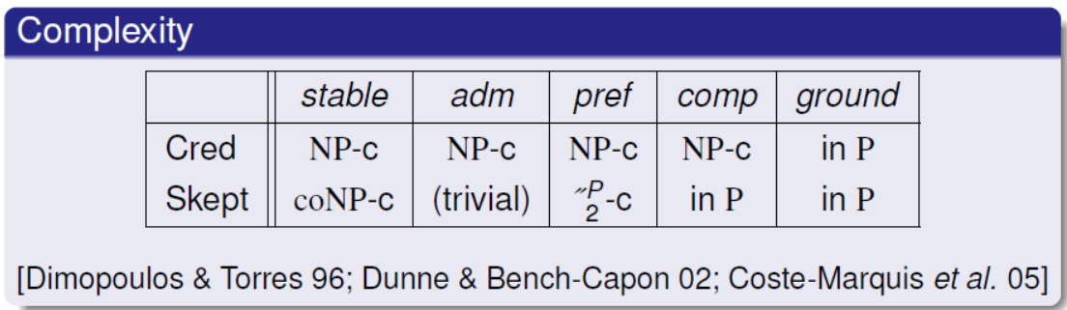The time complexity of the extension, taken from source - [10] is as follows:

Source: [10]

As noted above, both credulous and sceptical grounded extension have a polynomial time complexity, which is better in comparison to the other three extensions being considered. In conclusion, based on the discussion, the aim is to implement grounded extension to identify accepted arguments in debates for now, however, in the future, the plan is to have options for other extensions as well.

**Representing user input in debates as atomic arguments**

**for argumentation framework**

So far, we have explored the idea of abstract argumentation framework under the assumption that we already have a set of atomic arguments in the debate, however the challenge remains. In this chapter, we will explore different ways we could approach this problem.

**Textual entailment:**

Researchers have approached this [17] in the past through making use of textual entailment [16] in natural language processing to deduce claims in conversations and inter-connection between claims/arguments. Researchers approached the problem by the assumption that natural language conversation in debate can be broken down into 2 types of snippet - one being the text and the other being the hypothesis. They have used textual entailment on the 2 snippets of the text to deduce if the meaning of the hypothesis can indeed be derived from the meaning of the text. If so, then the overall text input can be classified as an atomic argument.

**Argumentation Schemes:**

Argumentation schemes [19] are structures of arguments which reflects around how we reason in everyday conversation exchanges. The core inference consists of a set of premises followed by a conclusion/claim. Researchers in the area have put forward common argumentation schemes which are regarded as commonly accepted ways of reasoning to put forward a point in conversation. In addition to this, each argumentation scheme consists of its own set of critical questions [19], which reflects the way we normally think critically about a claim. An example of a common argumentation scheme (taken from source [19] for demonstration) is as follows:

An expert source E

Who is an expert in subject matter S

Asserts C

C is true

Premise

Conclusion

The structure above conforms to the argument scheme known as ‘Appeal to Expert Opinion’. Note that the argument is rationally persuasive on the basis that there is a natural tendency to respect an expert but if we look at from inductive reasoning [20] or deductive reasoning perspective [20], it may not be valid, however that is the point of Argumentation schemes as it focus is to capture reasoning in everyday conversation exchanges.

As mentioned previously, each argumentation schemes consist of critical questions. A few example critical questions (taken from source [19]) for the above argumentation scheme is as follows:

* Is expert source really trustworthy?
* Can E really be considered an expert in the subject matter S?
* Does another expert make a claim which contradicts with C?

Note that the critical questions reflect how we might criticize the argument, if put forward in everyday conversation.

In addition to expert opinion, the following accepted argumentation scheme exists, each with their own structure (considered as rationally persuasive in everyday conversations) and critical questions:

* Argument from Analogy. [18].
* Argument from Position to Know [19].
* Appeal to Popular Opinion [19].
* Argument from correlation to cause. [18].
* Argument from positive negative consequence [18].

**Relating back to the problem and Review:**

If we take a high-level view of argumentation schemes, they have the potential to be used as tools by debaters to make a claim/point. By basing their claim on an argumentation scheme structure, they conform their argument to accepted ways of proposing rational and persuasive arguments in everyday discussions. This leads to the debates being significantly more concise and rational, because each argument has to follow a clear pre-set structure, which forces participants to focus on the point and also helps them follow proper accepted ways of reasoning to conclusion in exchanges.

Enforcing the use of structured arguments in debates, using argumentation scheme, addresses the problem of online debates having responses which are baseless, or in other words, responses which critique without following proper reasoning/backing with fact, as participants are now forced to structure their argument using argumentation schemes. Moreover, this also addresses the problem of contributors ridiculing each other’s argument as responses have to follow a structure.

Furthermore, each scheme has their own set of Critical questions which have the potential to encourage both parties to think critically about the proposed argument and subsequently, can be used as basis for critiquing the argument by making their own counter-argument, again using one of the argumentation scheme structures. Enforcing the use of critical question as basis of proposing counter argument, helps participants focus on the exact aspect of the original argument he is attacking, which leads to criticisms which are focused.

###########################

Lastly, each point in debate made using argumentation schemes can be modelled as atomic arguments in Dung’s abstract argumentation framework, due to the fact that argumentation scheme structures coupled with critical questions, enforce exchanges which are focused on a single point only. Hence the structured exchanges can simply be regarded as atomic arguments to fit the model.

###########################

Another way we could approach the problem is to use textual entailment. Researchers in the field have demonstrated the use of textual entailment to identify atomic arguments [17]. They have also evaluated accuracy of textual entail system by measuring how well it is able to assign correct entailment relations on datasets extracted from ‘Debatepedia’ (<www.debatepedia.com>). Having used a short dataset of 100 pairs for both training and test, they have noted an accuracy of 67% [17] on the latter, however its performance on larger dataset is yet to be evaluated.

Once we have atomic arguments in debates using either of the two approaches discussed above, subsequently, the attack relations can be extracted based on the which original argument the replies in debates target. Finally, based on the two, we can model according to Dung’s abstract argumentation framework and identify accepted arguments.

Having discussed both approaches, we can observe textual entailment have advantage with regards to user freedom of input, however argumentation schemes have the edge in terms of keeping arguments concise, focused and in alignment with structures which are deemed to follow the inferential reasoning we tend to apply in everyday life. In conclusion, based on the discussion, argumentation schemes have the potential to better address the problems numbered 1 and 4, better.

**Requirements**

The core requirements of the project, based on the problem, literature review, and supervisor’s recommendations, are as follows:

1. Based on the nature of the project, a web application solution fits well as it allows people all around the world to engage. In addition, the website should be able to be used on mobile phone as well.
2. The application should allow users to register and login to their account.
3. Once the user is logged in, he should be able to create a debate topic by inputting a title and proposing an initial argument using one of the 7 Walton’s argumentation schemes [18].
4. Once a debate topic is created, should be visible to all other users of the website.
5. In addition, they should be able to critique the argument by proposing a counter argument, however, before doing so, he will have to base it on the critical questions of the argumentation scheme of the original argument being addressed.
6. Once the user chooses his critique point, he should be able to choose one of the 7 argumentation schemes to base his counter argument on.
7. Once the argumentation scheme is chosen and the counter argument is made based on it. All users of the website should be able to see the counter argument proposed, displayed in the same structure as the argumentation scheme chosen.
8. Users should have to opportunity to critique the counter arguments in the same way as well. All users of the application should be able to view debate topics alongside all arguments/counter-arguments.
9. However, in order to engage in debates, they have to login using their credentials.
10. Users should have the ability to view visual representation of debate as dung’s abstract argumentation framework, in the form of directed graph. Nodes should represent the arguments in debates and arrows among them should represent attack relation, for instance, if argument A is attacking argument B, the graph should have two nodes representing A and B, with an arrow from A to B representing the attack.
    * It may be the case that when an argument attacks another, the argument attacks back as the point being attacked is already backed by its own reasoning. In this case, it should be represented in the graph as bidirectional arrow between the two nodes.
11. In the visualization, users should be able to hover mouse over an argument node in the visualization to view its respective content.
12. Users should be able to jump to a sub argument in debates and subsequently critique by clicking on nodes representing arguments in the visualization.
13. The node representing initial argument should be marked clearly in the visualization.
14. At any point in debate, set of arguments to be regarded as accepted according to grounded extension should be computed and the respective argument node in the graph visualization, should be clearly marked for the user to see.
15. Users should also have the option to upvote/downvote an argument to represent its popularity, however this should not be the sole basis on whether an argument in the debate is to be accepted.
16. In case arguments in debates are regarded as undecidable by the extension, in that case only, the winning argument is to be decided by the one which has higher voting count, however, if this was the decision process, then the argument node should be clearly marked to show it has been decided by vote count.
17. The web application should have an admin side, through which argumentation schemes can be added/deleted/edited in the future. The admin side should also allow CRUD (Create, Read, Update, Delete) operations on the database.

**Specification**

As stated previously, a web application solution is more in alignment with the nature of the problem, Django, a python-based framework provides a full set of benefits that come with using typical frameworks for web development such as efficiency, security, scalability, good code reusability etc. In addition, it enforces Model View Template architectural pattern which leads to excellent modularity of different components of the application. Moreover, it abstracts database layer of the application through the use of Object Relational Mapping via Django Models, allowing flexibility in switching database engine in the future without a single line of code change, thus making the application database engine independent with easy customizability. Last but not least, it also allows easy and automatic management of admin side of the website along with automatic synchronization with changes in model, which gives Django an edge over other similar web application development frameworks in the industry.

Considering the above-mentioned advantages of using frameworks as, coupled with excellent community support of both Django as a framework and python as a programming language, I have decided to use Django for the implementation.

**Specifications based on requirements:**

|  |  |
| --- | --- |
| **Requirement** | **Specification** |
| **R1** | - Use python-based Django framework as foundation for the web application  - Bootstrap is a framework which caters towards both, websites viewed on mobile browsers as well as traditional browsers used on PC, hence is a good choice for the front-end of the website. |
| **R2** | - Use Django’s built-In authentication and security libraries to implement secure user registration and login |
| **R3** | - Argumentation scheme structures are to be stored in the SQLite database for now (can be changed in future without need for modification because of Django ORM).  - Retrieve argumentation schemes structure from database and display appropriate number of text fields under each structure section according to the scheme chosen. Also have an input field for title of topic. All forms have to have appropriate form validation. |
| **R4** | - Once the user inputs data of the initial argument, it is to be converted to an html format highlighting structure sections along with its respective content and store in database to be displayed in a coherent manner to other users, along with date/time of post and number of upvotes. The initial argument is to be stored in database as a root node of a tree. |
| **R5** | - Other users seeing the initial argument of the topic, should have the option to critique the argument. If he chooses to critique, we retrieve respective set of critical questions of the argument he chose to critique from the database, and we allow the user to choose one the critical questions to base his counter argument on. |
| **R6** | - Retrieve the structure of the argumentation scheme chosen by the critique from the database and display appropriate number of text input fields required according to the structure to allow the user to construct counter argument. |
| **R7** | - Once the user inputs his counter argument according to the structure, the content is to be converted to appropriate html format to highlight structure headings. Subsequently, the argument is to be stored in database as child node of the argument that it is critiquing |
| **R8** | - The counter argument is also displayed in a text-based tree structure for others to see on the website. Subsequently, other users should be able to attack the new counter argument created. The specification for this is similar to the counter argument creation mentioned in R6 and R7 |
| **R9** | - Use Django’s built in authentication system coupled with permissions class to restrict permissions according to user type. (anonymous or logged in) |
| **R10, R11, R12, R13** | - Using the tree representation of the arguments in the database for a particular debate, we can construct a JSON formatted text which specifies the nodes, arrows, mouse hover text and click action for the directed graph.  - Once we have the JSON format representing the graph, we can then use a graph visualization library known as ‘D3’ which is compatible with Django framework to construct the visualization. |
| **R14** | Implement algorithm to extract grounded extension given data structured in a directed graph form. Once we have identified the accepted argument, we can amend the JSON formatted data containing specification for the graph and mark the nodes accepted clearly |
| **R15** | Users should have the option to upvote/downvote any argument. If one chooses to upvote/downvote, we simply add the user id and the respective argument id in the database, to mark the argument as upvoted/downvoted for the user |
| **R16** | For pairs of arguments which are classified as undecidable by the algorithm, we calculate which argument have the higher vote count and mark it accordingly with different colour in the JSON formatted graph specification for visualization |
| **R17** | Register the Django models in Django admin, to automatically instantiate the admin side of the website. |

**Design**

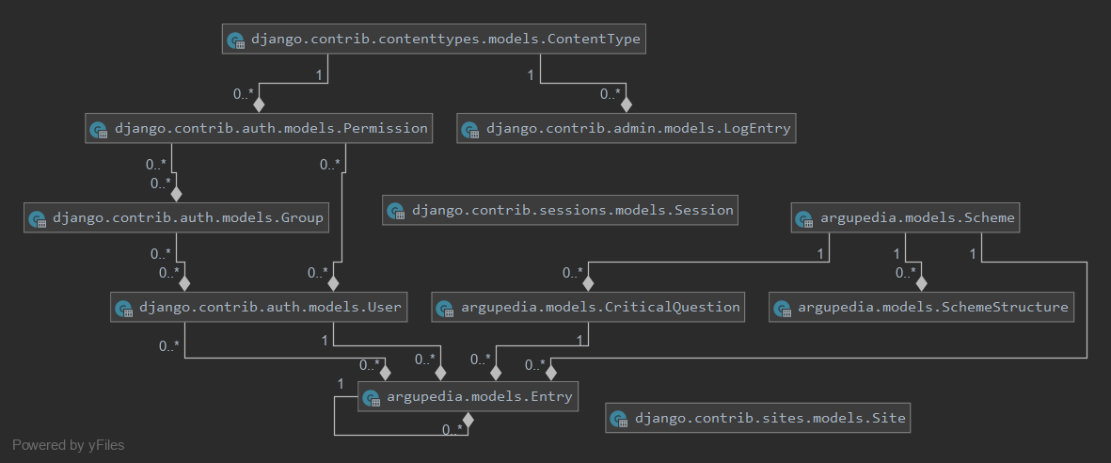**Entity Relational diagram representing backend model:**

We have a model representing arguments known as – ‘Entry’, which in turn have a 1 to many relationships with itself. The model ‘Entry’ is in essence a data structure resembling a tree, with initial arguments regarded as root node, and counter arguments as child nodes and so on and so forth. The Entry model have a many to 1 relationship with the model named – ‘CriticalQuestion’, representing critique point of a particular counter argument. However, for the root node, the relationship stays blank as it is not based on critical questions. The model ‘Scheme’ represents argumentation scheme and each scheme is linked to model SchemeStructure, which dictates the input structure of the respective scheme, and in addition to this, it is linked to CriticalQuestion model via a 1 to many relationship representing the scheme’s respective set of critical questions.

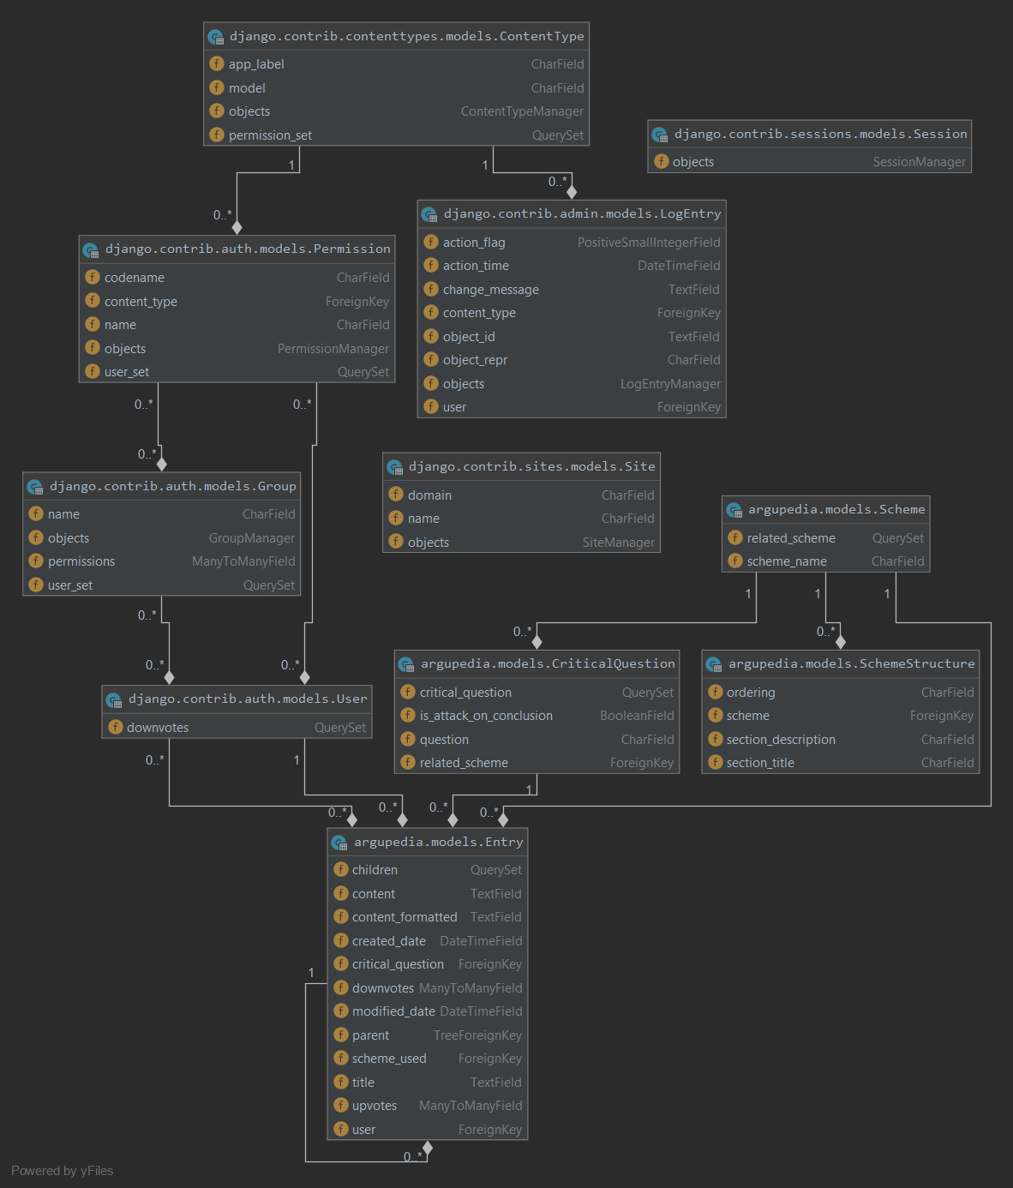**Relational Schema diagram:**

**References**

[1] Statista (2019, November 20). Reddit - Statistics & Facts [Online]. Available: <https://www.statista.com/topics/5672/reddit/>

[2] Ginny Marvin (2018, September 17). Quora introduces Broad Targeting, says audience hits 300 million monthly users [Online]. Available: <https://marketingland.com/quora-introduces-broad-targeting-says-audience-hits-300-million-monthly-users-248261>

[3] Amazon (2019, December). The top 500 sites on the web [Online]. Available: <https://www.alexa.com/topsites>

[4] Atkinson K, Bench-Capon T, McBurney P. PARMENIDES: facilitating deliberation in democracies. Artificial Intelligence and Law. 2006 Dec 1;14(4):261-75.

[5] SubReddit Stats (2019, December 4). Changemyview Stats [Online]. Available: <https://subredditstats.com/r/changemyview>

[6] Karin Osvaldsson, “Bullying in Context: Stories of Bullying on an Internet Discussion Board,” Dept. of Child Studies, Linköping University, 2011

[7] Plous Scott. The psychology of judgment and decision making. Mcgraw-Hill Book Company; 1993.

[8] Van Eemeren F, Van Eemeren FH, Grootendorst R. A systematic theory of argumentation: The pragma-dialectical approach. Cambridge University Press; 2004.

[9] Dung PM. On the Acceptability of Arguments and its Fundamental Role in Nonmonotonic Reasoning and Logic Programming. InIJCAI 1993 Aug 28 (Vol. 93, pp. 852-857).

[10] Gerhard Brewka, Class Lecture, Topic: " Handling Exceptions in Knowledge Representation: A Brief Introduction to Nonmonotonic Reasoning”, Computer Science, University of Leipzig, Leipzig, May 2017

[11] Caminada M. A gentle introduction to argumentation semantics. Lecture material, Summer. 2008.

[12] Baroni, P., Caminada, M. and Giacomin, M., 2011. An introduction to argumentation semantics. The knowledge engineering review, 26(4), pp.365-410.

[13] Peter McBurney, Class Lecture, Topic: "Lecture 7: Argumentation I”, Computer Science, King’s College London, London, November 2019.

[14] P. M. Dung, “On the acceptability of arguments and its fundamental role in nonmonotonic reasoning, logic programming,” Division of Computer Science, Asian Institute of Technology, 1995.

[15] Modgil S, Caminada M. Proof theories and algorithms for abstract argumentation frameworks. InArgumentation in artificial intelligence 2009 (pp. 105-129). Springer, Boston, MA.

[16] Dagan I, Dolan B, Magnini B, Roth D. Recognizing textual entailment: Rational, evaluation and approaches–erratum. Natural Language Engineering. 2010 Jan;16(1):105-.

[17] Cabrio E, Villata S. Combining textual entailment and argumentation theory for supporting online debates interactions. InProceedings of the 50th Annual Meeting of the Association for Computational Linguistics (Volume 2: Short Papers) 2012 Jul (pp. 208-212).

[18] Walton D., “Chapter 3: Argumentation Schemes” in Fundamentals of critical argumentation. Cambridge University Press; 2005 Oct 31.

[19] Walton D, Reed C. Argumentation schemes and defeasible inferences. InWorkshop on computational models of natural argument, 15th european conference on artificial intelligence 2002 Jul 22 (pp. 11-20).

[20] Live Science (2017, July 25). Deductive Reasoning vs. Inductive Reasoning [Online]. Available: <https://www.livescience.com/21569-deduction-vs-induction.html>.

[21] Atkinson, K., Bench-Capon, T. and McBurney, P., 2006. PARMENIDES: facilitating deliberation in democracies. Artificial Intelligence and Law, 14(4), pp.261-275.

[22] Atkinson KM. What should we do? Computational representation of persuasive argument in practical reasoning.