Snowflake SCD Data Pipeline Architecture
Is document mein AWS EC2, Apache NiFi, Jupyter, S3, Snowpipe, Snowflake Stream aur Tasks par mushtamil pipeline architecture ko step by step Roman Urdu mein samjhaya gaya hai.
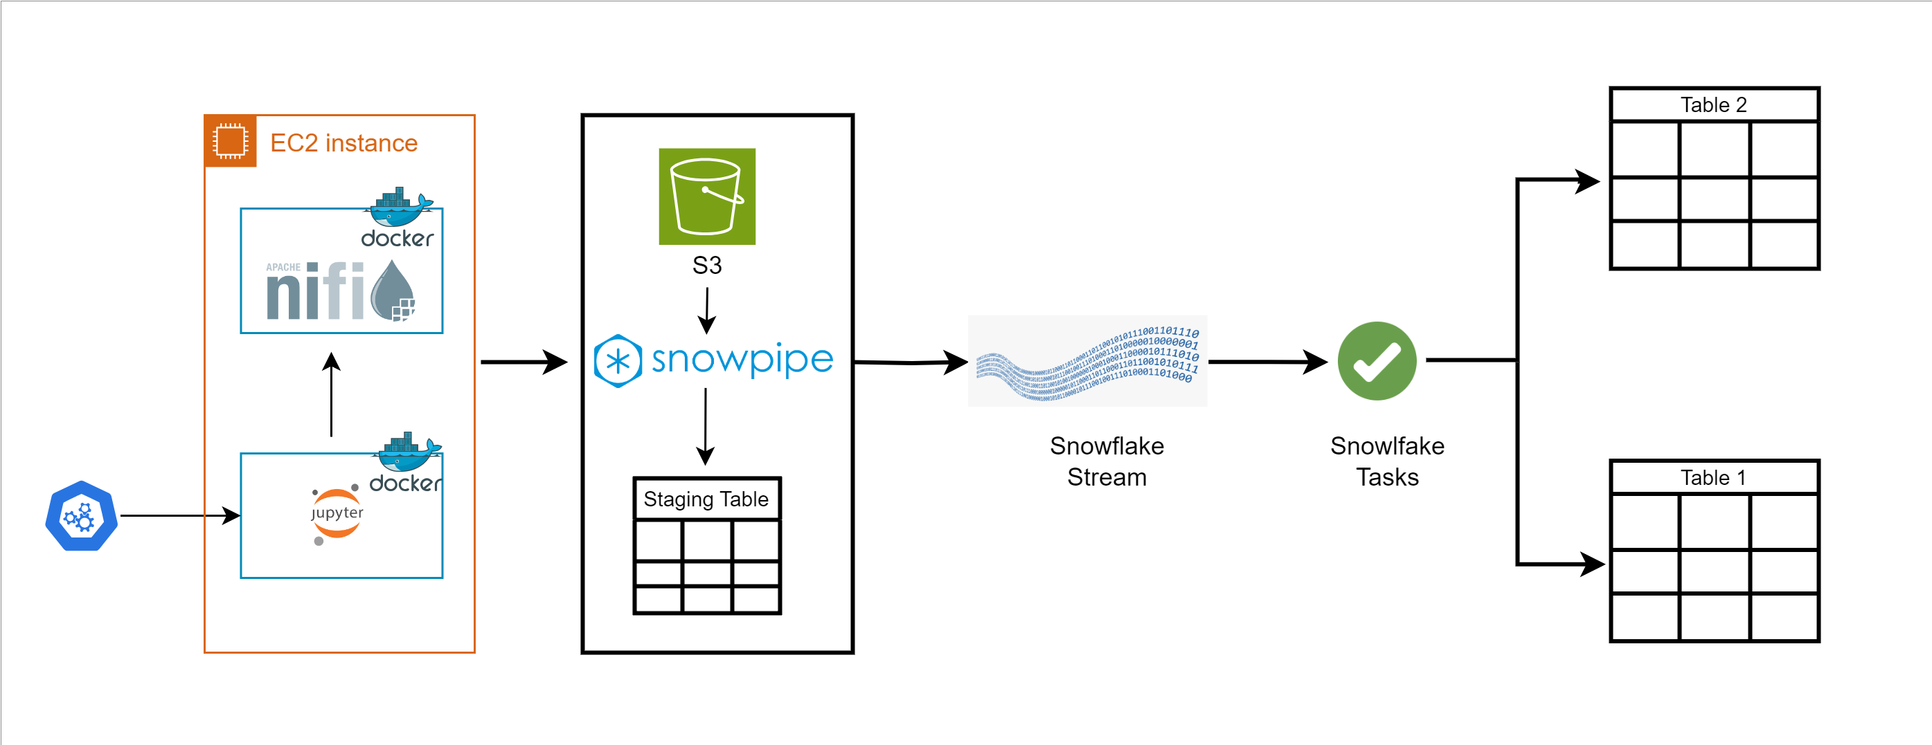
Figure 1: Poori Architecture ka Overview

Introduction
Yeh architecture ek complete data pipeline dikhati hai jo data ko source se le kar EC2 instance, phir AWS S3, phir Snowflake tak pohanchati hai, aur akhir mein data ko do final tables mein transform kar deti hai. Neeche har stage ko alag alag section mein detail se explain kiya gaya hai.

1. Data Ingestion Layer (EC2 Instance)
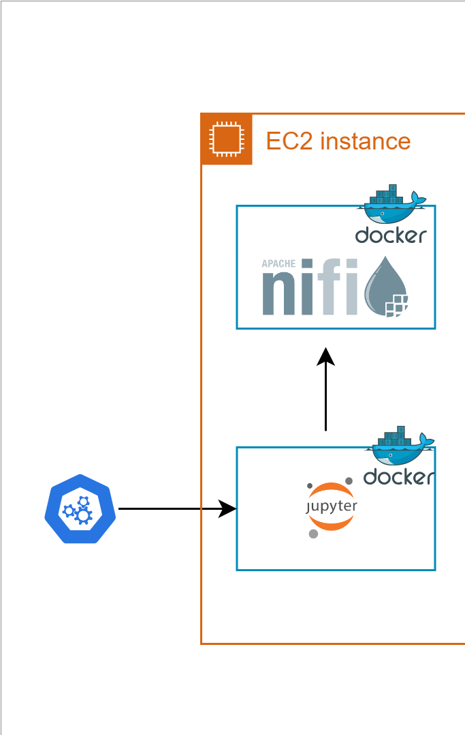
Figure 2: EC2 instance ke andar Jupyter aur NiFi containers
Sab se pehle ek orchestrator (neela hexagon icon, jaise Kubernetes ya koi scheduling tool) ek trigger bhejta hai jo EC2 instance ke andar chal rahe Jupyter Docker container ko activate karta hai.
Jupyter Notebook (Docker container): Yeh container data preparation, testing ya custom scripts chalane ke liye use hota hai. Iska output aage Apache NiFi ko diya jata hai.
Apache NiFi (Docker container): Yeh dataflow tool hai jo data ko ek jaga se doosri jaga move, transform aur route karta hai. Yahan yeh EC2 instance se data uthata hai aur usko AWS S3 bucket ki taraf bhejta hai.
Dono containers (Jupyter aur NiFi) Docker ke zariye isolated environment mein ek hi EC2 instance par chalte hain, jo deployment ko simple aur portable banata hai.

2. Storage aur Loading Layer (S3 + Snowpipe)
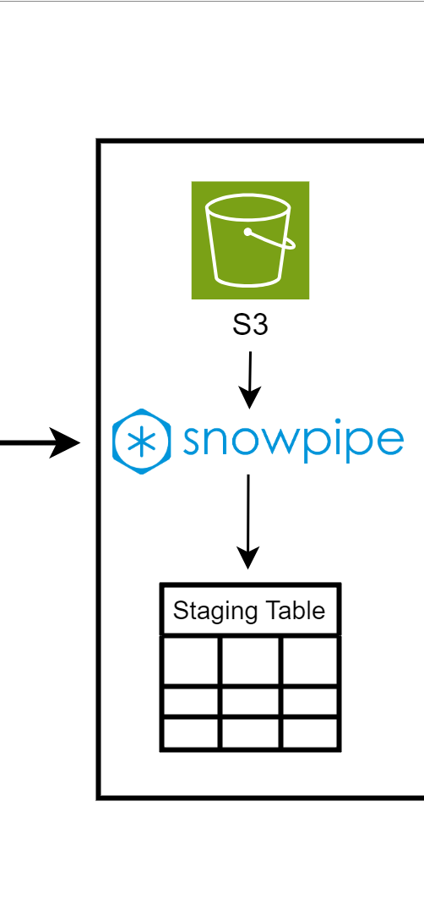
Figure 3: S3, Snowpipe aur Staging Table
AWS S3: NiFi se aane wala raw data pehle S3 bucket mein land karta hai. S3 yahan ek intermediate storage ka kaam karta hai jahan files temporarily rakhi jati hain.
Snowpipe: Yeh Snowflake ki continuous data loading service hai jo S3 bucket ko monitor karti hai. Jaise hi nayi file S3 mein aati hai, Snowpipe automatically usay detect kar ke Snowflake ke andar load kar deta hai — bina kisi manual trigger ke.
Staging Table: Snowpipe data ko sabse pehle ek Staging Table mein load karta hai. Yeh raw data ka temporary landing zone hai, jahan se aage processing hoti hai.

3. Change Data Capture Layer (Snowflake Stream & Tasks)
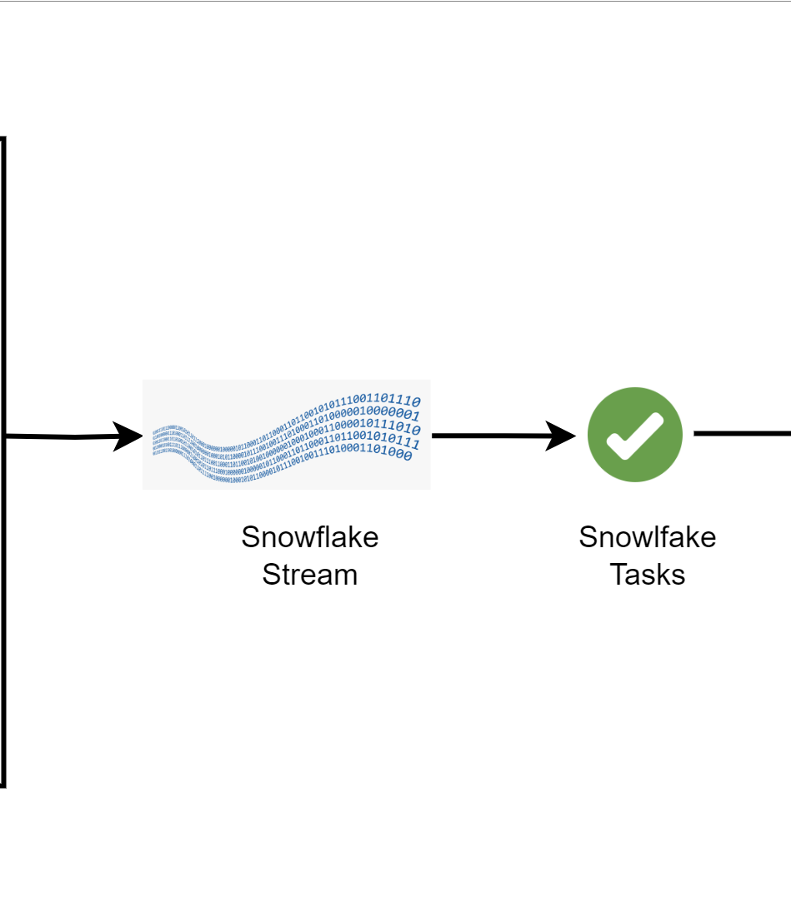
Figure 4: Snowflake Stream aur Tasks ka Flow
Snowflake Stream: Stream Staging Table par hone wale har change (insert, update, delete) ko track karta hai. Yeh ek Change Data Capture (CDC) mechanism hai jo batata hai ke table mein kya naya ya tabdeel hua hai.
Snowflake Tasks: Tasks ek scheduled ya event-based SQL execution mechanism hai. Yeh Stream se changes utha kar unko process karta hai aur phir final destination tables mein likhta hai. Yahi step SCD (Slowly Changing Dimension) logic implement karta hai — matlab purane records update ya historize hote hain aur naye records insert hote hain.

4. Final Tables (Target Layer)
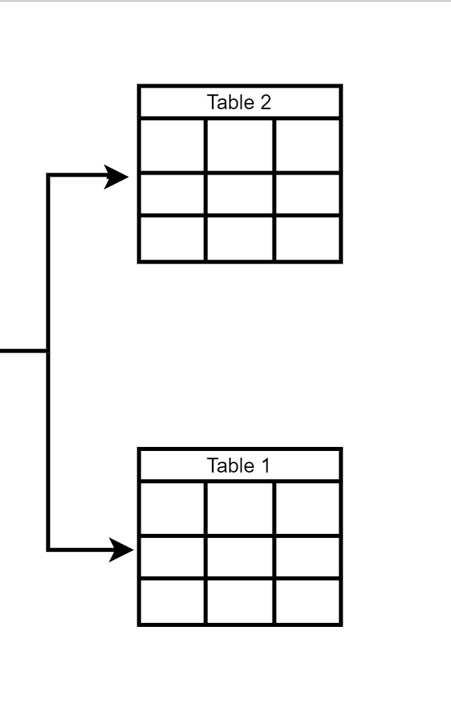
Figure 5: Final Target Tables
Snowflake Task ka processed data akhir mein do final tables — Table 1 aur Table 2 — mein split ho kar jata hai. Yeh tables clean, structured aur analysis-ready data rakhti hain jo reporting, dashboards ya downstream applications ke liye use hoti hain.

Summary
Poore pipeline ka flow is tarah hai: Trigger se Jupyter aur NiFi (EC2 par) data ko process kar ke S3 mein bhejte hain. Snowpipe S3 se data ko Snowflake ki Staging Table mein automatically load karta hai. Snowflake Stream changes detect karta hai aur Tasks unhein process kar ke final Table 1 aur Table 2 mein daal dete hain. Yeh poora system automated, scalable aur near real-time data pipeline hai.

