title: “Bayesian Clinical Trial Report”

author: “Nahian Tasnim”

date: “2025-08-06”

output: word_document

# Introduction

This report presents the results of a Bayesian clinical trial analysis comparing the frequentist and Bayesian models. The analysis aims to evaluate the effectiveness of the treatment based on clinical trial data.

# Methods

## Data Loading

The models used in this analysis are loaded from saved RDS files. The frequentist model is fitted using logistic regression, while the Bayesian model is fitted using a Bayesian approach.

# Model Summaries

## Frequentist Model Summary

##   
## Call:  
## glm(formula = diagnosis ~ radius_mean + texture_mean + perimeter_mean +   
## area_mean + smoothness_mean + compactness_mean + concavity_mean +   
## concave_points_mean + symmetry_mean + fractal_dimension_mean,   
## family = binomial, data = df_clean)  
##   
## Coefficients:  
## Estimate Std. Error  
## (Intercept) -8.33989 14.53963  
## radius_mean -0.74102 3.99281  
## texture_mean 0.38856 0.07353  
## perimeter_mean -0.27927 0.54268  
## area_mean 0.04017 0.01952  
## smoothness_mean 72.05652 34.28104  
## compactness_mean -1.35444 21.46859  
## concavity_mean 6.66079 8.45374  
## concave_points_mean 74.10069 31.46905  
## symmetry_mean 14.00628 11.75865  
## fractal_dimension_mean -39.60761 89.42235  
## z value Pr(>|z|)   
## (Intercept) -0.574 0.5662   
## radius_mean -0.186 0.8528   
## texture_mean 5.285 1.26e-07 ***  
## perimeter_mean -0.515 0.6068   
## area_mean 2.058 0.0396 *   
## smoothness_mean 2.102 0.0356 *   
## compactness_mean -0.063 0.9497   
## concavity_mean 0.788 0.4307   
## concave_points_mean 2.355 0.0185 *   
## symmetry_mean 1.191 0.2336   
## fractal_dimension_mean -0.443 0.6578   
## ---  
## Signif. codes:   
## 0 ‘***’ 0.001 ‘**’ 0.01 ‘*’ 0.05 ‘.’ 0.1 ‘ ’ 1  
##   
## (Dispersion parameter for binomial family taken to be 1)  
##   
## Null deviance: 588.87 on 454 degrees of freedom  
## Residual deviance: 119.87 on 444 degrees of freedom  
## AIC: 141.87  
##   
## Number of Fisher Scoring iterations: 9

## Bayesian Model Summary

## Family: bernoulli   
## Links: mu = logit   
## Formula: diagnosis ~ radius_mean + texture_mean + perimeter_mean + area_mean + smoothness_mean + compactness_mean + concavity_mean + concave_points_mean + symmetry_mean + fractal_dimension_mean   
## Data: df_clean (Number of observations: 455)   
## Draws: 4 chains, each with iter = 2000; warmup = 1000; thin = 1;  
## total post-warmup draws = 4000  
##   
## Regression Coefficients:  
## Estimate Est.Error l-95% CI u-95% CI Rhat Bulk_ESS Tail_ESS  
## Intercept -11.81 14.82 -42.48 16.14 1.00 1830 2213  
## radius_mean -0.41 4.08 -8.22 7.41 1.00 1460 2148  
## texture_mean 0.43 0.08 0.29 0.59 1.00 2915 2486  
## perimeter_mean -0.32 0.57 -1.42 0.78 1.00 1617 2305  
## area_mean 0.04 0.02 0.00 0.08 1.00 1651 1981  
## smoothness_mean 82.26 36.45 13.44 154.50 1.00 2016 2309  
## compactness_mean -2.90 22.36 -45.94 41.31 1.00 1870 2313  
## concavity_mean 8.54 9.32 -9.94 26.97 1.00 2033 2142  
## concave_points_mean 80.91 33.96 16.90 150.25 1.00 2141 2437  
## symmetry_mean 15.07 12.49 -9.75 39.23 1.00 3295 2532  
## fractal_dimension_mean -45.56 94.37 -231.05 136.04 1.00 2394 2711  
##   
## Draws were sampled using sampling(NUTS). For each parameter, Bulk_ESS  
## and Tail_ESS are effective sample size measures, and Rhat is the potential  
## scale reduction factor on split chains (at convergence, Rhat = 1).

# Results

## Model Comparison

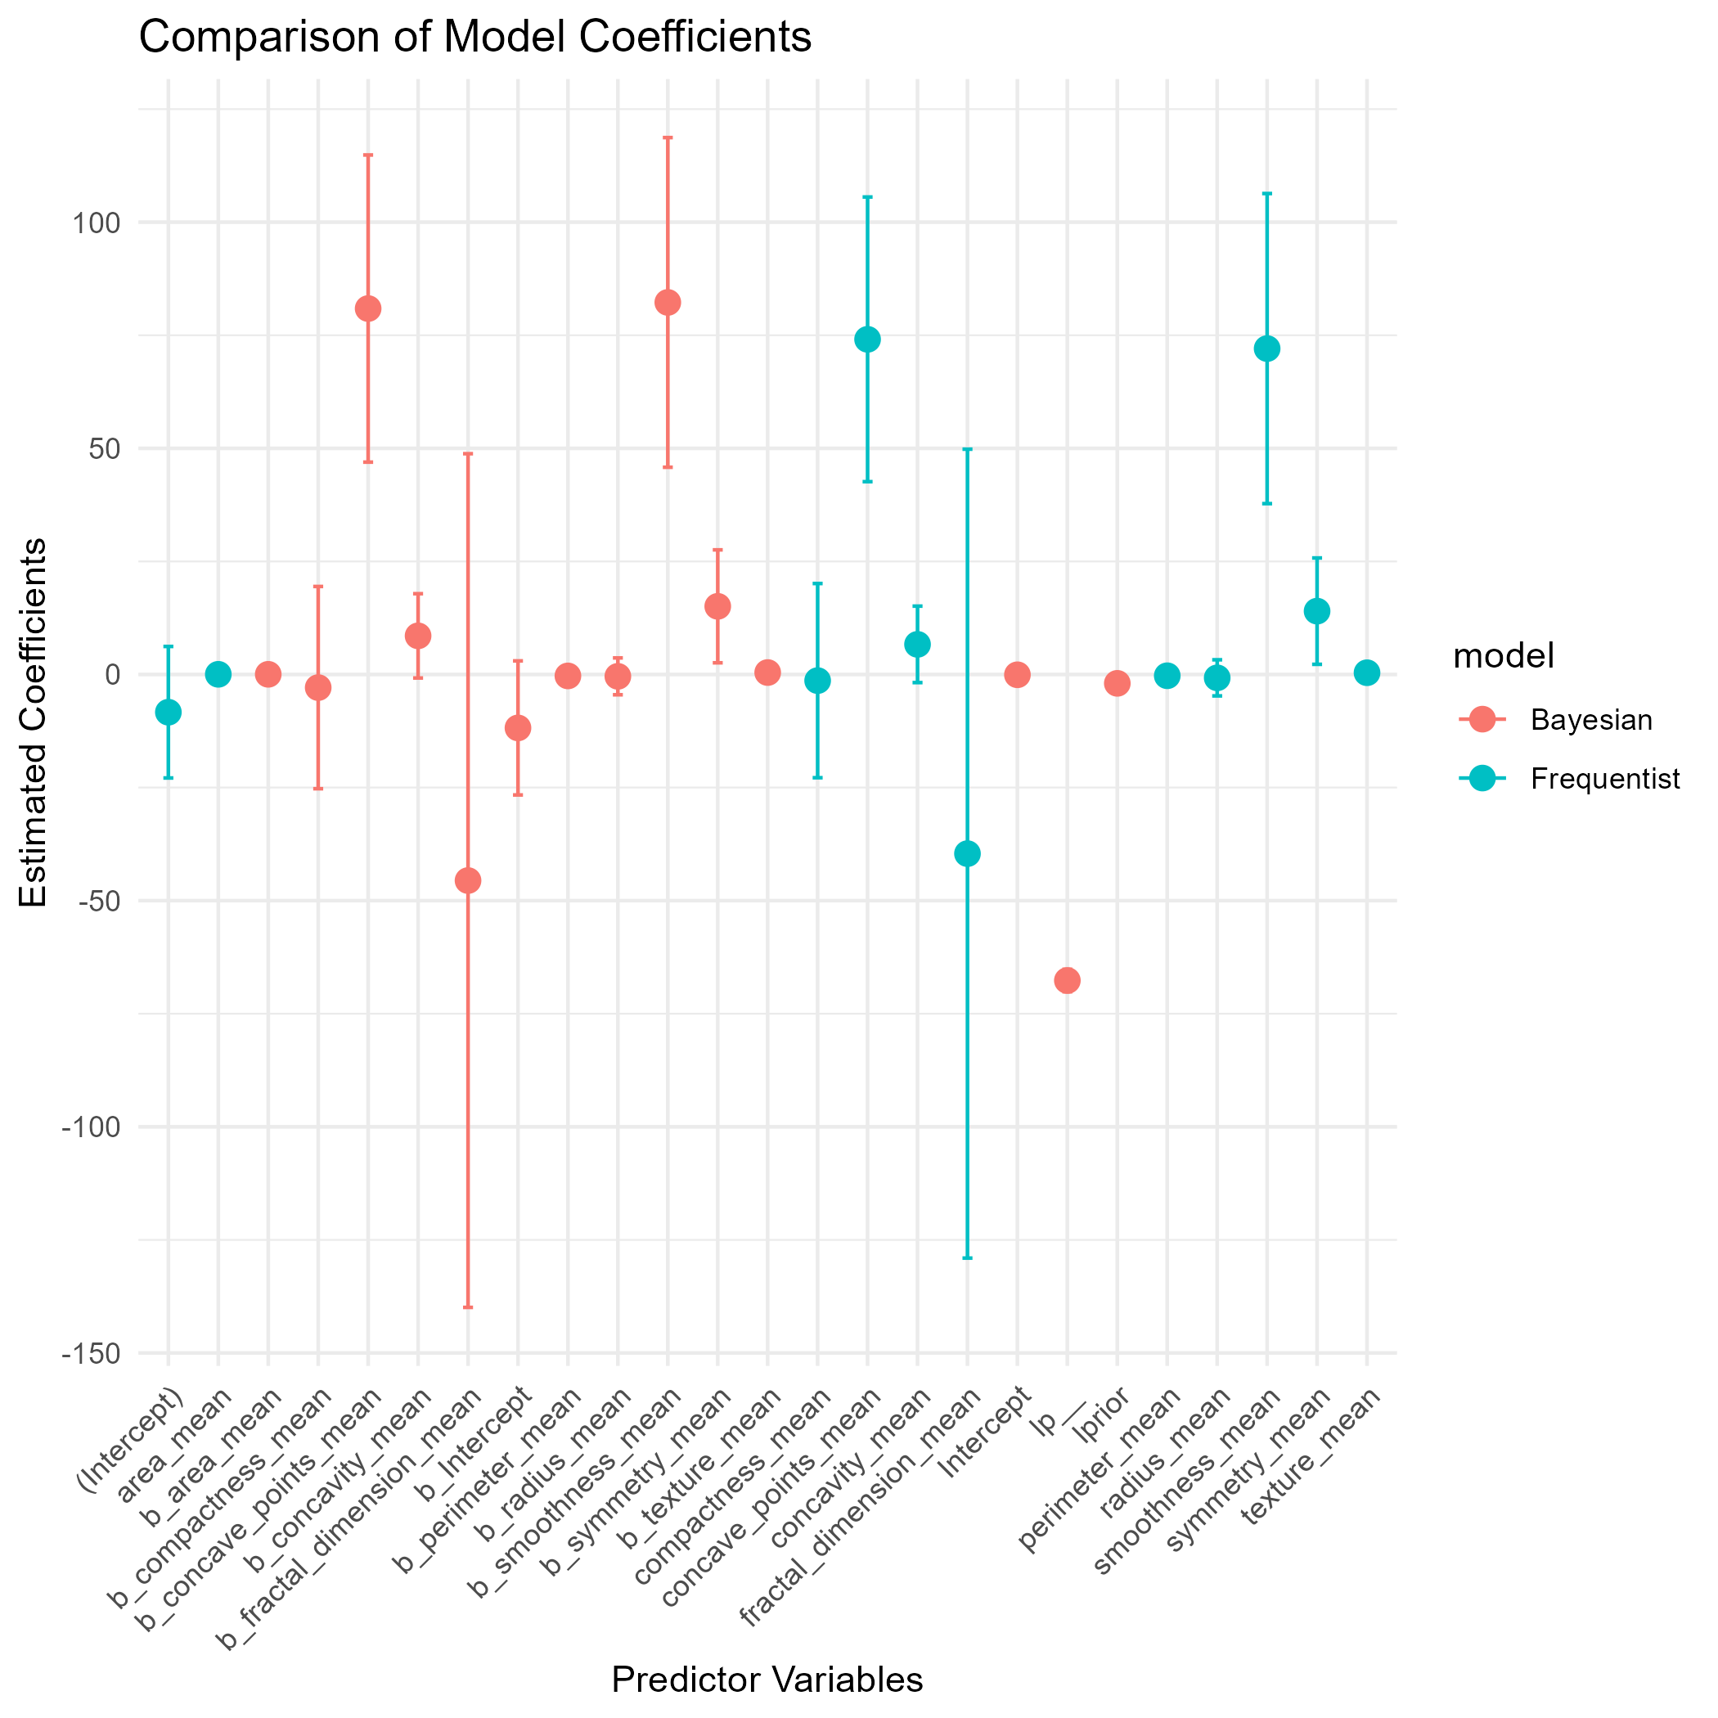

## Sensitivity Analysis

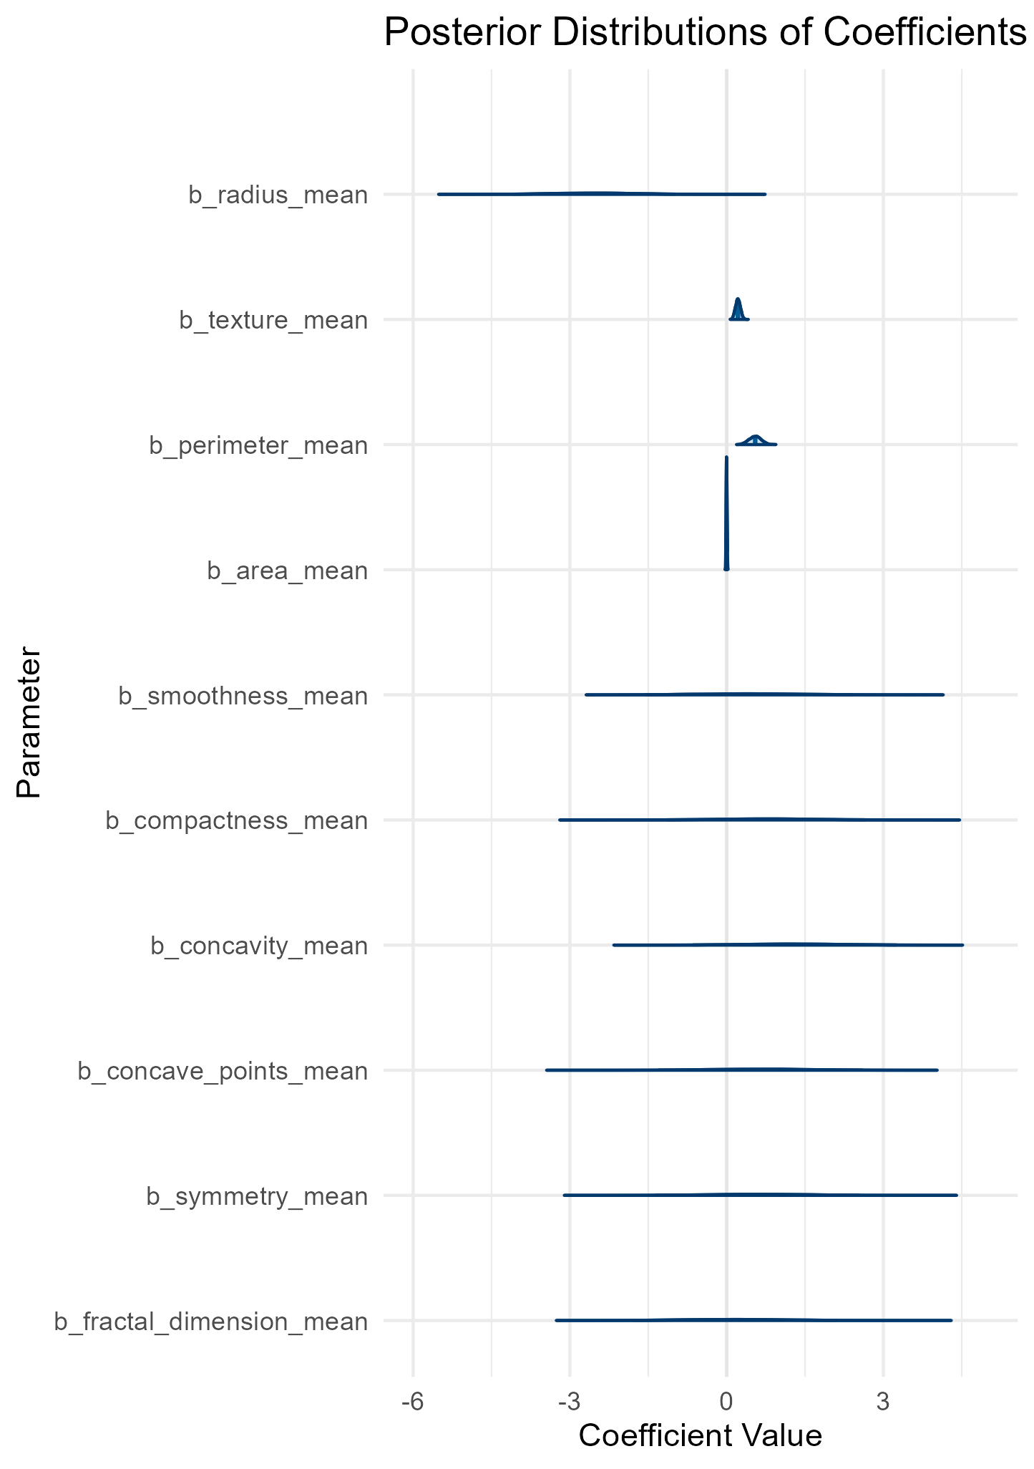

## Adaptive Analysis

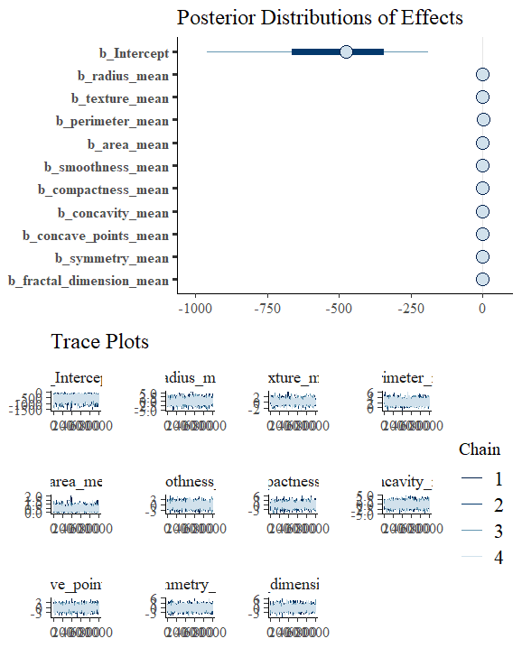

## Diagnostics

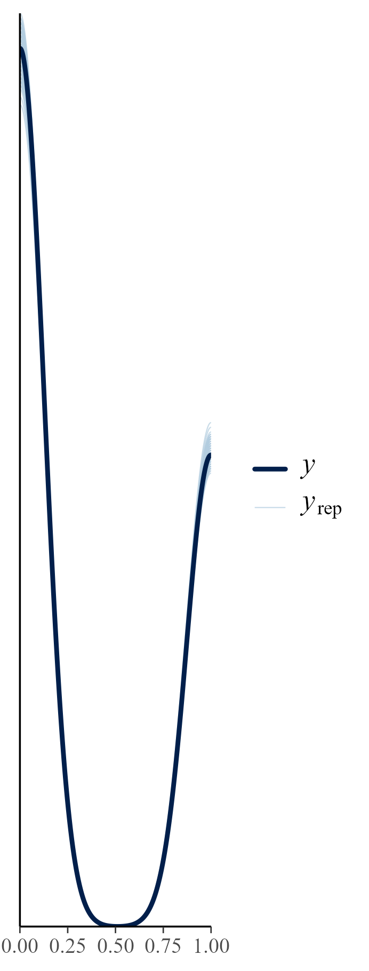

## Exploratory Data Analysis (EDA)

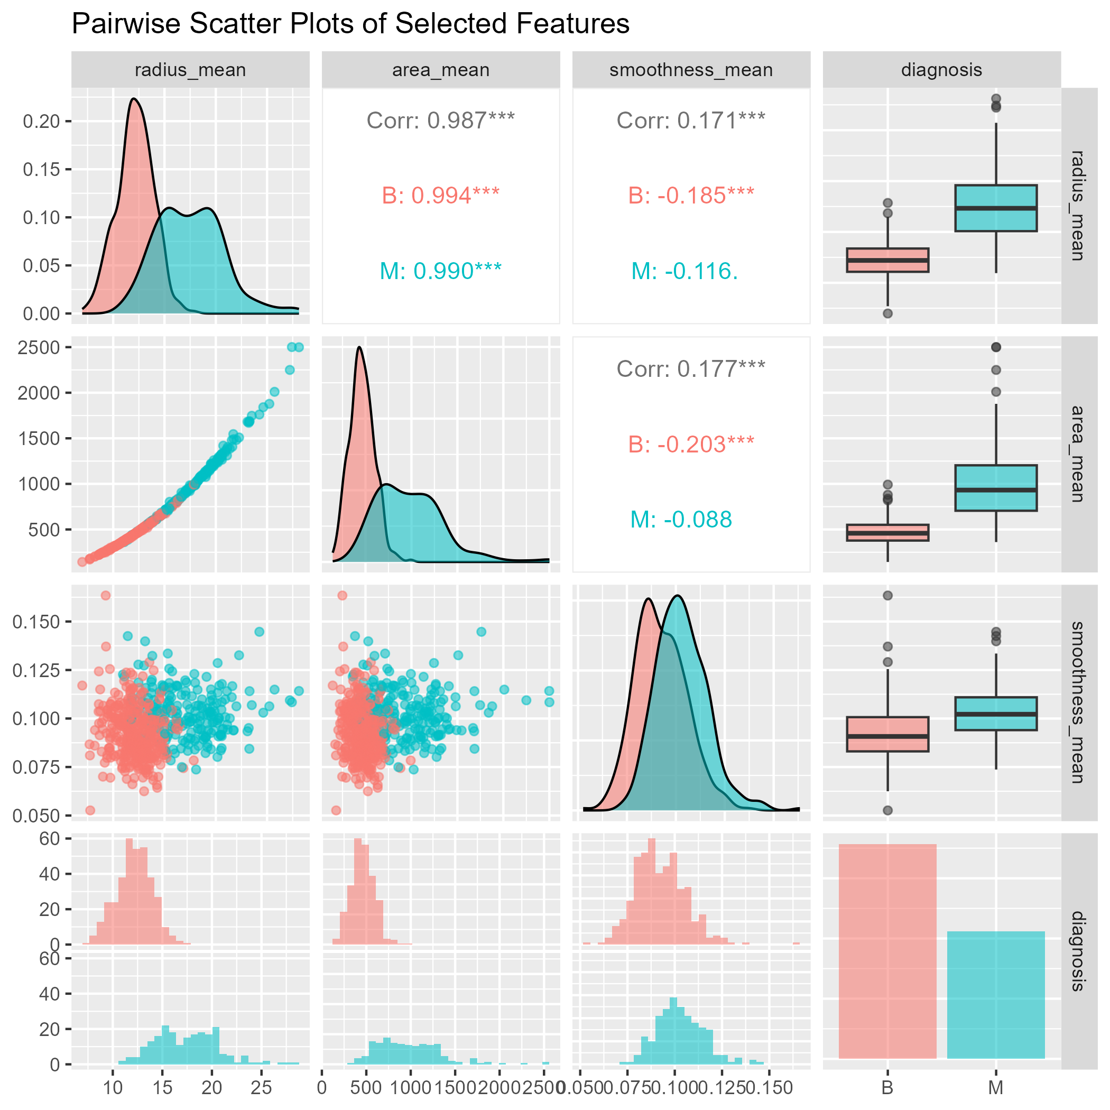

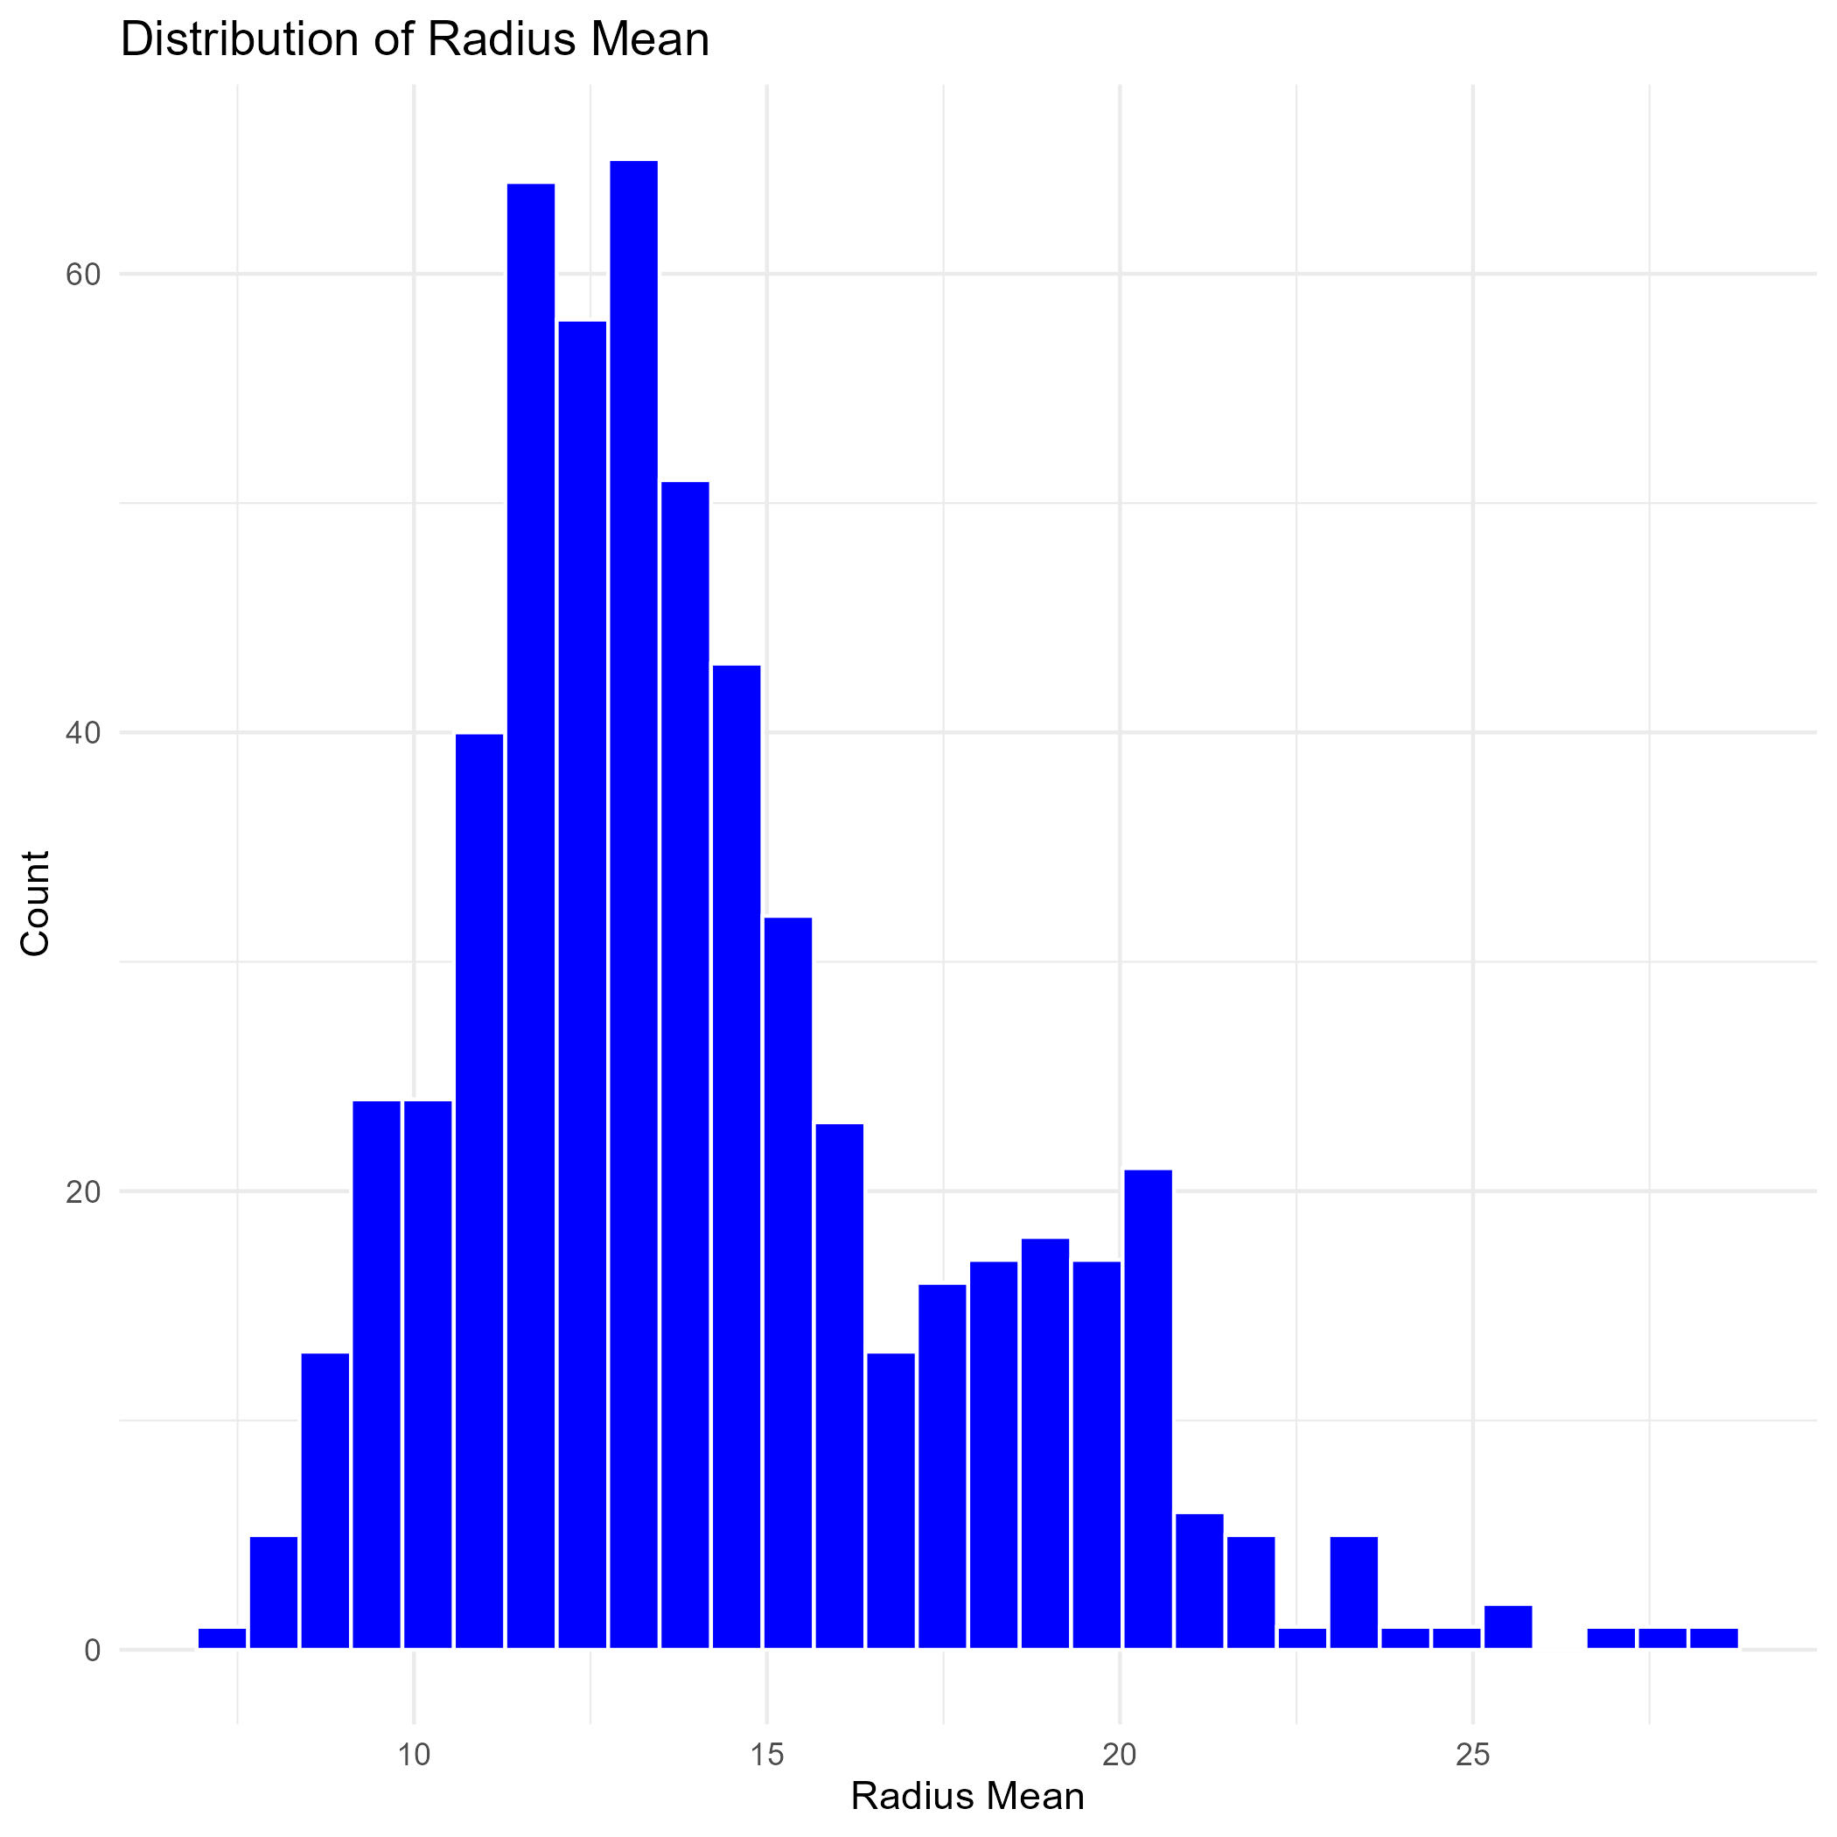

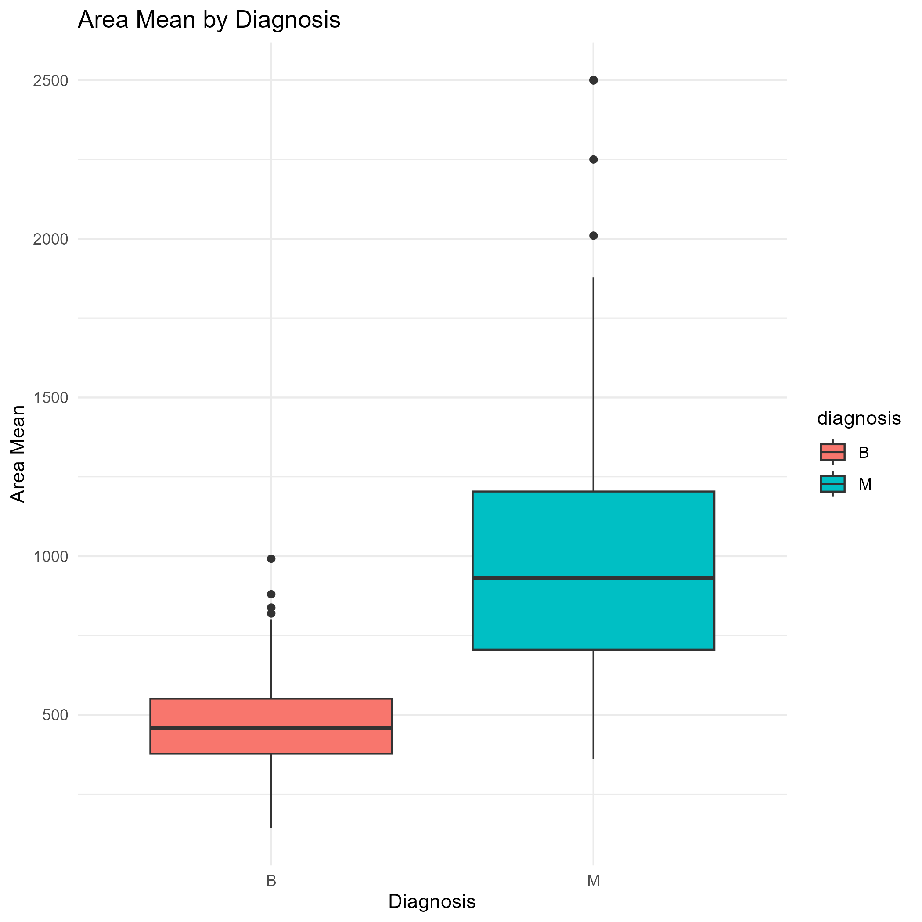

## Test Accuracy Comparison

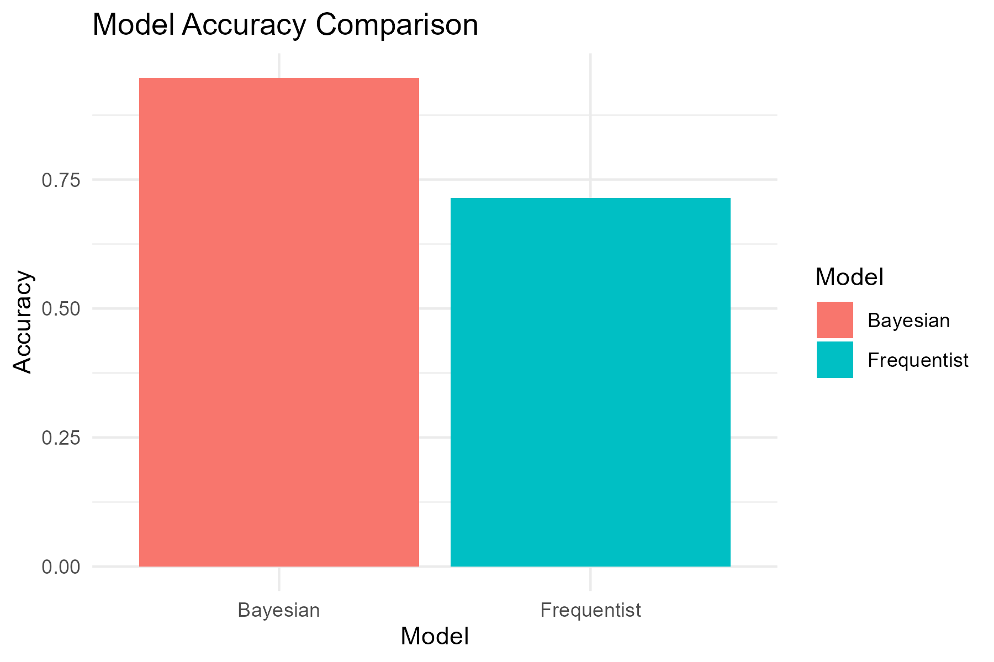

# Conclusion

In this report, we presented the results of the frequentist and Bayesian models. The comparison of the coefficients provides insights into the effectiveness of the treatment. Further analysis and validation are recommended to confirm these findings.