1. If one process finishes its task before its child processes what would happen?

2. When the processor is switched from one process to another process in a single processor system:
- Why does the OS process need to access process control block (PCB) ?
- Mark the place when Process P0, P1 and OS process are in the idle state?
- In a round-robin scheduling system, P0 and and P1 will have equal idle item.
- Will the processor be ever in the idle state? Why?
- Is it true that the idle time of the user process will increase if the number of user processes increases? Why?

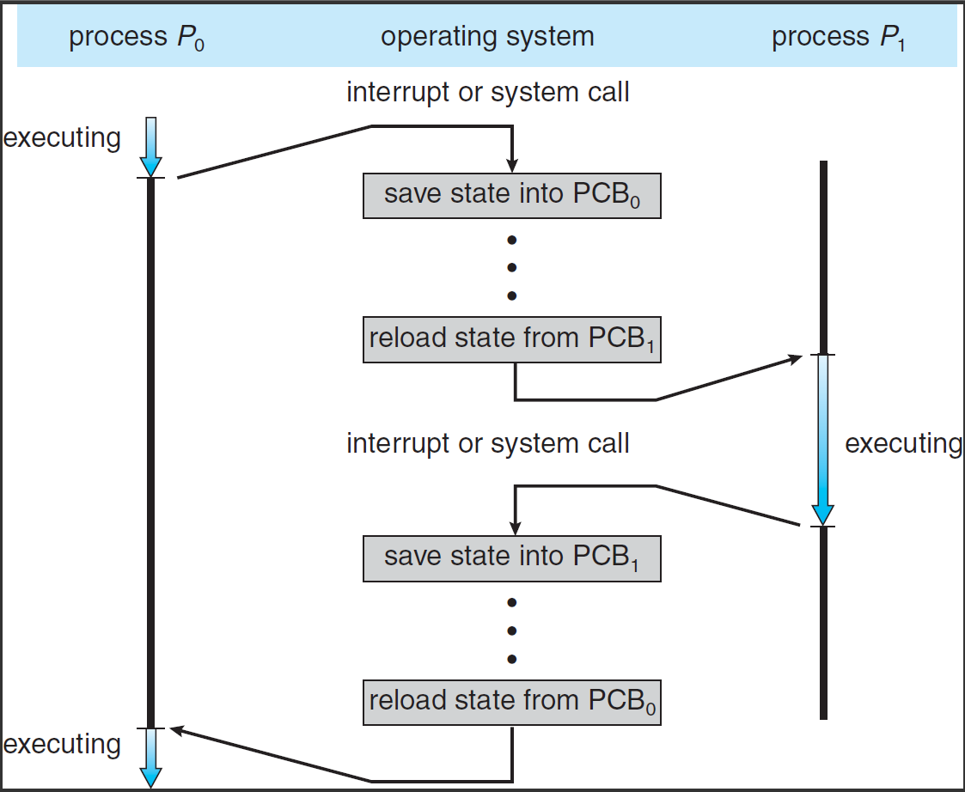

3. How many processes will be created if we run the following program, named ProcessCreation.c, in the following way after compilation? Why?

$ gcc ProcessCreation.c -o ProcessCreation
$ ./ProcessCreation I love to study Operating System

#include <unistd.h>
void main(int argc, char *argv[]){
for (int i = 0; i <argc; i++)
fork();
}

4. As process executes, it changes state. How many processes can be in the New, Running, Waiting, Ready and Terminated state in a system having two processors? Why?

