

American International University- Bangladesh

CSC 3222: Web Technologies

CO1.1 and CO2.1 Evaluation

Project Report

Fall 19-20

Project Title: Get Your Med

Section: D

|  |  |
| --- | --- |
| Student Name | Student Id |
| S. M. NAHID | 19-39998-1 |
| MOHAMMED MOHAIMENUL ISLAM | 17-34271-1 |
| MD. FARHAD HOSSAN | 18-37878-2 |
| MD. ABRANUL HAQE FUAD | 17-34837-2 |

**Get Your Med**

**Introduction:**

Medicine is one of the essential thing for any patient. But it is not possible for anyone or some patient to buy the necessary medicine when they need it and also they might not find everything at once. This web-based application will allowed customer/patient to order there necessary medicine just by flowing some steps. The users can view product, know price, able to share information and many more.

**Background Study:**

Ideas from this (https://healthtunnel.com/order-medicines-online/ )website was taken which helps us create a similar system allows its user to solution healthcare, order online medical pill/medicine & viewing other pharmacy product at their convenience.

**Requirement Analysis:**

1. **User Category:**

There are four types of Users here. They are:

* + - Admin
    - Seller
    - Buyer
    - Delivery man

1. **Feature List:**

In this project the “**Admin**” has the following features:

* Can Login
* Can Search
* Can register to the system
* Can update his profile information
* Can add seller
* Also can add buyer
* Verify Buyer profile
* Verify Seller profile
* Can block Buyer/Seller
* Can delete user/seller
* Generate sales report
* Also able to calculate revenue
* Check buyer review
* Can view products information etc.

In this project the “**Seller**” has the following features:

* Can Login
* Can Search for product
* Can register to the system as employee
* Can update his profile information
* Can add product
* Can publish product
* Can contact system admin
* Verify Buyer Order
* Can contact with the buyer
* Can view products information
* Check the inventory etc.
* Also can update inventory
* Can download order slip
* Able to view user review etc.

In this project the “**Buyer**” has the following features:

* Can Login
* Able to delete id
* Can Search for product
* Can register to the system
* Can update his profile information
* Can buy product & Set delivery Location
* Also can cancel order
* Add order to cart
* Able to filter product
* Can comment or provide review
* Can make a payment /online
* Can contact with the delivery boy
* Download order slip
* Able to send picture
* Can select product qty.
* Able to see order history
* Repeat History

In this project the “**Delivery**” has the following features:

* Can Login
* Registration
* Choose Service Area
* Receive Orders
* Multiple Deliveries
* Can see buyer location
* Able to communicate with buyer
* Can contact with the seller/warehouse
* Update Order status
* Able to take online payment
* Can see buyer information
* Set availability
* Push Notifications & alerts
* Link Bank Account
* Help &Support

**Design:**

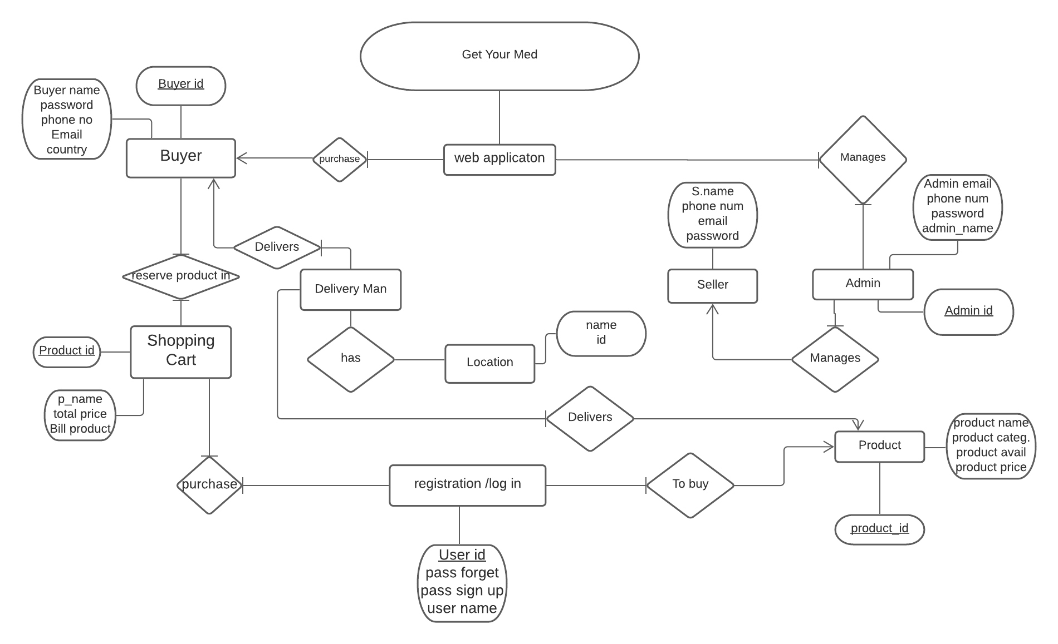

**Tools Used:**

To develop this project, we have used the following:

• Notepad++

• Lucidchart

• Snipping Tool

• Google Chrome

**System Images against the Specification:**

**Buyer:**

This is the buyer home page and he see all kind of page link, his cart, profile also able to upload image and update his profile.

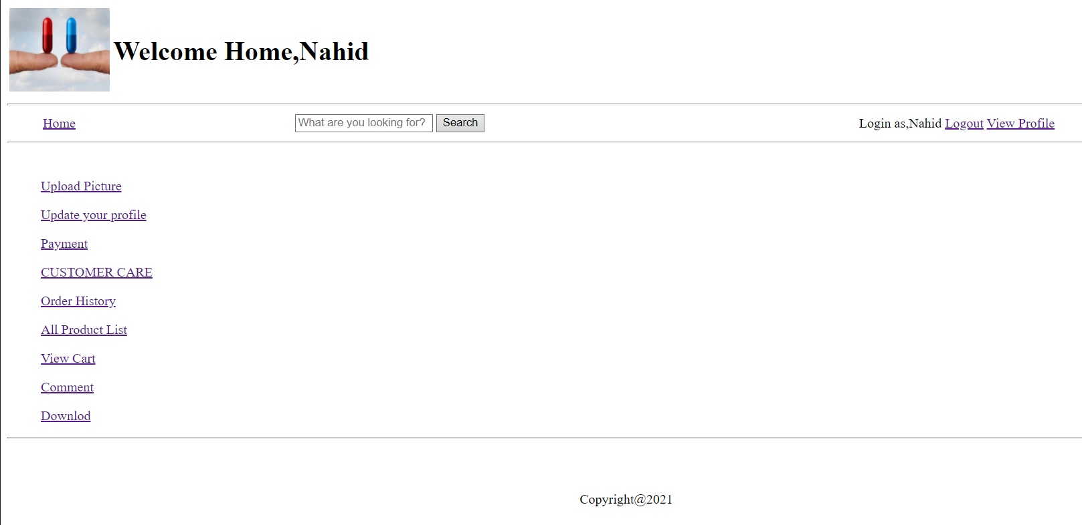

In this Product List user can know about the information and price they can also add the necessary product to the cart.

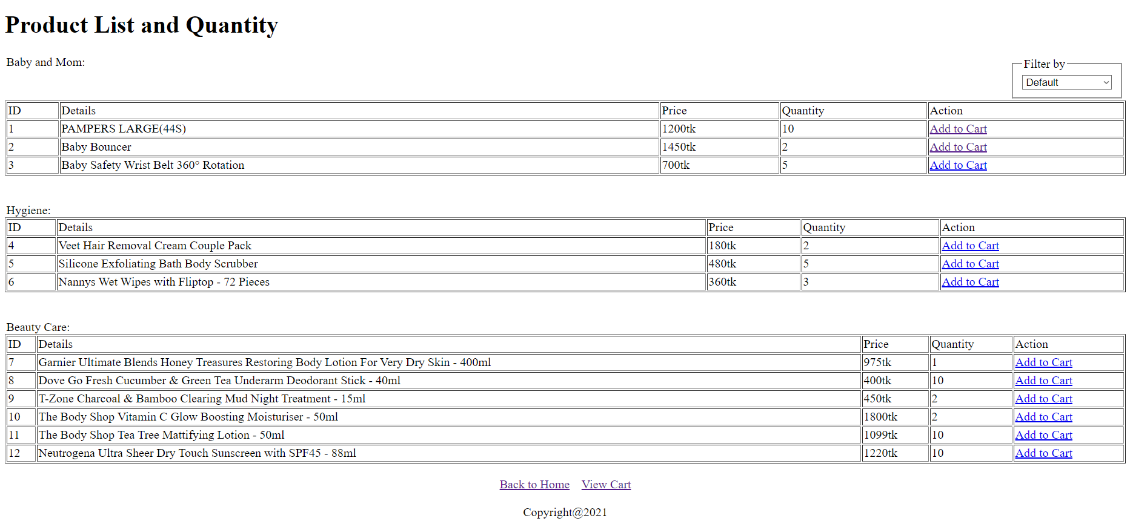

**Admin:**

This is the admin dashboard page, admin can go to other pages for other operation. Admin can add, block delete buyer or seller as well as can create sales report, see buyer review and so on.

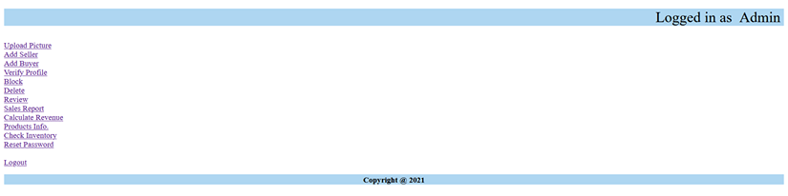

This page is for adding a seller admin can add seller from here

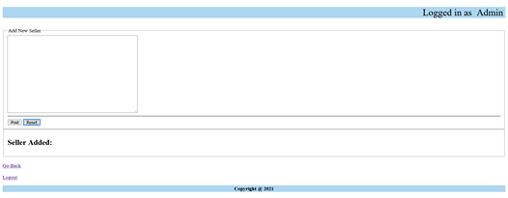

Give a screen shot of some GUIs (Midterm project) and write a very small description (Maximum 40 words) for each of the GUIs.

**Impact of this Project:**

This system will help the user to reduce unnecessary hustle for getting ready and go out to buy the medicines. It will also help the user by preventing to going one store to another and will provide accurate information about medicines, specific price and available stored product. Furthermore, it helps user in time saving and avoiding the need to negotiate with the salesman. This system can serve 24/7 with accurate information and one can easily order the necessary medicine that they need.

**Limitations and Possible Future Improvements**:

System may have some limitations like it always need internet connections, it may be unfriendly and complicated websites for some users. For possible future improvements system should be modified so that it can handle vast number of users. Order confirmation should be send by message or email. System should be updated after a certain amount of time so that users can be updated with the current changes and get the service smoothly.

*[Note: Make sure that your report is maximum 10 pages (including cover page). Print (Colored) the report and submit it with spiral bind.]*

|  |  |  |  |  |  |
| --- | --- | --- | --- | --- | --- |
| CO1.1 and CO2.1 Evaluation: Project Report Evaluation | | | | | |
| Project Proposal  (5) | Background  Study  (5) | Requirement Analysis  (5) | Entity  Diagram  (5) | System Images  against the  Specification (5) | Total (25) |
|  |  |  |  |  |  |
|  | | | | | |