

Project Documentation on

**BloodBank Management System**

**Submitted By:**

Md.Nahid ID:182-15-2194 (Leader)

Hasan hadiuzzaman ID:182-15-2165

Saiful Haque Zim ID:182-152114

SECTION: PC-B

**Under The Guidance Of:**

Saif Mahmud Parvez   
Lecturer

Department of CSE (PC)

Daffodil International University

Submission Date: 12 August, 2020

**Our project name: BloodBank Management System**

Project Overview:

Blood Bank Management System (BBMS) is database system to link between the donors and blood banks and act as an interface for the patient to find his/her desired blood in a fast and efficient way. It will make the blood transfusion service and its management more reliable and efficient than the conventional system. There are 6 entities in this project like Donor, Blood, Blood Bank, receptionist, Blood Bank Manager , Hospital and Orders. First of all will collect blood from the donor and then deposit it in the blood bank. The receptionist will collect blood from the donor and then put it in the blood bank under the manager .There will be many types of blood in the blood bank. There are different types of blood prices in the blood bank. This database will contain a lot of blood bank data. If the Hospital will need any type of blood can be found in this database from any blood bank easily.

Database Structure

# The database consists of Seven Entity. The main tables are the blood, donor and blood bank , hospital ,Receptionist and blood Bank manager. The remaining table ‘donor Id’ is the relational table which links donor and Blood and Receptionist tables with its foreign keys.

|  |  |
| --- | --- |
| Entity | Description |
| Donor | Contains all of the donor’s information who donate Blood. |
| Blood | Contains all of the Blood information like which type of blood and cost of different type of blood. |
| Receptionist | Contains all of the Receptionist information who collect blood from donor. |
| Blood Bank Manager | Contains all of the Manager information of Blood Bank. |
| Blood Bank | Contains all of the blood bank’s information. |
| Orders | Contains all of the orders information which hospital orders blood |
| Hospital | Contains all of the hospital information which needed Blood |

Design Documents

**Entity relationship diagram (ERD):**

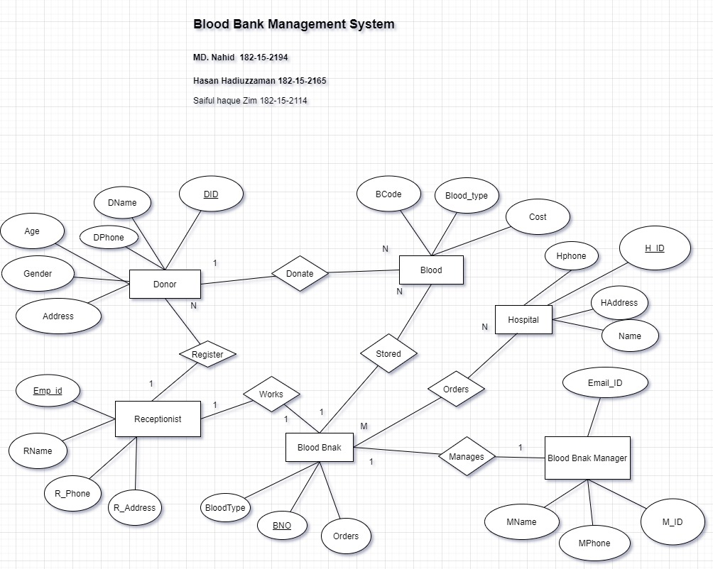

**Schema diagram:**

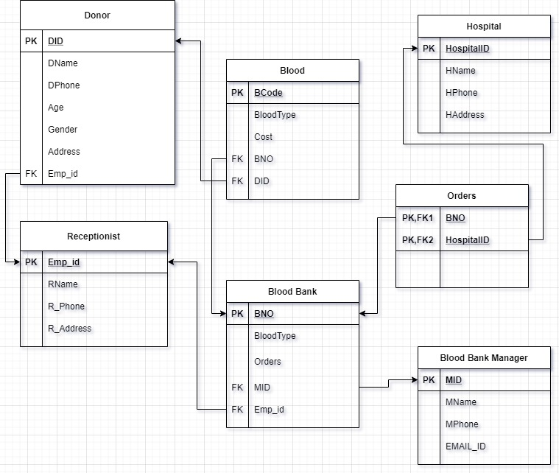

**Conclusion:**

**Every software has some limitations. There are some limitations in our Blood Bank Management System database. Suppose AB+ blood is not in any blood bank But it is urgently needed for the patient . There was a big problem . If searching The Database can found AB+ donor details Those who donated blood 120 days ago.**

**Then the Hospital can contact the donor and collect blood.** **But we could not use it in the Blood bank Management System database. There was a big limitations in our Project.**