Untitled

Nahid Ferdous

2023-06-16

panel <- read.csv("https://raw.githubusercontent.com/EricBrownTTU/ISQS5346/main/panel.csv")  
panel[,1]

## [1] 0.01 1.21 1.71 2.30 2.96 0.19 1.22 1.75 2.30 2.98 0.51 1.24 1.77 2.41 3.19  
## [16] 0.57 1.48 1.79 2.44 3.25 0.70 1.54 1.88 2.57 3.31 0.73 1.59 1.90 2.61 1.19  
## [31] 0.75 1.61 1.93 2.62 3.50 0.75 1.61 2.01 2.72 3.50 1.11 1.62 2.16 2.76 3.50  
## [46] 1.16 1.62 2.18 2.84 3.50

mean(panel[,1])

## [1] 1.935

median(panel[,1])

## [1] 1.835

sd(panel[,1])

## [1] 0.9286511

qqnorm(panel[,1])  
qqline(panel[,1])

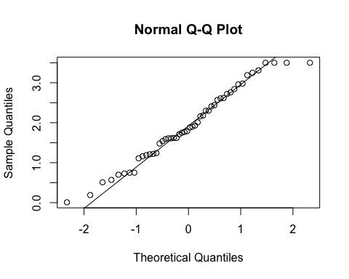 ## Most of the data fall in accordance with the theoretical quantiles. We can now look at the skewness and kurtosis.

x<- panel[,1]  
z<- (x-mean(x)/sd(x))  
k3= sum(z^3)/length(z)  
k3

## [1] -0.3860205

k4= sum(z^4)/length(z)-3  
k4

## [1] -1.31185

## Both the skewness and kurtosis are within acceptable limits, so we must conclude that the data that we have is sufficiently close to normal.

# Rankings of Universities

## Consider the data on academic reputation scores for the top 50 research universities.

topuniv <- read.csv("https://raw.githubusercontent.com/EricBrownTTU/ISQS5346/main/topuniv.csv")  
x <- topuniv[,4]  
qqnorm(x)  
qqline(x)

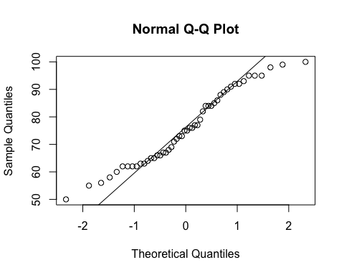

## The data do not adhere well to the linear relationship between quantiles.

z <- (x - mean(x))/sd(x)  
K3 = sum(z^3)/length(z)  
K3

## [1] 0.1411848

## [1] 0.1411848  
K4 = sum(z^4)/length(z) - 3  
K4

## [1] -1.183137

## [1] -1.183137

## The skewness and kurtosis values are reasonable, which indicates the data might be normal. I would argue that this data requires additional inspection before modeling using the normal distribution.