**AMERICAN INTERNATIONAL UNIVERSITY–BANGLADESH (AIUB)**

**DEPARTMENT OF ENGINEERING**

[**INTRODUCTION TO DATABASE**](https://portal.aiub.edu/Student/Section?q=j3Wc6QZpwj8GAUZ6rruD2A%3D%3D)

**Section: K, Group: 5**

**Supervised By**

SIFAT RAHMAN AHONA

**Submitted By**

|  |  |
| --- | --- |
| **Name** | **ID** |
| 1. SADAF KHAN | 22-47021-1 |
| 2. MD. FAHIM BIN IMAM NAHID | 22-46078-1 |
| 3. BADHON BISWAS | 22-46351-1 |
| 4. MD. SAIDUZZAMAN SOHAG | 22-46006-1 |

**Date of Submission: December 04, 2022**

/*===================================🡺

Inside (spot_id, address, Space_id, space_type)

1NF: No multivalued attribute

2NF: Spot_id, Address

Space_id, Space_Type,spot_id

3NF: No transitive dependency

Spot_id, Address

Space_id, Space_Type, Space_id

Table: Spot_id, Address

Space_id, Space_Type, Space_id

/*===================================🡺

Cost (Space_id, Space_type, Rate_id, Hourly_rate, Day_Rate)

1NF: No multivalued attribute

2NF: Space_id, Space_Type

Rate_id, Hourly_rate, Day_Rate,Type

SR_ID, Space_Id, Rate_id

3NF: No transitive dependency

Space_id, Space_Type

Rate_id, Hourly_rate, Day_Rate,Type

SR_ID, Space_Id, Rate_id

Table: Space_id, Space_Type

Rate_id, Hourly_rate, Day_Rate,Type

SR_ID, Space_Id, Rate_id

/*===================================🡺

Manages (Spot_id, Address Manager_id, phone_number,

first_name,last_name, address,salary)

1NF: Phone_number multivalued attribute

2NF: Spot_id, Address, Manager_id

Manager_id, phone_number, first_name,last_name, address,

salary

3NF: No transitive dependency

Spot_id, Address, Manager_id

Manager_id, phone_number, first_name,last_name, address,

salary

Table: Spot_id, Address, Manager_id

Manager_id, phone_number, first_name,last_name, address,

salary

/*===================================🡺

Manage by(Manager_id , phone_number , first_name,last_name, salary,address, Employee_id, first_Name , last_Name , hire_date, Salary,phone_number)

1NF: Phone_number multivalued attribute

2NF: Manager_id, phone_number, first_name,last_name, address,

salary

Employee_id, First_Name, Last_Name, hire_date, Salary,

phone_number, Manager_id

3NF: No transitive dependency

Manager_id , phone_number , first_name,last_name, address,

salary

Employee_id, First_Name , Last_Name , hire_date, Salary,

Manager_id

Table: Manager_id , phone_number , first_name,last_name, address,

salary

Employee_id, First_Name , Last_Name , hire_date, Salary,

phone_number, Manager_id

/*===================================🡺

Assigned (Space_id,Space_Type,parking_slip_id,Issue_date,Expair_date,Type)

1NF: No multivalued attribute

2NF: Space_id,Space_Type

parking_slip_id,Issue_date,Expair_date,Type,space_id

3NF: No transitive dependency

Space_id,Space_Type

parking_slip_id,Issue_date,Expair_date,Type,space_id

Table: Space_id,Space_Type

parking_slip_id,Issue_date,Expair_date,Type,space_id

/*===================================🡺

Purchases (Customer_id,First_name,Last_name,Email,Address,Phone_number,

license_plate_number, Parking_slip_id,Issue_date,

Expair_date,Type)

1NF: Phone_number multivalued attribute

2NF: Customer_id,First_name,Last_name,Email,Address,Phone,

license_plate_number

Parking_slip_id,Issue_date,Expair_date,Type,Customer_id

3NF: No transitive dependency

Customer_id,First_name,Last_name,Email,Address,Phone,

license_plate_number

Parking_slip_id,Issue_date,Expair_date,Type,Customer_id

Table: Customer_id,First_name,Last_name,Email,Address,Phone,

license_plate_number

Parking_slip_id,Issue_date,Expair_date,Type,Customer_id

/*===================================🡺

Fine (Customer_id,First_name,Last_name,Email,Address,Phone_number,

license_plate_number, Fine_id,Issue_date,paid_date,Amount)

1NF: Phone_number multivalued attribute

2NF: Customer_id,First_name,Last_name,Email,Address,Phone_number,

license_plate_number,Fine_id

Fine_id,Issue_date,paid_date,Amount

3NF: No transitive dependency

Customer_id,First_name,Last_name,Email,Address,Phone_number,

license_plate_number,Fine_id

Fine_id,Issue_date,paid_date,Amount

Table: Customer_id,First_name,Last_name,Email,Address,Phone_number,

license_plate_number,Fine_id

Fine_id,Issue_date,paid_date,Amount

/*===================================🡺

Issues (Manager_id, phone_number, Address, Fine_id,Issue_date,

paid_date,Amount)

1NF: Phone_number multivalued attribute

2NF: Manager_id, phone_number, Address

Fine_id,Issue_date, paid_date,Amount,Manager_id

3NF: No transitive dependency

Manager_id, phone_number, Address

Fine_id,Issue_date, paid_date,Amount,Manager_id

Table: Manager_id, phone_number, Address

Fine_id,Issue_date, paid_date,Amount,Manager_id

**Total Table:**

* 1.Spot_id, Address
* 2.Space_id, Space_Type, Space_id
* 3.Space_id, Space_Type
* 4.Rate_id, Hourly_rate, Day_Rate, Type
* 5.SR_ID, Space_Id, Rate_id
* 6.Spot_id, Address, Manager_id
* 7.Manager_id, phone_number, first_name,last_name, salary,

address

* 8.Manager_id, phone_number, first_name,last_name, salary

address

* 9.Employee_id, first_Name, Last_Name, hire_date, Salary,

Phone_nubmer, Manager_id

* 10.Space_id, Space_Type
* 11.parking_slip_id, Issue_date, Expair_date, Type,space_id
* 12.Customer_id, First_name,Last_name,Email,Address,Phone,

license_plate_number

* 13.Parking_slip_id, Issue_date, Expair_date, Type, Customer_id
* 14.Customer_id, First_name, Last_name, Email, Address,

Phone_number, license_plate_number, Fine_id

* 15.Fine_id, Issue_date, paid_date, Amount
* 16.Manager_id, phone_number, Address
* 17.Fine_id, Issue_date, paid_date, Amount,Manager_id

**Final Table:**

1.Spot_id, Address

2.Space_id, Space_Type, Space_id

3.Rate_id, Hourly_rate, Day_Rate,Type

4.SR_ID, Space_Id, Rate_id

5.Spot_id, Address, Manager_id

6. Manager_id, phone_number, first_name,last_name, salary,address

7.Employee_id, First_Name, Last_Name , hire_date, Salary,

Phone_number,manager_id

8.parking_slip_id, Issue_date,Expair_date,Type,space_id

9.Customer_id, First_name,Last_name,Email,Address,Phone,

license_plate_number

10.Parking_slip_id, Issue_date,Expair_date,Type,Customer_id

11.Customer_id, First_name,Last_name,Email,Address,Phone_number,

license_plate_number,Fine_id

12.Fine_id, Issue_date,paid_date,Amount

13.Fine_id, Issue_date, paid_date,Amount,Manager_id

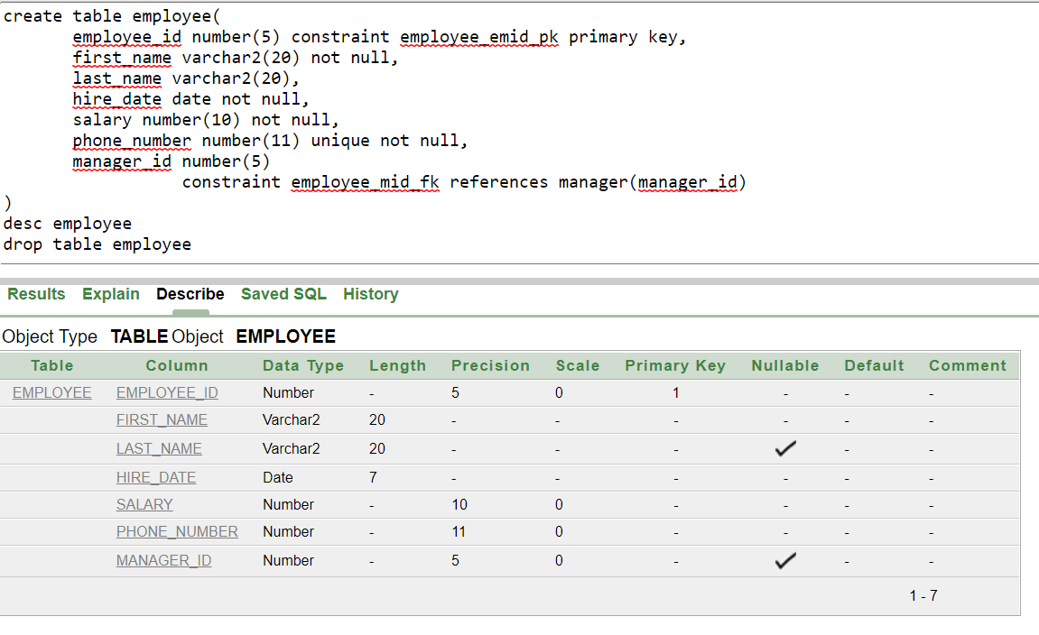

**Create Table Query:**

create table manager(

manager_id number(5) constraint manager_mid_pk primary key,

first_name varchar2(20) not null,

last_name varchar2(20),

phone_number number(11) unique not null,

salary number(10) not null,

address varchar2(20) not null

)

desc manager

drop table manager

create table parking_spot(

spot_id number(5) constraint pspot_sid_pk primary key,

address varchar2(20) unique not null,

manager_id number(5)

constraint paspot_mid_fk references manager(manager_id) not null

)

desc parking_spot

drop table parking_spot

create table parking_space(

space_id number(5) constraint pspace_spid_pk primary key,

space_type varchar2(20)

check( space_type in ('Small','Medium','Large')),

spot_id number(5)

constraint pspace_sid_fk references parking_spot(spot_id) not null

)

desc parking_space

drop table parking_space

create table rate(

rate_id number(5) constraint rate_rid_pk primary key,

hourly_rate number(10) not null,

day_rate number(10) not null,

type varchar2(20) check(type in ('Small','Medium','Large'))

)

desc rate

drop table rate

create table space_rate(

space_rate_id number(5) constraint space_rate_srid_pk primary key,

space_id number(5)

constraint space_rate_spid_fk references parking_space(space_id),

rate_id number(5)

constraint space_rate_rid_fk references rate(rate_id)

)

desc space_rate

drop table space_rate

create table employee(

employee_id number(5) constraint employee_emid_pk primary key,

first_name varchar2(20) not null,

last_name varchar2(20),

hire_date date not null,

salary number(10) not null,

phone_number number(11) unique not null,

manager_id number(5)

constraint employee_mid_fk references manager(manager_id)

)

desc employee

drop table employee

create table fine(

fine_id number(5) constraint fine_fid_pk primary key,

issue_date date not null,

paid_date date not null,

amount number(10) not null,

manager_id number(5)

constraint fine_mid_fk references manager(manager_id)

)

desc fine

drop table fine

create table customers(

customer_id number(5) constraint customer_cid_pk primary key,

first_name varchar2(20) not null,

last_name varchar2(20),

email varchar2(20),

address varchar2(20),

phone_number number(5) unique not null,

license_plate_number varchar2(10) unique not null,

find_id number(5)

constraint customer_fid_fk references fine(fine_id)

)

desc customers

drop table customers

create table parking_slip(

parking_slip_id number(5) constraint pkslip_psid_pk primary key,

issue_date date not null,

expair_date date not null,

type varchar2(20)

check(type in ('Small','Medium','Large')),

manager_id number(5)

constraint parkingslip_mid_fk references manager(manager_id) not null,

customer_id number(5)

constraint parkingslip_cid_fk references customers(customer_id) not null

)

desc parking_slip

drop table parking_slip