**AMERICAN INTERNATIONAL UNIVERSITY–BANGLADESH (AIUB)**

**DEPARTMENT OF ENGINEERING**

[**INTRODUCTION TO DATABASE**](https://portal.aiub.edu/Student/Section?q=j3Wc6QZpwj8GAUZ6rruD2A%3D%3D)

**Section: K, Group: 5**

**Project Name**

PARKING SPOT MANAGEMENT SYSTEM

**Supervised By**

SIFAT RAHMAN AHONA

**Submitted By**

|  |  |
| --- | --- |
| **Name** | **ID** |
| 1. SADAF KHAN | 22-47021-1 |
| 2. MD. FAHIM BIN IMAM NAHID | 22-46078-1 |
| 3. BADHON BISWAS | 22-46351-1 |
| 4. MD. SAIDUZZAMAN SOHAG | 22-46006-1 |

**Date of Submission: December 11, 2022**

**ER Diagram Case Study:**

**PARKING SPOT MANAGEMENT SYSTEM**

In a parking spot management system there are many employees who are managed by managers. One manager may manage one or more employees. Every employee and manager are uniquely identified by system through employee id and manager id respectively. System stores the first name, last name, hire date, phone_number and salary of the employee. Manager has name, salary, phone_number and address stored. Manager generally manages overall situation parking spot of the park. Parking spot are uniquely identified with spot id and it has own address. There are many parking spaces inside the parking spot which identified by space id. There are many types of parking space. Based on the space type there are different type of cost rate. Customer can hire parking space based on the cost rate. Based on space type rate can be hourly and daily and type it has unique rate id. Each parking space assigns one parking slip to the customers to purchase. Parking slip has slip id, issue date and expiration date . Customer has id which confirms the identity of customers. System stores the first name, last name, email,address, phone number, license_plate_number and address of the customer with respect to their id. There are many rules in a parking lot to better manage and to give better services. Manager issues fine to the customer who break the rules. Issued fine has id, issued date, amount and the date to be paid.

**ER Diagram:**

**Normalization of Database:**

/*===================================🡺

Inside (spot_id, address, Space_id, space_type)

1NF: No multivalued attribute

2NF: Spot_id, Address

Space_id, Space_Type,spot_id

3NF: No transitive dependency

Spot_id, Address

Space_id, Space_Type, Space_id

Table: Spot_id, Address

Space_id, Space_Type, Space_id

/*===================================🡺

Cost (Space_id, Space_type, Rate_id, Hourly_rate, Day_Rate)

1NF: No multivalued attribute

2NF: Space_id, Space_Type

Rate_id*,* Hourly_rate, Day_Rate,Type

SR_ID, Space_Id, Rate_id

3NF: No transitive dependency

Space_id, Space_Type

Rate_id, Hourly_rate, Day_Rate,Type

SR_ID, Space_Id, Rate_id

Table: Space_id, Space_Type

Rate_id, Hourly_rate, Day_Rate,Type

SR_ID, Space_Id, Rate_id

/*===================================🡺

Manages (Spot_id, Address Manager_id, phone_number,

first_name,last_name, address,salary)

1NF: Phone_number multivalued attribute

2NF: Spot_id, Address, Manager_id

Manager_id, phone_number, first_name,last_name, address,

salary

3NF: No transitive dependency

Spot_id, Address, Manager_id

Manager_id, phone_number, first_name,last_name, address,

salary

Table: Spot_id, Address, Manager_id

Manager_id, phone_number, first_name,last_name, address,

salary

/*===================================🡺

Manage by(Manager_id , phone_number , first_name,last_name, salary,address, Employee_id, first_Name , last_Name , hire_date, Salary,phone_number)

1NF: Phone_number multivalued attribute

2NF: Manager_id, phone_number, first_name,last_name, address,

salary

Employee_id, First_Name, Last_Name, hire_date, Salary,

phone_number, Manager_id

3NF: No transitive dependency

Manager_id , phone_number , first_name,last_name, address,

salary

Employee_id, First_Name , Last_Name , hire_date, Salary,

Manager_id

Table: Manager_id , phone_number , first_name,last_name, address,

salary

Employee_id, First_Name , Last_Name , hire_date, Salary,

phone_number, Manager_id

/*===================================🡺

Assigned(Space_id,Space_Type,parking_slip_id,Issue_date,Expair_date,Type)

1NF: No multivalued attribute

2NF: Space_id,Space_Type

parking_slip_id,Issue_date,Expair_date,Type,space_id

3NF: No transitive dependency

Space_id,Space_Type

parking_slip_id,Issue_date,Expair_date,Type,space_id

Table: Space_id,Space_Type

parking_slip_id,Issue_date,Expair_date,Type,space_id

/*===================================🡺

Purchases (Customer_id,First_name,Last_name,Email,Address,Phone_number,

license_plate_number, Parking_slip_id,Issue_date,

Expair_date,Type)

1NF: Phone_number multivalued attribute

2NF: Customer_id,First_name,Last_name,Email,Address,Phone,

license_plate_number

Parking_slip_id,Issue_date,Expair_date,Type,Customer_id

3NF: No transitive dependency

Customer_id,First_name,Last_name,Email,Address,Phone,

license_plate_number

Parking_slip_id,Issue_date,Expair_date,Type,Customer_id

Table: Customer_id,First_name,Last_name,Email,Address,Phone,

license_plate_number

Parking_slip_id,Issue_date,Expair_date,Type,Customer_id

/*===================================🡺

Fine (Customer_id,First_name,Last_name,Email,Address,

Phone_number,license_plate_number,Fine_id,Issue_date,

paid_date,Amount)

1NF: Phone_number multivalued attribute

2NF: Customer_id,First_name,Last_name,Email,Address,

Phone_number,

license_plate_number,Fine_id

Fine_id,Issue_date,paid_date,Amount

3NF: No transitive dependency

Customer_id,First_name,Last_name,Email,Address,

Phone_number,

license_plate_number,Fine_id

Fine_id,Issue_date,paid_date,Amount

Table: Customer_id,First_name,Last_name,Email,Address,

Phone_number,

license_plate_number,Fine_id

Fine_id,Issue_date,paid_date,Amount

/*===================================🡺

Issues (Manager_id, phone_number, Address, Fine_id,Issue_date,

paid_date,Amount)

1NF: Phone_number multivalued attribute

2NF: Manager_id, phone_number, Address

Fine_id,Issue_date, paid_date,Amount,Manager_id

3NF: No transitive dependency

Manager_id, phone_number, Address

Fine_id,Issue_date, paid_date,Amount,Manager_id

Table: Manager_id, phone_number, Address

Fine_id,Issue_date, paid_date,Amount,Manager_id

**Total Table:**

* 1.Spot_id, Address
* 2.Space_id, Space_Type, Spot_id
* 3.Space_id, Space_Type
* 4.Rate_id, Hourly_rate, Day_Rate, Type

5.SR_ID, Space_Id, Rate_id

* 6.Spot_id, Address, Manager_id
* 7.Manager_id, phone_number, first_name,last_name, salary,

address

* 8.Manager_id, phone_number, first_name,last_name, salary

address

* 9.Employee_id, first_Name, Last_Name, hire_date, Salary,

Phone_nubmer, Manager_id

* 10.Space_id, Space_Type
* 11.parking_slip_id, Issue_date, Expair_date, Type,space_id
* 12.Customer_id, First_name,Last_name,Email,Address,Phone,

license_plate_number

* 13.Parking_slip_id, Issue_date, Expair_date, Type, Customer_id
* 14.Customer_id, First_name, Last_name, Email, Address,

Phone_number, license_plate_number, Fine_id

* 15.Fine_id, Issue_date, paid_date, Amount
* 16.Manager_id, phone_number, Address
* 17.Fine_id, Issue_date, paid_date, Amount,Manager_id

**Final Table:**

1.Space_id, Space_Type, Spot_id

2.Rate_id, Hourly_rate, Day_Rate,Type

3.SR_ID, Space_Id, Rate_id

4.Spot_id, Address, Manager_id

5. Manager_id, phone_number, first_name,last_name, salary,address

6.Employee_id, First_Name, Last_Name , hire_date, Salary,

Phone_number,manager_id

7.Parking_slip_id, Issue_date,Expair_date,Type,Customer_id,

Space_id

8.Customer_id, First_name,Last_name,Email,Address,Phone_number,

license_plate_number,Fine_id

9.Fine_id, Issue_date, paid_date,Amount,Manager_id

**Table Creation And Data Insertion:**

**MANAGER TABLE:**

create table manager(

manager_id number(5) constraint manager_mid_pk primary key,

first_name varchar2(20) not null,

last_name varchar2(20),

phone_number number(11) unique not null,

salary number(10) not null,

manager_address varchar2(20) not null

)

desc manager

drop table manager

create sequence mgr_squ

increment by 1

start with 10

maxvalue 100

insert into manager(manager_id,first_name,last_name,phone_number,salary,manager_address) values (mgr_squ.nextval,'Diana','Lorentz',5904235567,4200,'Bashundhara A block')

insert into manager(manager_id,first_name,last_name,phone_number,salary,manager_address) values (mgr_squ.nextval,'John','Chen',515124426,8200,'Bashundhara B block')

insert into manager(manager_id,first_name,last_name,phone_number,salary,manager_address) values (mgr_squ.nextval,'Ismael','Sciarra' ,5151244369,7700,'Bashundhara C block')

insert into manager(manager_id,first_name,last_name,phone_number,salary,manager_address) values (mgr_squ.nextval,'Jose','Manuel Urman',5151244469,7800,'Bashundhara D block')

insert into manager(manager_id,first_name,last_name,phone_number,salary,manager_address) values (mgr_squ.nextval,'Luis','Popp',5151244567,6900,'Bashundhara E block')

insert into manager(manager_id,first_name,last_name,phone_number,salary,manager_address) values (mgr_squ.nextval,'Den','Raphaely',5151274561,11000,'Bashundhara F block')

insert into manager(manager_id,first_name,last_name,phone_number,salary,manager_address) values (mgr_squ.nextval,'Alexander','Khoo',5151274562,3100,'Bashundhara G block')

insert into manager(manager_id,first_name,last_name,phone_number,salary,manager_address) values (mgr_squ.nextval,'Shelli','Baida',5151274563,2900,'Bashundhara H block')

insert into manager(manager_id,first_name,last_name,phone_number,salary,manager_address) values (mgr_squ.nextval,'Sigal','Tobias',5151274564,2800,'Bashundhara I block')

insert into manager(manager_id,first_name,last_name,phone_number,salary,manager_address) values (mgr_squ.nextval,'Karen','Colmenares',5151274566,2500,'Bashundhara J block')

select * from manager

**PARKING SPOT TABLE:**

create table parking_spot(

spot_id number(5) constraint pspot_sid_pk primary key,

address varchar2(50) unique not null,

manager_id number(5)

constraint paspot_mid_fk references manager(manager_id) not null

)

desc parking_spot

drop table parking_spot

create sequence spot_squ

increment by 1

start with 1000

maxvalue 1050

insert into parking_spot(spot_id,address,manager_id) values (spot_squ.nextval,'Bashundhara A block Rd No 4',10)

insert into parking_spot(spot_id,address,manager_id) values (spot_squ.nextval,'Bashundhara B block Rd No 2',11)

insert into parking_spot(spot_id,address,manager_id) values (spot_squ.nextval,'Bashundhara C block Rd No 6',20)

insert into parking_spot(spot_id,address,manager_id) values (spot_squ.nextval,'Bashundhara D block Rd No 7',13)

insert into parking_spot(spot_id,address,manager_id) values (spot_squ.nextval,'Bashundhara E block Rd No 3',14)

insert into parking_spot(spot_id,address,manager_id) values (spot_squ.nextval,'Bashundhara F block Rd No 10',15)

insert into parking_spot(spot_id,address,manager_id) values (spot_squ.nextval,'Bashundhara G block Rd No 11',16)

insert into parking_spot(spot_id,address,manager_id) values (spot_squ.nextval,'Bashundhara H block Rd No 8',17)

insert into parking_spot(spot_id,address,manager_id) values (spot_squ.nextval,'Bashundhara I block Rd No 3',18)

insert into parking_spot(spot_id,address,manager_id) values (spot_squ.nextval,'Bashundhara J block Rd No 6',19)

select * from parking_spot

**PARKING SPACE TABLE:**

create table parking_space(

space_id number(5) constraint pspace_spid_pk primary key,

space_type varchar2(20)

check( space_type in ('Small','Medium','Large')),

spot_id number(5)

constraint pspace_sid_fk references parking_spot(spot_id) not null

)

desc parking_space

drop table parking_space

create sequence space_seq

increment by 1

start with 1

maxvalue 200

insert into parking_space (space_id,space_type,spot_id) values(space_seq.nextval,'Small',1000)

insert into parking_space (space_id,space_type,spot_id) values(space_seq.nextval,'Small',1000)

insert into parking_space (space_id,space_type,spot_id) values(space_seq.nextval,'Small',1000)

insert into parking_space (space_id,space_type,spot_id) values(space_seq.nextval,'Small',1000)

insert into parking_space (space_id,space_type,spot_id) values(space_seq.nextval,'Medium',1000)

insert into parking_space (space_id,space_type,spot_id) values(space_seq.nextval,'Small',1000)

insert into parking_space (space_id,space_type,spot_id) values(space_seq.nextval,'Small',1000)

insert into parking_space (space_id,space_type,spot_id) values(space_seq.nextval,'Medium',1000)

insert into parking_space (space_id,space_type,spot_id) values(space_seq.nextval,'Medium',1000)

insert into parking_space (space_id,space_type,spot_id) values(space_seq.nextval,'Medium',1000)

insert into parking_space (space_id,space_type,spot_id) values(space_seq.nextval,'Medium',1000)

insert into parking_space (space_id,space_type,spot_id) values(space_seq.nextval,'Medium',1000)

insert into parking_space (space_id,space_type,spot_id) values(space_seq.nextval,'Large',1000)

insert into parking_space (space_id,space_type,spot_id) values(space_seq.nextval,'Large',1000)

insert into parking_space (space_id,space_type,spot_id) values(space_seq.nextval,'Large',1000)

insert into parking_space (space_id,space_type,spot_id) values(space_seq.nextval,'Medium',1000)

insert into parking_space (space_id,space_type,spot_id) values(space_seq.nextval,'Large',1000)

select * from parking_space

**RATE TABLE:**

create table rate(

rate_id number(5) constraint rate_rid_pk primary key,

hourly_rate number(10) not null,

day_rate number(10) not null,

type varchar2(20) check(type in ('Small','Medium','Large'))

)

desc rate

drop table rate

create sequence rate_seq

increment by 1

start with 1

maxvalue 200

insert into rate(rate_id,hourly_rate,day_rate,type) values (rate_seq.nextval,100,700,'Small')

insert into rate(rate_id,hourly_rate,day_rate,type) values (rate_seq.nextval,170,1200,'Medium')

insert into rate(rate_id,hourly_rate,day_rate,type) values (rate_seq.nextval,250,2000,'Large')

insert into rate(rate_id,hourly_rate,day_rate,type) values (rate_seq.nextval,100,700,'Small')

insert into rate(rate_id,hourly_rate,day_rate,type) values (rate_seq.nextval,170,1200,'Medium')

insert into rate(rate_id,hourly_rate,day_rate,type) values (rate_seq.nextval,250,2000,'Large')

insert into rate(rate_id,hourly_rate,day_rate,type) values (rate_seq.nextval,100,700,'Small')

insert into rate(rate_id,hourly_rate,day_rate,type) values (rate_seq.nextval,170,1200,'Medium')

insert into rate(rate_id,hourly_rate,day_rate,type) values (rate_seq.nextval,250,2000,'Large')

insert into rate(rate_id,hourly_rate,day_rate,type) values (rate_seq.nextval,100,700,'Small')

select * from rate

**SPACE RATE TABLE:**

create table space_rate(

space_rate_id number(5) constraint space_rate_srid_pk primary key,

space_id number(5)

constraint space_rate_spid_fk references parking_space(space_id),

rate_id number(5)

constraint space_rate_rid_fk references rate(rate_id)

)

desc space_rate

drop table space_rate

create sequence space_rate_seq

increment by 1

start with 200

maxvalue 300

insert into space_rate(space_rate_id,space_id,rate_id) values (space_rate_seq.nextval,1,1)

insert into space_rate(space_rate_id,space_id,rate_id) values (space_rate_seq.nextval,2,1)

insert into space_rate(space_rate_id,space_id,rate_id) values (space_rate_seq.nextval,3,1)

insert into space_rate(space_rate_id,space_id,rate_id) values (space_rate_seq.nextval,4,1)

insert into space_rate(space_rate_id,space_id,rate_id) values (space_rate_seq.nextval,5,2)

insert into space_rate(space_rate_id,space_id,rate_id) values (space_rate_seq.nextval,6,1)

insert into space_rate(space_rate_id,space_id,rate_id) values (space_rate_seq.nextval,7,1)

insert into space_rate(space_rate_id,space_id,rate_id) values (space_rate_seq.nextval,8,2)

insert into space_rate(space_rate_id,space_id,rate_id) values (space_rate_seq.nextval,9,2)

insert into space_rate(space_rate_id,space_id,rate_id) values (space_rate_seq.nextval,10,2)

insert into space_rate(space_rate_id,space_id,rate_id) values (space_rate_seq.nextval,11,2)

insert into space_rate(space_rate_id,space_id,rate_id) values (space_rate_seq.nextval,12,2)

insert into space_rate(space_rate_id,space_id,rate_id) values (space_rate_seq.nextval,13,3)

insert into space_rate(space_rate_id,space_id,rate_id) values (space_rate_seq.nextval,14,3)

insert into space_rate(space_rate_id,space_id,rate_id) values (space_rate_seq.nextval,15,3)

insert into space_rate(space_rate_id,space_id,rate_id) values (space_rate_seq.nextval,16,2)

insert into space_rate(space_rate_id,space_id,rate_id) values (space_rate_seq.nextval,17,3)

select * from space_rate

**EMPLOYEE TABLE:**

create table employee(

employee_id number(5) constraint employee_emid_pk primary key,

first_name varchar2(20) not null,

last_name varchar2(20),

hire_date date not null,

salary number(10) not null,

phone_number number(11) unique not null,

manager_id number(5)

constraint employee_mid_fk references manager(manager_id)

)

desc employee

drop table employee

create sequence employee_seq

increment by 1

start with 200

maxvalue 300

insert into employee(employee_id,first_name,Last_name,hire_date,salary,

phone_number,manager_id) values(employee_seq.nextval,'Timothy','Gates',

'17-JUN-21',5000, 625635100,10)

insert into employee(employee_id,first_name,Last_name,hire_date,salary,

phone_number,manager_id) values(employee_seq.nextval,'Randall','Perkins',

'17-JAN-21',5000, 625635101,10)

insert into employee(employee_id,first_name,Last_name,hire_date,salary,

phone_number,manager_id) values(employee_seq.nextval,'Sarah','Everett','15-MAR-21',6000, 625635102,10)

insert into employee(employee_id,first_name,Last_name,hire_date,salary,

phone_number,manager_id) values(employee_seq.nextval,'Britney','Everett',

'17-JUN-20',5000, 625635103,13)

insert into employee(employee_id,first_name,Last_name,hire_date,salary,

phone_number,manager_id) values(employee_seq.nextval,'Vance','Timothy',

'16-JAN-22',6000, 625635104,13)

insert into employee(employee_id,first_name,Last_name,hire_date,

salary,phone_number,manager_id)values(employee_seq.nextval,'Everett',

'McCain','19-FEB-22',8000, 625635105,13)

insert into employee(employee_id,first_name,Last_name,hire_date,salary,

phone_number,manager_id) values(employee_seq.nextval,'Jones','Samuel','27-JUN-21',5000, 625635106,14)

insert into employee(employee_id,first_name,Last_name,hire_date,salary,

phone_number,manager_id) values(employee_seq.nextval,'Alana','Walsh','07-APR-20',3000,625635107,14)

insert into employee(employee_id,first_name,Last_name,hire_date,salary,

phone_number,manager_id) values(employee_seq.nextval,'McCainy','Feeney',

'14-FEB-20',9000, 625635109,15)

insert into employee(employee_id,first_name,Last_name,hire_date,salary,

phone_number,manager_id) values(employee_seq.nextval,'Kevin','Walsh','13-APR-20',8000, 625635108,15)

select * from employee

**FINE TABLE:**

create table fine(

fine_id number(5) constraint fine_fid_pk primary key,

issue_date date not null,

paid_date date not null,

amount number(10) not null,

manager_id number(5)

constraint fine_mid_fk references manager(manager_id)

)

desc fine

drop table fine

insert into fine (fine_id,issue_date,paid_date,amount,manager_id) values (01,'08-dec-22','09-dec-22',70,10)

insert into fine (fine_id,issue_date,paid_date,amount,manager_id) values (02,'11-dec-22','12-dec-22',120,10)

insert into fine (fine_id,issue_date,paid_date,amount,manager_id) values (03,'08-dec-22','09-dec-22',200,10)

insert into fine (fine_id,issue_date,paid_date,amount,manager_id) values (04,'15-dec-22','16-dec-22',300,10)

insert into fine (fine_id,issue_date,paid_date,amount,manager_id) values (05,'08-dec-22','09-dec-22',250,10)

insert into fine (fine_id,issue_date,paid_date,amount,manager_id) values (06,'20-dec-22','22-dec-22',500,10)

insert into fine (fine_id,issue_date,paid_date,amount,manager_id) values (07,'10-dec-22','15-dec-22',1000,10)

insert into fine (fine_id,issue_date,paid_date,amount,manager_id) values (08,'08-dec-22','09-dec-22',100,10)

insert into fine (fine_id,issue_date,paid_date,amount,manager_id) values (09,'08-dec-22','09-dec-22',100,10)

insert into fine (fine_id,issue_date,paid_date,amount,manager_id) values (10,'08-dec-22','09-dec-22',100,10)

select * from fine

**CUSTOMERS TABLE:**

create table customers(

customer_id number(5) constraint customer_cid_pk primary key,

first_name varchar2(20) not null,

last_name varchar2(20),

email varchar2(50),

address varchar2(20),

phone_number number(11) unique not null,

license_plate_number varchar2(20) unique not null,

find_id number(5)

constraint customer_fid_fk references fine(fine_id)

)

desc customers

drop table customers

create sequence customer_seq

increment by 1

start with 100

maxvalue 300

insert into customers(customer_id,first_name,last_name,phone_number,email,

address, license_plate_number)values(customer_seq.nextval,'Winston','Taylor',

'6505079876','instonaylor@gmail.com','Bashundhara A block','KA 45-2422')

insert into customers(customer_id,first_name,last_name,phone_number,

email,address, license_plate_number) values(customer_seq.nextval,'Jean',

'Fleaur','6505079877','jeanfleaur@gmail.com','Bashundhara B block',

'KA 34-3243')

insert into customers(customer_id,first_name,last_name,phone_number,

email,address, license_plate_number) values(customer_seq.nextval,'Martha',

'Sullivan','6505079878','marthasullivan@gmail.com','Bashundhara A block','KHA 22-1123')

insert into customers(customer_id,first_name,last_name,phone_number,

email,address, license_plate_number) values(customer_seq.nextval,'Girard',

'Geoni','6505079879','girardgeoni@gmail.com','Bashundhara B block','KA 11-3432')

insert into customers(customer_id,first_name,last_name,phone_number,

email,address, license_plate_number) values(customer_seq.nextval,'Nandita',

'Sarchand','6505091876','nanditasarchand@gmail.com','Bashundhara A block','GA 22-1232')

insert into customers(customer_id,first_name,last_name,phone_number,

email,address, license_plate_number) values(customer_seq.nextval,'Alexis',

'Bull','6505092876','alexisbull@gmail.com','Bashundhara E block','KA 33-4332')

insert into customers(customer_id,first_name,last_name,phone_number,

email,address, license_plate_number) values(customer_seq.nextval,'Julia',

'Dellinger','6505093876','juliadellinger@gmail.com','Bashundhara F block','KA 65-4534')

insert into customers(customer_id,first_name,last_name,phone_number,

email,address, license_plate_number) values(customer_seq.nextval,'Anthony',

'Cabrio','6505094876','anthonycabrio@gmail.com','Bashundhara B block','KHA 25-4311')

insert into customers(customer_id,first_name,last_name,phone_number,

email,address, license_plate_number) values(customer_seq.nextval,'Kelly',

'Chung','6505051876','kellychung@gmail.com','Bashundhara E block','CA 25-2432')

insert into customers (customer_id,first_name,last_name,phone_number,

email,address, license_plate_number) values(customer_seq.nextval,'Jennifer',

'Dilly','6505052876','jenniferdilly@gmail.com','Bashundhara A block','KA 53-2423')

insert into customers(customer_id,first_name,last_name,phone_number,

email,address, license_plate_number) values(customer_seq.nextval,'Timothy',

'Gates','6505053876','timothygates@gmail.com','Bashundhara G block','KA 43-2422')

insert into customers(customer_id,first_name,last_name,phone_number,

email,address, license_plate_number) values(customer_seq.nextval,'Randall',

'Perkins','6505054876','randallperkins@gmail.com','Bashundhara G block','KA 62-1434')

insert into customers(customer_id,first_name,last_name,phone_number,

email,address, license_plate_number) values(customer_seq.nextval,'Sarah',

'Bell','6505011876','sarahbell@gmail.com','Bashundhara A block','KHA 51-5234')

insert into customers(customer_id,first_name,last_name,phone_number,

email,address, license_plate_number) values(customer_seq.nextval,'Britney',

'Everett','6505012876','britneyeverett@gmail.com','Bashundhara C block','KHA 53-6423')

insert into customers(customer_id,first_name,last_name,phone_number,

email,address, license_plate_number) values(customer_seq.nextval,'Samuel',

'McCain','650.5013876','samuelmcCain@gmail.com','Bashundhara A block','CA 12-3433')

insert into customers(customer_id,first_name,last_name,phone_number,

email,address, license_plate_number) values(customer_seq.nextval,'Vance',

'Jones','6505014876','vancejones@gmail.com','Bashundhara C block','GA 13-4122')

insert into customers(customer_id,first_name,last_name,phone_number,

email,address, license_plate_number) values(customer_seq.nextval,'Alana',

'Walsh','6505079811','alanawalsh@gmail.com','Bashundhara A block','GA 31-4334')

insert into customers(customer_id,first_name,last_name,phone_number,

email,address, license_plate_number) values(customer_seq.nextval,'Kevin',

'Feeney','6505079822','kevinfeeney@gmail.com','Bashundhara B block','GA 22-4114')

Update customers set find_id = 2 where customer_id = 103

Update customers set find_id = 1 where customer_id = 110

Update customers set find_id = 7 where customer_id = 114

Update customers set find_id = 4 where customer_id = 112

select * from customers

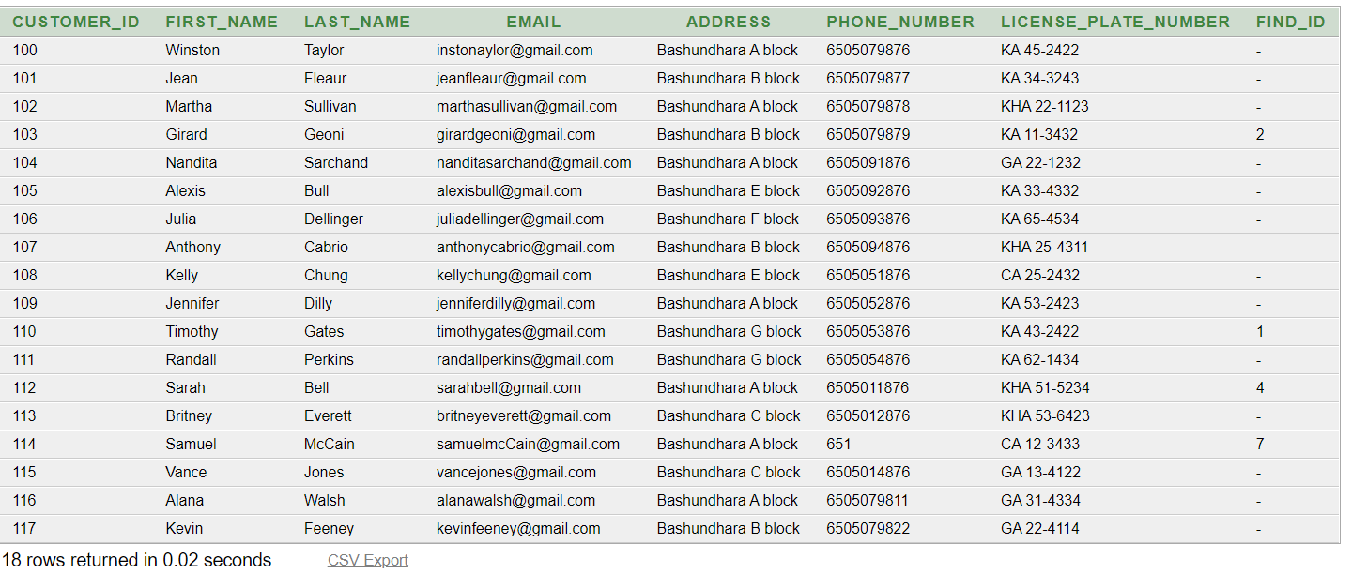

**PARKING SLIP TABLE:**

create table parking_slip(

parking_slip_id number(5) constraint pkslip_psid_pk primary key,

issue_date date not null,

expair_date date not null,

customer_id number(5)

constraint parkingslip_cid_fk references customers(customer_id) not null,

vehicle_type varchar2(30)

check(vehicle_type in ('small','medium','large')),

space_id number(5)

constraint parkingslip_spid_fk references parking_space(space_id) not null unique

)

alter table parking_slip add(duration varchar2(30) not null)

desc parking_slip

drop table parking_slip

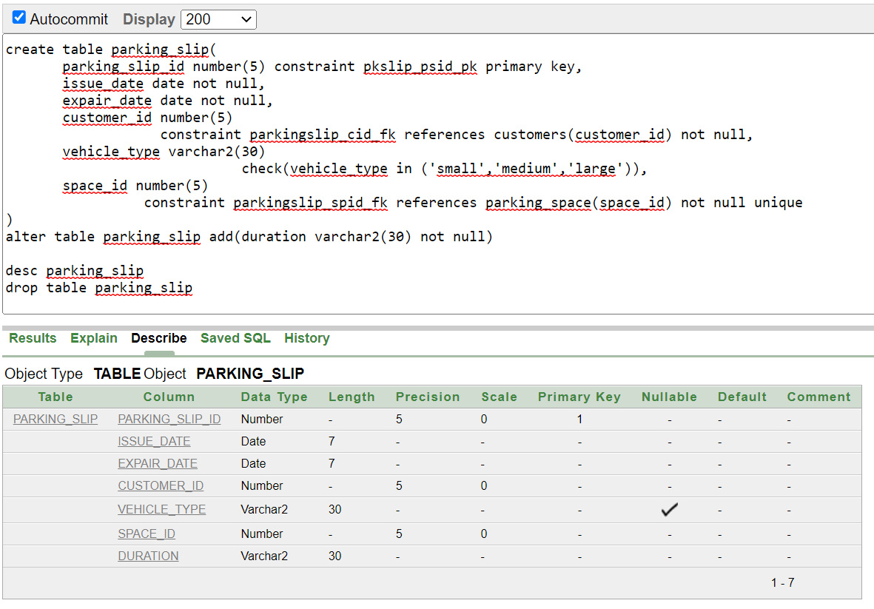

create sequence parking_slip_seq

increment by 1

start with 1

maxvalue 500

nocache

nocycle

insert into parking_slip(parking_slip_id,issue_date,expair_date,vehicle_type,

customer_id,space_id,duration) values(parking_slip_seq.nextval,'09-dec-22','09-dec-22','small',104,2,'2 hours')

insert into parking_slip(parking_slip_id,issue_date,expair_date,vehicle_type,

customer_id,space_id,duration) values(parking_slip_seq.nextval,'10-dec-22','10-dec-22','medium',105,5,'5 hours')

insert into parking_slip(parking_slip_id,issue_date,expair_date,vehicle_type,

customer_id,space_id,duration) values(parking_slip_seq.nextval,'10-dec-22','10-dec-22','small',106,1,'3 hours')

insert into parking_slip(parking_slip_id,issue_date,expair_date,vehicle_type,

customer_id,space_id,duration) values(parking_slip_seq.nextval,'09-dec-22','09-dec-22','small',107,3,'1 hours')

insert into parking_slip(parking_slip_id,issue_date,expair_date,vehicle_type,

customer_id,space_id,duration) values(parking_slip_seq.nextval,'11-dec-22','12-dec-22','large',108,13,'1 day')

insert into parking_slip(parking_slip_id,issue_date,expair_date,vehicle_type,

customer_id,space_id,duration) values(parking_slip_seq.nextval,'11-dec-22','12-dec-22','small',110,4,'1 day')

insert into parking_slip(parking_slip_id,issue_date,expair_date,vehicle_type,

customer_id,space_id,duration) values(parking_slip_seq.nextval,'09-dec-22','09-dec-22','large',111,14,'7 hours')

insert into parking_slip(parking_slip_id,issue_date,expair_date,vehicle_type,

customer_id,space_id,duration) values(parking_slip_seq.nextval,'15-dec-22','15-dec-22','large',112,15,'2 days')

insert into parking_slip(parking_slip_id,issue_date,expair_date,vehicle_type,

customer_id,space_id,duration) values(parking_slip_seq.nextval,'11-dec-22','13-dec-22','small',113,6,'2 days')

insert into parking_slip(parking_slip_id,issue_date,expair_date,vehicle_type,

customer_id,space_id,duration) values(parking_slip_seq.nextval,'11-dec-22','11-dec-22','medium',114,8,'1 days')

insert into parking_slip(parking_slip_id,issue_date,expair_date,vehicle_type,

customer_id,space_id,duration) values(parking_slip_seq.nextval,'12-dec-22','12-dec-22','medium',115,10,'3 hour')

insert into parking_slip(parking_slip_id,issue_date,expair_date,vehicle_type,

customer_id,space_id,duration) values(parking_slip_seq.nextval,'12-dec-22','12-dec-22','medium',116,9,'6 hour')

select * from parking_slip

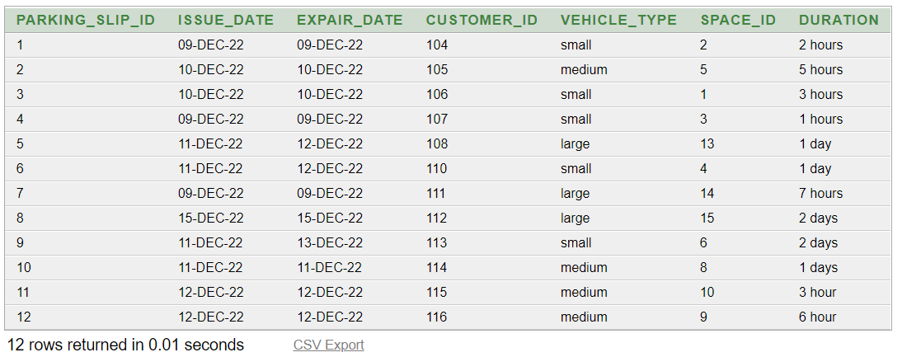

**8. Query**

select * from employee

select * from manager

select * from customers

select * from fine

select * from parking_slip

select * from parking_space

select * from parking_spot

select * from rate

select * from space_rate

**# Equijoin:**

1.Display empemployee first name and their manager first name

select e.first_name as employee_name,m.first_name as manager_name

from employee e,manager m

where e.manager_id = m.manager_id

2.Display customer name,parking slip issue_date,expair_date space id and space type

select c.first_name,p.issue_date as slip_issue_date,p.expair_date as slip_expair_date,

s.space_id,s.space_type

from customers c,parking_slip p,parking_space s

where c.customer_id = p.customer_id and s.space_id = p.space_id

**# Self-join:**

1.Display the first and last name and salary for those employees who earn less than the employee earn whose number is 208.

select e.first_name, e.last_name, e.salary

from employee e,employee s

where e.salary < s.salary

and s.employee_id = 208

2.Display first name and address whose address same as Nandita

select c.first_name ,c.address

from customers c,customers cs

where cs.address=c.address and cs.first_name='Nandita'

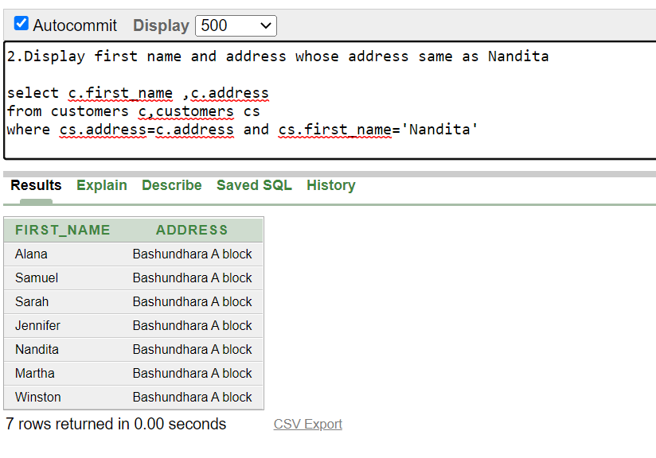

**# Outer join:**

1.Display the first name, last name, phone number for all employee who have or

have not parking any car.

select c.first_name,c.phone_number,s.space_id,issue_date,s.duration

from customers c,parking_slip s

where c.customer_id=s.customer_id(+)

2. Display all the managers id,name who do/don't have emloyees under them

select m.manager_id, m.first_name

from manager m, employee e

where e.manager_id(+) = m.manager_id

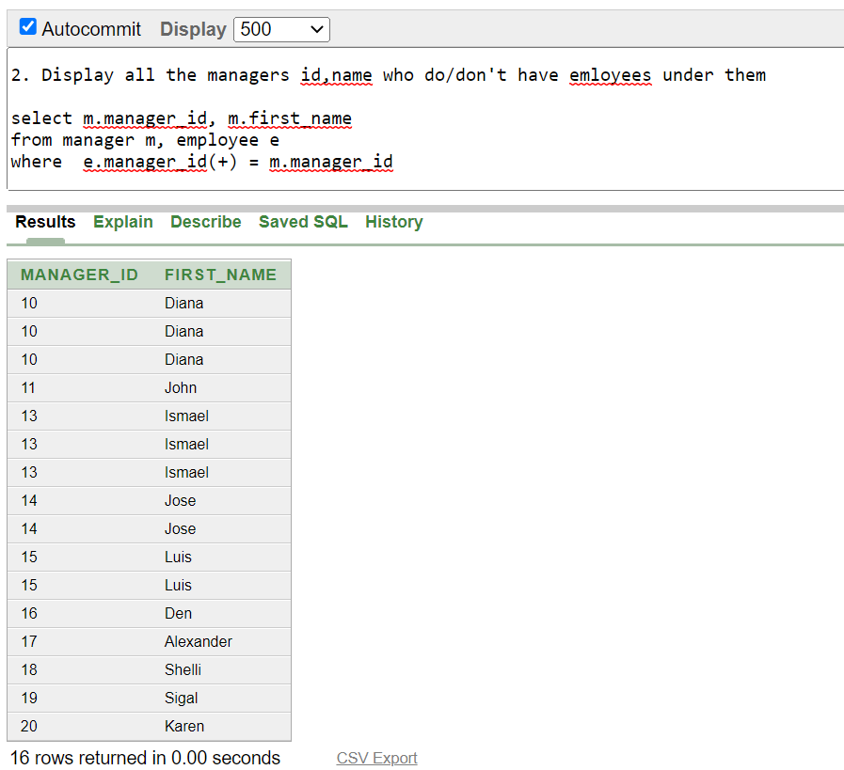

**# Subquery:**

1.Display the first name and salary for all employee who earn more than employee id 205

select first_name ,salary from employee

where salary>(select salary from employee

where employee_id = 205)

2.Display the last name and hire date for all employee who was hired after employee number 206

select first_name ,hire_date from employee

where hire_date<(select hire_date from employee

where employee_id = 206)

3.Display the first name, last name, and phone_number all employee whose manager name is Luis

select first_name,last_name,phone_number

from employee

where manager_id in(select manager_id

from manager where first_name='Luis')

4.Display the first name,last name, salary for all employees who earn less than the average salary

select first_name,last_name,salary

from employee

where salary<(select avg(salary) from employee)

5.

select first_name,last_name,hire_date

from employee

where manager_id=(select manager_id

from manager where

manager_id=(select manager_id from parking_spot

where address='Bashundhara A block Rd No 4'))

**# Single row function:**

1.

select first_name, concat(first_name,last_name), length(first_name),

instr(first_name, 'C')

from employee

where lower(first_name) = 'mccainy'

2.

select employee_id, round((sysdate - hire_date),3) Employment_days

from employee

3.

select first_name,to_char(hire_date,'DD Month YYYY') as hiredate

from employee

4.

select first_name, salary,

decode(first_name, 'Timothy', salary*3.1,

'Randall',salary*2.15,

'Sarah',salary*1.20,

salary) revised_salary

from employee

5.display the hire date, month before and after the hire_date in the from employee

select hire_date, to_char(add_months(hire_date, -1), 'DD-MON-YYYY') "Previous month",

to_char(add_months(hire_date, 1), 'DD-MON-YYYY') "Next month"

from employee

where employee_id=205

**# Group function:**

1.

select avg(salary), max(salary),

min(salary), sum(salary)

from employee

2.

select count(space_type)

from parking_space

where space_type = 'Small'

3.

select manager_id,avg(salary) from employee

group by manager_id

order by manager_id

4.

select manager_id,max(salary) from employee

group by manager_id

having max(salary)>5000

order by manager_id

5.

select max(avg(salary))

from employee

group by manager_id

**View:**

create view slip_details (customer_name,issue_date,expair_date,spot_id,space_id,space_type,spot_address)

as select c.first_name,p.issue_date,p.expair_date,sp.spot_id,s.space_id,s.space_type,sp.address

from customers c,parking_slip p,parking_space s,parking_spot sp

where c.customer_id = p.customer_id and s.space_id = p.space_id

and s.spot_id=sp.spot_id

select * from slip_details

**# General:**

1.Display 5 hourls small type parking space rate

select hourly_rate*5 from rate

where type='Small'

2.

select first_name ||' '||last_name as employee_name,

phone_number,

hire_date

from employee

where hire_date between '13-APR-20' and '17-JAN-21'

3.

select first_name,

hire_date

from employee

where hire_date like '%20'

4.

select first_name,email,address,phone_number

from customers

where find_id is not null

5.

select first_name,last_name,phone_number,salary

from employee

where salary >=7000

