# **Amplitude Shift Keying (ASK)**

## Binary ASK:

1. Determine the digital bit stream from the analog signal below. The signal was modulated using Binary ASK where 0 means signal element with no amplitude and 1 means signal element with amplitude of 3v.   
   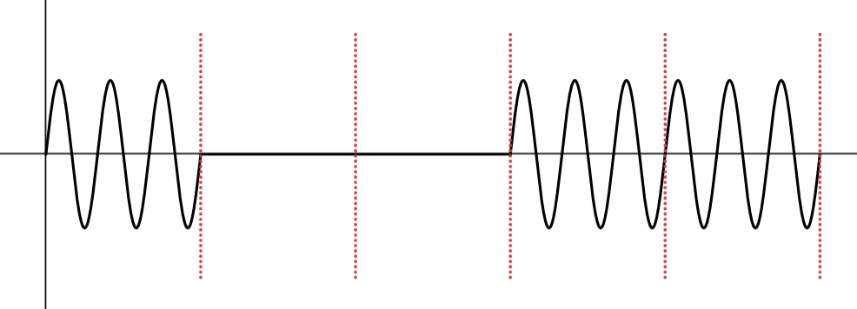
2. Draw the analog signal for the digital bit stream 010011 using Binary ASK where 0 means signal element with amplitude of 3v and 1 means signal element with amplitude of 6v.   
   [ *frequency = 2 for each signal element and phase 0 rad*]  
     
   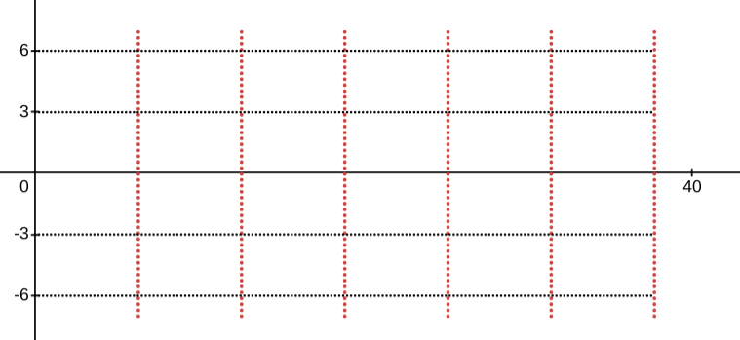

## Multi-level ASK

1. In a Multi level ASK, for each signal element, we want to send 2 bits at a time. We have used a carrier signal that has a frequency of 10 Hz (Each signal element has 2 cycles) and phase is 0 rad. If the amplitude changes according to the following table, draw the modulated signal for the bit sequence 1001010111  
   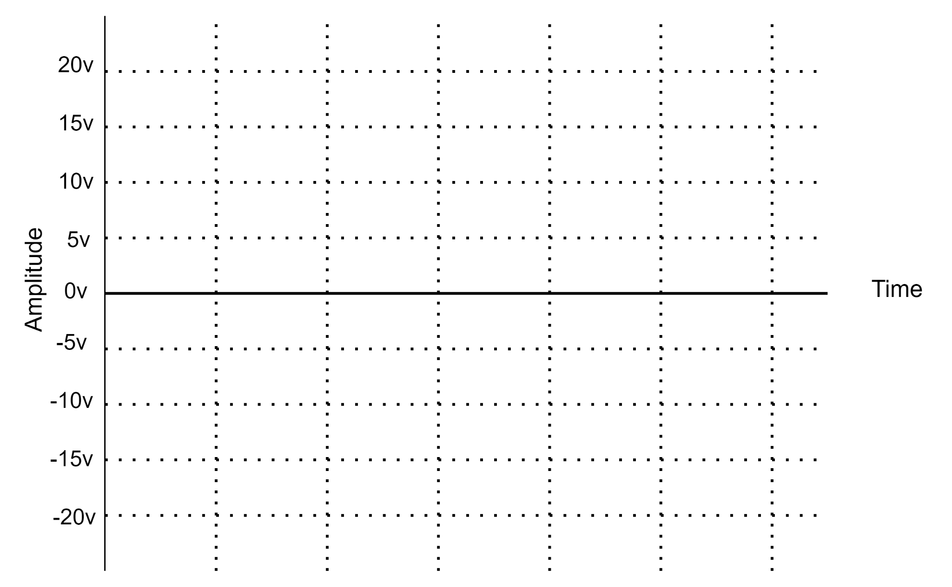

|  |  |  |  |  |  |  |  |  |  |  |  |
| --- | --- | --- | --- | --- | --- | --- | --- | --- | --- | --- | --- |
| |  |  | | --- | --- | | Bit Pattern | Max Amplitude | | 00 | 5v | | 01 | 15v | | 10 | 10v | | 11 | 20v | |  |

1. For the following Multi-level ASK, find the bitstream form the signal below: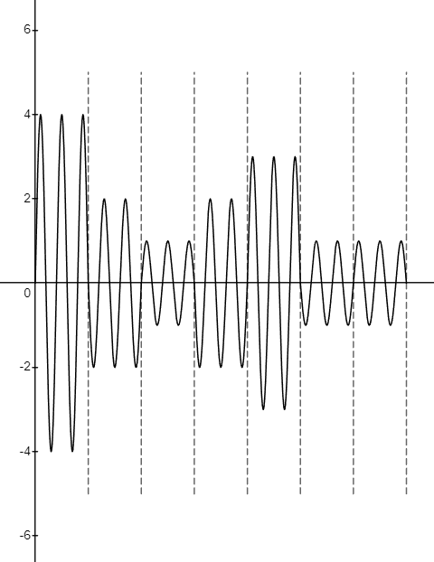

|  |  |  |  |  |  |  |  |  |  |  |  |  |
| --- | --- | --- | --- | --- | --- | --- | --- | --- | --- | --- | --- | --- |
| |  |  | | --- | --- | | Bit Pattern | Amplitude | | 00 | 1v | | 01 | 3v | | 10 | 2v | | 11 | 4v | |  |  |

# **Frequency Shift Keying (FSK)**

## Binary FSK:

1. Determine the digital bit stream from the analog signal below. The signal was modulated using Binary FSK where 0 means signal element with frequency of 2 and 1 means signal element with frequency of 4.  
   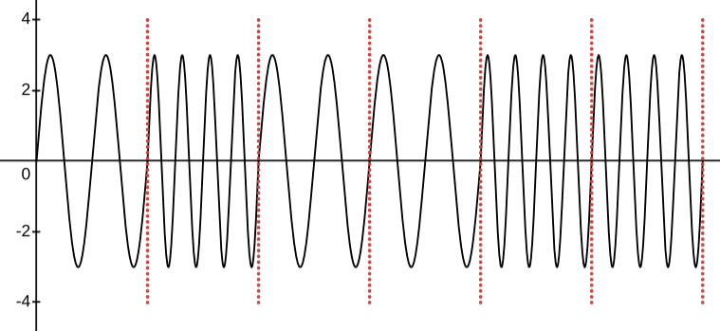
2. Draw the analog signal for the digital bit stream 010011 using Binary FSK where 0 means signal element with frequency of 2 and 1 means signal element with frequency of 4.   
   [ *Amplitude = 3v and phase 0 rad*]  
   

## Multi level FSK

1. In a Multi level FSK, for each signal element, we want to send 2 bits at a time. We have used a carrier signal that has an amplitude of 10v and phase is 0 degree. If the frequency changes according to the following table, draw the modulated signal for the bit sequence 1001010111

|  |  |  |  |  |  |  |  |  |  |  |  |
| --- | --- | --- | --- | --- | --- | --- | --- | --- | --- | --- | --- |
| |  |  | | --- | --- | | Bit Pattern | # cycles of the signal element | | 00 | 1 | | 01 | 3 | | 10 | 2 | | 11 | 4 | |  |

1. For the following Multi-level FSK, find the bitstream form the signal below:

|  |  |  |  |  |  |  |  |  |  |  |  |  |
| --- | --- | --- | --- | --- | --- | --- | --- | --- | --- | --- | --- | --- |
| |  |  | | --- | --- | | Bit Pattern | Frequency  (each signal element) | | 00 | 1 | | 01 | 3 | | 10 | 2 | | 11 | 4 | |  |  |

# **Phase Shift Keying (PSK)**

## Binary PSK

1. Determine the digital bit stream from the analog signal below. The signal was modulated using Binary PSK where 0 means signal element with phase of 0 rad and 1 means signal element with phase of π rad.  
     
   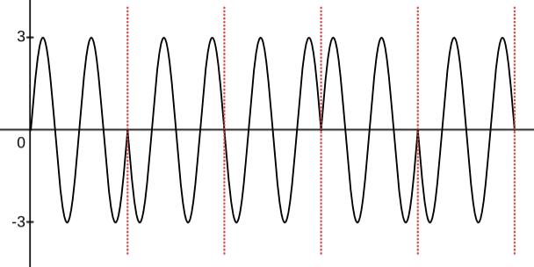
2. Draw the analog signal for the digital bit stream 010011 using Binary PSK where 0 means signal element with phase of 0 rad and 1 means signal element with phase of π rad.   
   [ *Amplitude = 3v and freq = 2 (for each signal element)*]  
     
   

## QPSK & Constellation Diagram:

1. Draw the constellation diagram for the QPSK given below:

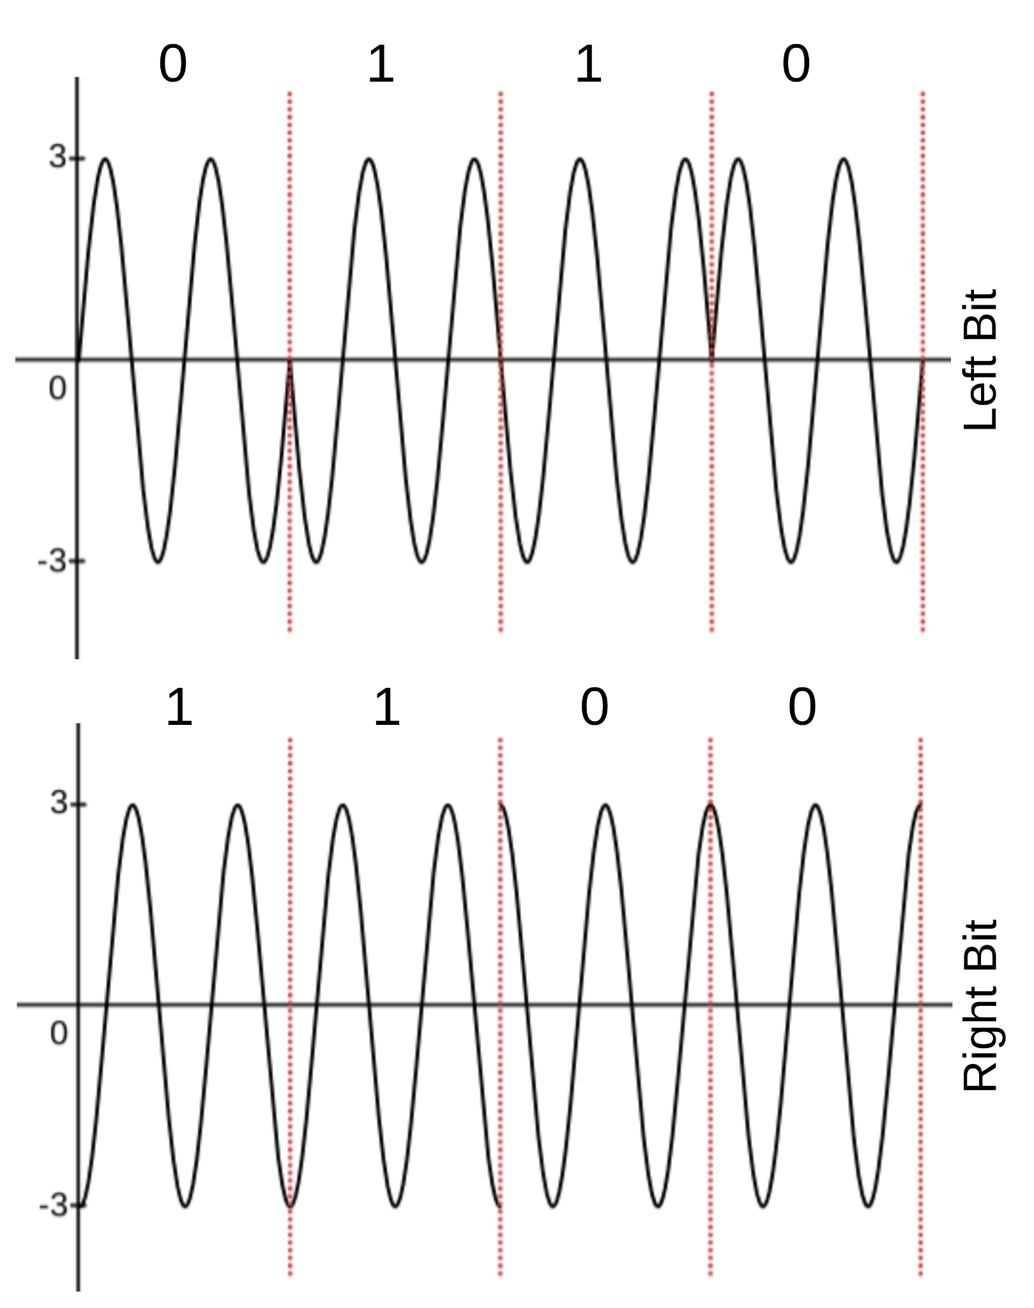

1. Draw the analog signal for the bit stream 1011001011 using the constellation diagram given below [frequency = 2 for each signal element]

|  |  |
| --- | --- |
|  |  |