[LJ UNIVERSITY ]
Department of Computer Applications
MEDICINE REMINDER
MASTER OF COMPUTER APPLICATION (INTEGRATED)
GROUP MEMBERS
[Divya Rathod]
[Surbhi Makwana]
[Nahiyan shaikh]
SUBMITTED TO
[Faculty ]
ACADEMIC YEAR
2026 - 2027
SUBMISSION DATE
14 August 2026
DIV-ROLL NO.
[IMCA / Roll No. G-16 H-36,H-41]

TABLE OF CONTENTS
- Introduction
- 1.1 Existing System
- 1.2 Need for the New System
- 1.3 Objective of the New System
- 1.4 Problem Definition
- 1.5 Core Components
- 1.6 Project Profile
- 1.7 Assumptions and Constraints
- 1.8 Advantages and Limitations
- 2. Project Planning
- 2.1 Team Details and Roles
- 2.2 Proposed Timeline (Gantt Chart)
- 3. Requirement Determination & Analysis
- 3.1 Requirement Determination
- 3.2 Targeted Users
- 4. System Design
- 4.1 Use Case Diagram
- 4.2 Class Diagram
- 4.3 Interaction Diagram
- 4.4 Activity Diagram
- 4.5 Data Dictionary
- 5. Development
- 5.1 Development Approach
- 5.2 Coding Standards
- 5.3 GitHub Repository Details
- 5.4 AI Tools/Libraries/APIs Used
- 5.5 Screenshots & Implementation Details
- 6. Proposed Enhancements
- 7. Conclusion
- 8. Bibliography

INTRODUCTION
This project documentation describes the analysis, design, development and implementation of a Medicine Reminder mobile application. It covers the problem, proposed solution, requirements, system design, development process, implementation details and future enhancements.
Medicine Reminder is a Flutter-based mobile application designed to help users manage medicine names, dosage and schedules and receive timely reminders. The application aims to make medicine management simple, organized and convenient.

Existing System
Users may currently depend on memory, paper notes, phone alarms or separate applications. When several medicines have different timings, maintaining an accur
ate schedule becomes difficult and missed doses may occur.
Workflow: Add medicine → set dosage/time → set reminder → wait for alarm → take medicine → repeat.

Need for the New System
A dedicated Medicine Reminder system centralizes medicine information and schedules, reduces dependence on memory and makes it easier to manage multiple medicines.

Objective of the New System
• To add and manage medicine details such as medicine name, dosage, frequency and schedule.
• To schedule reminders for medicines at the required time.
• To store and organize medicine dosage, frequency, date and timing information.
• To allow users to edit or delete existing medicine schedules.
• To provide a simple, user-friendly and convenient mobile interface.
• To help users remember their scheduled medicines and reduce the possibility of missed doses.

Problem Definition
Managing multiple medicines and remembering their correct dosage and schedule can be difficult for users. The proposed Medicine Reminder system is a Flutter-based mobile application that helps users manage medicine details and schedules in one place. It provides reminders at the scheduled time and allows users to view, edit and manage their medicine information. The system also helps users keep track of upcoming medicines and reduces the possibility of missing scheduled doses.

Core Components
• User Interface Module – Provides a simple interface to add, view, edit and delete medicine details.
• Medicine Management Module – Manages medicine name, dosage, type, quantity, frequency and other medicine information.
• Reminder Module – Provides notifications to remind users to take their medicines at the scheduled time.
• Schedule Management Module – Manages medicine dates, times and reminder schedules.
• Data Management Module – Stores and retrieves medicine information required by the application.
• History and Status Module – Helps users check medicine and reminder information for better schedule management.

Project Profile
Attribute | Details
Project Name | Medicine Reminder
Project Type | Mobile Application
Development Platform | Flutter / Dart
Database / Storage | Firebase Cloud Firestore
Team Size | 3 Students
Duration | Academic Year 2026–2027
Target Users | Patients, elderly users, caregivers and general users
Technologies | Flutter, Dart, Android Studio, Firebase, Cloud Firestore, Firebase Authentication
Notification System | Medicine Reminder Notifications
Deployment | Android Mobile Application

Assumptions and Constraints
- Users enter correct medicine information.
- Required notification permissions are granted.
- Reminder delivery can depend on Android notification and battery settings.
- The application is a reminder tool and does not replace professional medical advice.

Advantages and Limitations
Advantages:
- Easy management of medicine schedules.
- Timely reminders for scheduled medicines.
- Medicine information can be managed in one place.
- Easy to add, edit and delete medicine details.
- Helps users keep track of upcoming medicines.
- Simple and user-friendly mobile interface.
Limitations:
- Reminder delivery may be affected by device notification and battery settings.
- Incorrect medicine details or schedule input may result in incorrect reminders.
- The application mainly focuses on medicine reminders and schedule management.
- Advanced features such as complete health-record integration are not included in the current version.

PROJECT PLANNING

Team Details and Roles
Name of Student | Role
Divya Rathod | Frontend Developer
Surbhi Makwana | Backend / Database Developer
Nahiyan Shaikh | Testing & Documentation

Proposed Timeline
Activity | Start | End
Requirement Analysis | June 2026 | June 2026
System Design | June 2026 | July 2026
UI Development | July 2026 | July 2026
Medicine & Reminder Module | July 2026 | August 2026
Testing & Debugging | August 2026 | August 2026
Documentation | August 2026 | August 2026
Final Presentation | August 2026 | August 2026

REQUIREMENT DETERMINATION & ANALYSIS

Requirement Determination
The requirements for the Medicine Reminder application were identified by considering the common difficulties users face in managing medicines, remembering schedules and taking medicines on time. The system requirements were divided into functional and non-functional requirements.
Functional Requirements:
• Add medicine details such as medicine name, dosage, type, quantity and schedule.
• View saved medicine information and upcoming medicine schedules.
• Edit and delete existing medicine details.
• Set and manage medicine reminders.
• Store and retrieve medicine information.
• Display upcoming medicine reminders to the user.
Non-Functional Requirements:
• User-Friendly Interface – The application should be simple and easy to use.
• Responsive Navigation – Users should be able to move between different sections easily.
• Reliable Data Storage – Medicine information should be stored and retrieved properly.
• Input Validation – The system should validate important medicine details before saving them.
• Reliable Reminder Behavior – Reminders should work according to the configured schedule, subject to Android notification and battery settings.

Targeted Users
User Type | Role | Responsibilities
General User | Primary User | Add medicine details, manage schedules and respond to reminders.
Elderly User | Primary User | View medicine schedules and receive timely reminders.
Caregiver | Supporting User | Help users maintain medicine information and schedules.

SYSTEM DESIGN

Use Case Diagram
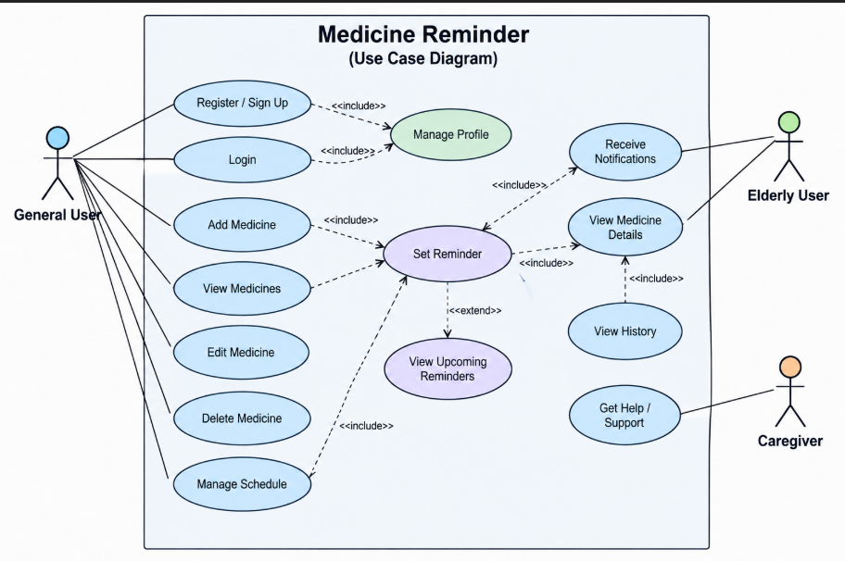

Class Diagram
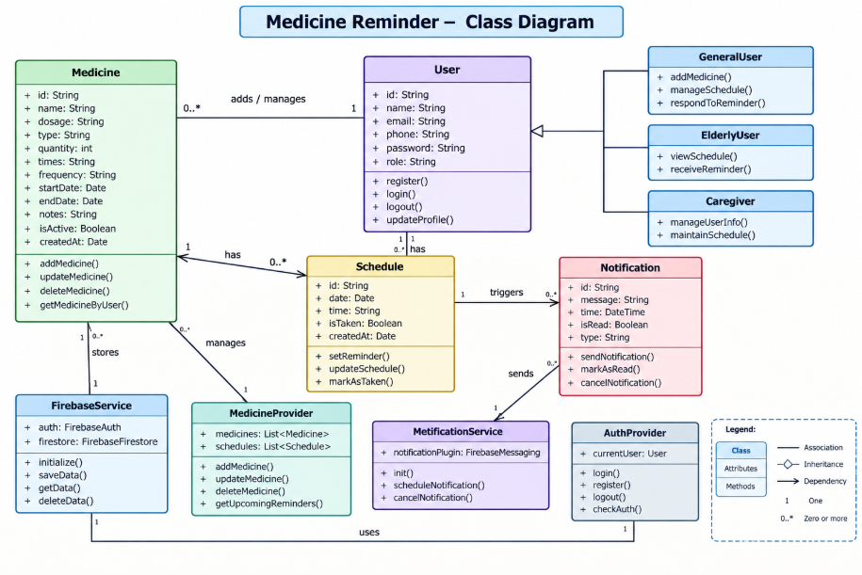

Interaction Diagram
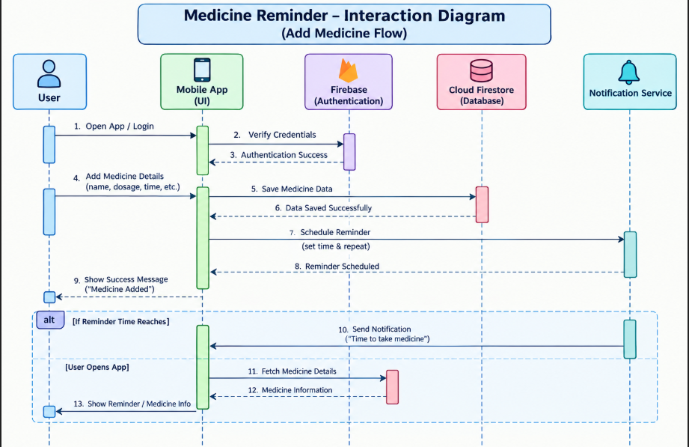

Activity Diagram
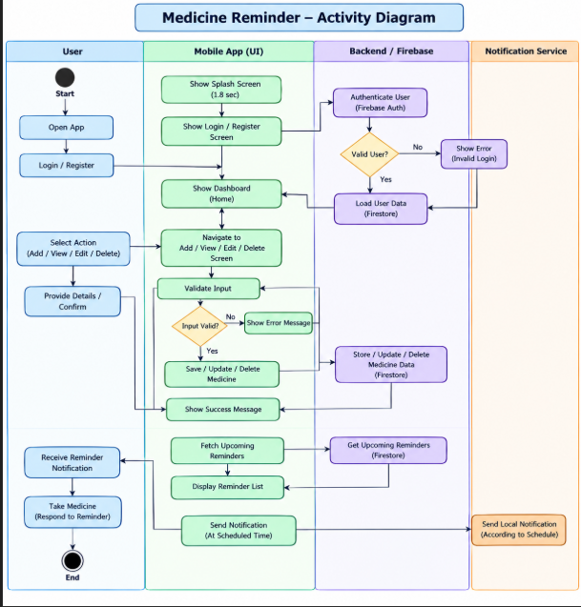
4.5 Data Dictionary
Column | Type | Size | Description | Example
medicineId | INTEGER | - | Unique identifier | 101
medicineName | VARCHAR | 100 | Medicine name | Paracetamol
dosage | VARCHAR | 50 | Dosage | 500 mg
frequency | VARCHAR | 50 | Frequency | Once Daily
scheduleTime | TIME/STRING | - | Reminder time | 08:00 PM
startDate | DATE/STRING | - | Start date | 2026-08-14
endDate | DATE/STRING | - | End date | 2026-08-20
status | VARCHAR | 30 | Current status | Pending

DEVELOPMENT

Development Approach
The project follows an iterative approach: requirement analysis, UI design, Flutter implementation, medicine management, reminder integration, testing and documentation. Flutter and Dart are used for Android development with Android Studio.

Coding Standards
- Meaningful names
- PascalCase for classes
- camelCase for variables and methods
- Modular reusable widgets
- Proper formatting
- Avoid code duplication
- Comments for complex reminder logic

GitHub Repository Details
Repository Name: [Medicine Reminder Repository Name]
Repository Link: [GitHub Repository Link]
GitHub is used for version control, backup, collaboration and project updates.

AI Tools/Libraries/APIs Used
AI Tool: ChatGPT – may be used for code suggestions, debugging guidance and documentation support.
Libraries/APIs: Add the exact packages and versions from the project's pubspec.yaml file.
5.5 Screenshots & Implementation Details

[SCREENSHOT: HOME / DASHBOARD]
Description: Access to medicine schedules and main functions.
Implementation Details: Shows medicine information and upcoming reminders.
[INSERT ACTUAL PROJECT SCREENSHOT HERE]

[SCREENSHOT: ADD MEDICINE]
Description: Entry of medicine details and schedule.
Implementation Details: Includes medicine name, dosage, frequency/date/time and validation.
[INSERT ACTUAL PROJECT SCREENSHOT HERE]

[SCREENSHOT: MEDICINE LIST]
Description: Displays saved medicines.
Implementation Details: Supports viewing, editing and deleting.
[INSERT ACTUAL PROJECT SCREENSHOT HERE] [SCREENSHOT: REMINDER NOTIFICATION]
Description: Reminder at scheduled time.
Implementation Details: Uses configured schedule and Android notification settings.
[INSERT ACTUAL PROJECT SCREENSHOT HERE]

PROPOSED ENHANCEMENTS
- Caregiver support
- Medicine history and adherence reports
- Cloud backup and synchronization
- Doctor/caregiver sharing
- Voice reminders
- AI-assisted reminder suggestions
- Analytics and notification controls

CONCLUSION
The Medicine Reminder project provides a practical Flutter-based solution for organizing medicine schedules and reminders. It aims to reduce missed reminders by keeping medicine information and schedules in one application. The project provides experience in Flutter UI development, Dart programming, data management, notification scheduling, testing and documentation.

BIBLIOGRAPHY
- Flutter Documentation
- Dart Documentation
- Android Developers Documentation
- Documentation of the packages actually used in the project

