October 2025

nhla aboromy
BIODYNAMICS TEAM

User Manual
SmartKinneret

User Manual – Table of Contents
- System Overview
1.1 General Description of SmartKinneret
1.2 System Objectives and Purpose
1.3 Target Users and Use Cases
- Main Screens and Interface Structure
2.1 Home Screen
2.2 All Simulations Screen
2.3 Specific Simulations Screen
2.4 Stations Map Screen
2.5 Forecast Screen
2.6 Alerts Screen
2.7 RAG Screen – Academic Document Retrieval
- Navigation and System Workflow
3.1 Navigation Between Tabs and Main Buttons
3.2 Recommended Operation Sequence
- Common Errors and Troubleshooting
4.1 Data Loading Errors
4.2 Display and Graph Issues
4.3 Typical Error Messages and Suggested Solutions

1. System Overview
1.1 General Description of SmartKinneret
The SmartKinneret system is an intelligent platform for monitoring and short-term forecasting of the physical state of Lake Kinneret.
It was developed as part of the Ecological Modeling Systems Lab course, with the goal of transforming raw field data collected from multiple measurement stations around the lake into an operational and user-friendly tool that provides users with an up-to-date, data-driven overview of the lake’s conditions.
The system gathers information from several sources:
Four land-based meteorological stations — Beit Zayda (B), Zemah, Ginosar, and Ein Gev — which record, every 10 minutes, data on wind speed, wind direction, air temperature, and relative humidity;
and two water stations — KNW (“Golan Beach”) and KNC (“F Station”) — which provide current and wave measurements across the full water column.
The integration of wind, current, and wave data enables the system to understand in real time the physical dynamics of the lake — how wind conditions affect surface motion, current directions, and the stability of navigation conditions.
The system operates through three main stages:
- Real-time data acquisition from external sources and periodic input files.
- Data processing and cleaning to create a uniform hourly resolution, including the computation of wind components (U, V).
- Advanced analysis and short-term forecasting using algorithms such as PCA, Kriging, and KNN Regressor.
The resulting insights are presented to the user in an interactive Gradio-based dashboard, which includes graphical displays, spatial maps, data tables, forecasts, and real-time alerts.

1.2 System Objectives and Purpose
The main objective of the SmartKinneret system is to enable intelligent, accessible, and clear real-time monitoring of lake conditions, while providing short-term forecasts based on actual field measurements.
The system was designed to assist beach managers, rescue teams, researchers, and the general public in rapidly identifying hazardous trends such as high waves and strong currents — thereby improving safety and preparedness around the lake.
Primary objectives:
- To provide a data-driven tool for continuous physical monitoring of environmental conditions.
- To enable short-term forecasting (up to 10 hours ahead) of wave height and current intensity using a KNN Regressor model.
- To make data and forecasts visually intuitive, simple, and interactive for all users.
- To strengthen the link between academic research and practical application, through a development process grounded in real measurements supplied by the Kinneret Research Laboratory (led by researcher Yael).

1.3 Target Users and Use Cases
The system is designed for a wide range of users:
- Beach managers and local authorities – for risk assessment, decision-making regarding beach closures, and allocation of rescue personnel.
- Rescue and marine police units – for real-time monitoring of changes in water surface conditions and detection of dangerous currents.
- Researchers and environmental-science students – as an analytical and educational tool based on real-world measurements.
- The general public – for accessing up-to-date information on swimming and boating conditions in Lake Kinneret.
The system’s applications include continuous monitoring, short-term forecasting, real-time alert generation, and seasonal trend analysis.
In this way, SmartKinneret serves as a highly valuable tool — both from a scientific research perspective and for practical, day-to-day field use.

2. Main Screens and Interface Structure
2.1 Home Screen
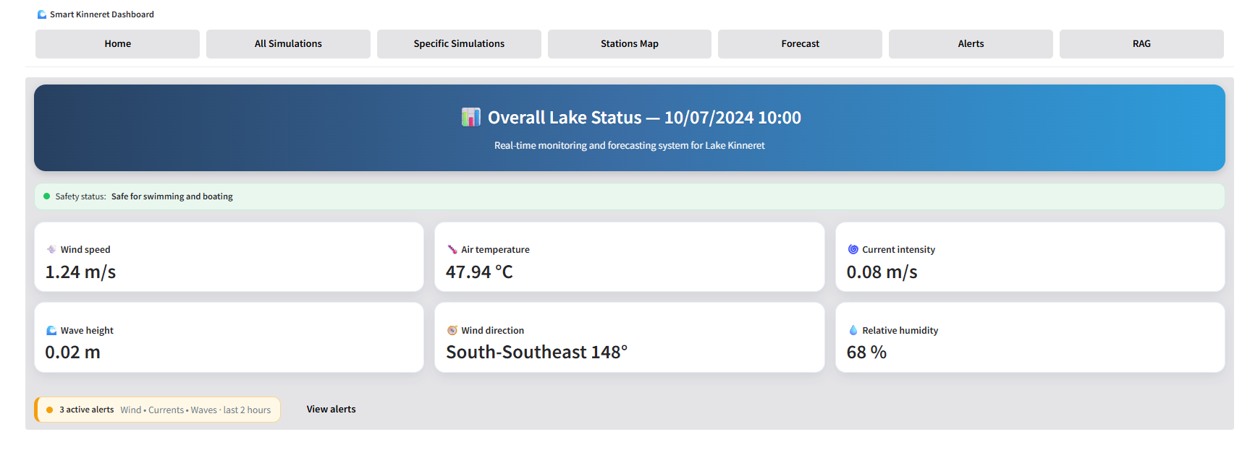
The Home Screen serves as the main entry point to the SmartKinneret system, providing users with a real-time overview of the current lake conditions.
At the top of the screen, a header displays the latest measurement timestamp (e.g., 10/07/2024 10:00) under the title “Overall Lake Status.”
Beneath it, a green safety banner shows the current safety level — for example, “Safe for swimming and boating” — indicating that conditions are suitable for recreational activities.
The dashboard is organized into a set of information cards, each presenting a key physical parameter:
- Wind speed – measured in meters per second (m/s).
- Air temperature – atmospheric temperature at the land stations (°C).
- Current intensity – water current velocity (m/s).
- Wave height – wave amplitude (m).
- Wind direction – directional angle of the wind (degrees).
- Relative humidity – atmospheric humidity expressed as a percentage (%).
The data are displayed using a clean, readable layout with soft colors and clear typography, allowing users to quickly detect abnormal or changing conditions.
At the bottom of the screen appears the Alerts bar, summarizing active alerts in real time — for instance: “3 active alerts: Wind • Currents • Waves (last 2 hours).”
Next to it, the “View alerts” button enables one-click navigation to the full Alerts Screen, where users can inspect each event in detail.
Overall, the Home Screen provides an intuitive starting point that summarizes the lake’s real-time status while offering seamless navigation to other specialized views — such as Forecast, Simulations, Map, and Alerts.

2.2 All Simulations Screen
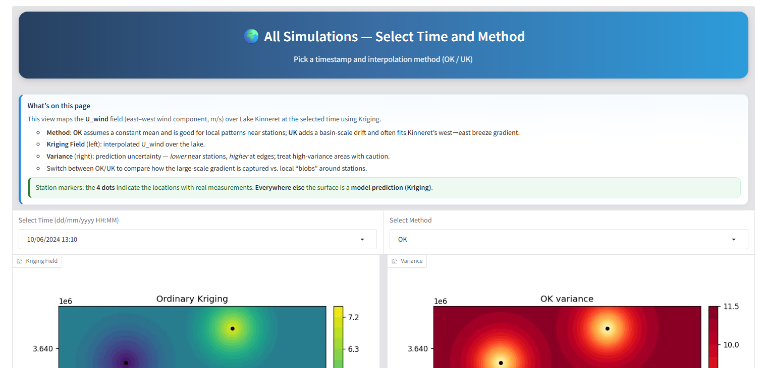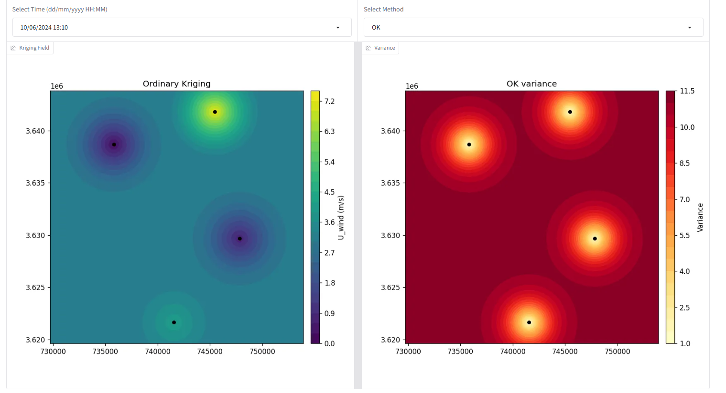
This screen allows users to visualize the spatial interpolation of wind speed (the U_wind component, east–west direction) across Lake Kinneret for a selected time and interpolation method.
Its purpose is to demonstrate how wind conditions vary spatially over the lake and to identify areas where the model predicts stronger or weaker winds.
At the top of the screen, the user can select:
- Time (Select Time) — a specific timestamp to display the data.
- Method (Select Method) — the interpolation technique used:
  - OK (Ordinary Kriging) – assumes a constant mean, suitable for local wind patterns near measurement stations.
  - UK (Universal Kriging) – adds a large-scale drift component, capturing basin-wide gradients such as the typical west-to-east lake breeze.
Once selected, two maps are displayed side by side:
- Kriging Field (left) – shows the spatial distribution of U_wind values across the lake.
- Variance (right) – represents prediction uncertainty (lower near stations, higher near the lake’s edges).
The four black dots on the maps indicate the real station locations, while the rest of the colored surface represents model-predicted wind values.
Through this screen, users can explore how wind patterns change across the lake, compare different interpolation models, and understand how the Kriging algorithm intelligently fills data gaps to produce smooth, realistic surfaces.

2.3 Specific Simulations Screen
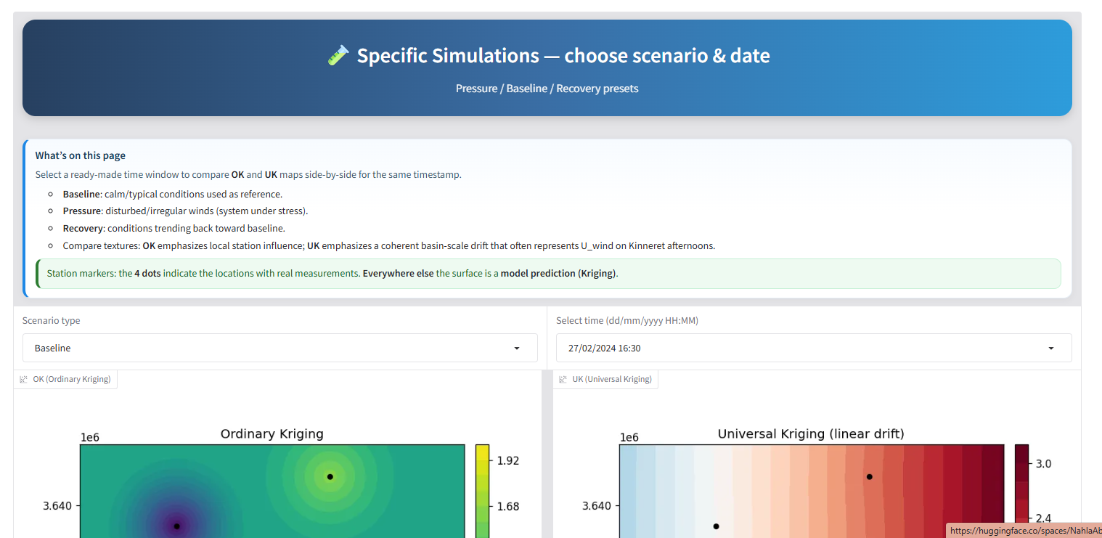
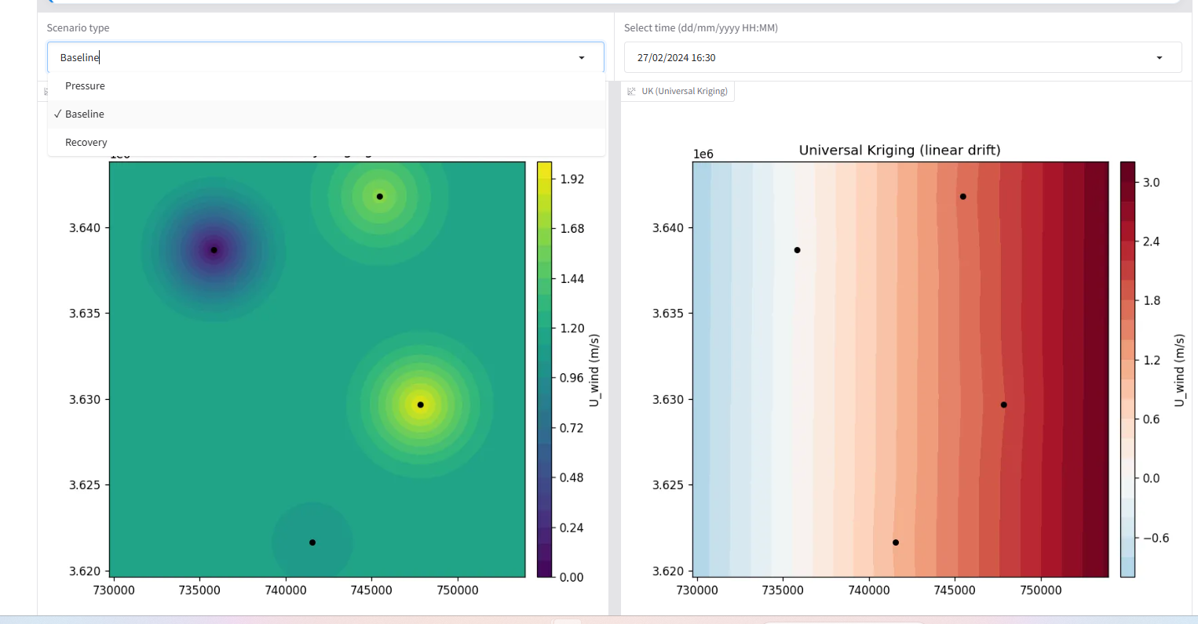
This screen allows users to explore predefined scenarios and visualize how wind patterns across Lake Kinneret change under different conditions.
The system includes three selected scenarios, each representing a distinct meteorological state:
- Baseline – calm and stable lake conditions with relatively low wind speed and consistent direction.
- Pressure – periods of strong, irregular winds showing sudden shifts in speed and direction, representing a “system under stress.”
- Recovery – the transition phase where the lake gradually returns to stable conditions after a stormy or disturbed period.
After selecting a scenario type and specific timestamp, the system displays two side-by-side maps:
- Left: Ordinary Kriging (OK) – emphasizes local station influence and small-scale variations around measurement points.
- Right: Universal Kriging (UK) – incorporates a large-scale drift to capture the broader wind gradient across the lake, such as the typical west-to-east afternoon breeze.
The four black dots indicate the real meteorological station locations, while the colored fields represent model predictions based on spatial interpolation.
Through this screen, users can easily compare different atmospheric states — calm, stressed, and recovering — and observe how the OK and UK algorithms capture these transitions.
This comparison helps visualize the dynamic behavior of the lake and understand how wind conditions evolve and influence water motion under varying scenarios.
2.4 Stations Map Screen
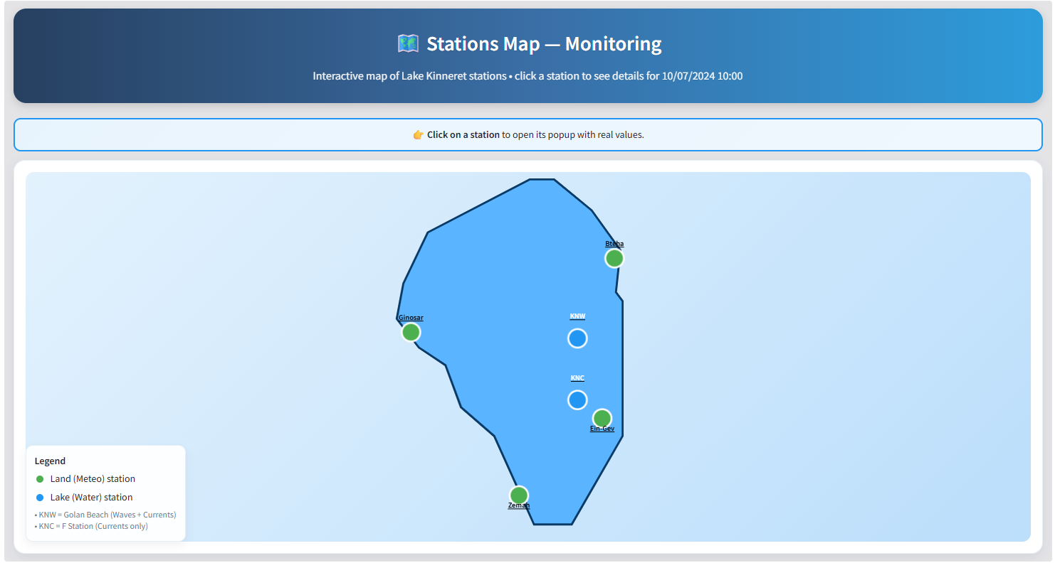
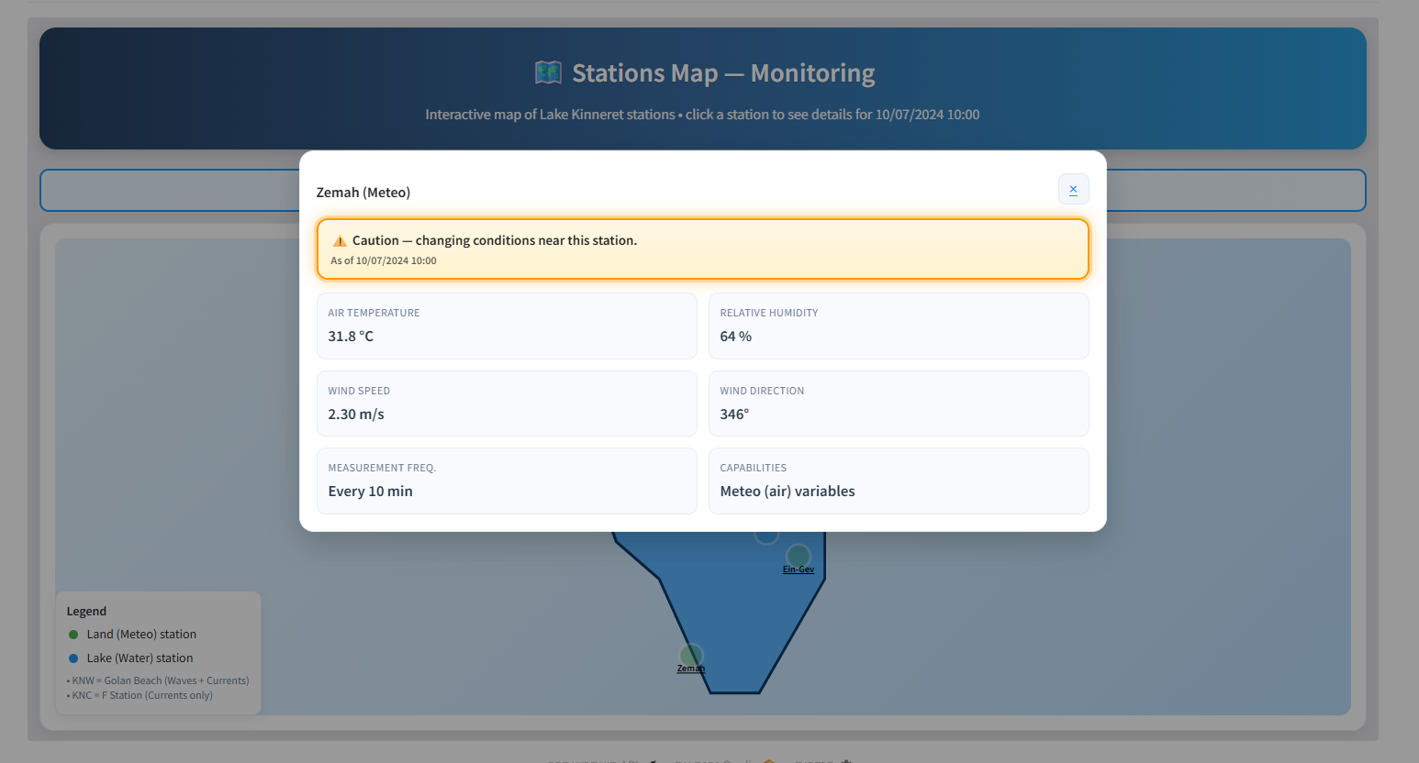
This screen displays an interactive map of Lake Kinneret showing all active monitoring stations — both land-based meteorological stations and in-lake water stations.
Its main goal is to provide users with a clear spatial overview of station locations and enable real-time data access from each one with a single click.
On the map, users can see:
- Land (Meteo) stations – marked in green circles, measuring air parameters such as temperature, humidity, wind speed, and wind direction.
- Lake (Water) stations – marked in blue circles, collecting wave and current data throughout the water column (e.g., KNW and KNC).
Clicking on a station opens a popup window displaying the latest live measurements, including:
- Air Temperature
- Wind Speed
- Wind Direction
- Relative Humidity
- Measurement Frequency (usually every 10 minutes)
If rapid or abnormal changes are detected at a given station, a warning banner appears — ⚠️ “Caution – changing conditions near this station” — alerting the user to local variations in conditions.
At the bottom-left corner, a Legend explains the meaning of the color codes and the capabilities of each station type.
This map helps users understand the spatial distribution of the monitoring network, identify zones with stronger winds or temperature shifts, and access real-time data crucial for analysis, forecasting, and early warning.
2.5 Forecast Screen
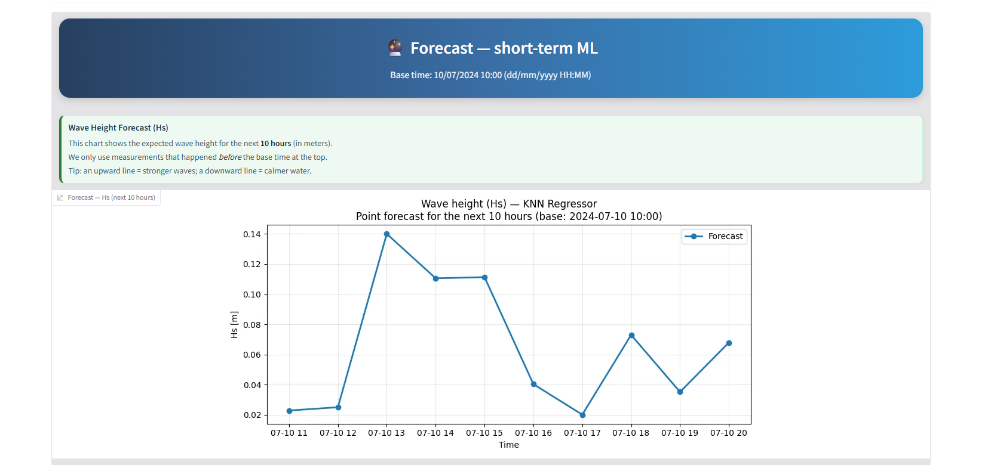
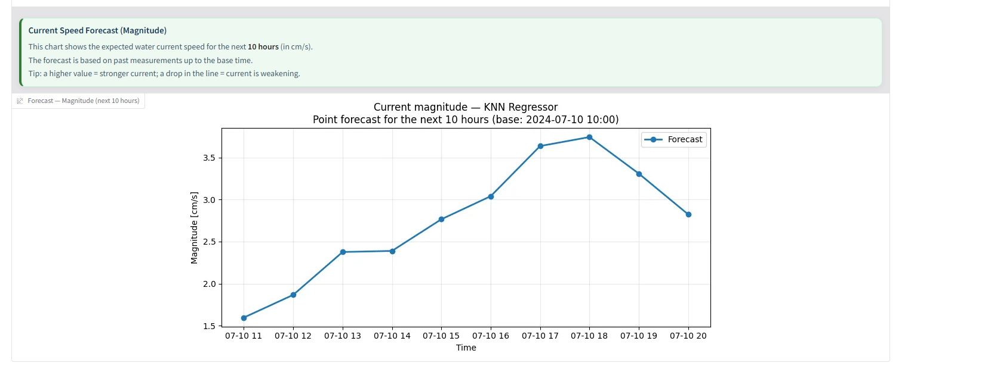
This page presents short-term forecasts (up to the next 10 hours) for wave and current conditions in Lake Kinneret, generated using a KNN Regressor machine-learning model.

What you can see here:
- Wave Height (Hs) — shows the expected wave height in meters.
  - An upward line means waves are getting stronger.
  - A downward line means the water is becoming calmer.
- Current Speed (Magnitude) — shows the expected water-current intensity (in cm/s).
  - A higher value = stronger current.
  - A drop in the line = current is weakening.

How it works:
The forecasts are based on real-time measurements collected from the lake’s monitoring stations.
The algorithm analyzes past data patterns to predict upcoming trends for the next few hours.
This helps users quickly identify approaching changes in lake conditions — such as strengthening winds, rising waves, or shifting currents — which is particularly valuable for beach managers, rescue teams, and sailors operating around the Kinneret.
2.6 Alerts Screen
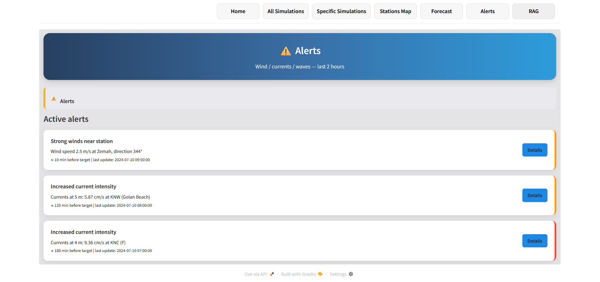
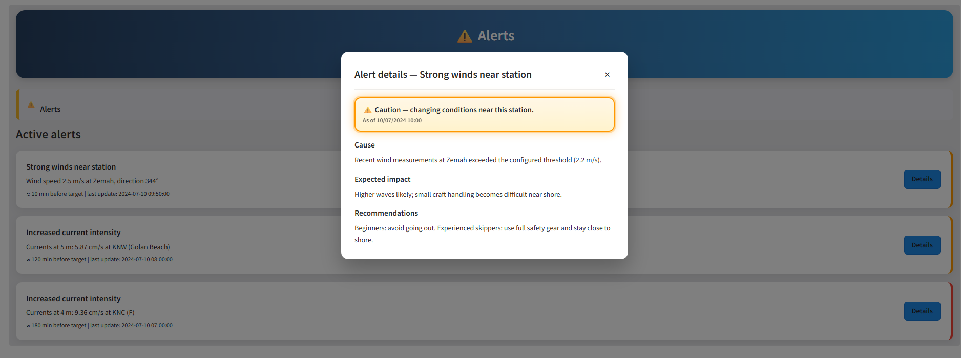
This screen displays all active alerts generated in real time based on measurements from the monitoring stations around Lake Kinneret.
Its purpose is to warn users about sudden changes in wind, current, or wave conditions that might affect safety and near-shore activities.

What you can see:
- The “Active alerts” section lists the most recent warnings.
- Each alert includes:
  - Alert type (e.g., “Strong winds near station” or “Increased current intensity”)
  - Station location where the anomaly was detected (e.g., Zemah, KNW, KNC).
  - Measured value (such as wind speed or current magnitude).
  - Time before target and last update time.
Clicking Details opens a popup window showing:
- Cause – what triggered the alert (e.g., exceeding a pre-set threshold).
- Expected impact – possible effects (for example: higher waves or difficult handling for small boats).
- Recommendations – clear safety guidance:
  - Beginners: advised not to go out.
  - Experienced skippers: use full safety gear and stay close to shore.

Why it matters:
The alert system is designed to enhance situational awareness and real-time safety.
It enables managers, lifeguards, and individual users to instantly recognize when conditions are changing — and take preventive action before risks escalate.
2.7 RAG Screen – Academic Document Retrieval
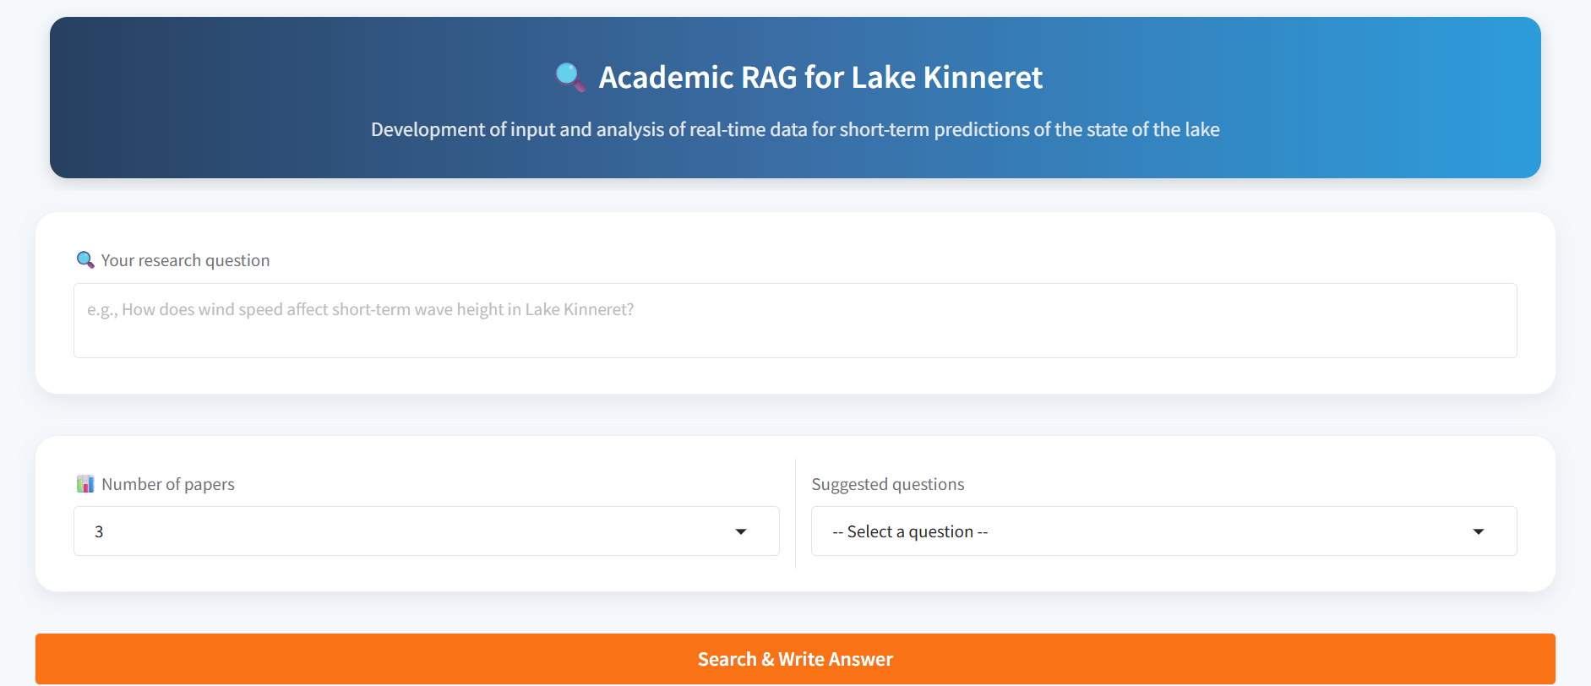
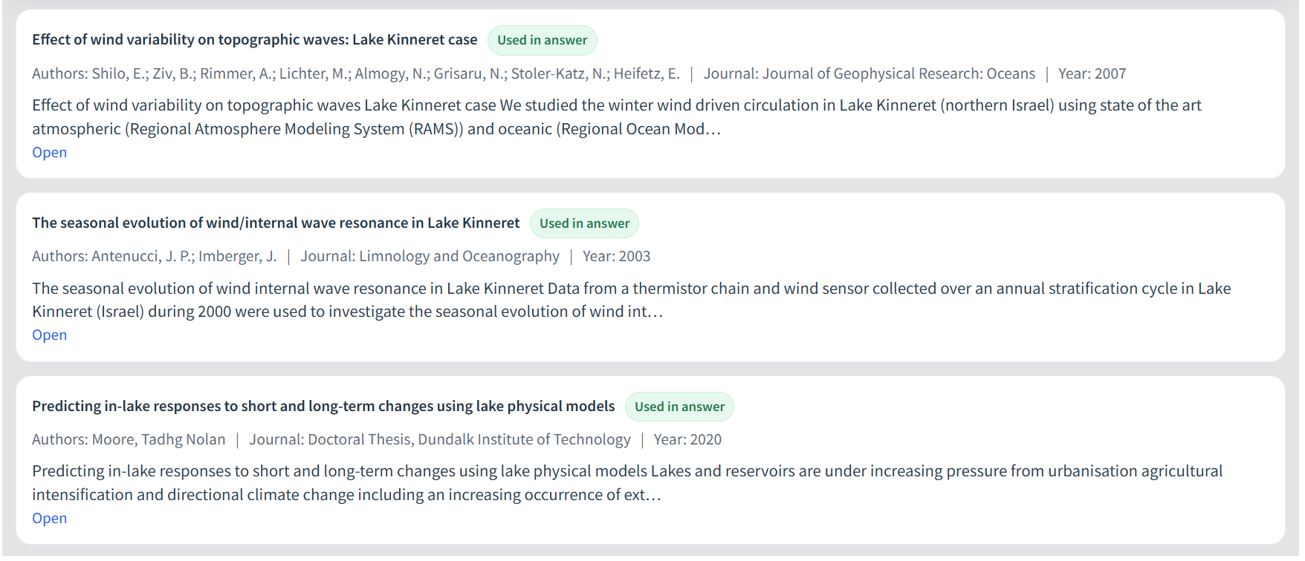
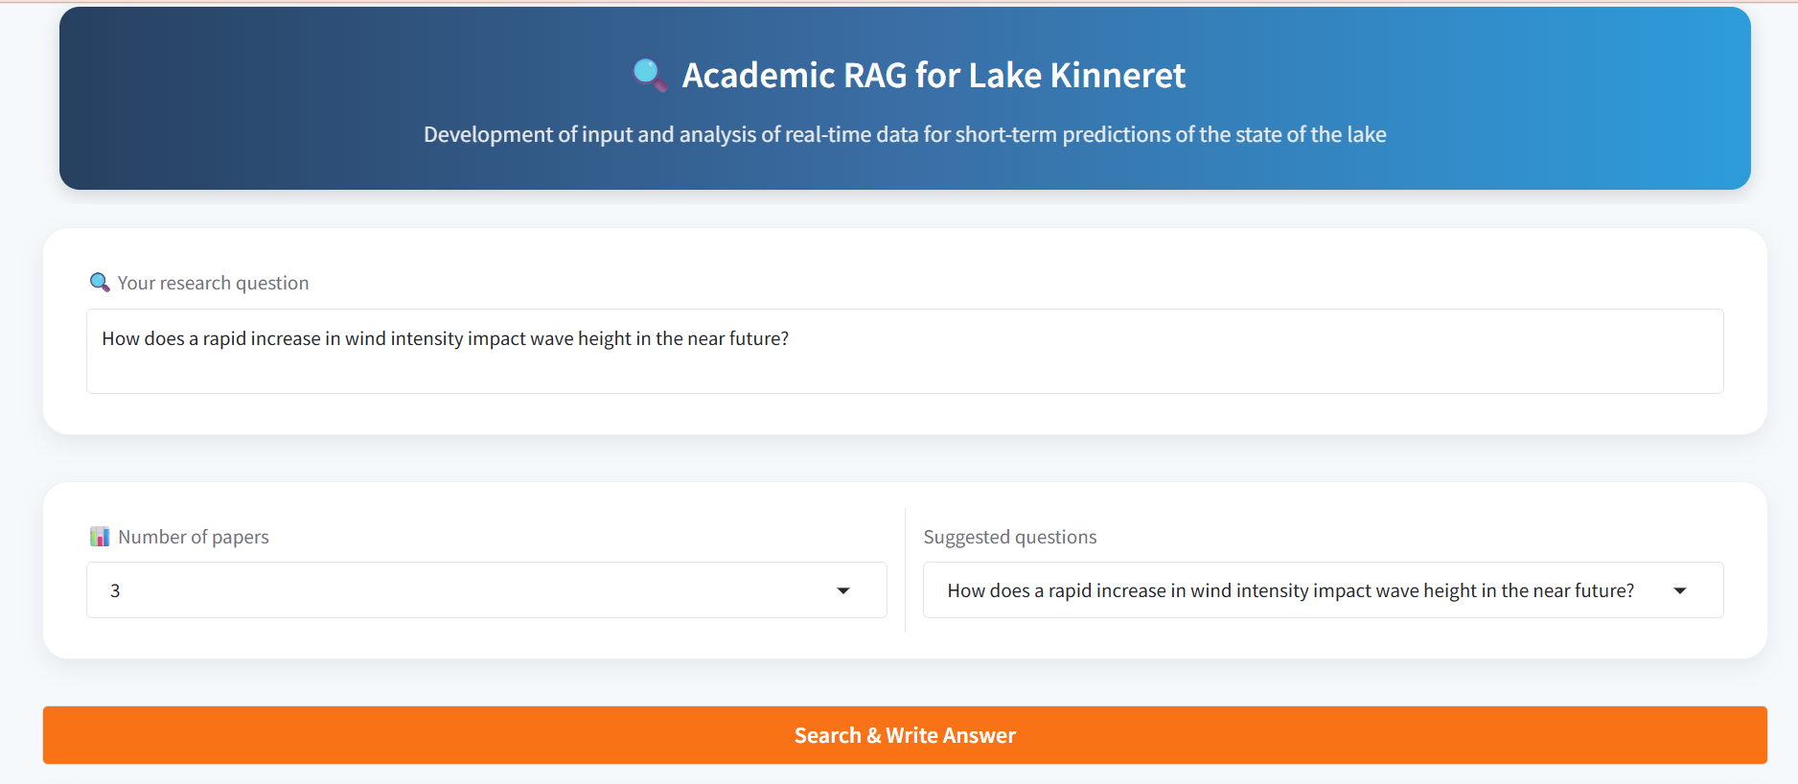
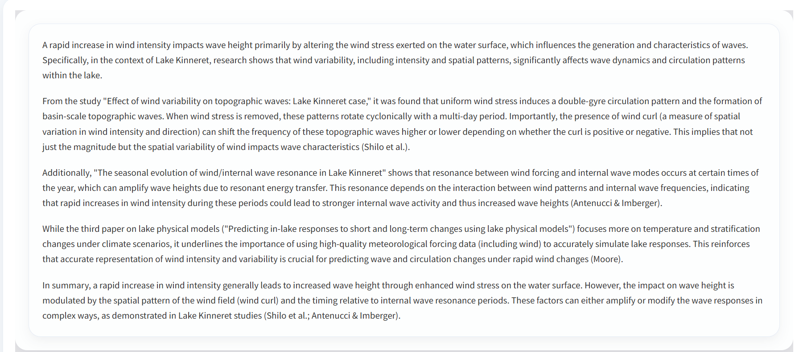

On this page, we developed a smart interface that allows users to explore real scientific questions using reliable academic papers, in a simple and interactive way.
The idea behind the interface is to combine information retrieval with deep understanding and answer generation, hence the name:
RAG – Retrieval Augmented Generation.

Purpose
To make the scientific knowledge about Lake Kinneret accessible, readable, and clear — a tool where users can enter a research question and receive a well-reasoned answer based on real studies.
For example, a user can ask:
“How does wind speed and direction affect short-term wave height in Lake Kinneret?”
and receive a summary of the main findings from the relevant studies, along with a full list of the sources used.

How It Works
Our system helps you find answers to real research questions — not just by searching online, but by reading and summarizing real academic studies.
All you need to do is:
- Type a question that interests you, for example:
“How does a change in wind direction affect wave height in Lake Kinneret?”
- Choose how many papers you’d like the system to use (for example, 3 or 5).
- Click Search & Write Answer.
The system will automatically gather reliable information from academic papers related to your question, read their abstracts, and write a short, clear, and easy-to-understand answer.
At the end of the process, you’ll see two clear results:
- On top – a summarized and well-written answer based on what the researchers found.
- Below – a list of the papers used, including titles, authors, year, and direct links.
This way, you get both a clear explanation and access to the original sources if you wish to explore further.
Think of it as your smart research assistant — summarizing the most relevant academic knowledge for your question.

- Navigation and System Workflow
3.1 Navigation Between Tabs and Main Buttons
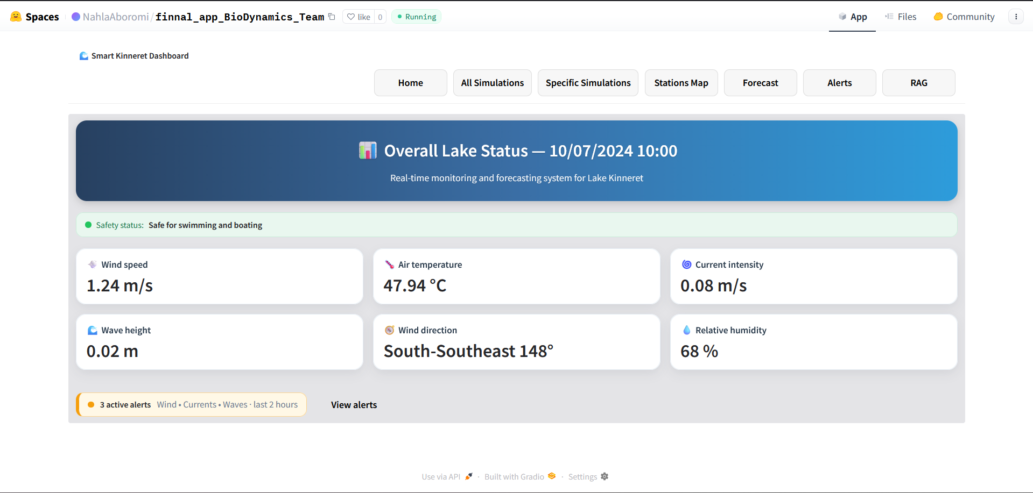
Navigation Bar :
The SmartKinneret system was designed for simple and consistent navigation between all sections.
At the top of every page appears a fixed Navigation Bar (Navbar), allowing quick and easy access to all main system areas with a single click — no need to reload or go back.
The Navbar includes the following main tabs:
- Home – Displays the lake’s real-time status.
- All Simulations – Shows all Kriging interpolation results.
- Specific Simulations – Allows exploring predefined weather scenarios (Baseline, Pressure, Recovery).
- Stations Map – Presents all active stations with live readings.
- Forecast – Provides short-term forecasts (up to 10 hours ahead).
- Alerts – Lists current alerts and safety recommendations.
- RAG – Enables interactive search in academic research papers.
The Navbar remains visible at all times, ensuring users always know where they are and can seamlessly navigate between sections.
Its clear design ensures a smooth and intuitive user experience.
On the Home Screen, users can view key lake parameters — wind speed, air temperature, current intensity, wave height, wind direction, and relative humidity — along with a Safety Status bar and a summary of active alerts at the bottom.
Possible Navigation Flow:
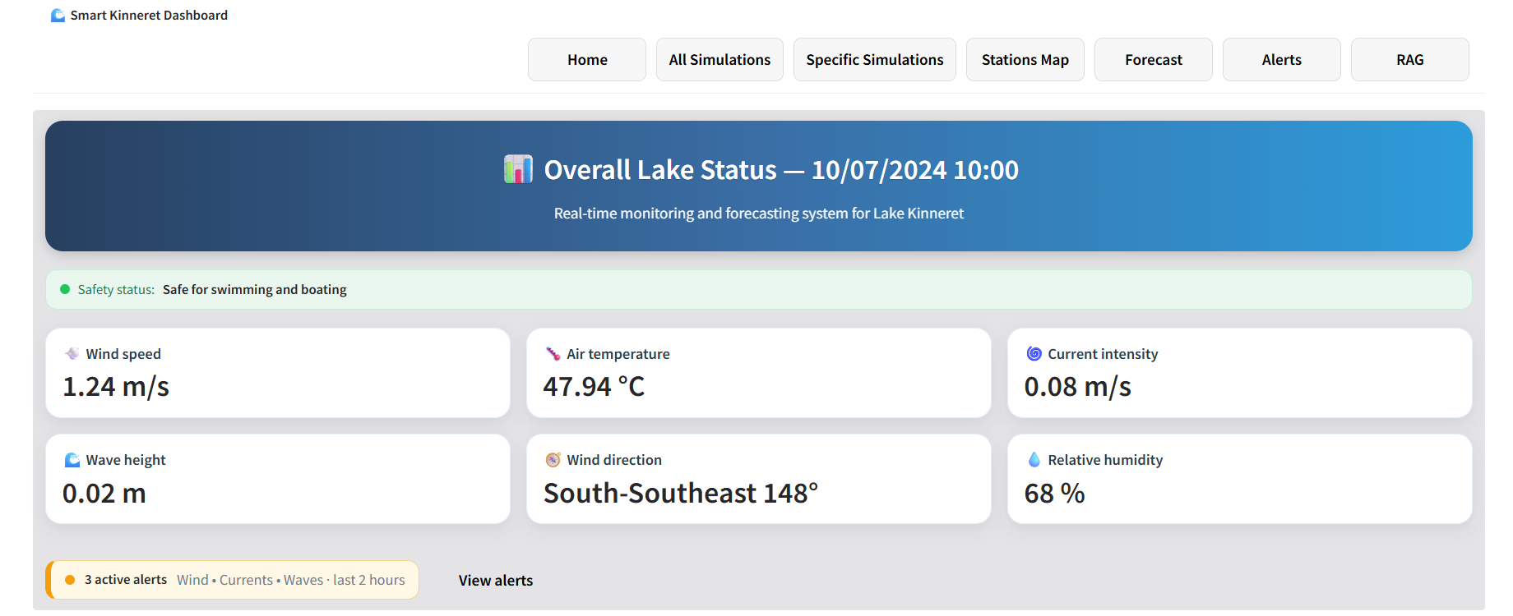
All Simulations

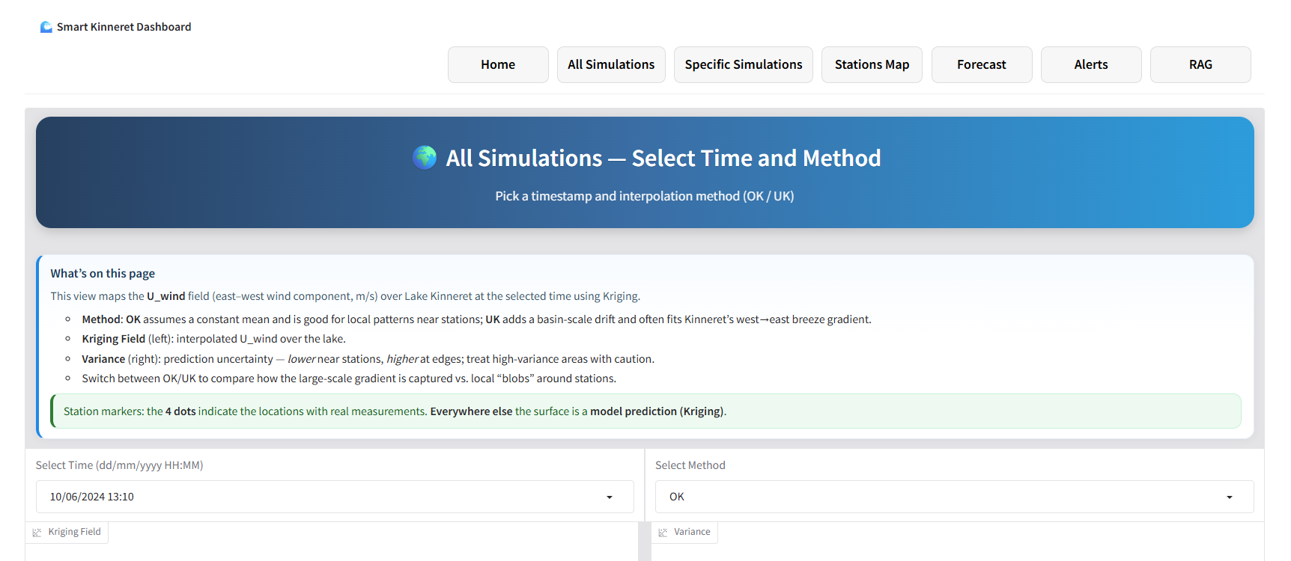
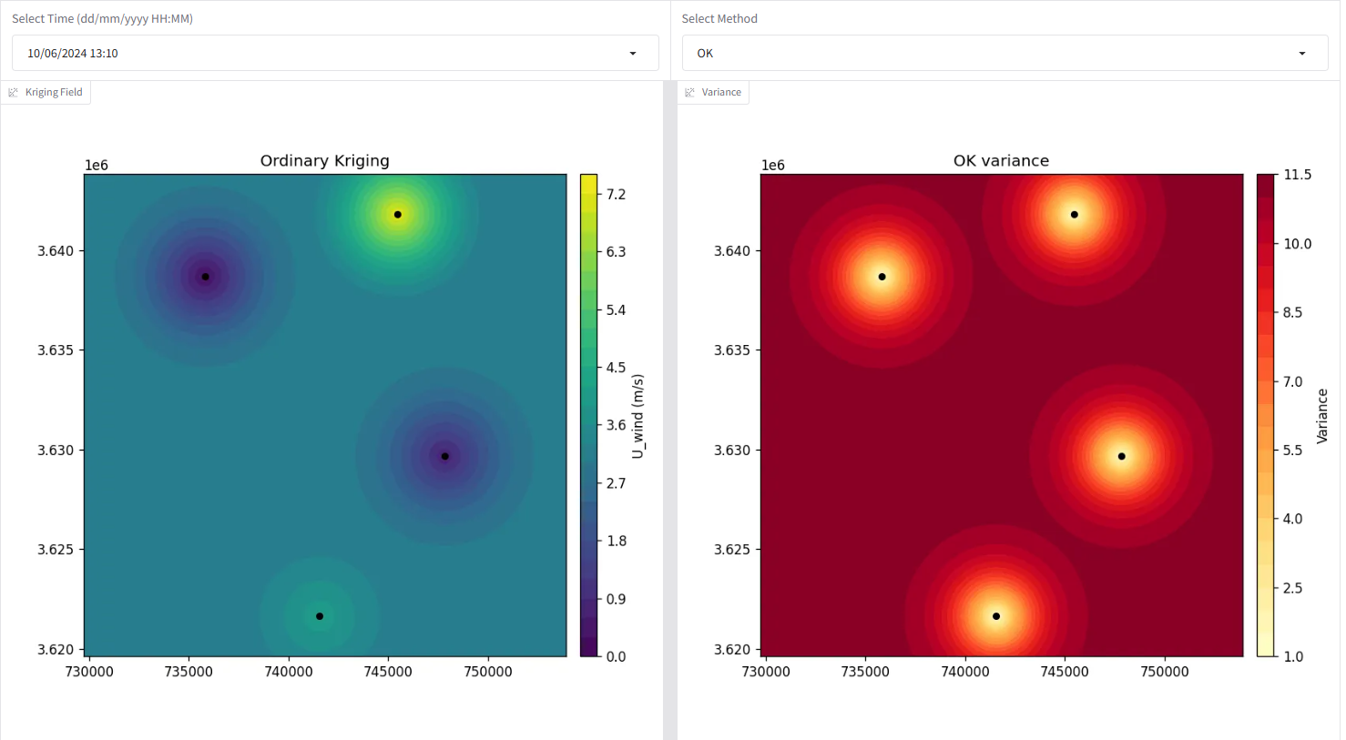
Specific Simulations
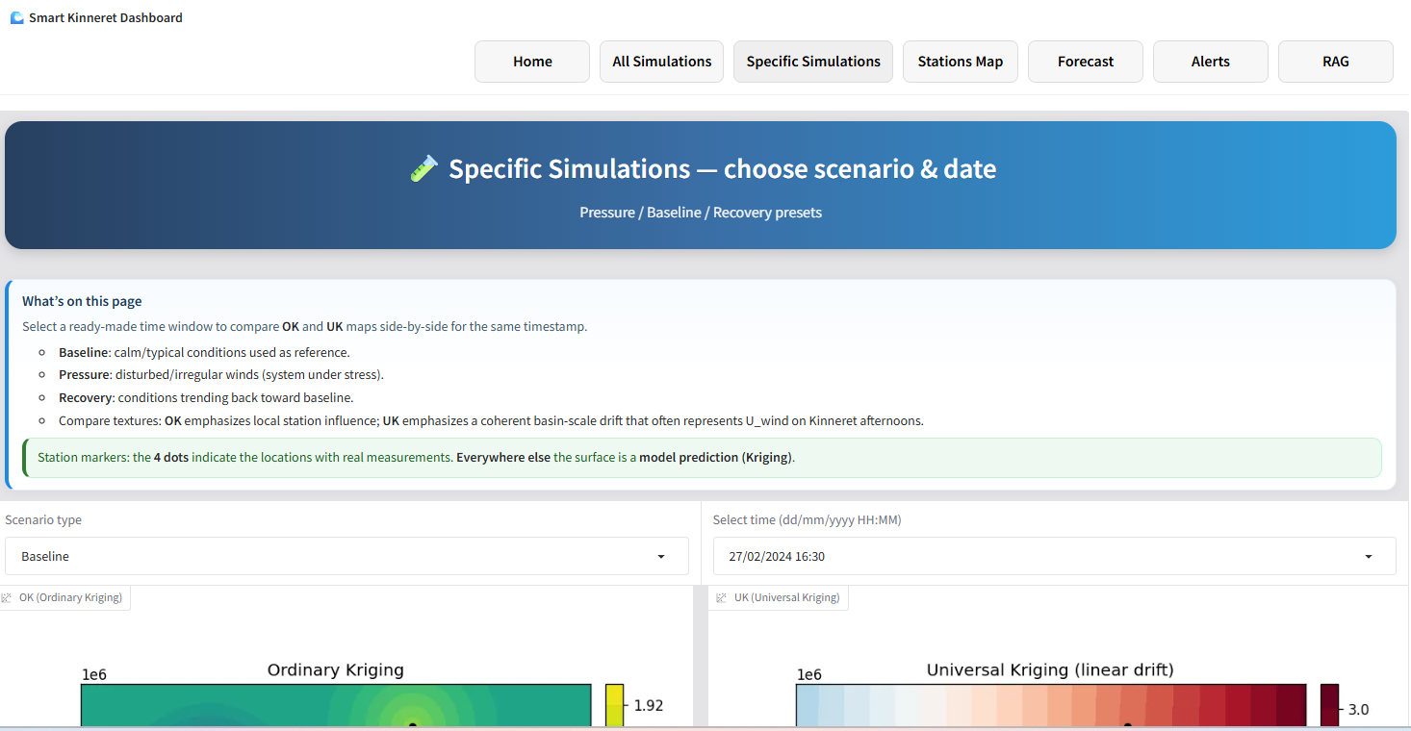
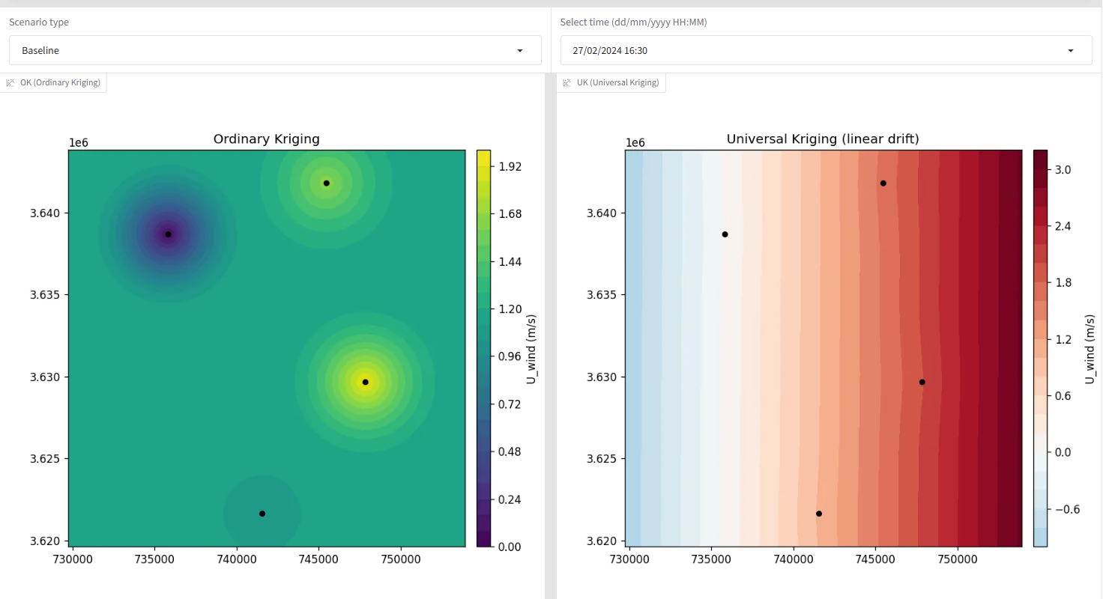
Stations Map
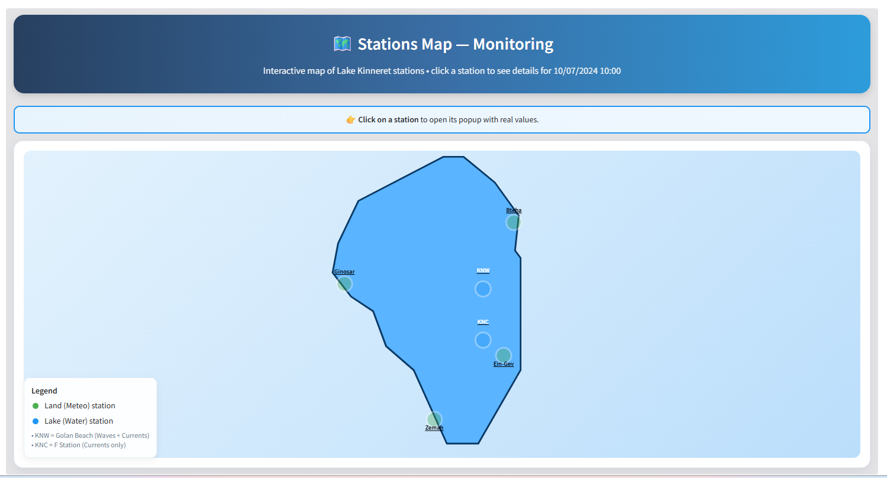
Forecast

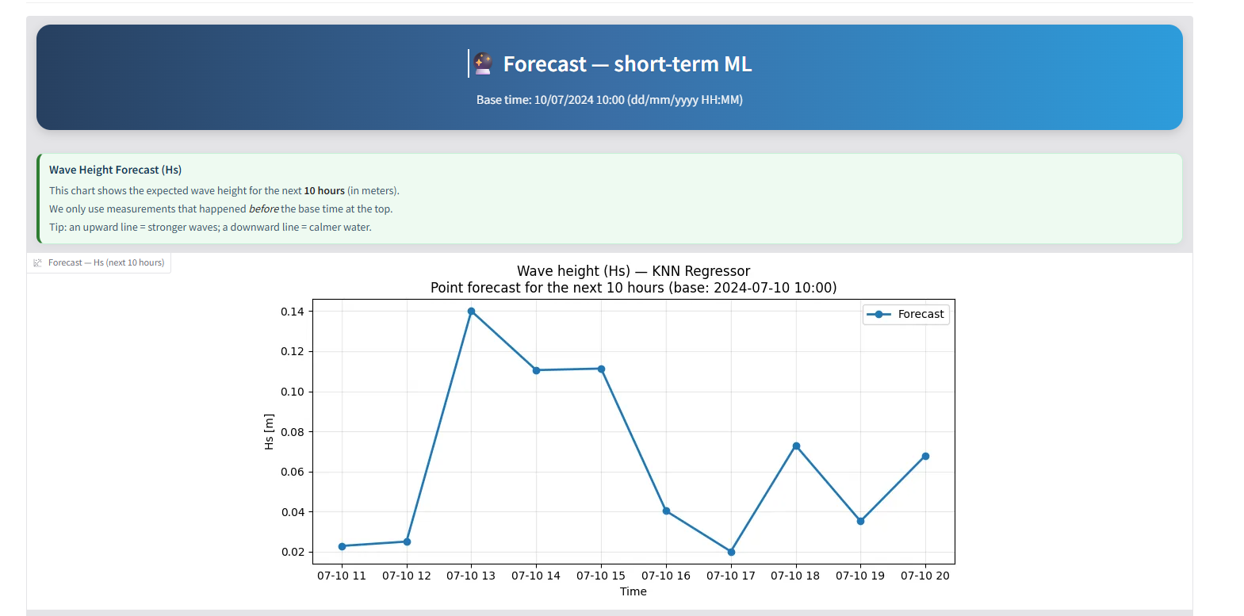
Alerts

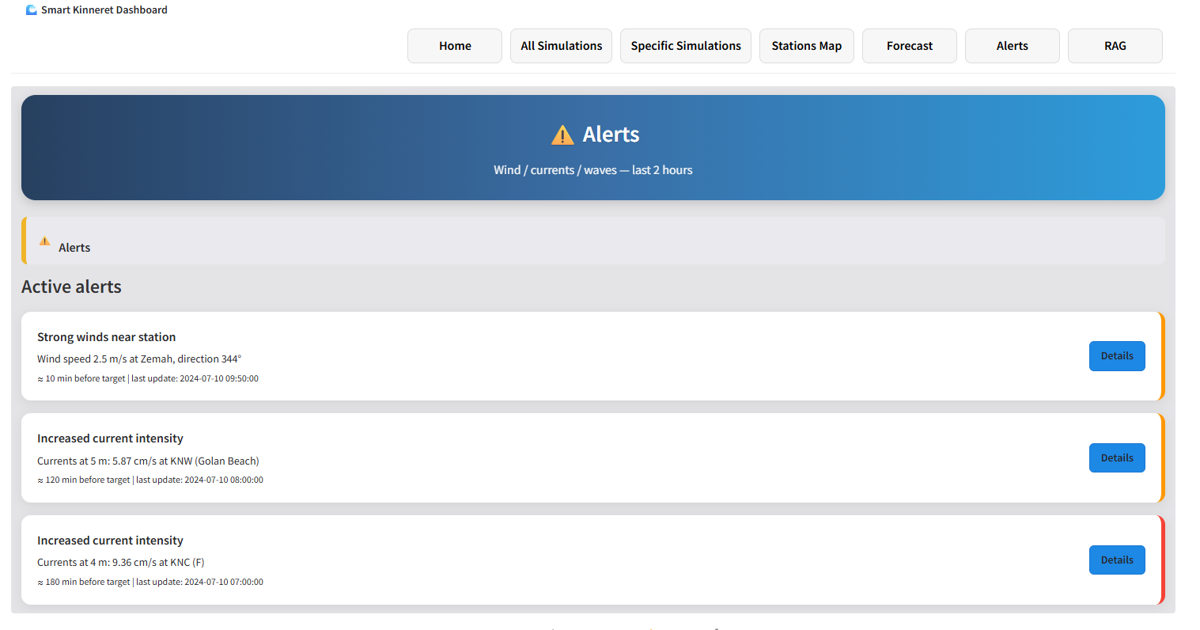
RAG
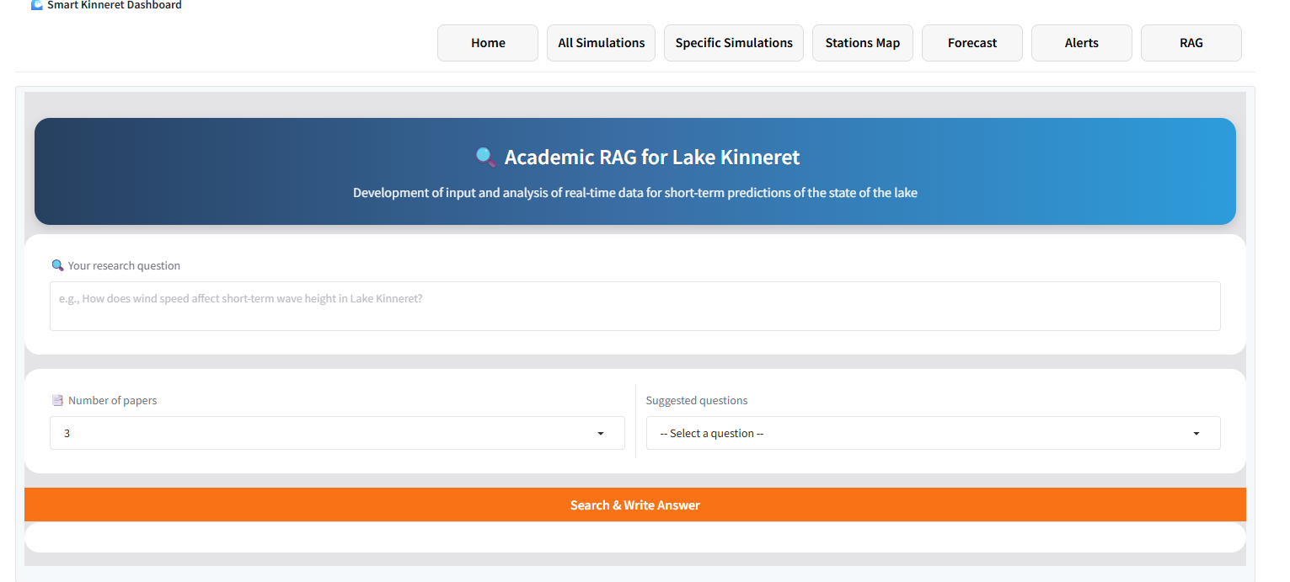
The diagram above illustrates a possible navigation flow between the main screens of the SmartKinneret system.
In practice, users can easily move between any screen using the Navigation Bar (Navbar), which appears at the top of every page.
This fixed and intuitive menu ensures smooth transitions and allows users to access any part of the system — from the Home screen to Simulations, Forecast, Alerts, or the RAG interface — with just one click.
The Navbar is therefore the starting point for navigation within the system.

3.2 Recommended Operation Sequence
To use the SmartKinneret system efficiently, it is recommended to follow this logical sequence of operation:
- Start at the Home Screen
  - Review the current lake conditions: wind speed, air temperature, relative humidity, wave height, wind direction, and active alerts.
  - Identify any abnormal or hazardous situations at a glance.
- Check the Stations Map
  - View all active monitoring stations (land and water) with real-time data.
  - Detect areas where conditions are changing rapidly.
- Explore the Simulations (All / Specific)
  - These pages focus only on wind fields (U_wind component, east–west direction) across Lake Kinneret.
  - In All Simulations, select a timestamp and an interpolation method (OK / UK) to visualize the Kriging wind field and its variance.
  - In Specific Simulations, choose a preset scenario to compare spatial wind patterns:
    - Baseline – calm, reference conditions.
    - Pressure – disturbed winds and stressed conditions.
    - Recovery – returning to stability after disturbance.
  - Compare OK (local station influence) vs UK (basin-scale drift) to observe how the wind field evolves across the lake.
- Open the Forecast Screen
  - View short-term forecasts (up to 10 hours) of wave height and current intensity.
  - Helps anticipate environmental changes and plan accordingly.
- Review the Alerts Screen
  - Read real-time warnings, understand their causes, impacts, and safety recommendations.
- Use the RAG Interface (Research Q&A)
  - Ask scientific questions and get summarized answers derived from real academic studies.
  - Deepen understanding of physical processes such as wind–wave interactions or seasonal trends.
Note:
The top Navigation Bar (Navbar) is always visible, allowing free movement between screens.
However, following this sequence ensures a clear workflow — from real-time monitoring to spatial wind analysis, forecasting, and academic exploration.
4. Common Errors and Troubleshooting
4.1 Data Loading Errors
Sometimes a message may appear saying that the data failed to load or that updates are delayed.
This usually happens due to a temporary network issue or heavy server load.
What to do:
- Check that your internet connection is stable.
- Wait a few seconds and click Refresh.
- If the message persists, log out and log back in.
- If graphs appear empty, select a different timestamp from the dropdown list.
4.2 Display and Graph Issues
Sometimes graphs or maps may not display fully due to partial page loading or screen settings.

What to do:
- Click Refresh.
- Adjust the screen zoom level (In/Out).
- Make sure you are using an updated browser (Chrome or Edge recommended).
- On the wind map (Kriging), if no color layer appears, select another time or switch between OK and UK.
4.3 Typical Error Messages and Suggested Solutions
Message | Explanation | Suggested Action
No data available for the selected time | The system couldn’t find measurements for that timestamp (usually because the dataset doesn’t include that specific hour). | Select a different time from the dropdown list — data may not exist for every hour.
Error: Could not generate Kriging map | The interpolation method (OK/UK) failed due to missing or invalid wind data. | Try switching between OK and UK or selecting another time. If the error persists, refresh the page.
Invalid selection — please choose a method first | The user clicked Run before choosing a Kriging method (OK/UK). | Make sure to select a method from the dropdown menu before running.
Unable to fetch latest station data | The live connection to the Kinneret stations was temporarily lost. | Check your internet connection and refresh the page after a few seconds.
Alert loading failed | The alerts component didn’t receive updated data from the backend. | Refresh the page or wait a few seconds for the next update.
RAG request failed – please try again later | The connection to the academic search API was interrupted or temporarily limited. | Try again later — the service will automatically resume within a minute or two.
Empty response from forecast module | The forecasting model didn’t return valid values (often due to a short or missing dataset window). | Select a different time range or refresh the screen.
Component failed to render | A temporary Gradio display or rendering error. | Click Refresh — in most cases, the graph will reload successfully.

