1. **Task 1 Component test on the Process Explorer.**

Please check “Celonis Task 1 - ServiceNow Ticketing Scenario” file

1. **Task 2 Automated health checks:**
   1. **Project Structure** 
      1. src/main
      2. src/test
   2. **src/main/java Packages**
      1. celonisTests.pages → AUT pages classes + BasePage class, POM is used
      2. Factories → for different browser types, browser factory is is used
   3. **src/main/resources**
      1. Config & propeerties files of Logs & Reports → Not completed.

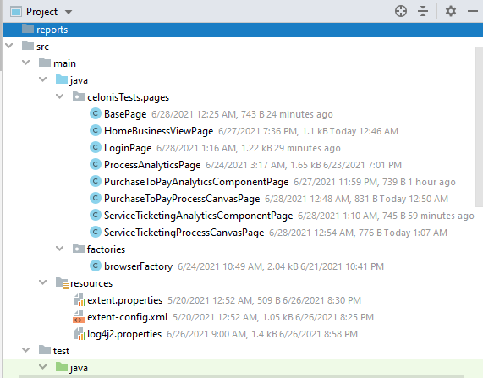

* 1. **src/test/java Packages**
     1. celonisTests → Login componenet test classes + BaseTest class, POM is used
     2. Regression→ 2 Regression test cases
     3. testData**/dataProviders** → 2 examples of Testng data providers. First one using Json and the other one using the noramal one
     4. testData**/json**→ test data in Json file used in the data provider with Json
     5. utilis.Logs → Logs implementation class, not completed.
  2. **src/main/resources**
     1. Feature Files → contains 1 manual test case using gherkin language for BDD.
     2. Config & propeerties files of Logs & Reports → Not completed.
     3. testNG XML files

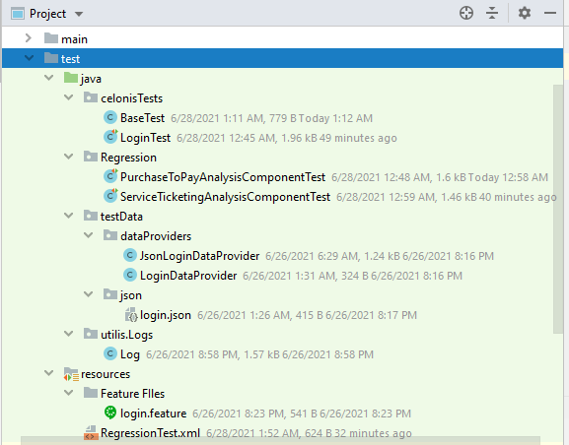

* 1. **POM.xml file**
     1. **Plugins**:
* compiler
* Surefire plugin: not compelted

Note:

Using below config, i got error and i did have enough time to trace it.

<**plugin**>

<**groupId**>org.apache.maven.plugins</**groupId**>

<**artifactId**>maven-surefire-plugin</**artifactId**>

<**version**>3.0.0-M5</**version**>

<**configuration**>

<**groups**>componenet</**groups**>

<**systemPropertyVariables**>

<**browser**>chrome</**browser**>

</**systemPropertyVariables**>

<**suiteXmlFiles**>

<**file**>src/test/resources/ComponentTest.xml</**file**>

</**suiteXmlFiles**>

</**configuration**>

</**plugin**>

However, it worked after removing it from pom and use console command:

**mvn surefire:test**.

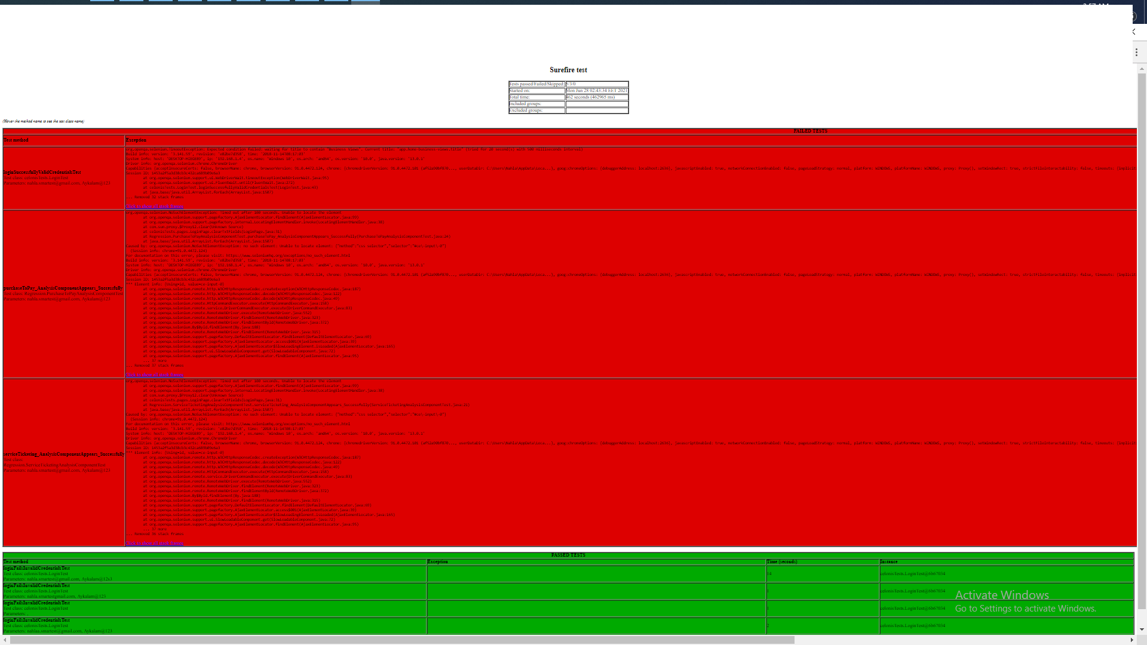

The 2 Testng.xml files (Regression & Componenet) have been executed and i got the report.

* + 1. **Frameworks & Libraries:**
* Selenium
* Testng
* webdrivermanager
* json-simple
  1. **Logs & Reporting**
     1. **Testng**

In Test Output folder, you will find the test report including the log messages using Reporter class.