CineReview
Movie Review Web Application

CST8326 Web Programming
Algonquin College
Group 40
Nahoum Legesse
Boris Gueye
Ruoyu Gong
Michel Lienou Zeitcheu
3 April 2026

Table of Contents
1. Project Overview 3
2. Sitemap 4
3. Wireframes 5
4. Task Breakdown 11
5. Application Features 11
6. Installation and Setup 12
Prerequisites 12
Step 1 — Extract the Project 12
Step 2 — Edit the .env File 12
Step 3 — Install Dependencies 12
Step 4 — Start the Server 12
Step 5 — Open the Application 13

1. Project Overview
CineReview is a movie review web application built with Node.js, Express, MongoDB Atlas, and Pug templates. The application allows users to register, log in, browse a collection of movies, search and filter by genre or title, and write, edit, or delete their own reviews.

Movies are pre-loaded into the database automatically on the first server start. All user data and reviews are stored in a cloud hosted MongoDB Atlas database.

2. Sitemap
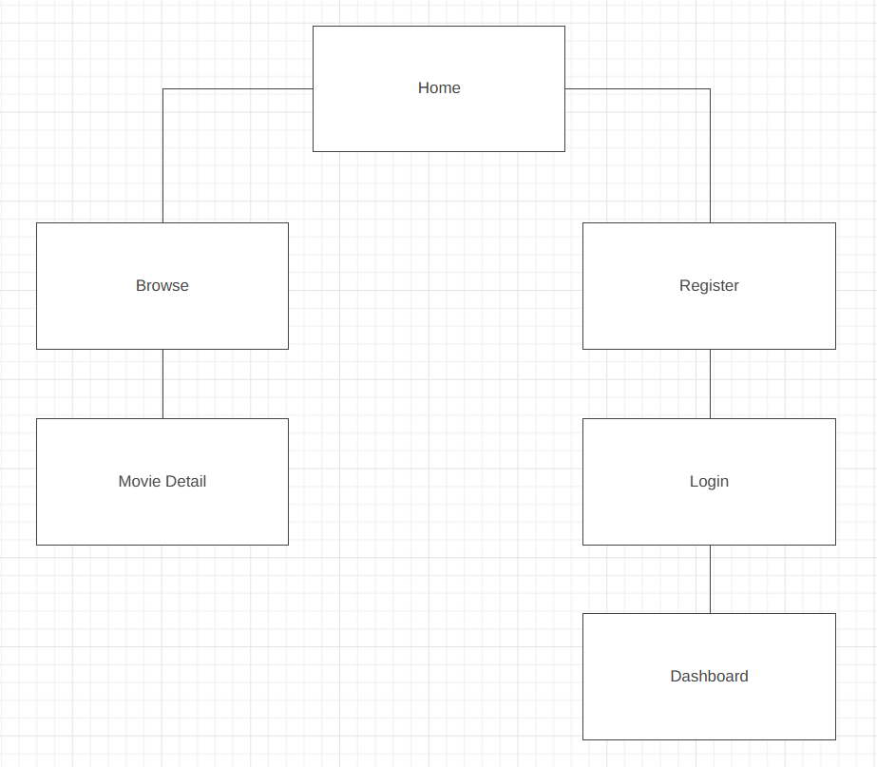

3. Wireframes
Wireframe 1 — Homepage
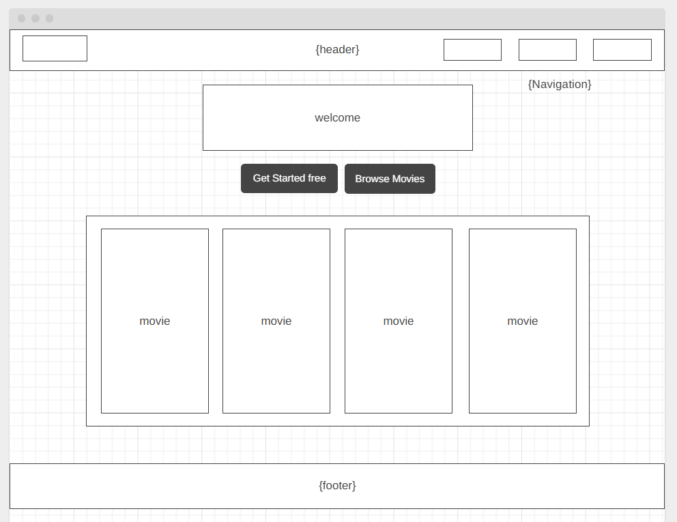

Wireframe 2 — Browse Movies
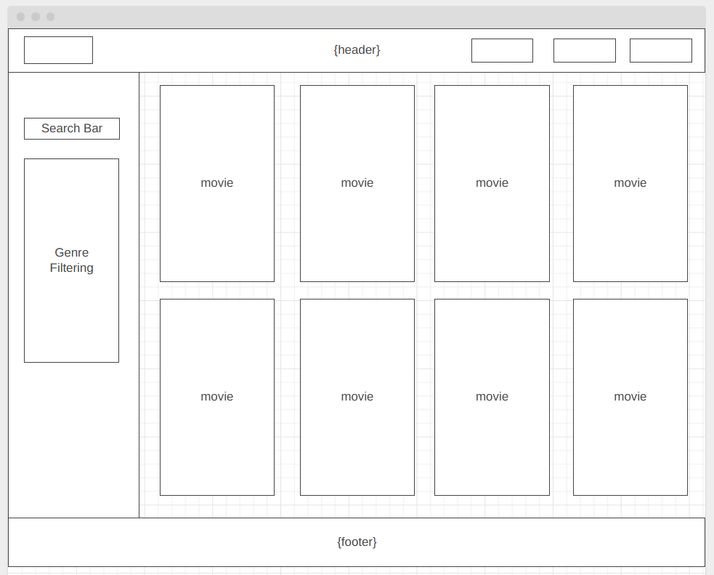

Wireframe 3 — Movie Detail
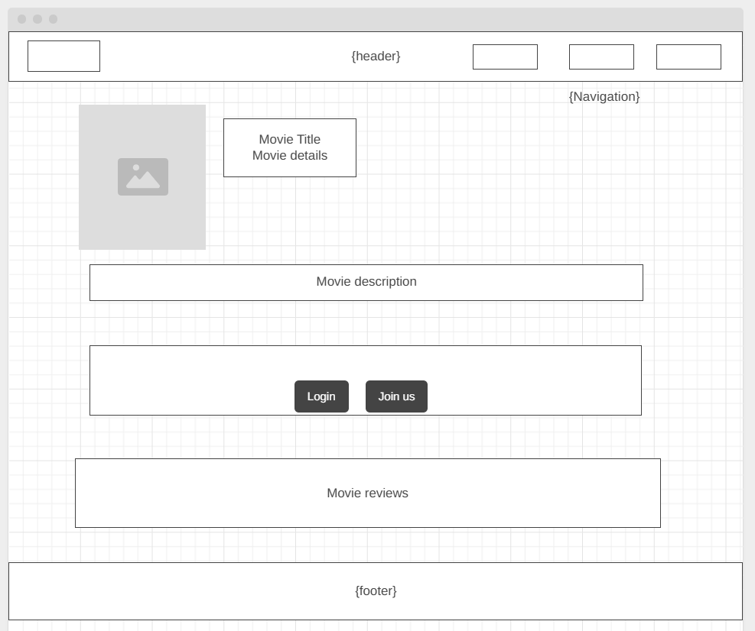

Wireframe 4 — Dashboard
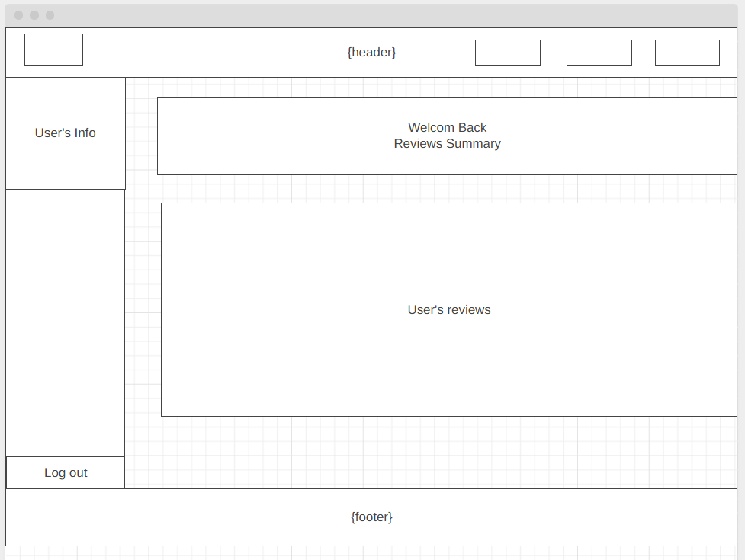

Wireframe 5 — Login
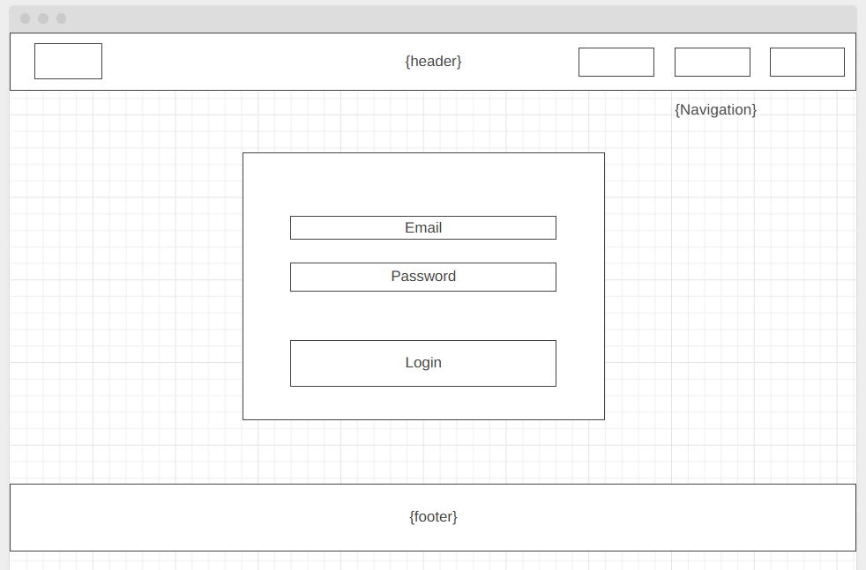

Wireframe 6 — Register
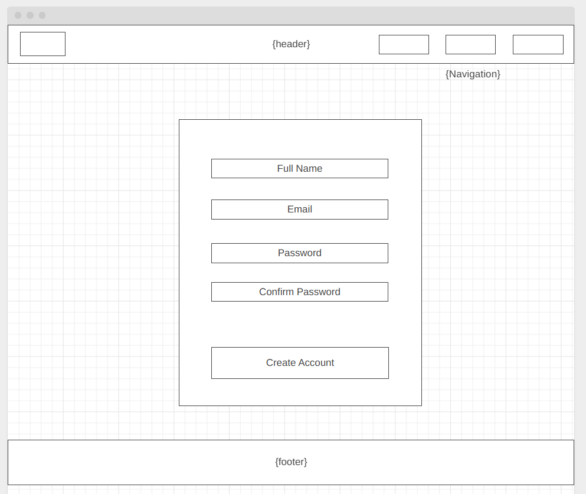
4. Task Breakdown
The following table shows the responsibilities assigned to each group member.

Name | Role | Responsible for
Nahoum Legesse | Auth + Movie Backend | routes/auth.js and movies.js
Boris Gueye | Frontend | public/css/style.css, public/js/*.js, views/*.pug
Ruoyu Gong | Review Backend | routes/reviews.js
Michel Lienou Zeitcheu | Database Structure | models/User.js, Movie.js and Review.js

5. Application Features
- User registration: sign up with name, email, and password. Passwords are hashed with bcrypt.
- User login/logout: authenticate using email and password.
- Browse movies: view all movies in a grid with poster, title, year, director, and genre.
- Search by title: filter the movie grid by typing a title in the search box.
- Filter by genre: filter movies by selecting a genre from the sidebar.
- Movie detail page: view full movie info and all community reviews.
- Write a review: logged-in users can submit a rating (1–5) and written review.
- Edit a review: users can update their own reviews.
- Delete a review: users can remove their own reviews.
- User dashboard: shows the logged-in user's profile and all their reviews.

6. Installation and Setup

Prerequisites
- Node.js version 18 or higher
- A MongoDB Atlas account with the cluster already set up

Step 1 — Extract the Project
Unzip and open the project folder in VS Code.

Step 2 — Edit the .env File
In the .env file, paste your Atlas connection string in the provided space:

MONGO_URI=<paste here>
PORT=3000

Step 3 — Install Dependencies
Open the terminal in VS Code and run the following command once:

npm install

Step 4 — Start the Server
Run the following command to start the application:

node server.js

The terminal should display:
MongoDB Connected
CineReview running at http://localhost:3000

On first run all 16 movies will be loaded into the database automatically.

Step 5 — Open the Application
Open a browser and go to:

http://localhost:3000

To stop the server press Ctrl + C in the terminal.

