Zustand
State Concerns That Don't Need a State Management Library
So, what is this "state" that we want to manage?
Essentially, it's just data. Data that influences how your system works or behaves. When you're eating ice cream, for example, the state of your mind as a system can be defined as:
- In anticipation of eating ice cream.
- Enjoying eating ice cream.
- Satisfied after finishing ice cream.
Or, if we focus on React, it can be:
- The state of a modal dialog's openness (open/closed).
- The state of data fetching from an endpoint (no data/loading data/error happened/successfully loaded data).
- The state of a component's lifecycle (mounted or not mounted).
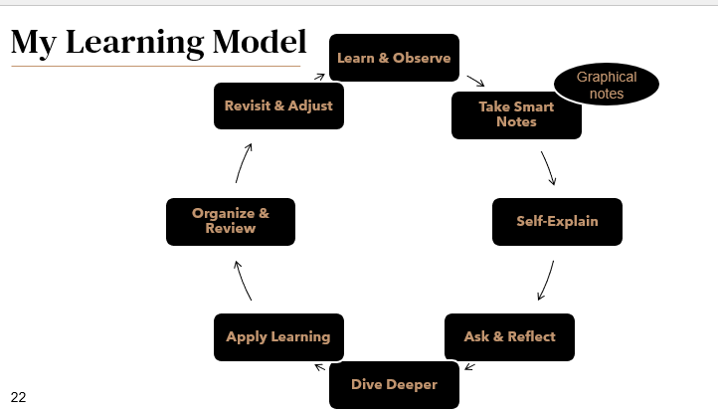Speaking of data and React...
State in React refers to the data that changes over time and impacts what the user sees on the screen.
⚙️ 3️⃣ What is Zustand?
Goal: Introduce the main topic simply.
Slide Title: What is Zustand?
Key points:
- Zustand is a small, fast, and scalable state management library for React.
- It means “state” in German 🇩🇪.
- Created by the same developer who built Jotai and React Spring.
- Uses simple hooks (useStore) instead of complex setup like Redux.
🗣️ Explain it like this:
“Zustand helps React apps manage shared data easily — without the boilerplate of Redux or Context API. It’s lightweight and has a very simple syntax.”

🧰 4️⃣ How Zustand Works
Goal: Show conceptually how it fits inside React.
Slide Title: How does Zustand work?
Key points:
- You create a store (a central place to keep data).
- Components can read and update that store using hooks.
- Zustand automatically re-renders components when the store data changes.
🧠 Example diagram:
Store (global state) ⟷ Component A, Component B
🗣️ Example explanation:
“Instead of passing props down multiple layers, we use a store — a central source of truth. Any component can access it directly using a custom hook like useStore().”
. Introduction to State Management
State management is a crucial aspect of modern web development, especially in complex applications. It involves handling the data that can change over time and ensuring that this data is consistently represented across the entire application. Effective state management leads to more predictable and maintainable applications.
2. Understanding Zustand
Zustand is a small, fast, and scalable state management solution for React applications. Created by Jared Palmer and Daishi Kato, Zustand offers a simple and intuitive API that makes state management less cumbersome compared to other solutions.

. Async is just JavaScript
Normally, some state managers (like Redux) need special setup to handle async actions (e.g., fetching data).
But in Zustand, you can just write normal JavaScript like this:
login: async (creds) => {
const res = await fetch("/api/login", { method: "POST", body: creds });
set({ user: await res.json() });
}
✅ No extra configuration. Just await inside your function — simple.

2. Middleware = built-in add-ons
Zustand lets you easily extend your store with extra features using middleware.
Some popular ones:
- persist → saves your data (e.g. theme, login) to localStorage so it stays after page refresh
- devtools → allows you to inspect your state in your browser (for debugging)
- immer → makes updating state easier and cleaner, without mutating data manually
✅ You can mix and match these like plug-ins — no setup headaches.

3. TypeScript support
If you use TypeScript, Zustand automatically understands what kind of data and actions you have in your store.
That means:
- You don’t have to manually define types everywhere.
- You get autocomplete and error checking for free.
✅ So, less typing, fewer bugs.

