Dilasha Shakya
Lecture Lab 4
Computational Science

Problem 1:
- H = 0.1

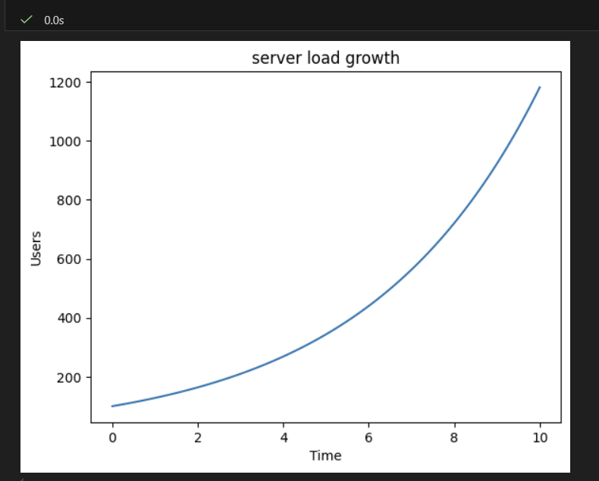

- H = 0.5

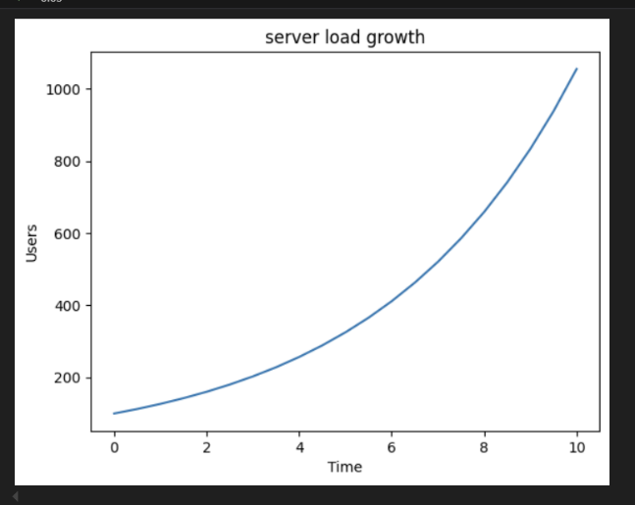

- H = 1.0

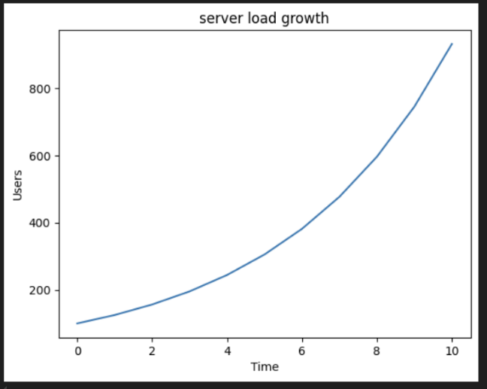

- What system was simulated?
The system checks how users grow in a server load system per time.

- What does the result tell you about the system?
The result shows how user growth increases exponentially on every h value. The systems load can rise very fast and must be handled well to avoid system crashes if looked from a real word perspective.

Problem 2:

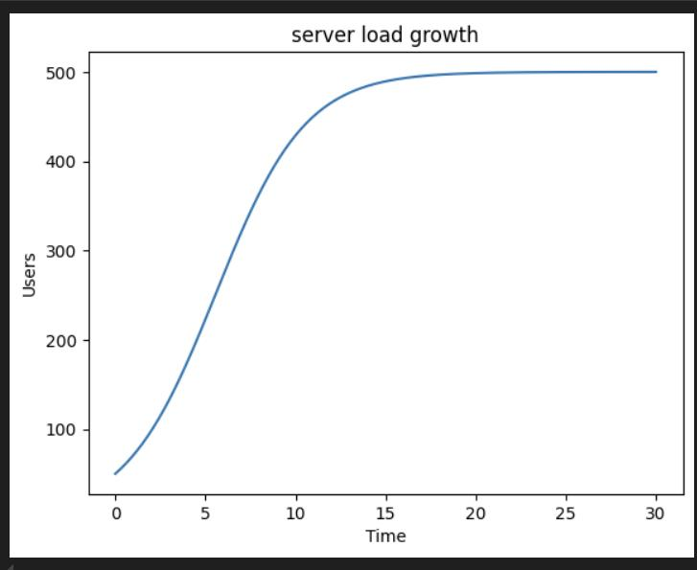
- What system was simulated?
The system models an API server receiving requests but have rate limitations. The request load can grow quickly at first and then seems to be stabilizing later on hinting how server handles incoming requests over time with such limits.

- What does the result tell you about the system?
The results show how the system can rise and perform very well. The rising graph shows how it can handle requests as many and quickly. In real world contexts, it shows how server has maximum capacity and once that has been reached it cannot grow or slow down. Users can use this to see the impact and assess it.

Problem 3:

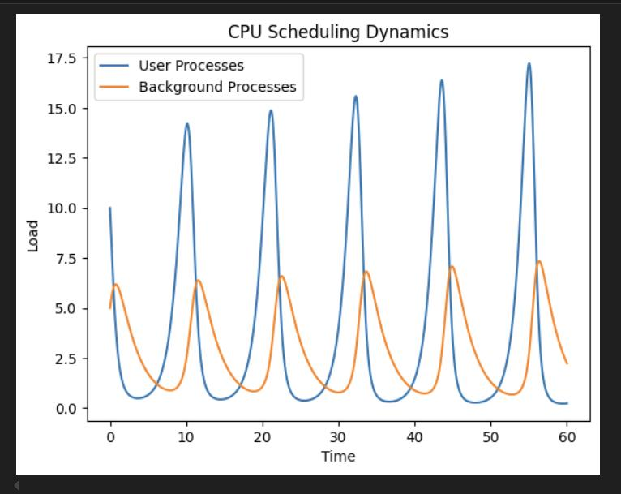

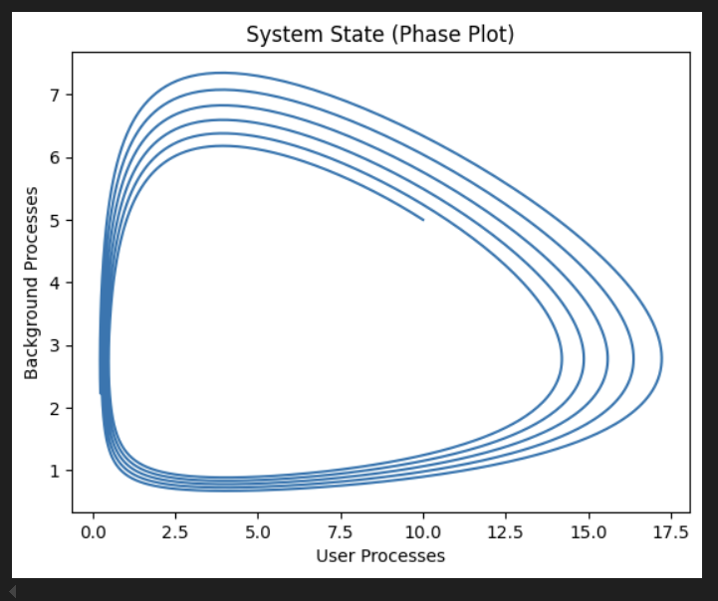
- What system was simulated?
The system models CPU scheduling between user processes and background system processes. It show how CPU handles load over time and how user processes and background processes and handled/switched.

- What does the result tell you about the system?
The graph shows that user activity goes up and down a lot, while background tasks change more slowly. When user activity goes up, background tasks seem to fall behind. When user activity goes down, background tasks catch up. Basically, the CPU focuses more on user tasks first. Background processes come in later.

Problem 4:

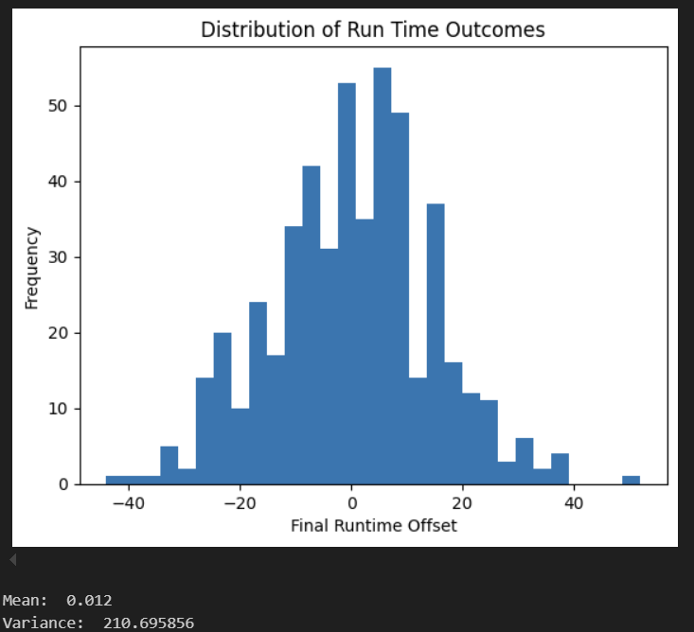

- What system was simulated?
This simulation shows random run times and how they are distributed the system is run many times.

- What does the result tell you about the system?
Even though the runtimes are random, most of them end up being close to the average value. Only a few runs are much faster or much slower but there is clustering in the graph. Running it many times, the results start to form a bell shape. It shows that randomness still follows a pattern overall.

