CS 450 – Topics in Computational Science -Midterm
Dilasha Shakya
Professor: Dr. Koundinya Challa
Question1: Modeling Choices and Assumptions
- System Boundary: The model only looks at crowds in Wissink Hall on the second floor during the afternoons when crowds are busy from their classrooms to the staircase. Variables I could track are
- Number of students
- Classes during the day and their end times.
- Average walking speed
- Deterministic Model: A model with 15 students in each classroom where each student takes three seconds to exit the classroom one by one assuming everyone exits the building without pausing anywhere with constant speed.
Stochastic model: A model where students in each classroom exit the classroom at their own pace, some could be pausing to use the restroom or have a chat while others could be rushing to get to their other class.

- Two assumptions that would break my model in real life are:
- Assuming that everyone walks at the same constant speed would not work in real life. There are times where students talk to the professor, spend time talking with their peers or pausing to look at their phones. Hence, it would never be the same for everyone.
- Assuming that every class ends at the exact times would break the model. Sometimes due to assignments or extra questions, classes end later than the finishing time. In the case that there was a class in the same classroom the class was supposed to be at, it will lead to students waiting outside causing more crowd. Sometimes classes end sooner and students leave the classroom earlier. In the hallways, students could end up falling down, slipping which can add bottlenecks to the assumptions that break the model in real life.
Question 2: Monte Carlo Simulation Reasoning
- This is a Monte Carlo simulation because we are using random numbers to model a real situation. Instead of solving it with one exact formula, we simulate the system many times (10,000 trials) using random values from the given distributions. Then we use the results to estimate the probability of overload.
- One trial represents one possible version of what could happen in the next hour. In that one trial, we randomly generate how many requests arrive and how long each request takes. Here, we are randomly generating the number of incoming requests for each minute using a Poisson distribution (λ = 120), then we randomly generate a service time for each request using the exponential distribution. After this the total busy time is calculated during the hour and divided by total available time which tells us how utilized this trial is.

- If we run 10,000 trials, our answer becomes more reliable as there is less random error, and the estimate goes to become closer to truer probability. It does not improve the model itself in case we have made errors already such as in the server time etc.
- The estimate could still be wrong if the requests don’t follow the distribution in that manner. In the real world, the model could behave the opposite way which can lead to the estimate being wrong.

Question 3: Euler Method and Numerical Errors
- Tn+1​=Tn​+Δt⋅dt/dT​
[Dt/dT​=−0.2(T−10) ]
Tn+1​=Tn​+Δt⋅[−0.2(Tn​−10)]
Tn+1​=Tn​- 0.2Δt(Tn​−Tout​) [tout = 10]
- t1 -> 30 – 0.2 * 1 * 30 -10 = 30 – 0.2 * 20 = 30 – 4 = 26
t2 -> 26 – 0.2 * 1 * (26 -10) = 26 – 0.2 * 16 = 22.8
t3 -> 22.8 – 0.2 * 1 * (22.8 -10) = 22.8 – 0.2 * 12.8 = 20.24
T3 = 20.24 C
- If Δt is too large such as 10, the Euler’s method can give less accurate results because we will be taking very big steps instead of small steps which defeats the purpose of the method. For Euler method works well by using slope to move forward little at a time creating values that are closer to the curve but if we take larger values, we may move too far than the slope. This can lead to values that are larger than the actual value and a model that is unstable.
Question 4: Data Processing and cleaning Logic
- One robust way to make the bytes all numeric is by
- first converting all the values to strings.
- After this we can strip away the spaces.
- The commas in “1,500” can be confusing thus, we can remove all.
- After that, we replace bad values like "N/A", "unknown", "-", or empty values with NaN
- Then we can use the pandas library to convert values to numeric by pd.to_numeric
- The Nan values can then be dropped or converted to 0 .
- Pd.to_numeric tries to convert all the values in the column into numbers. If a value can be converted, it becomes a value such as “1200”. If a value cannot be converted such as Unknown, NA, it becomes NaN. It helps build a numeric value and identify values before hand so any NaN can be removed which helps the system perform better and not crash.
- The spikes in averages could be :
  - Data related: There could be some outliers present which are very large values that after cleaning is used correctly. It could have been a string and not identified before. But after converting to numeric, the value is known and shows spikes visually.
  - Model related: By dropping Nan values or sometimes when replaced with 0 it can change the way data is distributed. Also, if data is grouped differently such as instead of per hour, we do per minute, spikes show up more. In the same way, if we take the data to average peak hours instead of all data, average increase and spikes show up more.
Question 5: Simulation Design
- 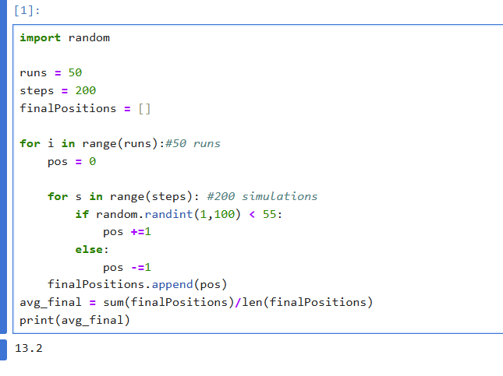
- 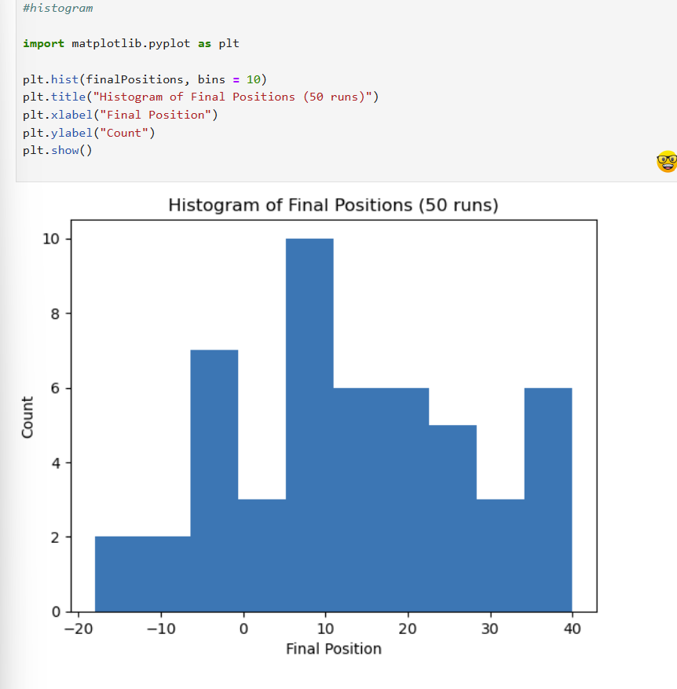
- To determine whether the walk is biased or not, we can look at the histogram. If the values shift more toward the right or left instead of being centered around 0, then the walk is biased. In this scenario, the probabilities were set at 0.55 for +1 and 0.45 for -1, so the bias starts there. If both probabilities were 0.5, then the walk would be unbiased.The average final position is around 13.2, which is positive, so the walk is drifting toward the right. In the histogram, there are more values on the positive side than on the negative side. This tells us the walk is biased. If the values were mostly centered around 0, then the walk would be neutral or unbiased.

