Test 1:

History output list appears as it should according to the saved history file.

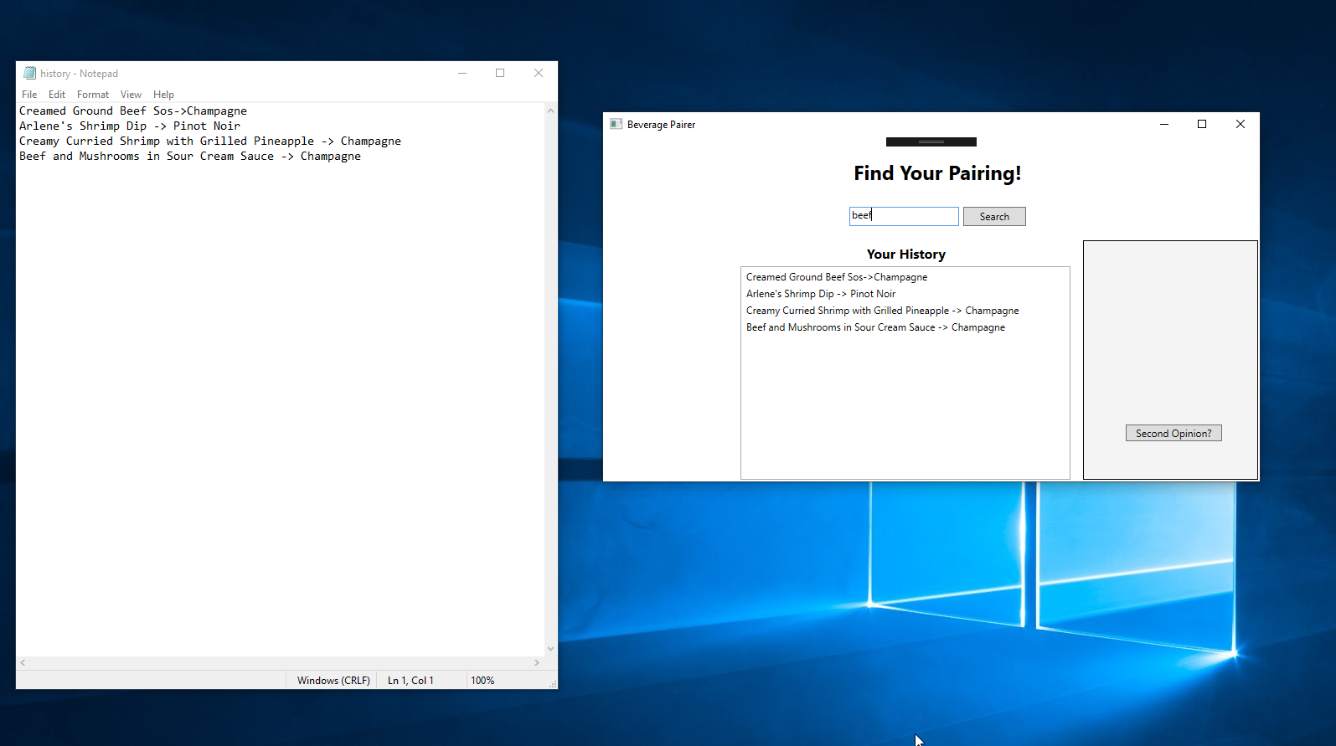

Test 2:

Searching for a beef dish will result in beef related dishes being displayed for selection. 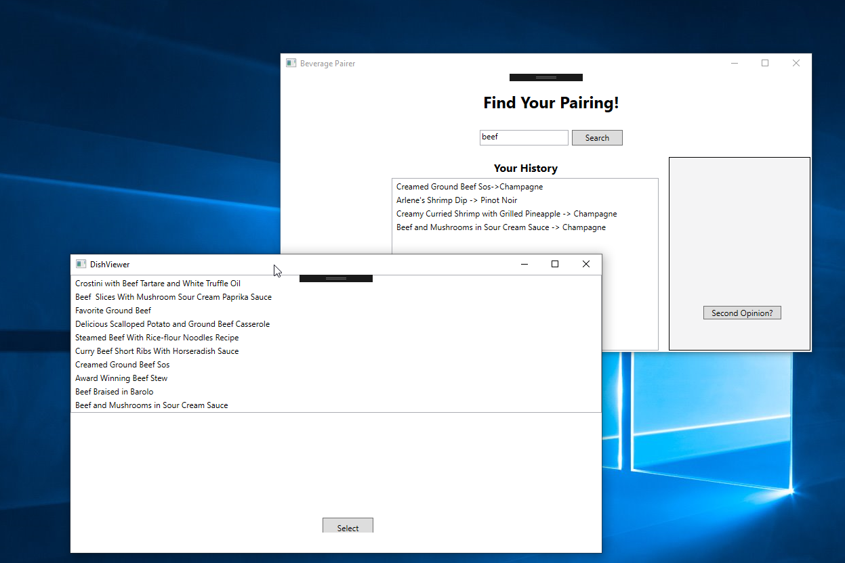

Test 3:

If no dish is selected and the window is minimized, an alert is shown and the program returns to a normal state.

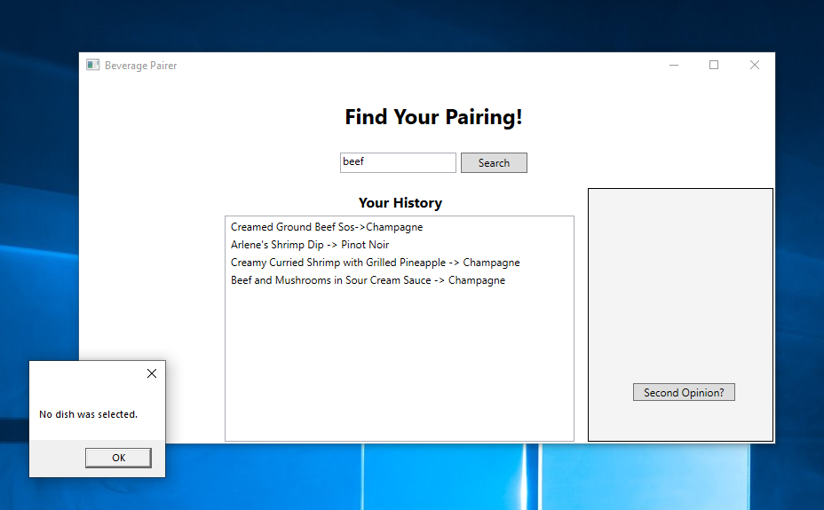

Test 4:

When clicking the second opinion button, a different wine will appear if there is another option available (provided by the ML.NET prediction engine.) If not, then the beverage displayed will be a Merlot.

Pre-Click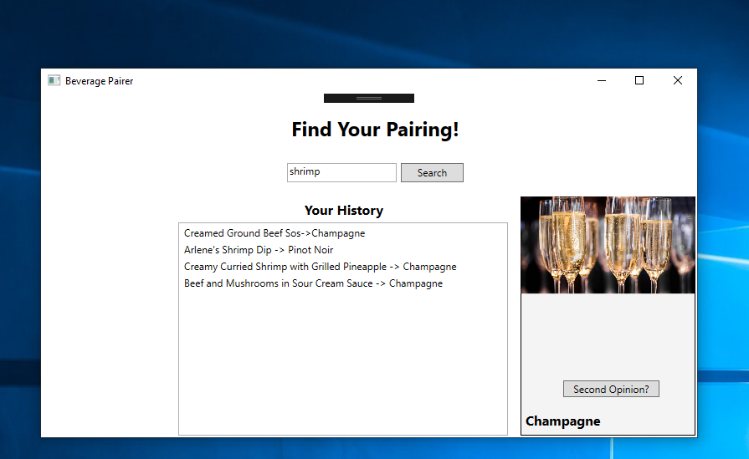

Post-Click