BDA400 – Assignment 2: Technical Analysis using R (Preliminary Stage)
Name: Nahom Naizghi
Course: BDA400 – Data Science Tools and Techniques
Assignment: Assignment 2 – Technical Analysis using R, Preliminary Stage
GitHub Repository:

1. GitHub Repository Setup
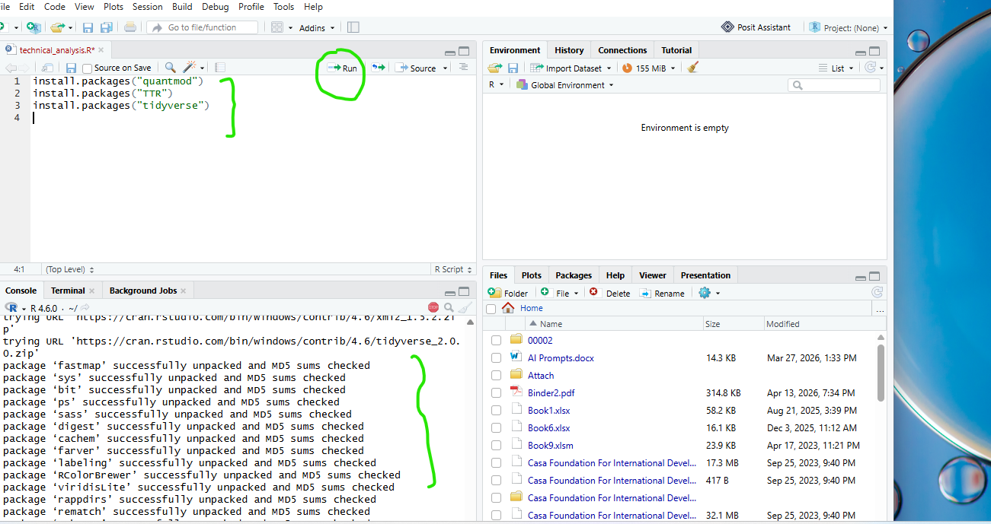
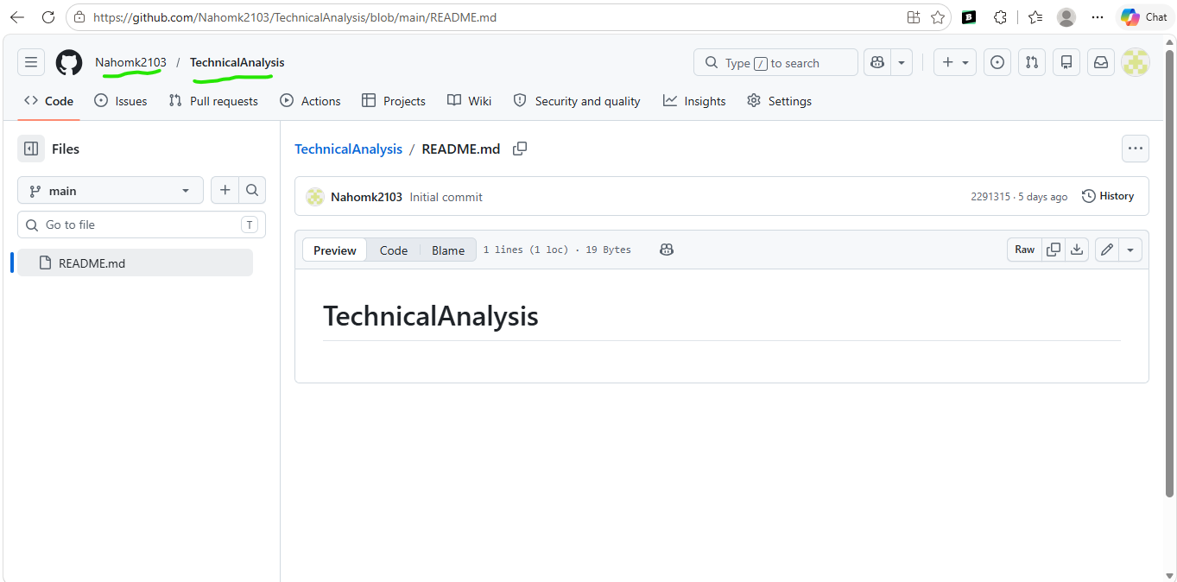

A GitHub repository named TechnicalAnalysis was created to store all assignment files and project documentation.

2. R and RStudio Installation
R download page
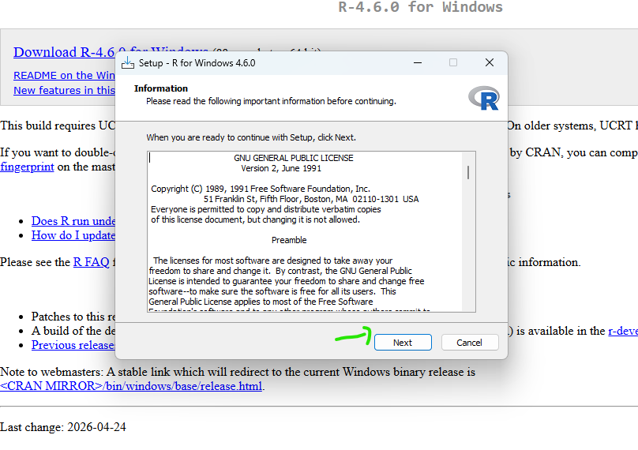
R installation
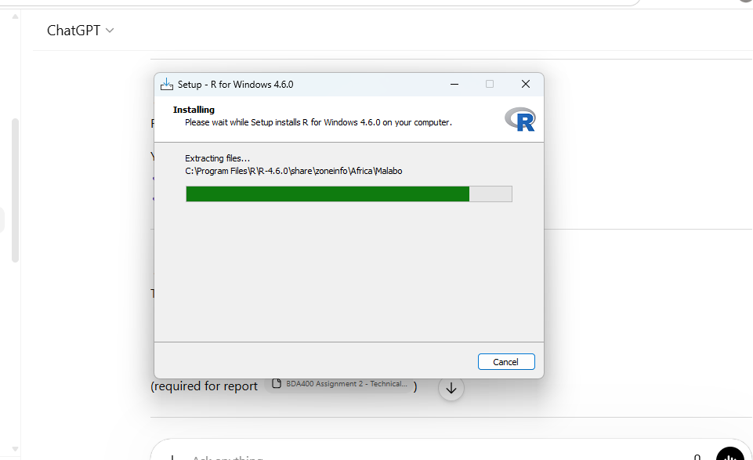

RStudio installation
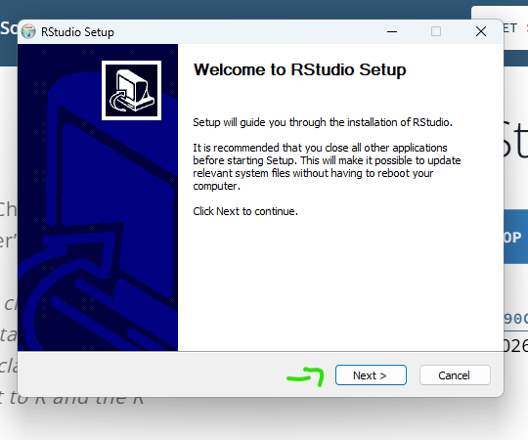
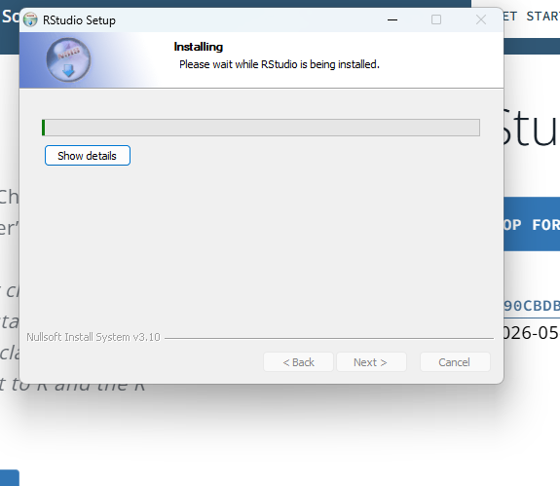

RStudio launched successfully
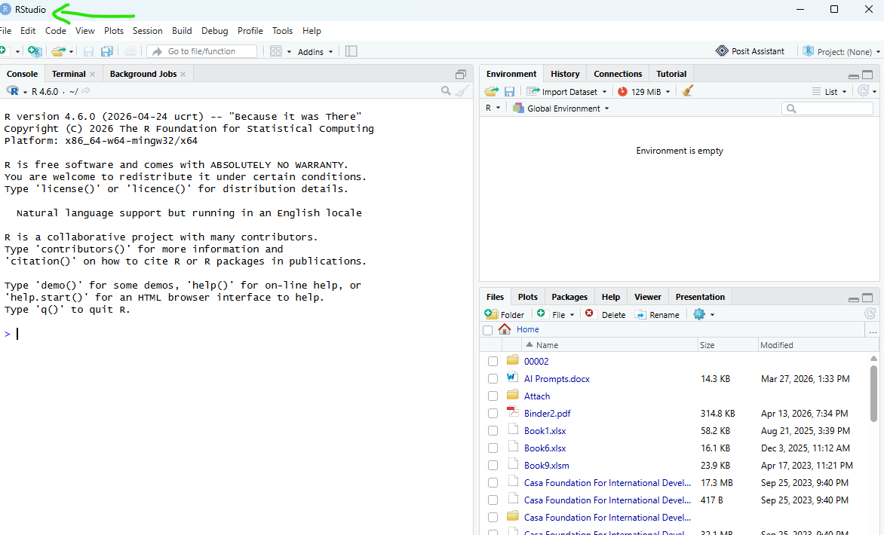
R and RStudio were installed successfully to provide the development environment for technical analysis.

3. Package Installation
Quantmod, TTR, tidyverse installations and successful library loading1
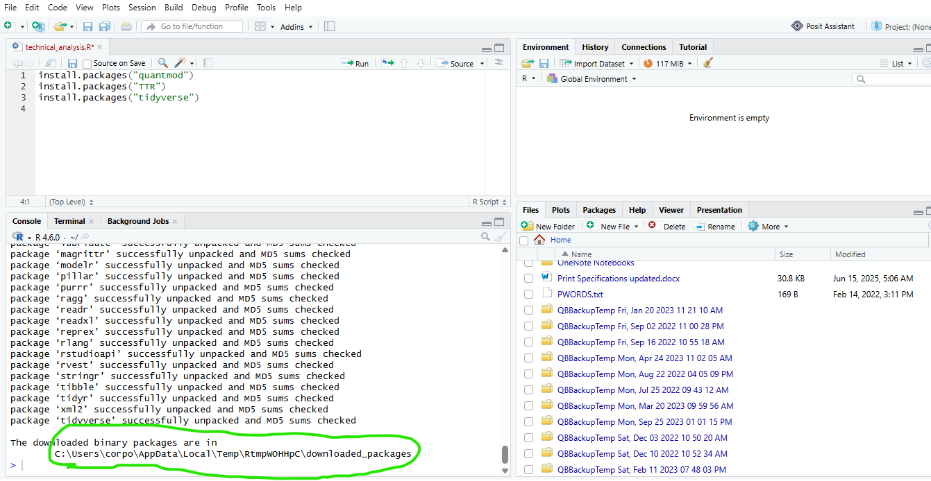
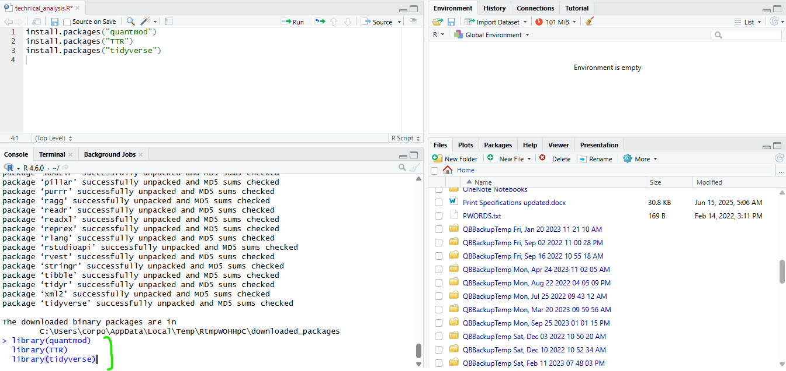
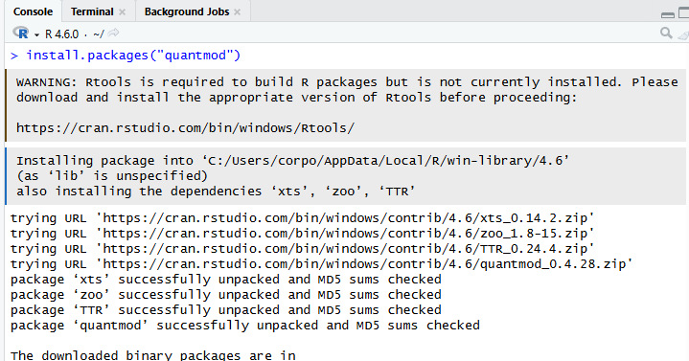
Required packages were installed and loaded successfully.

4. Project Configuration
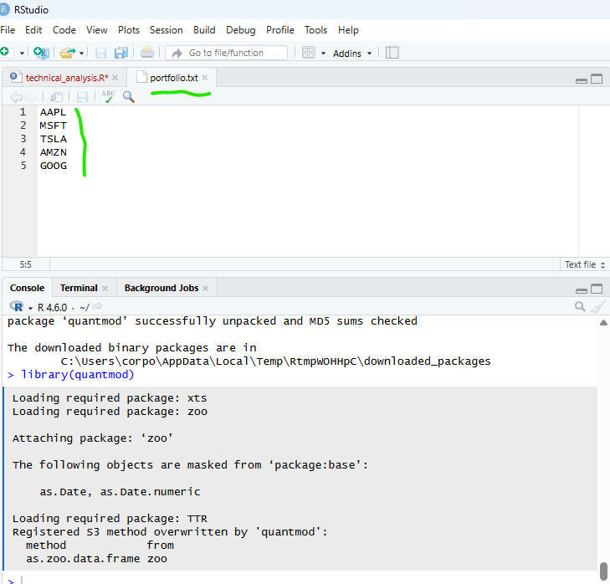
The portfolio file contains the stock symbols used for analysis.
5. Importing Stock Data
Load stock data function
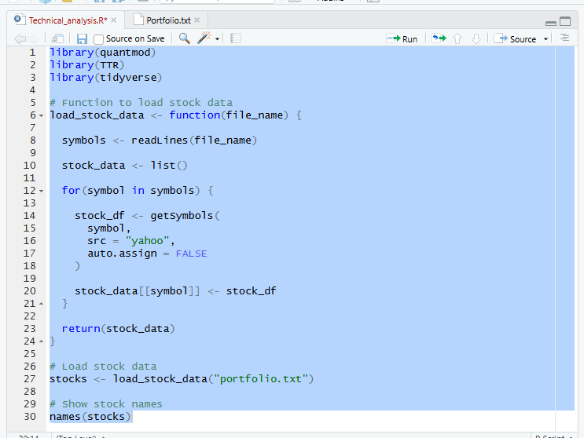
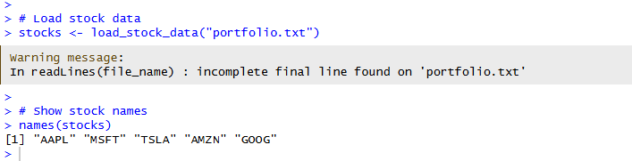
names(stocks) output
Stock data were imported from Yahoo Finance using the quantmod package.
6. Computing Statistics
Calculate statistics function
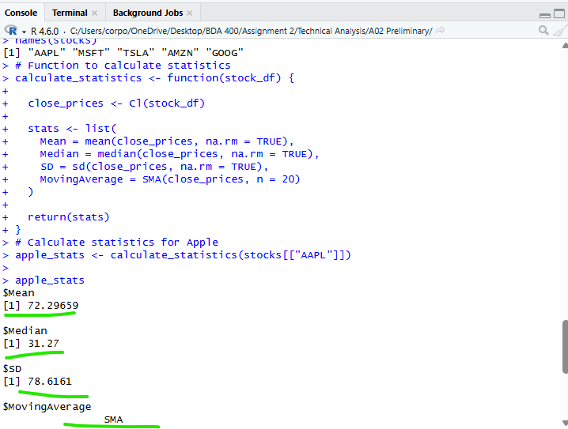

Calculate mode function
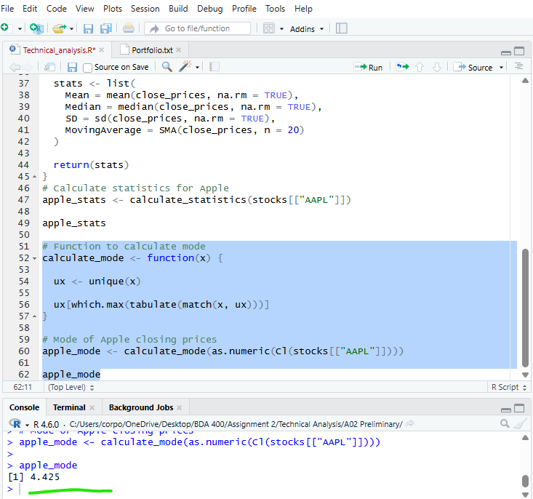
Results from apple stats
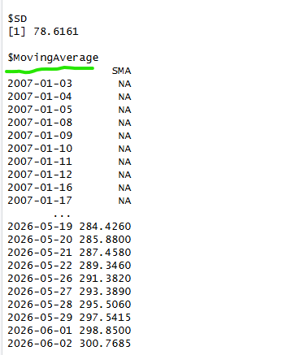

Mean, median, mode, standard deviation, and moving average were calculated for stock closing prices.
7. Data Display and Visualization
Head stocks "AAPL"
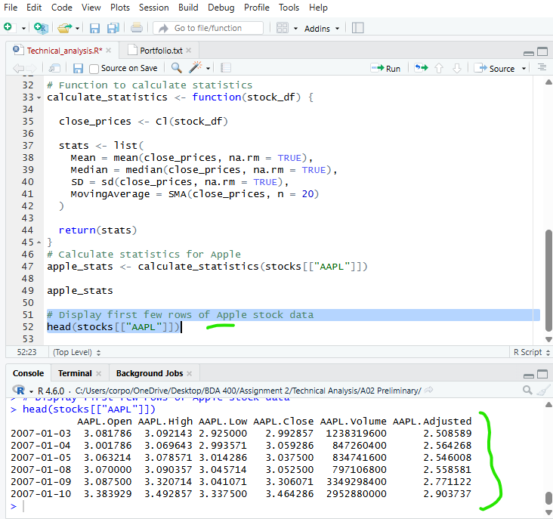

Apple stock chart
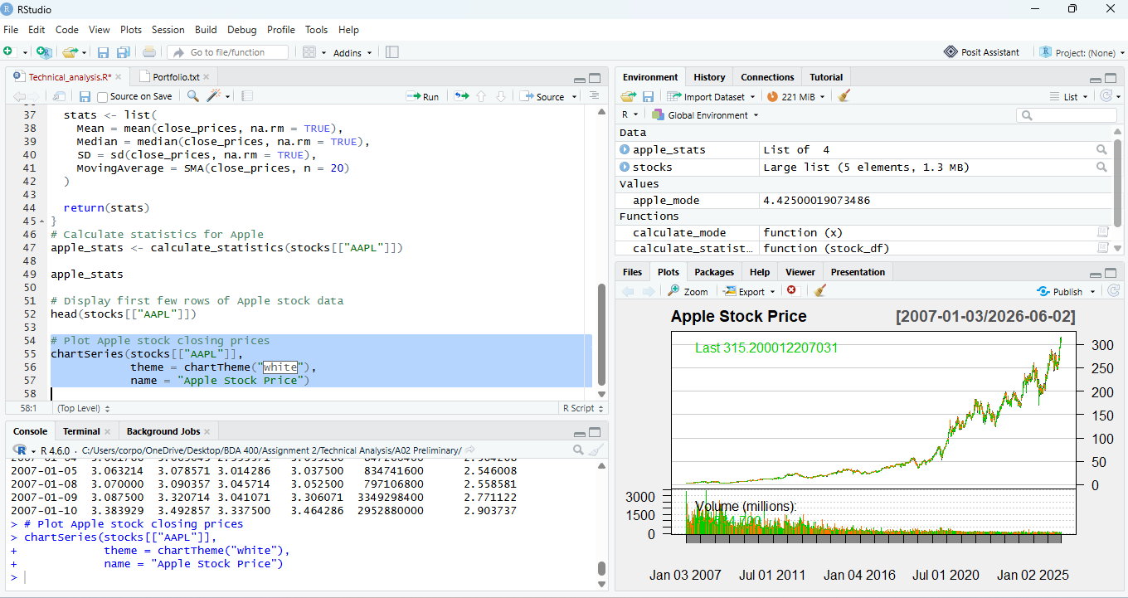
Stock data were displayed and visualized using quantmod charting functions.

8. Conclusion
This assignment demonstrated the setup of a technical analysis environment using R and RStudio. Stock data were imported from Yahoo Finance and analyzed using custom functions to calculate key statistical measures. Visualizations were also generated to support data analysis.

