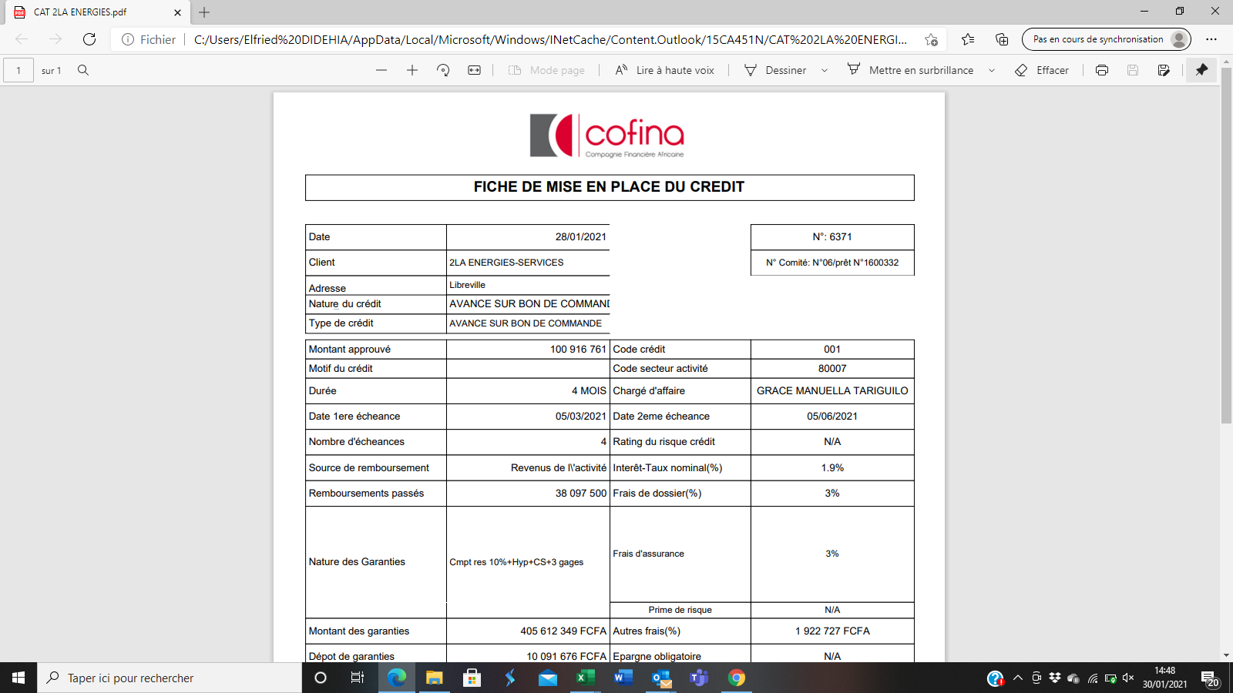

|  |  |  |  |  |
| --- | --- | --- | --- | --- |
| **Date** | **${current_date}** |  | **N° Comité: ${contract.verbal_trial.committee_id}**  **/prêt N°**${credit_number} |  |
| **Client** | **${contract.verbal_trial.applicant_full_name}** |  |  |  |
| **Adresse** | **${contract.representative_home_address}** |  | **Code crédit** | ${credit_number} |
| **Nature du crédit** | **${contract.verbal_trial.type_of_credit.name}** |  |  |  |
| **Type de crédit** | **${credit_type}** |  | **Code secteur activité** | ${code_sector} |
|  |  |  |  |  |
| **Montant approuvé** | **${contract.verbal_trial.amount} FCFA** |  | **Chargé d'affaires** | **${contract.verbal_trial.caf.full_name}** |
| **Motif du crédit** | ${contract.verbal_trial.purpose_of_financing} |  |  |  |
| **Durée** | **${contract.verbal_trial.duration}** MOIS |  | **Date dernière écheance** | **${last_deadline}** |
|  |  |  | **Interêt-Taux nominal (%)** | **${contract.verbal_trial.tax_fee_interest_rate} %** |
| **Date 1ere écheance** | **${first_deadline}** |  | **Frais de dossier (%)** | **${contract.verbal_trial.administrative_fees_percentage}**% |
| **Nombre d'écheances** | **${contract.number_of_due_dates}** ECHEANCES |  |  |  |
| **Source de remboursement** | **${source_of_reimbursement.fr}** |  | **Frais d'assurance** | 3% |
|  |  |  | **Prime de risque** | N/A |
| **Remboursements passés** | N/A |  | **Autres frais(%)** | **${other_expenses}**FCFA |
| **Nature des Garanties** | ${guaranteeList}   * ${type_of_guarantee.name} ${comment}   ${/guaranteeList} |  | **Epargne obligatoire** | 5 000 FCFA |
| **Montant des garanties** | **${guarantee_amount_total}** FCFA |  | **TEG** | N/A |
| **Dépot de garantie** | **${security_deposit}** FCFA |  | **Interêts** | ${contract.verbal_trial.due_amount} FCFA |
| **Etat des garanties** | EFFECTIVES |  | **Frais dossier** | ${contract.verbal_trial.insurance_premium} FCFA |
| **Expiration des garanties** | 01/09/2028 |  | **Frais assurance partenaire** | 57 720 FCFA |
| **Date d'approbation** | **${date_of_approval}** |  | **Frais d assurance Cofina** | 59 280 FCFA |
|  |  |  | **Commission d engagement** |  |
| Autres frais | TVA+CSS |  | **Total** | N/A |
|  |  |  |  |  |
|  |  |  |  |  |
| Date de valeur |  |  | Date d'expiration |  |
|  |  |  |  |  |
|  |  |  |  |  |
|  |  |  |  |  |
|  |  |  |  |  |
| **Visa Dépt Crédit Controle 1** | **Visa Dépt Crédit Controle 2** | **Visa Dépt Operation control** | |  |
|  |  |  | |  |
|  |  |  |  |  |