Table of Contents

Project Description 2
System Design: 2
Functional Requirements: 4

Project Description

A website needs to be developed where the mobile user can recharge the mobile. User can activate any services offered by the company with the help of this website. The website allows paying the Post Paid bill of the mobile, creating account. User has to register their account for using any of the services except the recharge of mobile (i.e. Top up). All the details whether registered user, daily recharge done will be viewed by the Admin.

System Design:

- The Home Page should display the name of the organisation and all the mandatary links required.
- Navigation link such as:
  - Online Recharge
  - My Account
  - Post Bill Payment
  - Feedback
  - Site Map
  - About Us
  - Contact Us
  - Customer Care
- When the user clicks on Online Recharge Tab
  - It must first ask the mobile number (10 digit validation) and then click on Proceed button.
  - Then it must show this links
    - Top Up :
      - It should list all the talk time available in the tabular fashion and user can select the appropriate one.
      - Once they select the required data they need to click on “SUBMIT BUTTON”.
      - Then it should ask to proceed with the Payment.
      - User has to complete the payment details.
      - Once the payment is done a transaction script must display on the screen which the user can take the print out or cancel as per the wish.
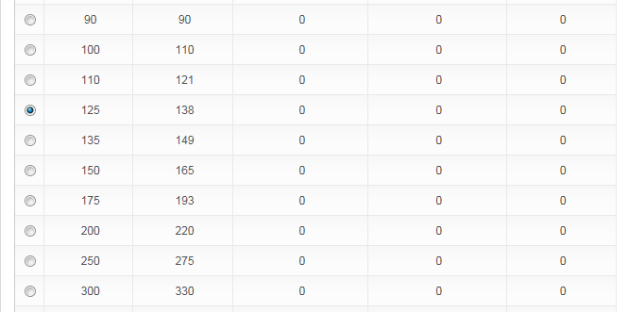
    - Special Recharge:
      - It should list all the Special Recharge available in the tabular fashion and user can select the appropriate one.
      - Once they select the required data they need to click on “SUBMIT BUTTON”.
      - Then it should ask to proceed with the Payment.
      - User has to complete the payment details.
      - Once the payment is done a transaction script must display on the screen which the user can take the print out or cancel as per the wish.
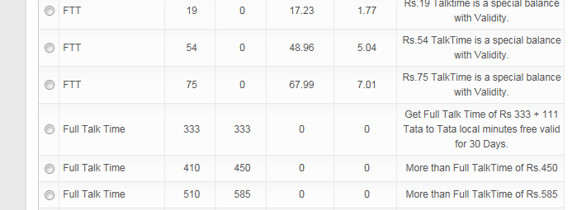
  - My Account:
    - It must allow the user to create the account where username must be there mobile number details.
    - User must able to activate services such as
      - Do not Disturb
      - Caller tunes
      - Online Recharge (same as above)
    - Edit Personal Details
  - Post Bill Payment:
    - Here the user can enter the post paid mobile number and pay the bill online.
  - Feed Back :
    - To take the feed back from the user
  - Site Map:
  - About Us:
    - Must display the About us message
  - Contact Us:
    - Must display the Contact details of the entire Mobile centre.
  - Customer Care:
    - Must display the customer care number.

Note : Constraint Validation must be provided for accepting the correct details.

Functional Requirements:

Here the website will have two logins:
- Admin Login:
  - To view the entire transaction details done daily
  - To view the details of the registered users.
- User Login :
  - For using the services mentioned above
- Guest Users:
  - They can view the site details
  - Can provide feedback
  - Also can perform the activity of Online Recharge.

