|  |  |
| --- | --- |
|  | **FPT ACADEMY INTERNATIONAL**  **FPT – APTECH COMPUTER EDUCATION** |

**Centre Name: ACE-HCMC-2-FPT.**

**Address: 590 Cach Mang Thang 8, District 3, Ho Chi Minh City, Viet Nam.**

**[Thrif Fashion]**

|  |  |  |
| --- | --- | --- |
| **Team:** | T1.2203.M1 | |
| **Order:** | **Full name** | **Roll No.** |
| 1. | Lâm Quế Phương | Student1370221 |
| 2. | Nguyễn Thảo Trí | Student1371439 |
| 3. | Huỳnh Minh Quân | Student1373762 |
| 4. | Nguyễn Quí | Student1373753 |
| 5. | Lê Việt Hải Dương | Student1373756 |
| 6. | Trần Gia Bảo | Student1370236 |

Month **08** Year **2022**

# Content

Content 2

Acknowledge 3

Synopsis 4

Review 1 5

Problem Definition 6

Customer Requirement Specifications 7

Architecture and Design of the project 10

Site map 10

Screen shots 11

Home 11

Product 12

About Us 13

Contact Us 14

Shopping Cart 15

Task Sheet 16

Review 2 17

Home 18

Product 19

About Us 20

Contact Us 20

Shopping Cart 21

Task Sheet 22

Final Checklist 24

# ACKNOWLEDGE

As we understand this competition is another way to learn by building a website that is 80-90% similar to the websites many companies have. It was a project where we had to execute the processes as if we were building a website that our client wanted. The benefits of doing take part in this project are:

* Being able to make a plan for the whole process
* Enhance skills and value
* Have the opportunity to find more ways to build a website in a more minimalist way
* Improve group-work skill
* Learn how to express what we do in our project through words
* Work on real-life projects
* Able to use a different program to design layout
* Understand how important self-learning is during the main course

We want to thank all professors, who supported us during the project when we had any problems.

During the project, we made several mistakes and that is an enormous experience for us to widen our knowledge in web development.

Last but not least, we extremely appreciate that India Aptech has allowed us to study and do this project. We will take advantage of this opportunity to learn as much as we can and do our best so that in the future, we will be able to succeed and proud that we are studying at Aptech.

# SYNOPSIS

This project is given to students who have completed the HCJS and AJS courses. However, during the activity, students were able to find and use more languages that support us to gain more information.

The objective of this program is to give a sample project of working on a real-life project. We have to make a plan and follow it step-by-step to get the result and understand how important to work as a team to create a useful and large website.

Before starting to take part in the process, students have to be able to use HTML, Javascript, and AngularJS to build the web. Another no less important is understanding English so that can get what the project required and do the report.

During the development, students need to update the process frequently and come to lab sessions with the assistant based on the schedule. Also, the report is required.

After finishing the website, the advantages that students will take are:

* Understand the process of building the website
* Able to express logical things through words by giving presentations and writing report
* Can write the essay to express what have done
* Have experience in web development
* Team-work experience

# REVIEW 1

# Problem Definition

People often discard clothing items when they are no longer in use. They buy clothing from malls, online retail stores, or regular neighborhood stores and later, when these clothes outgrow their utility, they throw them away or dump them in bins. This has even happened in the case of high cost clothing. People who can afford expensive fashion typically do not like to repeat their outfits. They move on to buy newer items barely after using current items on two or three occasions. The older ones are then just discarded. This causes burden on the planet because as the number of such discarded fashion (which is still in good condition, nevertheless) increases, the effort to dispose them also increases. These days, recycling, sustainability, and reuse are not just buzzwords, but actionable behaviors to support a better planet. Instead of discarding clothes that are still in good condition, but no longer required by the original buyers, these clothes can be sold as thrift fashion or pre-used clothing. In simple terms, shopping for thrift fashion is second hand purchases for fashionable clothing. This supports the theme of recycling and sustainability and is also affordable by many who otherwise could not purchase new fashionable clothing

# Customer Requirement Specifications

|  |
| --- |
| **LAYOUT** |
| * **Safe to use:** The system should not result in any malicious downloads or unnecessary file downloads. * **Accessible:** The system should have clear and legible fonts, user-interface elements, and navigation elements. * **User-friendly:** The system should be easy to navigate with clear products/items and other elements and easy to understand. * **Operability:** The system should operate in a reliably efficient manner. * **Performance:** The system should demonstrate high value of performance through speed and throughput. In simple terms, the system should be fast to load and page redirection should be smooth. * **Capacity:** The system should support large number of users. * **Availability:** The system should be available 24/7 with minimum down time. * **Compatibility:** The system should be compatible with latest browsers. |

|  |
| --- |
| **WEBSITE SHOULD INCLUDE** |
| * **Home Page:** It will display menus such as Products, About Us, Contact Us, Feedback, and so on. A few featured products displayed with images and captions will be displayed on the home page. The home page should accept first name from the user and display a personalized welcome message. At the top corner, the user's first name should be displayed for the entire duration that the portal is loaded. * **Products:** This option will showcase the products one can order online via Thrift Fashion Store. Products can be displayed through an image gallery and can have product information such as availability, stock, price, discount (if any), product description, and so on. * **Find Product:** Using this option, users can search for a specific product that they are looking out for/of their interest. * **Checkout:** This should show the shopping cart contents and total bill based on product price and quantity of products purchased. You need not implement payment functionality; just list the cart contents and compute the bill. * **About Us and Contact Us:** This menu option should display Email id, address, and contact number of the organization who is developing the system. This acts like the Customer Care service, which is available 24/7 to the users in case of any query. |

|  |
| --- |
| **HARDWARE/SOFTWARE REQUIREMENT** |
| **Hardware**   * Intel Core i5 Processor or higher 8 GB RAM or above Color SVGA * 500 GB Hard Disk space Mouse Keyboard |
| **Software**   * Frontend: HTML5, CSS3, Bootstrap, JavaScript, jQuery, AngularJS, Angular9 (optional), and XML 2. * Data Store: JSON/Text |

# Architecture and Design of the project

# 

# Site map



**HTML**

**CSS**

**JavaScript**

**AngularJS**

# Screen shots

# Home

**Description:**  This is a ***Home*** page of Thrift Fashion, at the header area which is on the top contain the logo of the website and the name. Right next to that area is the navigation bar which have Home, Product, About Us and Contact Us. At the end, there is a shopping card. In the main part of this page, first area will be the slider about some images which are related. Below that which will be shown the best seller products and the products that on sale. Finally, in the footer, the way to contact, links related and map to the store.

# Product

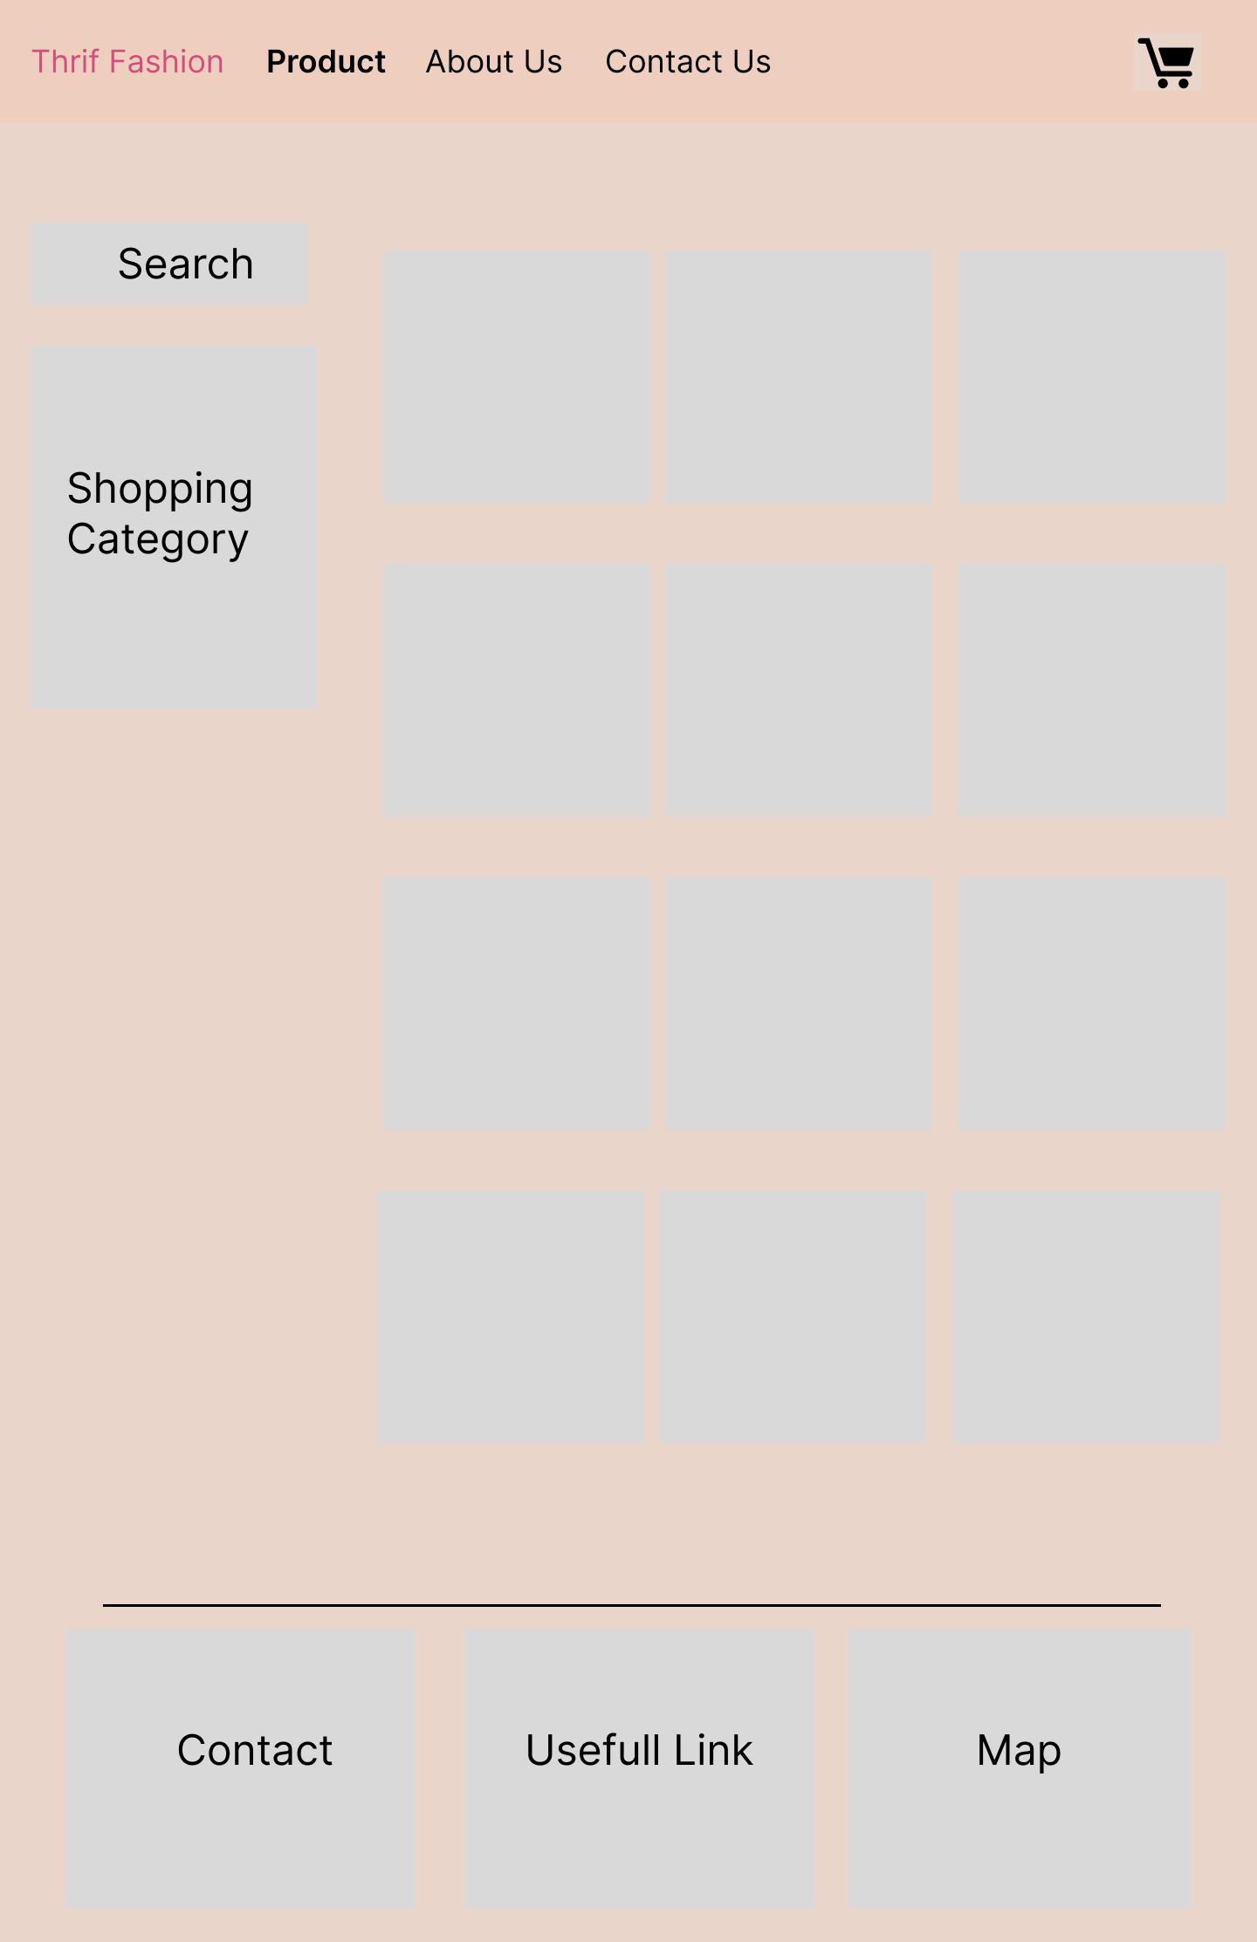

**Description:**  When user click on ***Product*** tag in the navigation bar, it will lead to this page. The main part will have 2 section: the first section on the left will have search bar and the bar to choose the category and on the section on the right, there will show the product which relate to the category we choose.

# About Us

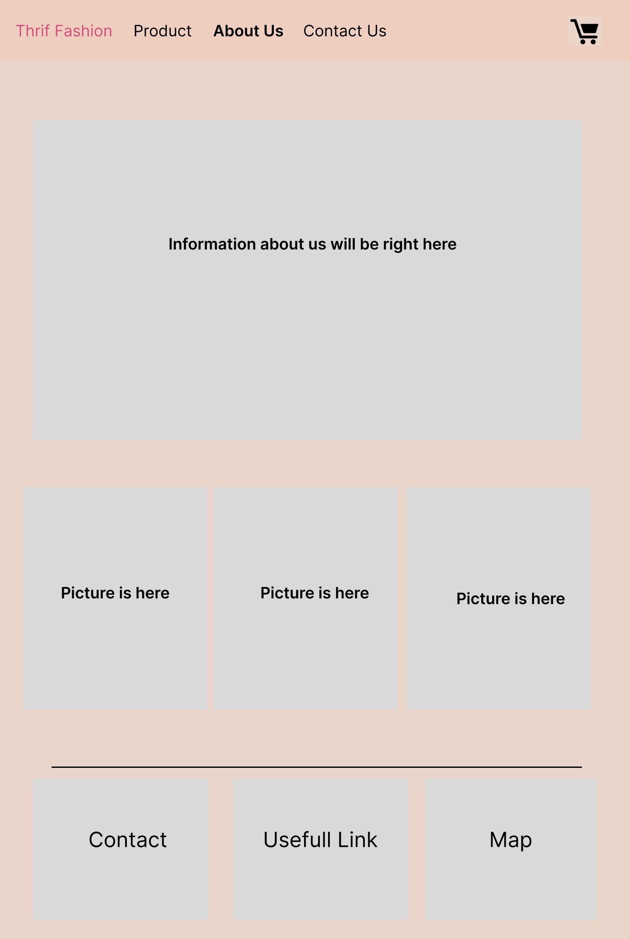

**Description:**  When the user clicks on the ***About Us*** tag in the navigation, this page will appear. At here, all the information about the website will be appear.

# Contact Us

**Description:** After the ***Contact Us*** tag is clicked, the page which contain the contact form will be appear.

# Shopping Cart

**Description:** After the ***Shopping Cart*** tag is clicked, the page which contain all the products customer choose and the final prize will be appear and right under is a customer right.

# Task Sheet

|  |  |  |  |  |  |  |
| --- | --- | --- | --- | --- | --- | --- |
| **Project Ref No.** | **Project Title – The Nobel Prize** | **Activity Plan Prepared by** | **Date of preparation of Activity Plan** | | | |
| **Task** | **Actual Start Date** | **Actual Days** | **Teammate Names** | **Status** |
| Brainstorming ideas for layouts and Project Object | | Quí, Bảo, Trí, Dương | 10/08/2022 | 1 days | Quí, Bảo, Trí, Dương | Completed |
| Draw site maps and architecture design | | Phương | 10/08/2022 | 1 days | Phương | Completed |
| Wire framing general page layout | | Dương | 10/08/2022 | 1 days | Dương | Completed |
| Collect static assets (pictures, mp4, documentation,…) | | Trí, Bảo, Quí | 10/08/2022 | 1.5 days | Trí, Bảo, Quí | Completed |

# REVIEW 2

# Home

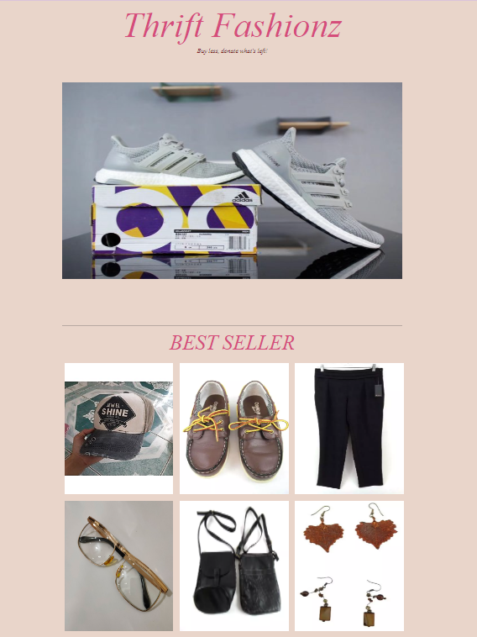

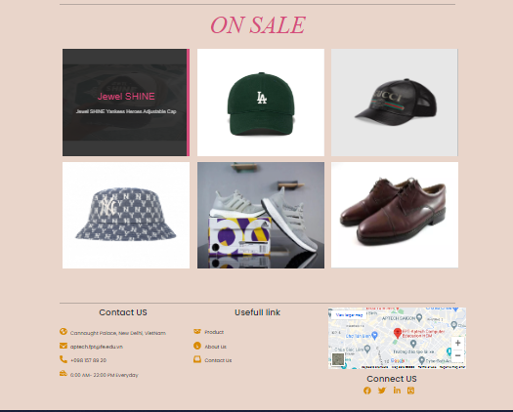

# Product

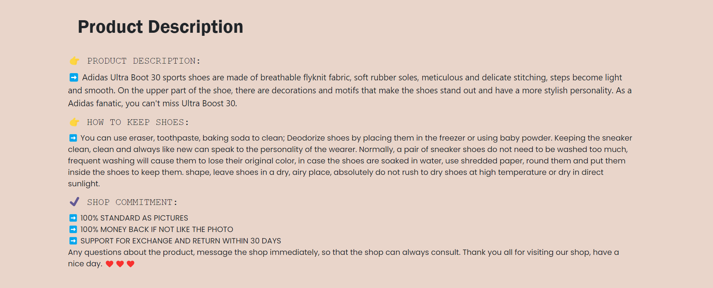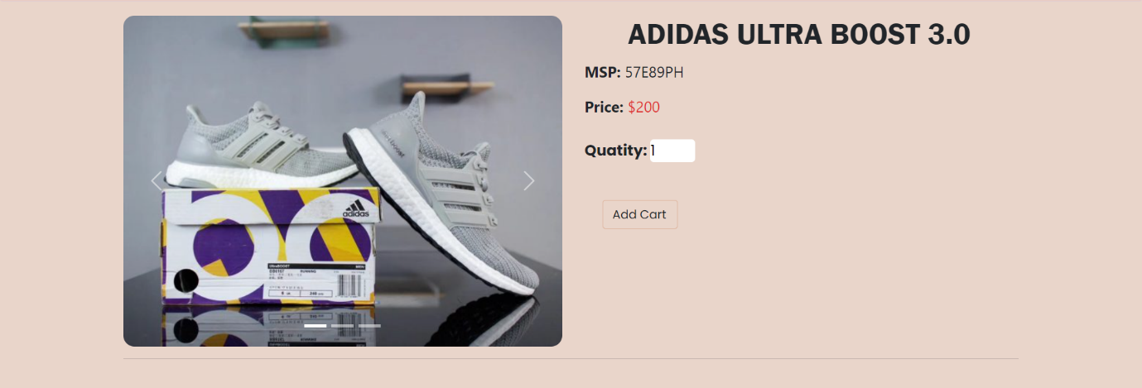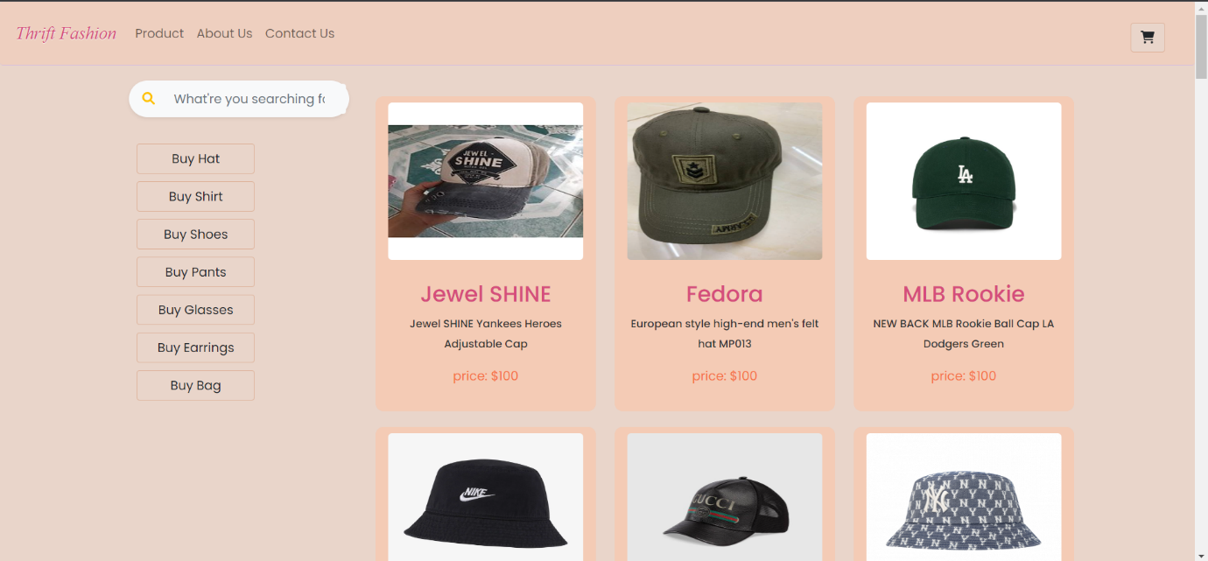Click on the product

# About Us

# Contact Us

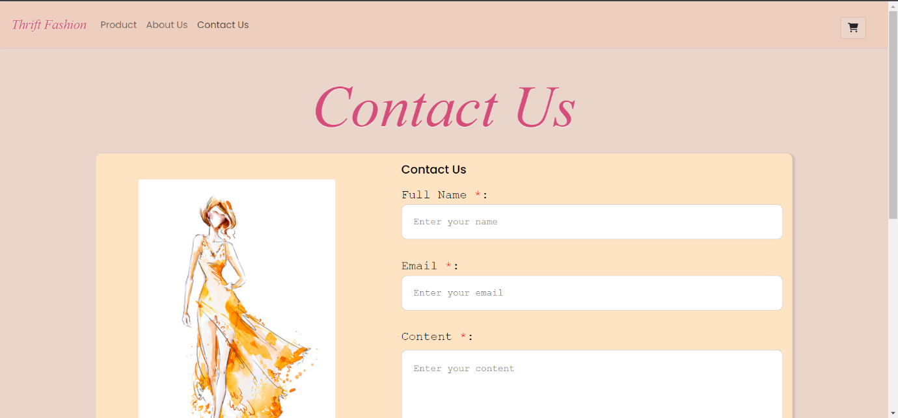

# Shopping Cart

# Task Sheet

|  |  |  |  |  |  |  |
| --- | --- | --- | --- | --- | --- | --- |
| **Project Ref No.** | **Project Title – The Nobel Prize** | **Activity Plan Prepared by** | **Date of preparation of Activity Plan** | | | |
| **Task** | **Actual Start Date** | **Actual Days** | **Teammate Names** | **Status** |
| Design & Built Home | | Phương | 11/08/2022 | 1 days | Phương | Completed |
| Design & Built Product | | Quí, Quân | 11/08/2022 | 2 days | Quí, Quân | Completed |
| Design & Built About Us | | Bảo | 11/08/2022 | 2 days | Bảo | Completed |
| Design & Built Contact Us | | Bảo | 11/08/2022 | 2 days | Bảo | Completed |
| Design & Built Event | | Khiêm | 11/08/2022 | 2 days | Khiêm | Completed |
| Design & Built Shopping Cart | | Trí, Dương | 11/08/2022 | 3 days | Trí, Dương | Completed |
| Design & Built Footer | | Bảo, Trí | 11/08/2022 | 1 day | Bảo, Trí | Completed |
| Design & Built Header | | Dương | 11/08/2022 | 1 day | Dương | Completed |
| Push to Github host | | Dương | 13/08/2022 | 1 days | Dương | Completed |
| Write Project Report | | Phương | 13/07/2022 | 1 days | Phương | Completed |

# Final Checklist

|  |  |  |  |  |
| --- | --- | --- | --- | --- |
| **Sr.No** | **Features Tested** | | | **Remarks** |
| 1 | Are all the users able to view the images and links? | | | OK |
| 2 | Have all the views, modules and controllers been | |  | OK |
| properly integrated and is the site function as a single | | |
| page application? | |  |
| 3 | Are the GUI content devoid of spelling mistakes? | | | OK |
| 4 | Is the application user-friendly? | | | OK |
| 5 | Is the Website launching correctly in all popular | |  | OK |
| browsers? |  |  |
| 6 | Are all the forms validated with proper criteria? | | | OK |
| 7 | Do all text links lead to the appropriate website? | | | OK |
| 8 | Do all image links lead to the appropriate website? | | | OK |
| 9 | Are all the images and links clearly visible on the page? | | | OK |
| 10 | Does the Web page work properly in all the tested | |  | OK |
| browsers? |  |  |
| 11 | Does the Web page take too long to be loaded fully? | | | OK |
| 12 | Is the navigation sequences correct through all the Web | | | OK |
| pages on the site? | |  |
| 13 | Is the JavaScript code working as expected in all click | | | OK |