***Lab 4 –UML Modelling***

***Answer the following questions.***

1. Given the following use case diagram. Explain the UML elements.

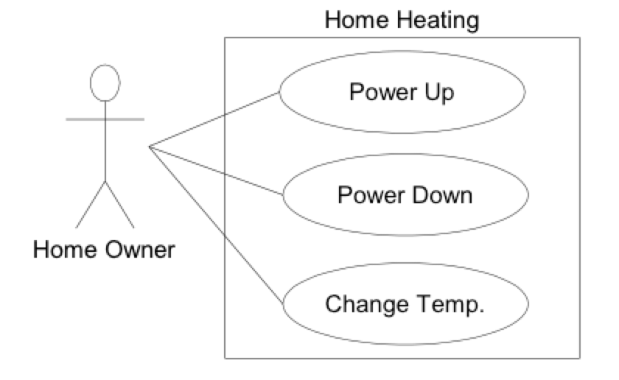

1. What is the main purpose of use case modeling?
2. Specify the situation for the following UML notations where it would be sensible to use these elements to structure your use case.
   1. <<include>>
   2. <<extend>>
3. Suppose you plan to develop application for an alarm clock. The clock shows the time of day. Using buttons, the users can set the hours and minutes fields individually and choose between 12 and 24 hour display. It is possible to set one or two alarms. When an alarm fires, it will sound some noise. The user can turn it off, or choose to “snooze”. If the user does not respond at all, the alarm will turn off itself after 2 minutes. “Snoozing” means to turn off the sound, but the alarm will fire again after some minutes of delay. This “snoozing time” is pre-adjustable. Identify the top-level functional requirements for the clock, and model it with a use case diagram.

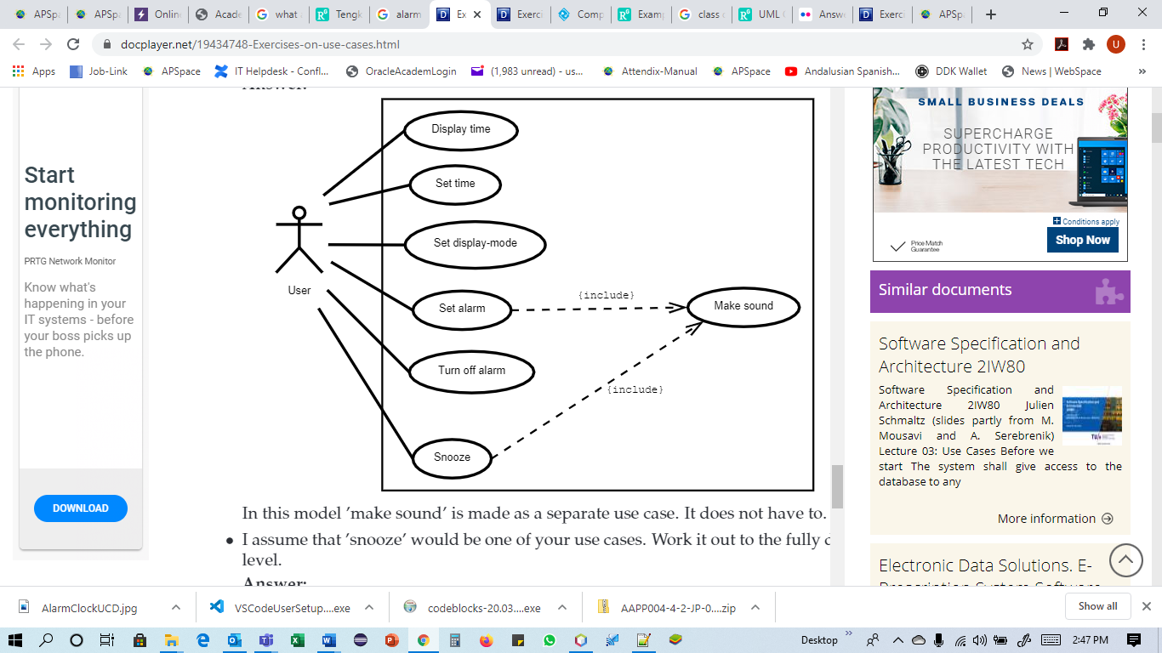

Alarm Clock