***Lab 7 –Abstract Class and Interfaces***

***Answer the following questions.***

Instructor-led Demo:

1. Write a program that handles employees’ salaries and workloads. There are part time and full time employee and they are payable with salaries. The salary for full time employee will be paid as monthly basis and part time employee will be based on hourly worked. There is a kind of employee (Assistant) which is not payable. All employees are required to work a certain number of hours depending on the type of employee. Part time work not more than 6 hour a week, full time work 40 hours a week and assistant work only 2 hours a week.

Exercise:

1. Consider the UML diagram:

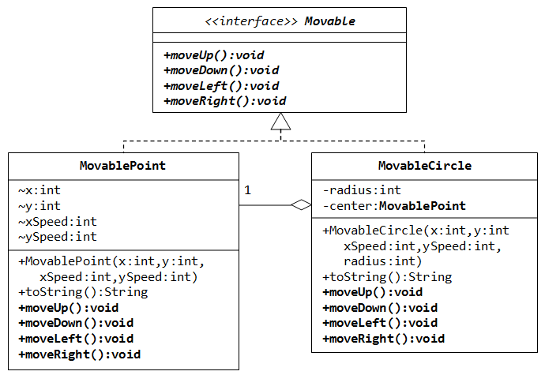

Write a program that demonstrate Movable interface and MovablePoint and MovableCircle classes. State any assumption for your program.

1. Modify the Lab 6-Q2 (Exercise), according to the UML diagram below:

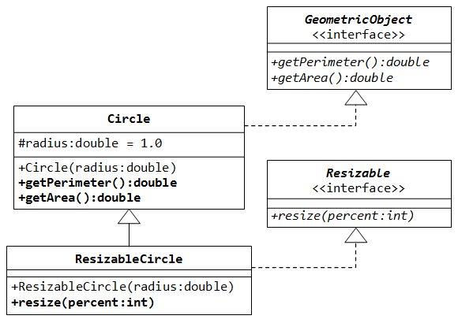

Write a test program called TestResizableCircle to test the method defined in ResizeableCircle.