***Lab 8 –Java GUI Development***

***Answer the following questions.***

Instructor-led Demo:

1. Write a program that creates a JFrame for system login. The form/UI has username and password textfields, and a login button. Display a message box when the button is clicked. Note that the login authentication or authorisation can be hardcoded in this demo.

Exercise:

1. Write a program that adds a group of radio buttons to select background colours. The available colours are red, yellow, white, gray, and green.

1. Write a program that creates a simple calculator performs add, subtract, multiply and divide operations.
2. Write a program that converts miles and kilometres. If you enter a value in the Mile text field and press that Enter key, the corresponding kilometre is displayed in the Kilometer text field.
3. Write a program that calculates the future value of an investment at a given interest rate for a specified number of years. The formula for the calculation is as follows:

futureValue = investmentAmount * (1 + montlyInterestRate)years*12

Use text fields for interest rate, investment amount, and years. Display the future amount in a text field when the user clicks the Calculator button.

1. Create a JFrame form that display the following JComponent objects (JLabel, JTextField, JButton, and JTable).

Handle the events for Add, Edit and Delete buttons.

1. The Add button inserting each JTextField's value to a row of JTable.
2. The Edit button modifying the record in the JTable.
3. The Delete button removing the record of JTable.

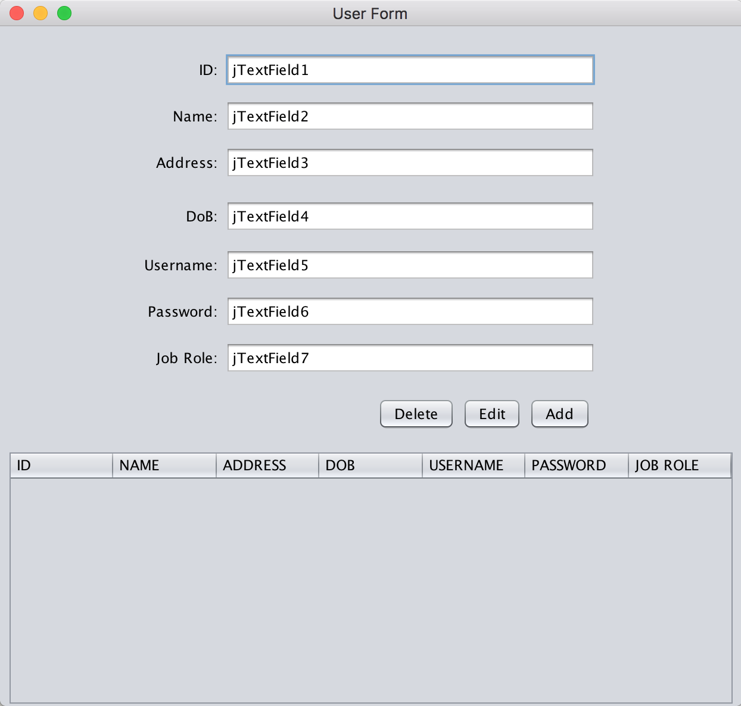

Figure 1: User Form

**Reference**:

JTable class

<https://docs.oracle.com/javase/7/docs/api/javax/swing/JTable.html>

DefaultTableModel class

<https://docs.oracle.com/javase/7/docs/api/javax/swing/table/DefaultTableModel.html>