Introduction:

Within this manual, the main sections with their respective functions and characteristics will be presented and developed. The sections are grouped by priority according to their relevance and their corresponding utilities. The following pages describe, in an orderly matter, how to go through each section of the program.

* 1. First window:

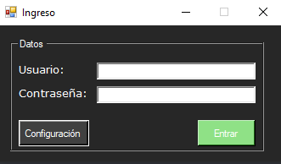

The login screen, as is, the first window shown, requests the user to enter their login credentials. For the first blank field, one shall enter their username. Likewise, in the second field, the password.

If the data is valid, the user could choose whether to enter the configuration screen or proceed into the main screen.