# Manual Introduction:

Within this manual, the main sections with their respective functions and characteristics will be presented and developed. The sections are grouped by priority according to their relevance and their corresponding utilities.  
The following pages describe, in an orderly matter, how to go through each section of the program.

# Manual:

### 1.1 First window

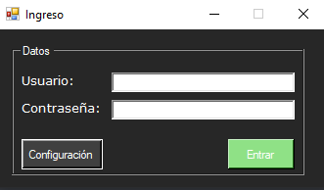

The login screen, as is, the first window shown, requests the user to enter their login credentials. For the first blank field, the user shall enter their username. Likewise, in the second field, their password.  
If the data is valid, the user could choose whether to enter the configuration screen or proceed into the main screen.

### 1.2 Configuration screen

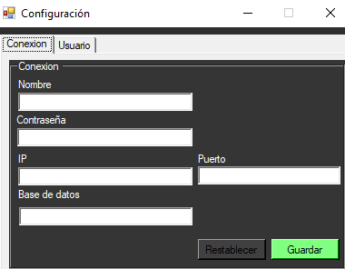

The first thing the user could appreciate is the several text fields allowing the user to add or modify login info, each field with their corresponding datatype. It also has the option to return to their default values, or save changes.  
In addition to this, it has a tab to manage users (only available if the user has enough permissions).

- - - - - - -

### 1.3 Users tab

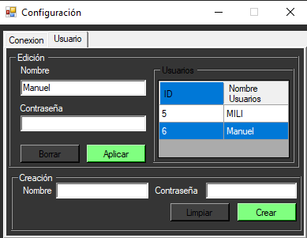

The users tab presents an user creation section as well as an user editing section.  
The user creation section offers a name field and a password field, for the administrator to set the new user's credentials. Down below there exists a button to finish up and create the new user, as well as other one to clear all text fields.  
The user editing section shows a table with every user's id and username. Upon selecting any of them, the section will be filled up with the selected user's data, allowing the administrator to modify their name and/or password. Afterwards, the administrator can either apply or discard the changes made.