How the Script Measures
Lysosome Diameter
Blob LoG detection → center refinement → radial intensity profile → FWHM → diameter

Simple workflow infographic
1 CHANNEL 1 IS SMOOTHED
Gaussian smoothing reduces small intensity fluctuations before detection.
↓
2 BLOB LoG FINDS CANDIDATE LYSOSOME CENTERS
blob_log searches for bright, approximately spherical structures across a range of sigma values.
↓
3 THE SCRIPT DOES NOT USE LoG SIGMA AS THE FINAL SIZE
The original sigma/radius in blob column 3 is reset to 0. The detected z, y, x positions are retained as candidate centers.
↓
4 SIZE IS REFINED
First: local 3D Gaussian fit.
Then: radial intensity-profile refinement around each detected center.
↓
5 FWHM IS MEASURED FROM THE RADIAL PROFILE
The script finds the peak, a baseline, the half-maximum level, and the left/right crossings.
↓
6 FINAL RADIUS AND DIAMETER
FWHM = r_right − r_left
Radius = FWHM / 2 • Diameter = FWHM
Key idea: Blob LoG tells the script WHERE the lysosome is; the radial FWHM measurement determines the final displayed/measured size.

What does FWHM mean?
FWHM means Full Width at Half Maximum. F = Full, W = Width, H = Half, M = Maximum. In the lysosome intensity profile, it is the full distance across the signal peak measured at 50% of the peak intensity. The script uses this width to estimate the lysosome diameter.

FWHM measurement, visually
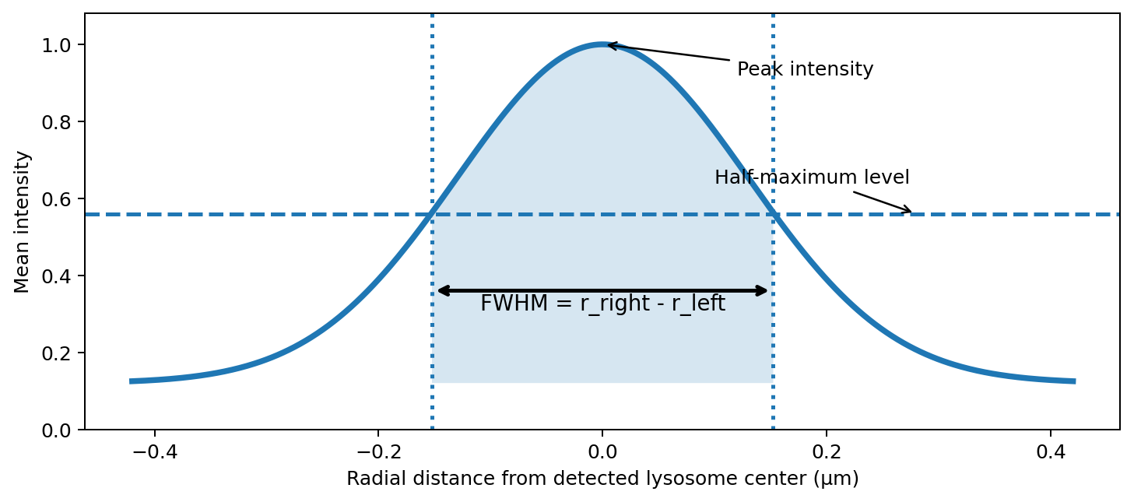
Conceptual intensity profile (illustrative, not a plot of one specific lysosome).

What the script actually calculates
Quantity | Script logic | Meaning
I_max | maximum of smoothed radial profile | Peak intensity of the radial profile
baseline | I_min if the two sides are exactly equal; otherwise max(I_left, I_right) | Reference intensity used by this implementation
I_half | baseline + 0.5 × (I_max − baseline) | Half-maximum threshold
r_left / r_right | radial positions where the profile crosses I_half | Physical FWHM limits in µm
FWHM | r_right − r_left | Full width at half maximum
radius_um | 0.5 × (r_right − r_left) | Radius assigned by radial-profile refinement
diameter_um | 2 × radius_um | Final diameter column; algebraically equal to FWHM before any later radius cap
Important script-specific detail. After refinement, the script caps radius_um to a maximum of 0.4 µm, then calculates diameter_um = 2 × radius_um. Therefore the stored diameter is capped at 0.8 µm by this code path.

From image to diameter: one lysosome
A | Bright punctum in Channel 1 — The lysosome signal is present in the fluorescence stack.

B | Blob LoG candidate — LoG proposes a center (z, y, x). Its original sigma is not kept as the final radius.

C | 3D Gaussian refinement — A local 3D Gaussian fit provides an intermediate size refinement.

D | Radial profile — Mean intensity is sampled as a function of physical radial distance around the center and smoothed in 1D.

E | Half maximum — The code computes a baseline-aware half-maximum threshold.

F | Two crossings — The left and right radial positions at the threshold define the FWHM interval.

G | Diameter — Radius = FWHM/2; then diameter = 2×radius. The final stored radius is capped at 0.4 µm.

Parameters involved
- CH1_SMOOTH_SIGMA: Gaussian smoothing before Blob LoG.
- BLOB_MIN_SIGMA, BLOB_MAX_SIGMA, BLOB_NUM_SIGMA, BLOB_THRESHOLD: control candidate detection, not the final FWHM diameter.
- RADIAL_MAX_RADIUS_NM: maximum radial distance examined during radial-profile refinement.
- RADIAL_DR_NM: radial sampling/bin spacing.
- RADIAL_MIN_DROP_FRACTION: passed to the radial-refinement function; the exact role should be interpreted from that function implementation.
- Voxel sizes vx_um, vy_um, vz_um: convert image coordinates and radius measurements to physical units.

One-line summary
Detect center with Blob LoG → refine locally → build radial intensity profile → find half-maximum crossings → FWHM → radius = FWHM/2 → diameter = 2×radius

