Lysosome + Cell Segmentation (GUI)
Simple User Manual
A beginner-friendly explanation of every field, button, checkbox, and setting
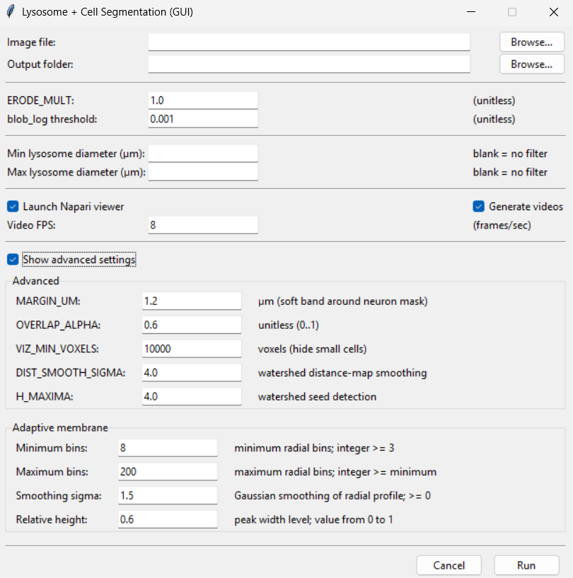
Figure 1. Main program window with the Advanced settings section open.
The simplest way to use the GUI
1) Choose the image file. 2) Choose where results will be saved. 3) Keep the default settings for the first run. 4) Click Run. 5) Only tune settings if the result needs improvement.
This manual explains what each control does and how to change it safely.

1. What this window is for
This GUI is the control panel for the analysis. It lets you select the microscopy image, choose the output folder, decide which results to create, and adjust how the program detects lysosomes and separates cells.
Good rule for new users: start with the default values shown in the window. Change one parameter at a time only when you can see a specific problem in the result.

2. How to read the GUI
Control type | What it looks like | What you do
Input field | White box with a number or path | Type a value, or let the Browse button fill the path.
Browse button | Button labeled “Browse...” | Opens a file/folder chooser.
Checkbox | Small square with a check mark | Checked = enabled. Unchecked = disabled.
Run button | Button labeled “Run” | Starts the analysis after checking the inputs.
Cancel button | Button labeled “Cancel” | Closes the GUI without starting the analysis.

3. Image file and output folder

Image file
Default / starting state | Empty until you choose a file
What it means | The microscopy image that will be analyzed.
What the user does | Click Browse... and select a supported TIFF/TIF or CZI image.
Important | This is required. The program cannot run without an input image.

Output folder
Default / starting state | Automatically suggested after choosing an image, or you can choose one
What it means | The folder where tables, TIFF files, videos, and other results will be stored.
What the user does | Click Browse... to select the parent folder. The program can create a timestamped results folder.
Important | Use a new output folder for each analysis so results from different runs do not get mixed.

4. Basic lysosome settings

ERODE_MULT
Default | 1.0
What it means | Changes the amount of erosion used while refining the cell/neuron mask.
If you increase/decrease it | Higher value = stronger erosion and more shrinking/separation. Lower value = less erosion.
When to change it | Increase slightly when objects stay connected by thin bridges. Decrease if the mask becomes too thin or loses real structure.
Easy tuning method | Change slowly, for example 1.0 → 1.5 or 1.0 → 0.5.
Important note | In the current script this value is added to the automatically estimated erosion radius, even though the name contains “MULT”.

blob_log threshold
Default | 0.001
What it means | Controls how easily the blob detector accepts a candidate lysosome.
If you increase/decrease it | Lower value = more sensitive, usually more detected spots. Higher value = stricter, usually fewer spots.
When to change it | Lower it if clear lysosomes are missed. Raise it if many weak/noisy spots are detected as lysosomes.
Easy tuning method | Try small changes, for example 0.001 → 0.0008 or 0.001 → 0.0015.
Important note | This is one of the first parameters to tune when the lysosome count looks clearly too low or too high.

5. Optional lysosome diameter filter
These two boxes are optional. Leaving them blank means “do not filter by diameter.” They are useful when you only want to visualize/export lysosomes inside a selected size range.

Min lysosome diameter (µm)
Default: Blank
Meaning: Smallest diameter allowed in the selected output subset.
Example: Example: enter 0.20 to keep lysosomes with diameter ≥ 0.20 µm.

Max lysosome diameter (µm)
Default: Blank
Meaning: Largest diameter allowed in the selected output subset.
Example: Example: enter 0.45 to keep lysosomes with diameter ≤ 0.45 µm.
Important: If both values are used, the minimum must be smaller than or equal to the maximum. Negative diameters are not accepted.

6. Output checkboxes and video speed

Launch Napari viewer
Default | Checked
What it means | When checked, the interactive Napari viewer opens after processing.
User advice | Keep it checked when you want to inspect the segmentation in 2D/3D and review the result. Uncheck it for automated/batch runs where you do not want a viewer window.

Generate videos
Default | Checked
What it means | When checked, the program creates video-style visualizations from the image stack.
User advice | Uncheck it when you only need data/tables/images and want to save processing time or disk space.

Video FPS
Default | 8 frames/second
What it means | Controls how fast the exported video plays.
User advice | Higher FPS = faster playback. Lower FPS = slower playback and more time to inspect each slice. This changes playback speed, not the segmentation result.

7. “Show advanced settings” checkbox
Checked: the Advanced panel is visible. Unchecked: the Advanced panel is hidden, but the program still uses its stored/default values.
New users can normally keep the default advanced values. Open this section only when the segmentation needs a specific correction.

8. Advanced settings

MARGIN_UM
Default | 1.2 µm
What it means | Defines a soft physical band around the neuron/cell mask used when associating nearby lysosome regions.
If changed | Higher = a wider allowed band. Lower = a tighter band.
When to tune it | Increase if valid lysosome-associated signal just outside the mask should still be considered. Decrease if too much nearby background is being included.

OVERLAP_ALPHA
Default | 0.6
What it means | Minimum overlap fraction used when deciding whether a lysosome is associated with a cell.
If changed | Higher = stricter assignment. Lower = more permissive assignment.
When to tune it | Raise it if lysosomes are being assigned to cells too easily. Lower it if clearly intracellular lysosomes are being left outside.

VIZ_MIN_VOXELS
Default | 10000 voxels
What it means | Minimum object size used for some visualization layers. Small objects below this size may be hidden from display.
If changed | Higher = hide more small objects. Lower = show more small objects.
When to tune it | Lower it when small real cells/objects disappear from the visualization. Raise it when the display is cluttered with tiny fragments.

DIST_SMOOTH_SIGMA
Default | 4.0
What it means | Smooths the distance map before watershed cell separation.
If changed | Higher = smoother distance map and usually fewer/simpler seeds. Lower = more local detail.
When to tune it | Increase if the watershed is over-fragmenting a single cell. Decrease if adjacent cells are not being separated enough.

H_MAXIMA
Default | 4.0
What it means | Controls which peaks in the distance map are strong enough to become watershed seeds.
If changed | Higher = fewer, stronger seeds. Lower = more seeds.
When to tune it | Increase if one cell is split into many pieces. Decrease if multiple touching cells are being merged into one.

9. Adaptive membrane settings
These settings control how the program analyzes the radial intensity profile used for membrane detection. They are more technical, so new users should normally keep the defaults unless the membrane boundary is clearly unstable or incorrect.

Minimum bins
Default | 8
What it means | Minimum number of radial bins used to describe the intensity profile.
Rule / limit | Must be an integer of at least 3.
User advice | Usually keep at 8. Increase only if the profile is too coarse in difficult images.

Maximum bins
Default | 200
What it means | Maximum number of radial bins allowed for the profile.
Rule / limit | Must be greater than or equal to Minimum bins.
User advice | Usually keep at 200. Lower it only if you intentionally want a less detailed profile.

Smoothing sigma
Default | 1.5
What it means | Gaussian smoothing applied to the radial profile before peak/width measurements.
Rule / limit | Higher = smoother profile; lower = more sensitive to fine variations/noise.
User advice | Increase if the profile is noisy. Decrease if real sharp features are being smoothed away.

Relative height
Default | 0.6
What it means | Relative level used when estimating peak width / membrane thickness.
Rule / limit | Allowed range: 0 to 1.
User advice | Keep near the default unless membrane thickness is consistently over- or underestimated; tune in small steps.

10. Run and Cancel buttons

Run
Checks the entries, saves the selected configuration, closes the GUI, and starts the analysis. If an input is invalid, the program shows an error message instead of running.

Cancel
Closes the GUI without starting the analysis. Use this when you opened the program by mistake or want to stop before processing begins.

11. Recommended tuning workflow
Step | What to check | What to do
1 | First run | Use the default values. Do not tune everything before seeing the first result.
2 | Check lysosome count | If there are clearly too many/few detected lysosomes, adjust blob_log threshold first.
3 | Check cell separation | If touching cells are merged or one cell is split too much, tune H_MAXIMA and DIST_SMOOTH_SIGMA.
4 | Check cell assignment | If lysosomes are wrongly assigned inside/outside cells, tune OVERLAP_ALPHA and, if needed, MARGIN_UM.
5 | Check membrane behavior | Only then consider the Adaptive membrane settings.
6 | Change one thing at a time | Keep a note of the value you changed so you can return to the previous setting if the result becomes worse.

12. Quick troubleshooting: what should I change?
What you see | First setting to try
Too many lysosomes detected | Increase blob_log threshold a little.
Too few lysosomes detected | Decrease blob_log threshold a little.
One cell is split into many pieces | Increase H_MAXIMA and/or DIST_SMOOTH_SIGMA cautiously.
Touching cells stay merged | Decrease H_MAXIMA and/or DIST_SMOOTH_SIGMA cautiously.
Too many lysosomes assigned to a cell | Increase OVERLAP_ALPHA; consider reducing MARGIN_UM.
Valid intracellular lysosomes are marked outside | Decrease OVERLAP_ALPHA; consider increasing MARGIN_UM.
Small real cells are hidden in visualization | Decrease VIZ_MIN_VOXELS.
Visualization contains many tiny fragments | Increase VIZ_MIN_VOXELS.
Membrane profile looks noisy/unstable | Increase Adaptive membrane Smoothing sigma slightly.
Video plays too fast | Lower Video FPS.
Video plays too slowly | Raise Video FPS.

13. Input rules the GUI checks automatically
- An image file must be selected and must exist.
- Numeric fields must contain valid numbers.
- Minimum and maximum lysosome diameters cannot be negative.
- If both diameter limits are entered, minimum cannot be larger than maximum.
- OVERLAP_ALPHA must be between 0 and 1.
- Adaptive membrane Minimum bins must be at least 3.
- Adaptive membrane Maximum bins must be greater than or equal to Minimum bins.
- Adaptive membrane Smoothing sigma must be 0 or greater.
- Adaptive membrane Relative height must be between 0 and 1.

14. Before you click Run
☐ Correct microscopy image selected
☐ Correct output folder selected
☐ Diameter filter left blank unless you intentionally want a size range
☐ Napari viewer enabled if you want interactive inspection
☐ Video generation enabled only if you need videos
☐ Default parameters used for the first run, unless you already have a validated tuned set
☐ Only one or two settings changed from the previous run so you can understand their effect
Best practice for users: save a screenshot or note of the settings for every successful run. This makes the analysis reproducible and makes future tuning much easier.

