napari Interface and Layer Guide
Current interface - microscopy cell and lysosome workflow

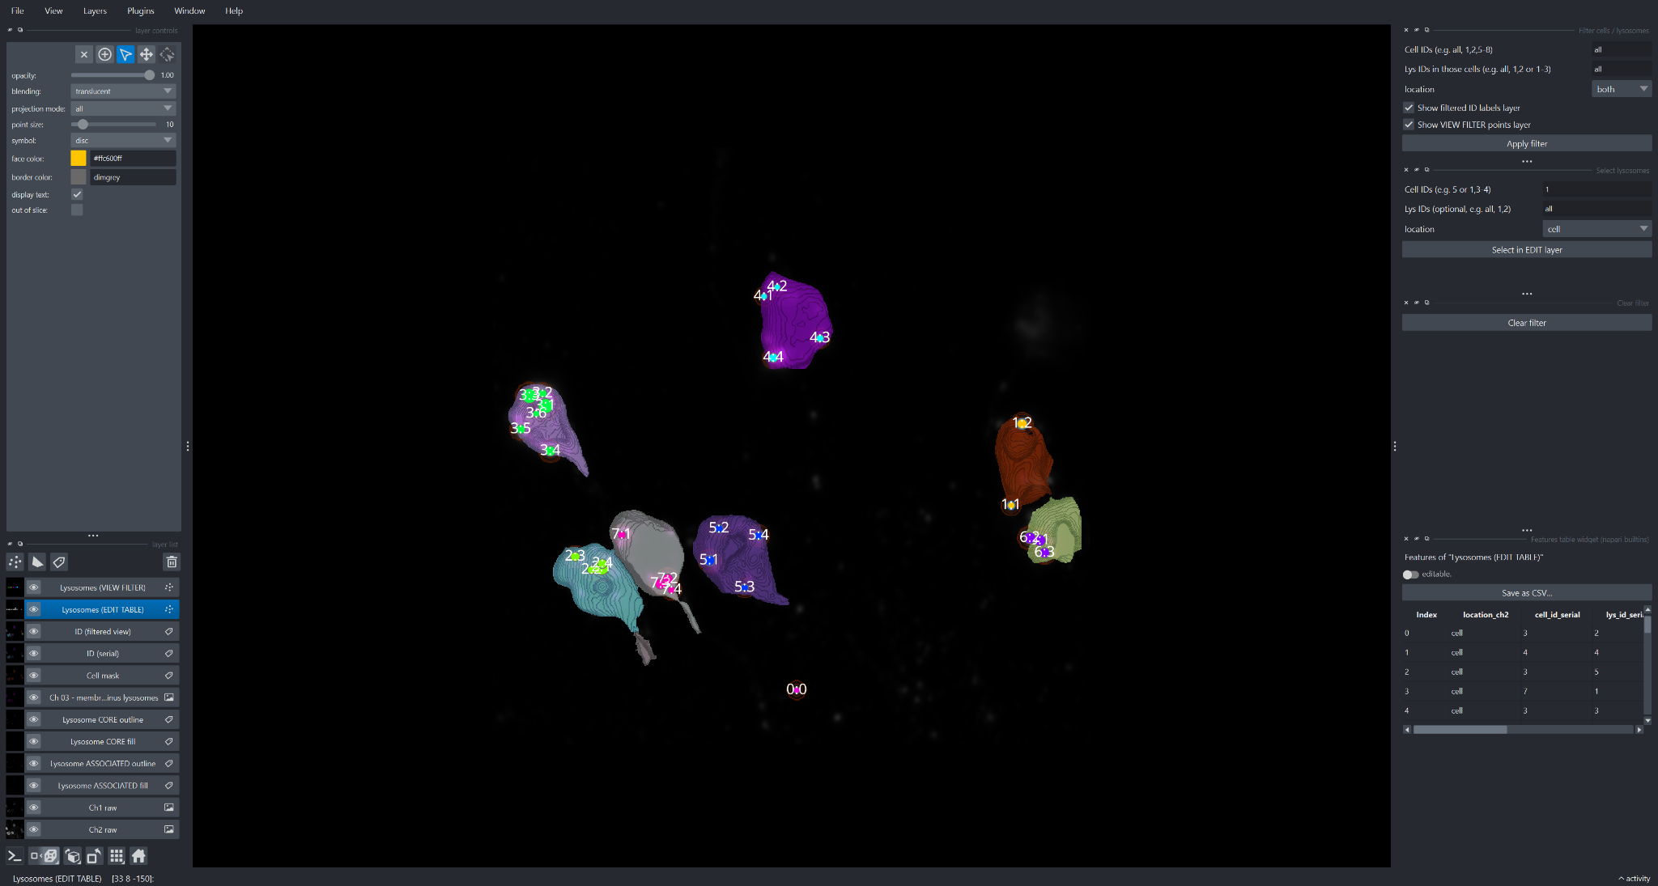
Figure 1. Current napari workspace used in this guide.
Scope. This version intentionally replaces the earlier interface description. It documents only the current layer stack and the current filter, selection, and feature-table controls shown in the latest screenshot.

1. Quick orientation to the current napari window
- Main menu: File, View, Layers, Plugins, Window, and Help are at the top.
- Layer controls: The upper-left panel changes according to the selected layer type. In the screenshot, a Points layer is selected, so point controls such as opacity, blending, point size, symbol, colors, text display, and out-of-slice visibility are shown.
- Layer list: The lower-left panel contains the current raw images, masks, lysosome regions, and point/ID layers.
- Canvas: The central area composites all visible layers and displays the cell/lysosome annotations.
- Dock widgets: The right side contains the cell/lysosome filter, lysosome selection panel, clear-filter control, and the feature table for the editable lysosome layer.
- Viewer/status controls: The bottom controls and status area are used for navigation, dimensional display, coordinates, and slice position.
Official napari reference: Tour of the napari viewer
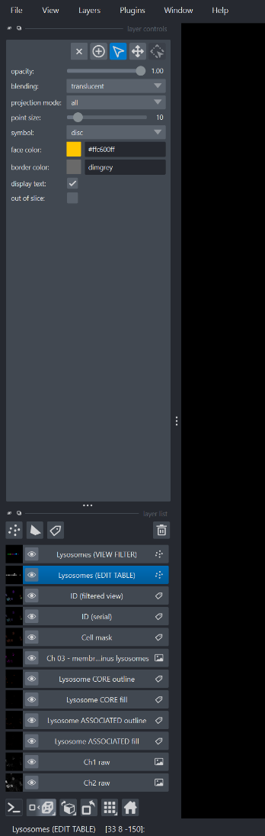 | 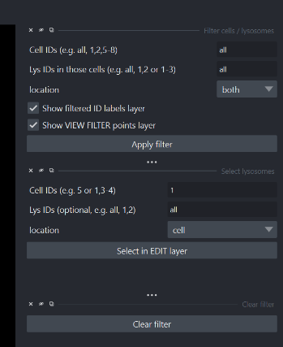
Figure 2. Current left-side layer controls/list and right-side filter/selection widgets.

2. Layers in the current project
The table below consolidates the current layer stack into one place. The layer names are taken from the latest screenshot; where the exact internal array or plugin behavior is not visible, the description is explicitly framed as a likely role rather than a certainty.
Layer | Type | Current role | How to use it
Lysosomes (VIEW FILTER) | Points | Filtered viewer subset of lysosome points produced by the active cell/lysosome filter. | Use for uncluttered inspection of the current subset; do not treat it as the master editable dataset.
Lysosomes (EDIT TABLE) | Points | Working lysosome point layer linked to the feature table on the right. This is the selected layer in the screenshot. | Use for selection and metadata review/editing. Cross-check the point and the feature-table row before making changes.
ID (filtered view) | Points/text | Filtered object-ID annotations for the currently displayed subset. | Turn on after filtering to reduce label clutter; hide the full ID layer if duplicate labels appear.
ID (serial) | Points/text | Complete serial object-ID annotations, likely the full reference set. | Use when you need all cell:lysosome identifiers visible; hide when only the filtered subset is needed.
Cell mask | Labels | Segmented cell regions used as the spatial reference for assigning objects to cells. | Keep above the raw images with reduced opacity when checking alignment; use IDs to confirm cell identity.
Ch 03 - memb, nuc lysosomes | Image/derived overlay | Processed contextual layer combining membrane-, nucleus-, and/or lysosome-related information. Exact content depends on the code that generated it. | Toggle against the raw channels to check whether the processed structures remain spatially plausible.
Lysosome CORE outline | Labels/Shapes | Boundary display of the lysosome core regions. | Prefer the outline for boundary QC because it does not obscure the fluorescence underneath.
Lysosome CORE fill | Labels | Filled core segmentation for each lysosome. | Use partial opacity for region/measurement context and compare it with the core outline.
Lysosome ASSOCIATED outline | Labels/Shapes | Boundary of the associated/peripheral region around each lysosome core. | Compare directly with the CORE outline to judge the extent of the associated region.
Lysosome ASSOCIATED fill | Labels | Filled associated/peripheral region assigned to each lysosome. | Toggle with the CORE fill to compare core-only versus expanded regions.
Ch1 raw | Image | Raw channel-1 fluorescence/intensity data. | Keep unchanged; adjust only display contrast/colormap for inspection.
Ch2 raw | Image | Raw channel-2 fluorescence/intensity data. | Use independent display settings from Ch1 and compare masks/points against the original signal.
ID labels. Canvas text such as “4:2”, “3:5”, and “7:4” is consistent with a cell-ID : lysosome-ID convention. The feature-table columns cell_id_serial and lys_id_serial support that interpretation, but the exact formatting rule is defined by your code/plugin.

3. Layer types used by this workflow

Image layers
Image layers display intensity data such as Ch1 raw and Ch2 raw. Contrast limits, gamma, colormap, opacity, and blending affect visualization rather than the underlying pixel/voxel values.
Documentation: Image layer guide

Labels layers
Labels layers store integer segmentation maps. Label 0 is background; positive integer values can represent separate cells or segmented objects. Labels can be inspected and, in 2D, edited with pick/paint/fill tools when editing is intended.
Documentation: Labels layer guide

Points layers
Points layers store coordinates and associated feature values. They are appropriate for lysosome centers, selections, serial IDs, and text labels. The controls visible in the latest screenshot are Points-layer controls.
Documentation: Points layer guide

Layer ordering
A useful QC order is raw image channels at the bottom, filled segmentation masks above them with partial opacity, outlines above fills, and point/text annotations at the top. This keeps structural reference images visible while preserving readable boundaries and IDs.
General documentation: Layers: bringing data into napari

4. Tutorial: basic navigation and layer control
- Select a layer - Click its row in the Layer List. The upper-left controls immediately change to the controls for that layer type.
- Show or hide a layer - Use the eye icon. Toggle frequently when comparing raw data, fills, outlines, and ID annotations.
- Change layer order - Drag rows in the Layer List. Keep outlines and text above fills, and raw channels below derived overlays.
- Change opacity - Reduce mask/fill opacity when the overlay hides the underlying fluorescence.
- Pan and zoom - Use pan/zoom mode; drag to move around the canvas and use the mouse wheel or trackpad to zoom. Holding Space commonly gives temporary pan/zoom while another tool is active.
- Inspect Z slices - For volumetric data, move through Z rather than validating an object from a single slice.
- Switch 2D/3D - Use 3D for context and 2D for precise layer editing/selection when the editing tools require it.
- Isolate one object - Filter to one cell or a small group of lysosomes, then compare the point/ID with the raw channel and segmentation boundaries.

5. Tutorial: raw channels and segmentation overlays

Ch1 raw and Ch2 raw
- Adjust contrast, not data - Change display contrast limits to reveal dim and bright structures without modifying the stored intensities.
- Choose colormaps for inspection - Grayscale is useful for morphology; distinct colormaps can help when comparing two channels.
- Use blending carefully - If one channel dominates, reduce its opacity rather than forcing both channels into the same intensity scale.
- Validate derived layers - Turn off fills and leave outlines visible when you need to judge whether segmentation boundaries follow the raw signal.

Cell and lysosome segmentation layers
- Cell mask - Check whether the cell boundary follows the visible cell in the raw image and whether the ID corresponds to the intended cell.
- CORE outline/fill - Use the outline for edge placement and the fill for understanding the measured core region.
- ASSOCIATED outline/fill - Compare with CORE to see how far the associated region extends and whether that expansion is plausible.
- Edit with care - If manual editing is part of your workflow, preserve a copy of the original segmentation or save a version before editing.

6. Current Points-layer controls: Lysosomes (EDIT TABLE)
In the latest screenshot, Lysosomes (EDIT TABLE) is selected. The visible controls therefore describe how the editable lysosome points are drawn and interacted with:
Control | Meaning in this view
Opacity = 1.00 | The points are fully opaque. Reduce opacity if the marker hides important fluorescence or boundaries.
Blending = translucent | The layer is composited with layers beneath it instead of replacing them.
Projection mode = all | When projection behavior applies, all relevant points participate in the displayed projection.
Point size = 10 | Controls the marker size. Increase it for easier selection; reduce it when points or text overlap.
Symbol = disc | Displays each point with a circular marker.
Face color = yellow/orange | Controls marker fill color; useful for distinguishing editable/selected points from other annotation layers.
Border color = dimgrey | Adds a darker edge so markers remain visible over bright backgrounds.
Display text = on | Renders text derived from point properties/features, such as object identifiers.
Out of slice = off | Reduces clutter from points away from the current slice.

7. Current right-side filter, selection, and feature-table workflow
The latest interface separates viewing/filtering from editing. This is useful because you can reduce clutter without altering the master editable point layer.
Figure 3. Current filter, selection, and clear-filter controls.

Filter cells / lysosomes
- Cell IDs - Enter one or more cell IDs to restrict the view.
- Lys IDs in those cells - Optionally restrict the filter to specific lysosome IDs within the selected cells.
- location - Choose the relevant location/classification value from the drop-down.
- Show filtered ID labels layer - Controls whether the filtered ID annotation layer is visible.
- Show VIEW FILTER points layer - Controls whether the filtered lysosome point layer is visible.
- Apply filter - Applies the requested visual subset. Verify the resulting IDs before interpreting or editing anything.

Select lysosomes
- Cell IDs - Specify the cell or cells containing the lysosomes you want to select.
- Lys IDs (optional) - Provide specific lysosome IDs when you do not want every lysosome in the selected cell(s).
- location - Choose the same relevant location/classification used by your analysis.
- Select in EDIT layer - Transfers the requested records into an active selection in Lysosomes (EDIT TABLE), allowing the canvas selection and feature table to be checked together.

Clear filter
Use Clear filter before starting an independent inspection. This prevents a previous visual subset from being confused with a new selection request.

8. Feature table for Lysosomes (EDIT TABLE)
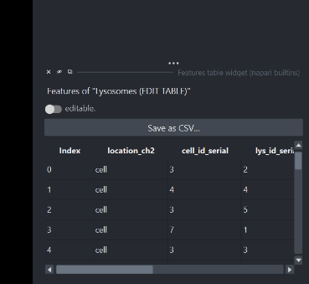
Figure 4. Current feature table associated with Lysosomes (EDIT TABLE).
The table shows one row per point/lysosome record. The visible columns in the screenshot are:
Column | Interpretation
Index | Displayed row position in the feature table; it is not necessarily a biological ID.
location_ch2 | Categorical location/classification for the object in channel 2. The exact allowed values are defined by your analysis code.
cell_id_serial | Serial cell identifier associated with the lysosome record.
lys_id_serial | Serial lysosome identifier. Together with cell_id_serial, it is consistent with canvas labels formatted like cell:lysosome.
- Editable toggle - Keep editing disabled during routine review. Enable it only when you intend to change feature values.
- Save as CSV - Export the feature metadata after review or deliberate edits so the CSV corresponds to the state you validated in napari.

9. Recommended current QC workflow
- Start from raw data - Show Ch1 raw and/or Ch2 raw and hide most derived overlays.
- Check the cell segmentation - Show Cell mask with reduced opacity and confirm the boundary against the raw image.
- Check lysosome CORE - Enable CORE outline first; use CORE fill only when you need the region itself.
- Check the ASSOCIATED region - Compare the ASSOCIATED outline/fill directly with CORE and the raw signal.
- Show complete IDs when needed - Use ID (serial) for full field context.
- Reduce clutter with the filter - Enter cell/lysosome IDs, choose location, and apply the filter. Use Lysosomes (VIEW FILTER) and ID (filtered view) to inspect the subset.
- Select the records to review/edit - Use Select lysosomes and Select in EDIT layer so the intended points become selected in Lysosomes (EDIT TABLE).
- Cross-check identity - Compare the selected canvas point with location_ch2, cell_id_serial, and lys_id_serial in the feature table.
- Edit only intentionally - Turn on the editable control only for deliberate metadata corrections.
- Re-validate after edits - Return to the raw fluorescence and segmentation boundaries before accepting the change.
- Export if needed - Use Save as CSV after validation so the external table matches the reviewed state.
- Clear the filter - Reset the visual subset before moving to the next independent cell/lysosome query.

10. Useful napari shortcuts and habits
Action | Typical shortcut | Use
Toggle 2D/3D | Ctrl+Y | Switch between slice editing and volumetric visualization.
Reset view | Ctrl+R | Recover a sensible camera/view if zoom or rotation becomes confusing.
Show shortcuts | Ctrl+Alt+/ | Open napari’s shortcut reference.
Temporarily pan/zoom | Hold Space | Useful while another interaction mode is active.
Points: add | 2 | Add a point when a Points layer is selected.
Points: select | 3 | Select points when a Points layer is selected.
Labels: pan/zoom | Z | Return a Labels layer to pan/zoom mode.
Labels: pick | L | Pick an existing label.
Labels: paint | P | Paint the selected label in 2D.
Labels: fill | F | Fill a connected region with the selected label in 2D.
Shortcuts can be customized. Documentation: napari Preferences and shortcuts

11. Official napari documentation
Use the links below for authoritative napari behavior and interface details:
- Viewer interface tour
- Layers overview
- Layers guide index
- Image layer
- Labels layer
- Points layer
- Plugins overview
- Finding/installing plugins
- Preferences / keybindings

12. One-page quick reference
Goal | Use | Best practice
See original fluorescence | Ch1 raw / Ch2 raw | Keep raw data unchanged; change only display settings.
Check cell boundaries | Cell mask | Use reduced opacity against the raw image.
Check lysosome core | CORE outline/fill | Outline for QC; fill for region context.
Check expanded region | ASSOCIATED outline/fill | Compare directly with CORE and raw signal.
See every object ID | ID (serial) | Use for full context.
Focus on a subset | Filter widget + VIEW FILTER + ID (filtered view) | Apply filter, verify IDs, inspect, then clear.
Select records for review/editing | Select lysosomes + Lysosomes (EDIT TABLE) | Select by cell/lysosome IDs, then cross-check the feature table.
Edit metadata | Feature table editable toggle | Keep off unless a deliberate correction is being made.
Export metadata | Save as CSV | Export after validation/editing.

