Microscopy Pipeline: Block-by-Block & Line-by-Line Guide
A practical, theoretical, and visual walkthrough of the lysosome detection and cell segmentation workflow.

1) Overview
This document explains each major block of the analysis script for 3D microscopy data: loading multi-channel CZI/TIFF, detecting lysosomes with Laplacian of Gaussian (LoG) and distance-transform (DT) radius refinement, segmenting cell bodies in channel 2, mapping detected lysosomes to cells, and exporting quantitative tables and illustrative videos.
- Inputs: two-channel 3D stacks (lysosome channel and neuron/channel for cell mask).
- Core libraries: NumPy, SciPy, scikit-image, tifffile/czifile, OpenCV, napari, pandas.
- Outputs: CSV tables (metrics, counts), MP4/GIF videos (fused views & rotations), PNG screenshots, and an interactive napari session.

2) Imports and Environment Setup
import os, re, numpy as np, pandas as pd, cv2, imageio, xml.etree.ElementTree as ET
import czifile, tifffile as tiff
from skimage.feature import blob_log
from skimage.filters import gaussian, threshold_local
from skimage.morphology import remove_small_objects, binary_opening, binary_closing, ball, binary_erosion
from scipy.ndimage import distance_transform_edt as edt, rotate as ndrotate, binary_fill_holes
from skimage.measure import label, regionprops
from skimage.segmentation import watershed, find_boundaries
import napari
- *OpenCV* (`cv2`) and *imageio* for frame compositing and video writing.
- *czifile* and *tifffile* for reading CZI and TIFF/OME-TIFF and their metadata.
- *scikit-image* operators: LoG blobs, Gaussian smoothing, morphology, thresholding, labeling, watershed.
- *SciPy ndimage* for distance transform (EDT), rotations, hole filling.
- *napari* for interactive visualization and screenshots.

3) Quick Theory Snapshots
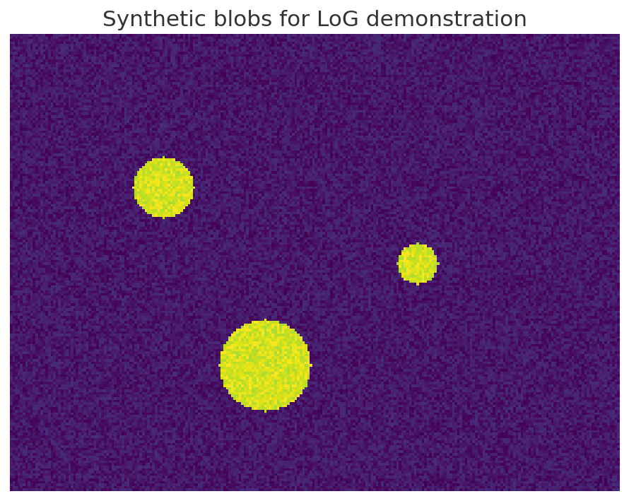
Fig. 1 – Synthetic blobs used to illustrate LoG-based detection.
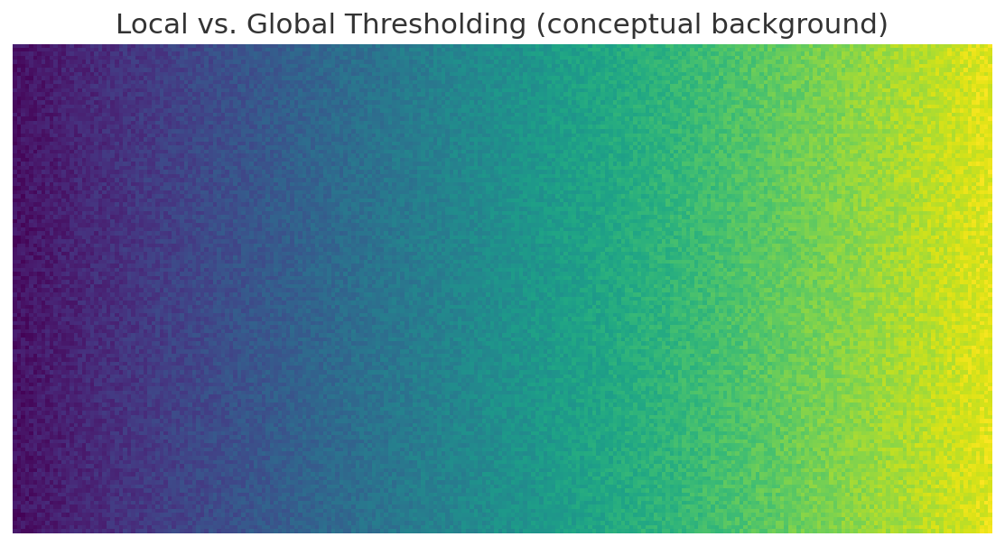
Fig. 2 – A smoothly varying background motivates local/adaptive thresholding.
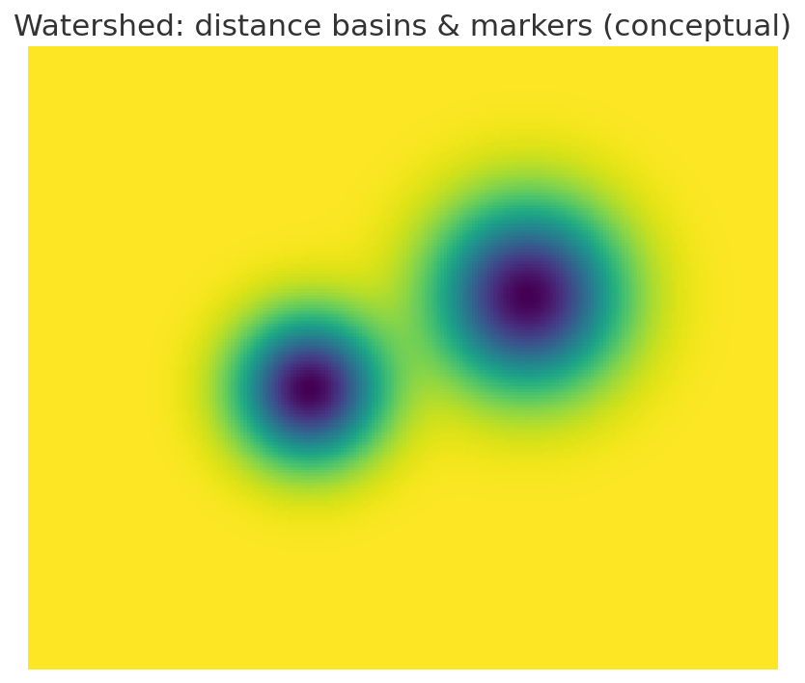
Fig. 3 – Watershed segmentation treats images as topographies.
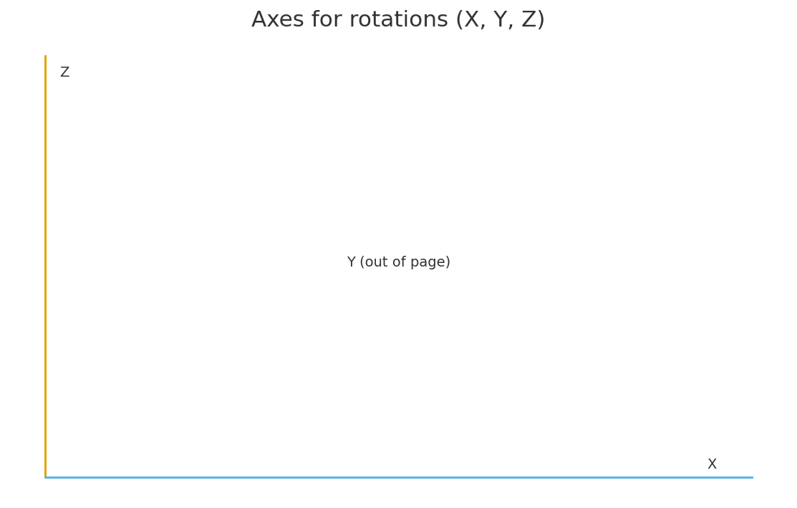
Fig. 4 – Coordinate axes used for per-cell rotations.

4) Helper: refine_radii_via_dt
def refine_radii_via_dt(img3d, blobs, win_px=25, bin_method="sauvola"):
"""
Refine per-blob radius using a local 2D mask + distance transform (DT) on a single Z slice.
blobs: [N, 4] with [z, y, x, r_px]. Overwrites r_px using EDT-based radius.
"""
# pick a local patch around each blob center
# adaptive binarization (Sauvola/local/Otsu)
# clean-up (opening, remove small objects)
# keep the connected component under the center
# EDT on that component; radius = distance to nearest background pixel
return out
- **Idea:** LoG estimates a scale/radius, but DT provides a more robust local radius by measuring the distance from the center to the nearest background.
- **win_px:** Half-size of the XY patch extracted around each (y, x) center for robust local thresholding.
- **bin_method:** `sauvola` is generally robust on uneven backgrounds; `local` (mean/gaussian) and `otsu` are alternatives.
- After binarization, a light **opening** and **remove_small_objects** suppress speckle noise; EDT then yields a continuous radius in pixels.
- Result is written back into `blobs[:, 3]` so subsequent physical-unit conversions use the refined estimate.

5) Generic Loader (CZI & TIFF/OME)
def load_any(file_path):
# Detect extension; branch to CZI or TIFF.
# For CZI: use czifile to read array and XML; infer 2 channels (C,Z,Y,X) or (Z,C,Y,X).
# Extract voxel sizes from XML Scaling (X,Y,Z) and convert to µm.
# For TIFF: use tifffile; prefer OME-XML PhysicalSizeX/Y/Z; else fall back to XResolution/YResolution & spacing tags.
# Return ch1, ch2, (vx_um, vy_um, vz_um), meta
- Handles multiple common axis orders by checking shapes and placing channels appropriately.
- Voxel size extraction prioritizes **OME-XML**, then **ImageJ tags**. Units are coerced to µm with safe fallbacks.
- If only XY resolution exists, Z-spacing may be derived from `ImageDescription` keys like `spacing` or `SliceSpacing`.

6) Physical Units & Voxel Geometry
voxel_um3 = vz_um * vy_um * vx_um
lin_equiv_um = voxel_um3 ** (1.0 / 3.0)
- Per-voxel volume (µm³) enables conversion of counts to volumes (e.g., cell volumes from voxel counts).
- The cube-root of the voxel volume gives a **linear equivalent** spacing for rough isotropic intuition.

7) Lysosome Centers: LoG + Gaussian Pre-filter
image_smooth = gaussian(image, sigma=1.5)
blobs = blob_log(image_smooth,
min_sigma=0.8, max_sigma=3.0, num_sigma=5,
threshold=0.0035, overlap=1)
if len(blobs) > 0:
blobs[:, 3] = blobs[:, 3] * np.sqrt(3)
blobs = refine_radii_via_dt(image_smooth, blobs, win_px=25, bin_method="sauvola")
- **Gaussian smoothing (σ=1.5)** dampens noise before LoG.
- `min_sigma/max_sigma/num_sigma` define the multi-scale search; match to expected lysosome diameters (in pixels).
- `threshold` trades sensitivity vs. false positives; lower values find more blobs but risk noise.
- `overlap=1` allows full overlap merging logic (here permissive to keep close blobs).
- The **√3 scale correction** maps LoG scale to radius (conventional factor for LoG on 3D/2D); refined later by DT.

8) Physical Conversion of Blob Metrics
z_um = blobs[:, 0] * vz_um
y_um = blobs[:, 1] * vy_um
x_um = blobs[:, 2] * vx_um
radius_um = (blobs[:, 3] * vx_um) * 0.1 # NOTE: script applies an extra 0.1 factor
diameter_um = 2.0 * radius_um
volume_um3 = (4/3) * π * radius_um**3
- Blob centers (z,y,x) are converted to microns using per-axis voxel sizes.
- Radius is from DT (XY pixels) scaled by **vx_um**; the script multiplies by **0.1** as an additional scaling—ensure this matches microscope calibration. Remove or adjust if radii seem 10× too small/large.

9) Segmenting Cells from Channel 2
# normalize ch2 to [0,1], then gaussian(sigma=1.5)
# per-slice local threshold (block_size=281, offset=-0.15*std)
# remove_small_objects(..., min_size=20000), closing(ball(10)), erosion(ball(9))
# distance transform → initial cell_mask
# label somas, watershed(-dist_inside, markers=body_lab, mask=neuron_mask)
- Local thresholding per Z-slice counteracts axial intensity variations and inhomogeneous illumination.
- Morphological **closing** fills gaps; **erosion** tightens borders; **remove_small_objects** removes speckles.
- Distance transform inside `neuron_mask` seeds the **watershed**, splitting touching somas into territories.
- Tune `block_size`, `offset`, and structuring element radii (`ball(…)`) to match microscope resolution.

10) Optional Filtering of Oversized Bodies
MAX_BODY_VOXELS = 65000
# compute voxel counts per label and drop those exceeding threshold
- Rejects implausibly large connected components (artifacts/merges).
- Adapt threshold to your volume and voxel scaling; inspect histograms of voxel counts.

11) Mapping Lysosomes to Cell IDs
for (z,y,x) in blobs[:, :3]:
if cell_mask[z,y,x]: label = cell_seg[z,y,x] else 0 (outside)
# augment df with location and cell_id; export counts per location and per cell
- Each blob is classified as **'cell'** if its center lies inside the binary `cell_mask`; otherwise **'outside'**.
- If watershed labels exist, `cell_id_ch2` records the specific cell ID for per-cell statistics.
- Exports: `lysosome_counts_cell_vs_outside.csv`, `lysosome_counts_by_cell.csv`, `lysosomes_with_cell_vs_outside.csv`.

12) Cell Volumes and Merged Metrics
counts = bincount(cell_seg.ravel())
volume_um3 = counts[1:] * voxel_um3
merge with per-cell lysosome counts → cell_metrics_ch2.csv
- Computes per-cell physical volumes (µm³) from label voxel counts and voxel size.
- Merges with lysosome counts to facilitate density metrics (e.g., lysosomes per 1000 µm³).

13) Napari Overlays & Boundaries
viewer.add_labels(cell_mask, name='Cell (Ch2)')
viewer.add_labels(cell_seg, name='Cell ID (Ch2)')
boundaries = find_boundaries(cell_seg)
viewer.add_image(boundaries, name='Cell ID boundaries', colormap='magenta')
- Binary cell mask (green, translucent) provides overall footprint.
- Label image displays per-cell territories; boundaries layer highlights watershed edges.
- Optional points layer shows only in-cell lysosomes with ID labels for quick QC.

14) 2D Slice Videos (Fused & Side-by-Side)
# Fused: overlay cell mask (green) and draw only in-cell lysosomes (yellow/cyan) → ch2_fused_cell.mp4
# Side-by-side: raw Ch1 | segmented Ch2 with overlays → raw_vs_segmented_side_by_side.mp4
- Frame-by-frame traversal along Z conveys 3D context for presentations and QC.
- Only **in-cell** lysosomes are drawn to emphasize biologically relevant detections.

15) Per-Cell Rotation Videos (X, Y, Z)
# For each cell containing lysosomes:
# - extract subvolume and corresponding labels
# - rotate around X/Y/Z (ndrotate), compute projection (MIP), outline cell, plot lysosome points
# - export MP4/GIF per-axis (cell_###_spinX/Y/Z.mp4)
- Three axis families provide complementary perspectives on intracellular distribution.
- Points are rotated analytically to match rotated projections, ensuring spatial consistency.
- Edge-enhanced intensity projections help visualize surface relief without explicit 3D rendering.

16) 3D Screenshots via napari
viewer.dims.ndisplay = 3
# camera.angles/elevation/azimuth set for XY/YZ/XZ orientations
viewer.screenshot(canvas_only=True) → PNG
- Automates XY/YZ/XZ 3D views for quick documentation.
- Useful for manuscripts and lab notebooks to capture the final segmentation context.

17) Practical Tuning & Troubleshooting
- Voxel scaling: double-check OME-XML or calibration; verify a known ruler object.
- LoG scale: align `min_sigma/max_sigma` with expected lysosome sizes in **pixels** (convert from µm).
- DT window: `win_px` should be large enough to enclose each lysosome but small enough to avoid neighbors.
- Adaptive thresholding: start with `sauvola`, then experiment with `offset` and `block_size` if backgrounds vary.
- Morphology radii (`ball`): choose comparable to soma boundary thickness in voxels; excessive operations may erode small neurites.
- Watershed markers: consider pre-labeling robust somas as markers to avoid spurious splits or merges.
- QC: overlay detected points and IDs in napari; spot-check a few slices for false positives/negatives.
- Scaling factor in radius: confirm the extra ×0.1 is desired; remove if mismatched to ground truth spheres.
- Performance: for large volumes, consider chunking or restricting LoG scales; avoid overly large `block_size` in thresholding.

18) Minimal Parameter Map (What to tweak first)
- **LoG**: `min_sigma`, `max_sigma`, `threshold`
- **DT refinement**: `win_px`, `bin_method`
- **Thresholding (Ch2)**: `block_size`, `offset`
- **Morphology**: radii in `ball()`, `min_size` in `remove_small_objects`
- **Watershed**: marker quality (derived from distance peaks) and mask quality

19) Closing Notes
The pipeline balances classical image processing (LoG, morphology, watershed) with careful calibration. Always validate physical units and spot-check overlays. For manuscript figures, prefer fixed random seeds, consistent intensity normalization, and record parameter sets alongside results.

