|  |  |  |  |
| --- | --- | --- | --- |
| No. | Name | ID | Contribution |
| 01 | Aunindya Prosad Saha | 202114014 | Project Idea  Making GUI interactive  Implemented:  OOP Features  Categorical Search  Transaction History  Marketplace  Player Line Up  PDF Implementation |
| 02 | G.M.Fahim Tazwar | 202114025 | Database Connection (MySQL)  Data Fetch, Insert, Update, Delete.  Implemented:  Log In  Registration  Forgot Password  Data Pictorial Representation  Custom Exception |
| 03 | Md. Nahul Rahman | 202214049 | Frontend/GUI Design (Java FX)  Making GUI responsive  Report Writing  PowerPoint Making |

Contribution Matrix

MIST KickOff marks the culmination of dedicated teamwork, blending a passion for football and technology. Our project introduces football management to the Military Institute of Science and Technology (MIST) through an intuitive desktop application. Meet the creators: Aunindya Prosad Saha, the coding wizard; G. M. Fahim Tazwar, the data maestro, and Md. Nahul Rahman, the design expert. Built on object-oriented programming principles in Java, our project incorporates Abstraction, Encapsulation, Polymorphism, Inheritance, Exception Handling. Leveraging JavaFX, IntelliJ, Scenebuilder, and MySQL, we've meticulously crafted a feature-rich experience encompassing user login/registration, player management, a real-time marketplace, subject-wise search, and more. Join us in reshaping football management at MIST.



Our proposed and implemented features encompass:

1. User login/registration

1. Forgot password handling

1. Home interface housing main features and Subject-wise search:

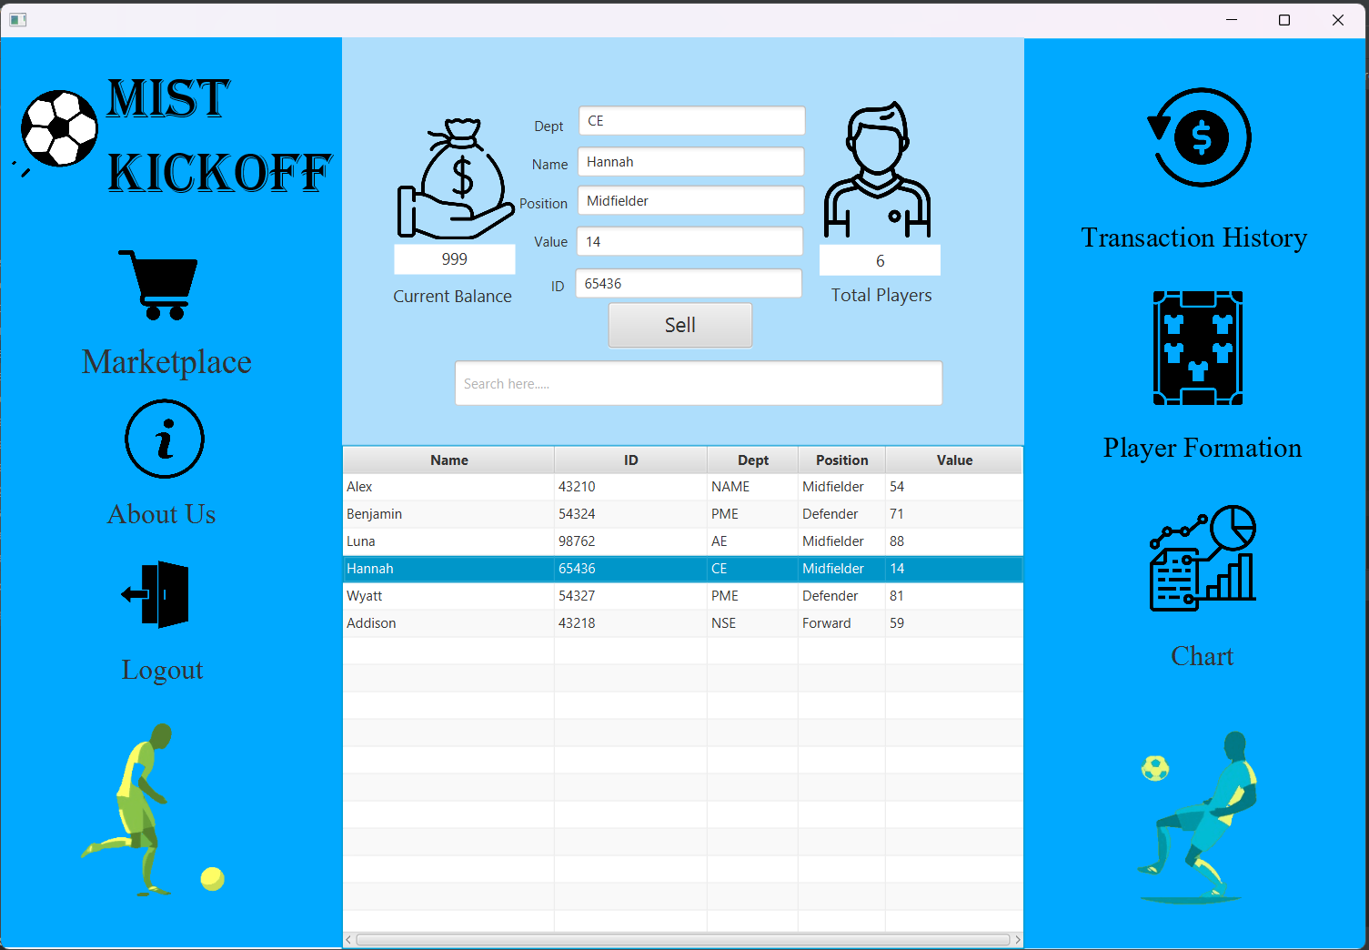

1. Real-time marketplace for player buy and sell

1. Transaction History to review all previous transaction records.

1. Player Line Up in PDF format
2. Graphical representation of data

Join us on this innovative journey as we redefine the landscape of football management at MIST.

Features of OOP in JAVA

While explaining about the project that features the basic operations of object-oriented programming, all the codes can’t be shown at a time but yes some basic implementation can be shown.

Encapculation in OOP:

Encapsulation is the bundling of data and the methods that operate on that data, restricting direct access to some of an object's components and preventing the accidental modification of data.

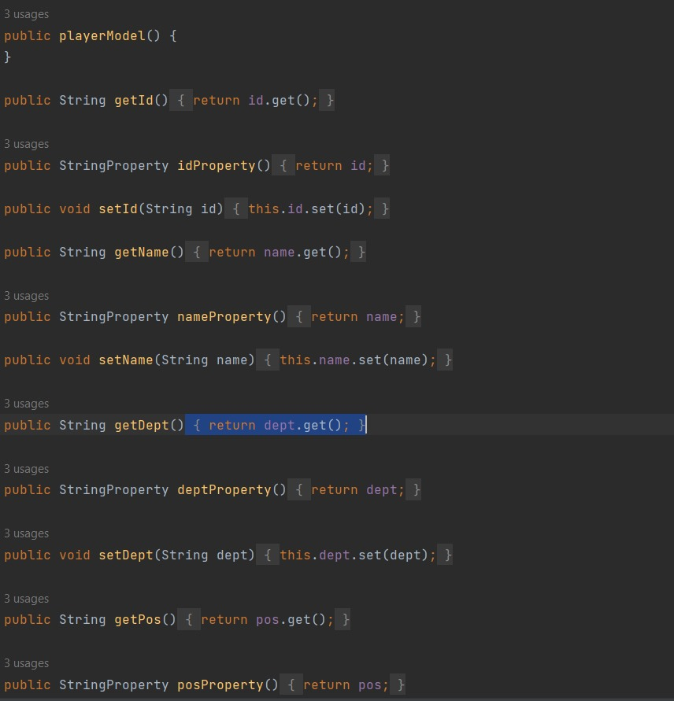

Inheritance in OOP:

Inheritance is a mechanism in Java that allows a new class to inherit the properties and behaviors of an existing class, facilitating code reusability and creating a hierarchical relationship among classes.

Database Connection

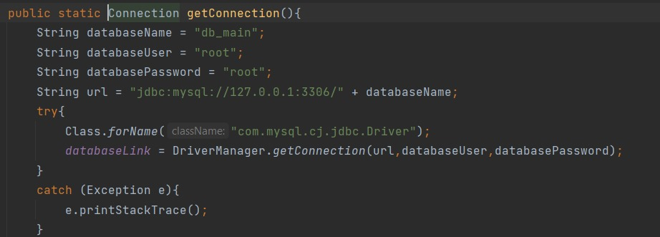

Data Fetch

Previous Data Delete then Update

