**MILITARY INSTITUTE OF SCIENCE AND TECHNOLOGY**



**DEPARTMENT OF COMPUTER SCIENCE AND ENGINEERING**

**From Data to Diagnosis: Exploring the Ideas of Computer Science in Nuclear Medicine Focusing Affordable Healthcare in Bangladesh**

**MD. NAHUL RAHMAN**

**CSE-22, ID: 202214049**

**Email:** [**ssl.arahman@gmail.com**](mailto:ssl.arahman@gmail.com)

**01741334838**

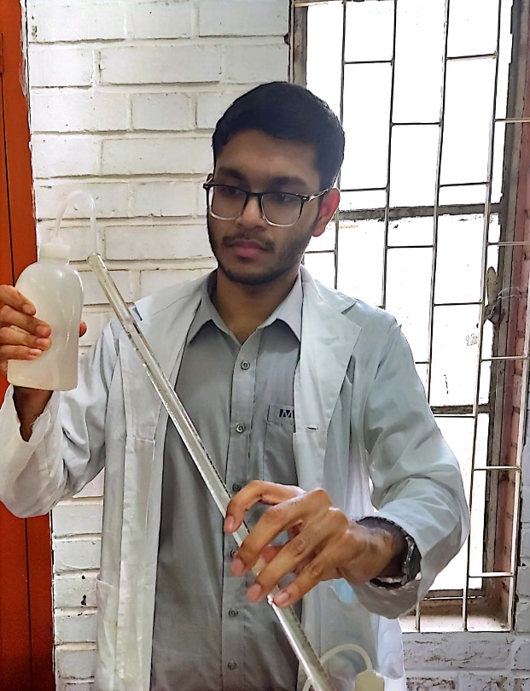

**Abstract**

In Bangladesh, nowadays, a large number of people are diagnosed with diseases like Cancer and Thyroid malfunction and many are treated through the use of atoms. Nuclear medical technologies have revolutionized the diagnostic services owing to its accuracy. The National Institute for Nuclear Medicine and Allied Sciences (NINMAS), through a number of centers, is providing various nuclear medicine services throughout the country. The institute is an establishment of Bangladesh Atomic Energy Commission (BAEC) under the Ministry of Science & Technology of the government NINMAS and BSMMU offer diagnosis, treatment; and concurrently conducts research and development activities (Bashar, 2017) .With the integration of computer science have the potential to enhance the treatment, research and diagnosis of nuclear medicine sector making more accurate, precise, efficient and time saving, specifying in revolutionizing healthcare delivery for patients in Bangladesh in order to give better medical services through nuclear medicine at low cost, regardless of any economic background.

**Introduction**

With the advancements of technology and a subtle urge to make Bangladesh digitalized, computer scientists can come forward to boost the advancement of nuclear medicine sector, with the aid of computer science the main goal of this country in nuclear medicine sector is to prioritize affordable healthcare for all the general people of Bangladesh can be achieved in an optimized way. Computer science will give enhancement in the efficiency research, diagnostic and treatment sectors. Our objectives in this article is to integrate the topics of nuclear medicine and computer science and to discuss the ideas where computer science can help in nuclear medicine in revolutionizing a better healthcare service at the doorstep of patients at low cost in Bangladesh and to reduce the waiting process focusing the point as patients in Bangladesh still can't be provided with seating facilities, they have to wait a long time to get services. Tackling the challenges Bangladesh can ensure proper medication and further research for common people.

Nuclear medicine or nucleology is a medical specialty involving the application of radioactive substances in the diagnosis and treatment of disease (<https://en.wikipedia.org/wiki/Nuclear_medicine>). Nuclear medicine uses radioactive material inside the body to see how organs or tissue are functioning (for diagnosis) or to target and destroy damaged or diseased organs or tissue (for treatment) (<https://www.cdc.gov/nceh/radiation/nuclear_medicine.htm#:~:text=Nuclear%20medicine%20uses%20radioactive%20material,or%20tissue%20(for%20treatment)>.). Some types of Nuclear Medicine (Proven Radiology Procedures in New Jersey) are : Bone or Joint Scan, Gallium Scan, Gastroesophageal Reflux Study, Gastric Emptying, Liver or Spleen Scan, MUGA Scan etc. (<https://www.atlanticmedicalimaging.com/radiology-services/nuclear-medicine/types-of-nuclear-medicine/>) Nuclear medicine is described by three elements - clinical problem, the radiopharmaceutical and the instrumentation. Since nuclear medicine involves exposure of patients, the general principles of radiation protection should be applied. (<https://www.iaea.org/resources/rpop/health-professionals/nuclear-medicine#:~:text=Nuclear%20medicine%20is%20described%20by,radiation%20protection%20should%20be%20applied>.)

Bangladesh, a developing county, has a rich history of nuclear medicine in the sectors of research, diagnosis and treatment, breaking down barriers to nuclear medicine. Starting the journey from a tin shed ‘Radioisotope Center’ in 1962, the first nuclear medicine establishment, Bangladesh now have 20 NM centers with 3 PET-CTs, 42 gamma camera/SPECTs having 95 NM physicians, 20 physicists, 10 radiochemists and 150 technologists and it’s still advancing. The National Institute of Nuclear medicine and Allied Sciences (NINMAS) in Dhaka is by far the largest NM facility in the country. Bangladesh didn’t stop in staying within the boundaries but the country has also maintained international relationship with ARCCNM, AOFNMB, ASNM, WFNMB and WARMTH for coordinated approach of development (Hussain, 2016). Bangladesh is building a nuclear medicine system with well-trained medical staff, advanced imaging tools and a cost-effective source of essential radiopharmaceuticals. The number of people who can affordably access diagnostic medical care in Bangladesh has increased three times over the last ten years, as the country has expanded and strengthened its nuclear medical services (Jawerth, 2016).

The rapid growth in the capability of computers has implications for the management of a nuclear medicine department. it focuses on the phenomenal increase in computing capabilities, storing images on a computer, image processing, data acquisition, file format, information system. (<https://humanhealth.iaea.org/HHW/MedicalPhysics/e-learning/Nuclear_Medicine_Handbook_slides/Chapter_12._Computers_in_Nuclear_Medicine.pdf>) In the history of nuclear medicine through the eyes of computers the excellent anatomic details of central nervous system (CNS) disease provided by computerized transaxial transmission tomography emphasized the limited ability of nuclear imaging to assess morphology. The greatest impact has been seen in cardiovascular nuclear medicine. The introduction of computerized transaxial tomography (CT) for radiographic systems in the mid-1970's had an enormous impact on the practice of nuclear medicine. The effects of improved computer algorithms have had an impact on analysis of data obtained from numerous radioisotope studies. Computers have also been used in nuclear medicine to perform administrative functions, like data reporting and retrieval. The data organization and retrieval functions of computers are also quite useful for in vitro operations where hundreds of samples are counted in close proximity. Computers have also been used for programmed instruction of nuclear medicine technologist and physician trainees, and have even been used to "interpret" digital organ images (Alderson,1978).

**Enhancing Nuclear Medicine Practices with Computer Science Technologies in Bangladesh**

The first and foremost sector that Bangladesh needs to focus on is creating an effectively managed and analyzed database containing all the patient’s information for priority order and further research purpose. They can get inspirations and study the data structures that maintains NUclear Medicine DAtaBase (NUMDAB), an information resource on the status of nuclear medicine practice worldwide (<https://www.iaea.org/resources/hhc/nuclear-medicine/databases/numdab>). Understanding the current state of infrastructure, technology and educational resources for implementing nuclear medicine practice, training and research the development of efficient databases and data analytics techniques is mandatory in order to the extraction of valuable insights from the data to execute patient’s treatments quickly and further purpose also.

Computer science needs to be used to enhance and analyze medical images obtained from nuclear medicine procedures. One of the major parts of nuclear medicine is image processing, and with the aid of computers and ADC and DAC system converters image processing is the new digital image processing, the use of algorithms and mathematical models to process and analyze digital images. The goal of digital image processing is to enhance the quality of images, extract meaningful information from images, and automate image-based tasks (Kumar, 2023). In digital image processing the sectors mentioned needs to be explored focusing on the enhancement of image acquisition, reconstruction, analysis in nuclear medicine, the development and utilization of advanced machine learning algorithms, AI-driven tools and technologies and integration of computer-aided detection systems to assist radiologists for automated image analysis and detection of abnormalities, advanced imaging systems, such as hybrid modalities and molecular imaging techniques for achieving quick and accurate diagnosis and treatment purpose. Innovative imaging techniques, such as low-dose protocols and novel data processing algorithms, reduce radiation exposure without compromising diagnostic accuracy, safeguarding patient safety while minimizing associated costs.

Telemedicine is a sustainable and optimized solution for ensuring initial procedures for rapid treatment. Telemedicine refers to the provision of remote clinical services, via real-time two-way communication between the patient and the healthcare provider, using electronic audio and visual means(Thomas, 2023). Bangladesh has advanced in telemedicine services, remote healthcare and consultation isn't a difficult job now. Here Telecommunication engineering comes in handy. This solution is effective in rural areas where healthcare services are limited. Gathering efficient information prioritize the treatment of patients in order of emergency level if real time patient monitoring if is ensured.

The utilization of computer science enhancing radiation dosage optimization in nuclear medicine treatments in order to gain precise diagnostic or therapeutic dosages focusing on minimum potential risks. The importance for creating algorithms and software tools for achieving precise dose calculation and optimization is worth mentioning.

Proper utilization of computer-based simulations and modeling techniques can ensure an optimized treatment plant in order to reduce side effects. The enhancement of computerized systems to ensure precision and effectiveness of radiation therapy in nuclear medicine can be an effective solution. AI based decision support systems can help doctors while conducting the proper steps of treatments maintaining medical ethics.

In the field of medicine, in particular, medical imaging, the hype of recent years about artificial intelligence (AI) has had a significant impact. The following figure explains the sectors in medical imaging can be explored:

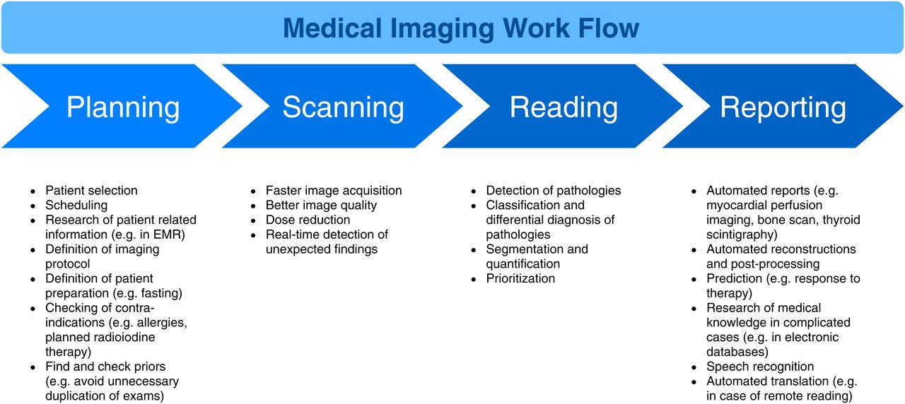

Division of typical medical imaging Work Flow into 4 steps: planning, image acquisition, interpretation (reading), and reporting. Each step is assigned a list with examples of typical tasks that could be performed in that step and could be improved, accelerated, or completely automated with the help of AI (Nensa et al., 2019).

**Challenges**

Discussing about all the probable sectors and possible ways to contribute into nuclear medicine via computer science in medical sectors of Bangladesh, challenges and drawbacks still remain evident. The bridge between computer science and nuclear medicine it still quite fragile. We can’t overlook the challenges that can hinder the advancement of nuclear medicine with the aid of computer science as inadequate facilities still remain in this developing country. One of the biggest problems we need to overcome is limited infrastructure and inadequate resources for example: the need of high performing computing systems (super computers), advanced imaging equipment. These sophisticated machineries can’t be afforded still in root level medical and research institutions. The challenge professionals in the field are facing is two-fold. On the one hand, there is scarcity of trained manpower. On the other, the population is growing. While international standards recommend operating one radiotherapy machine per one million inhabitants, Bangladesh still has only 24 machines for its population of 166 million [14]. Dr Nafisa Zahan, director of Inmas in Barishal, says "The number of our patients has increased a lot compared to before. An average of 150 patients come daily for treatment. Patients can't be provided with seating facilities, they have to wait a long time to get services." (Tajmim et al., 2022) Lack of financial supports or in governmental aids in research and development projects due to corruption, inertness in systems hinders the technical, theoretical, practical and analytical progress in each sector. Bangladesh though advancing in IT sectors still face a technical expertise gap in simulation, imaging sectors as most of the aspirants focus on marketing and management skills in commerce fields. Medical sector, a demanding field still faces the shortage of skilled computer engineers, data scientists, imaging experts. High expanses, maintenance costs of computer systems, software, and specialized training are significant financial challenges for nuclear medicine specialized healthcare institutions. While diagnosing numerous patients the need of an optimized data management systems is still seen evident. When a researcher wants to do research on a numerical database basis the problem always rises first.

**Strategies to Overcome the Challenges**

Investments in infrastructure, education, and training programs will further strengthen the integration of computer science in nuclear medicine and its affordability in Bangladesh. The government has taken an initiative to install modern equipment and develop infrastructure at the country's five nuclear medicine institutes to cope with the growing number of patients. It will help common people outside Dhaka get an opportunity for diagnoses and treatment of some complex diseases, through nuclear medicine at low cost. In addition, the diagnostic capacity of the institutes will increase and the patient control system will improve. The Institutes of Nuclear Medicine and Allied Sciences (Inmas) will be modernized at Mitford, Cumilla, Faridpur, Barishal and Bogura at a total cost of Tk216 crore. The Bangladesh Atomic Energy Commission will implement the project by 2025. In the proposed development project proposal, known as DPP, Tk122 crore has been earmarked for the purchase of foreign equipment, which is 56.37% of the total project cost. Another Tk18 crore has been proposed for the purchase of local machinery, which is 8.63% of the total project cost (Tajmim et al., 2022). While tackling the challenges in the sector of cost and affordability, computer science is itself the solution. Bangladesh still faces a shortage of manpower, including doctors, against the number of sanctioned posts in the sector of nuclear medicine. The first and foremost duty to ensure a skilled manpower is education and training. But nuclear medicine in practical training isn't free from risks as it is associated with isotopes and radiation. Also providing medical training centers are expensive, mentioning maintenance of the equipments, machines etc. As a developed country like Bangladesh in the era of digitalization interactive educational tools, virtual environments and simulation software can be a solution to minimize the cost and risks of practical training. Providing virtual simulators for educational and training purposes, it can minimize the cost, risks while doing practical training and a skilled workforce can be ensured.Academic institutions, healthcare providers, technology companies, and the government should foster partnerships to drive research, development, and implementation of computer science solutions. Emphasizing the requirement of a powerful database management system for storing, managing and analyzing numerous patient data is a demand while diagnosing patients along with constant monitoring to avoid the leakage of these data. The simultaneous working of cybersecurity and database sectors is must need while handling with the huge amount of database.

**Conclusion**

Such a vast topic like nuclear medicine having a rich history even in Bangladesh, it's importance in medical sector can't be bounded in limited words. Despite all the challenges Bangladesh is still fighting against all odds to get the solution in order to provide efficient treatment to the general people by delivering at the doorsteps of the country’s people at low cost. Here computer science can be revolutionary to make the treatment low-cost and research fast paced. As the matter costing is extremely important for people in Bangladesh. If Bangladesh can’t provide subsidized care many people would not be able to get the care they need.

**References**

Bashar, R. (2017, August 20). Nuclear medicine for affordable health care in Bangladesh - Nuclear Asia. Nuclearasia. <https://www.nuclearasia.com/feature/bangladesh-riding-high-affordable-healthcare-nuclear-medicine-brief-account/822/>

Hussain, R. (2016). History and Perspectives of Nuclear Medicine in Bangladesh. Asia Ocean J Nucl Med Biol, 4(1), 55–58. 10.7508/aojnmb.2016.04.009

Jawerth, Nicole. "How Bangladesh is Breaking Down Barriers to Nuclear Medicine | IAEA" Iaea, 2 Nov. 2016, <https://www.iaea.org/newscenter/news/how-bangladesh-is-breaking-down-barriers-to-nuclear-medicine> . Accessed 1 Jan. 1970.

P. O. Alderson, "The Impact Of Computers In Nuclear Medicine," The Second Annual Symposium on Computer Application in Medical Care, 1978. Proceedings., Washington, DC, USA, 1978, pp. 59-64, doi: 10.1109/SCAMC.1978.679899. <https://ieeexplore.ieee.org/document/679899>

Kumar, N. (2023, February 22). Digital Image Processing Basics - GeeksforGeeks. Geeksforgeeks. <https://www.geeksforgeeks.org/digital-image-processing-basics/>

Thomas, Dr. Liji. (2023, January 18). What is Telemedicine?. News-medical. <https://www.news-medical.net/health/What-is-Telemedicine.aspx>

Nensa, F., Demircioglu, A. & Rischpler, C. (2019). Artificial Intelligence in Nuclear Medicine | Journal of Nuclear Medicine. <https://jnm.snmjournals.org/>, 60.<https://doi.org/10.2967/jnumed.118.220590>

Gil, L. (2019, March 8). Nuclear Medicine, Radiation Oncology Get Major Uplift in Bangladesh | IAEA. Iaea. <https://www.iaea.org/newscenter/news/nuclear-medicine-radiation-oncology-get-major-uplift-in-bangladesh>

Tajmim, T. & Saif, S. (2022, July 19). Scope for nuclear medicine services growing | The Business Standard. Tbsnews. <https://www.tbsnews.net/bangladesh/health/scope-nuclear-medicine-services-growing-442538>