BARKOT BAR & RESTAURANT
Software Architecture Specification
BARKOT-SAS-001
Architecture Baseline | 28 September 2026
By Nahom Desta | +251983204356 | nahomdesta.dev@gmail.com

Document Attribute | Value
Document ID | BARKOT-SAS-001
Version | 1.0.0
Status | Architecture Baseline / Pre-Implementation
System | Barkot Bar & Restaurant Business Operations System
Primary Modules | Admin Dashboard, Sales/Income, Inventory, Finance/Balance, Payroll
Primary Users | Owner, Manager, Cashier, Barman
Primary Currency | ETB
Primary Business Timezone | Africa/Addis_Ababa
Prepared Scope | MVP + production-ready foundation

Architecture intent
Build the smallest production-capable system that gives Barkot reliable sales, inventory, financial balance and monthly payroll control without introducing unnecessary microservices, managed SaaS dependencies or recurring foreign-currency infrastructure unless the business actually needs them.

Document Contents
1. Purpose and Scope
2. Business and System Context
3. Architectural Principles
4. Architecture Decision Summary
5. Target Technology Stack and Versions
6. System Context and Logical Architecture
7. Frontend Architecture
8. Backend Architecture
9. Authentication and Authorization
10. Core Domain and Transaction Architecture
11. Data Architecture and PostgreSQL Design
12. Inventory Architecture
13. Sales and Finance Architecture
14. Payroll Architecture
15. Reporting and Analytics Architecture
16. Integration Architecture (Chapa / Fiscal / Email / Storage)
17. Optional Async Processing: Redis/Valkey + Celery
18. Infrastructure, Deployment and Hosting Options
19. Domain and DNS Strategy (Yegara Host)
20. Security Architecture
21. Backup, Disaster Recovery and Business Continuity
22. CI/CD and Release Management
23. Testing Strategy
24. Observability and Operations
25. Repository and Project Structure
26. Complete Dependency Inventory
27. Cost-Control Strategy
28. Phased Implementation Plan
29. Architecture Risks and Mitigations
30. Open Decisions / Validation Items
31. References and Source Notes

1. Purpose and Scope

1.1 Purpose
This specification defines the target technical architecture for Barkot Bar & Restaurant's internal business operations system. The architecture is designed to support the client-validated business problems: inventory/stock control, income and expense tracking, financial balance reporting, and monthly payroll.

1.2 Product scope
- Business dashboard: Owner/manager overview of income, expenses, balance, stock alerts and operational exceptions.
- Sales: Record customer sales, payments and transaction history.
- Inventory: Products, stock receiving by the Barman, stock movements, breakage/waste, stock counts and variance.
- Finance: Income, expenses, balance and related operational reports.
- Payroll: Employees, monthly payroll, additions, deductions, approval and payment status.
- Reports: Financial, inventory and payroll reports with date filters and exports.
- Administration: Users, roles, business settings, categories, payment methods and audit controls.

1.3 Explicit non-goals for MVP
- Customer-facing ordering application.
- Delivery management.
- Restaurant reservation management.
- Multi-branch or multi-warehouse support.
- Full ERP/accounting suite.
- Advanced AI forecasting.
- Offline financial transaction processing without a reconciliation model.
- Microservice deployment.

2. Business and System Context
The client confirmed that the Barman receives stock. Physical stock counting depends on the situation and is usually performed by the Cashier, Owner or Manager. Employees are paid monthly. The main reports currently used are Payroll, Inventory/Stock Balance and Balance (Income, Expense and Balance).
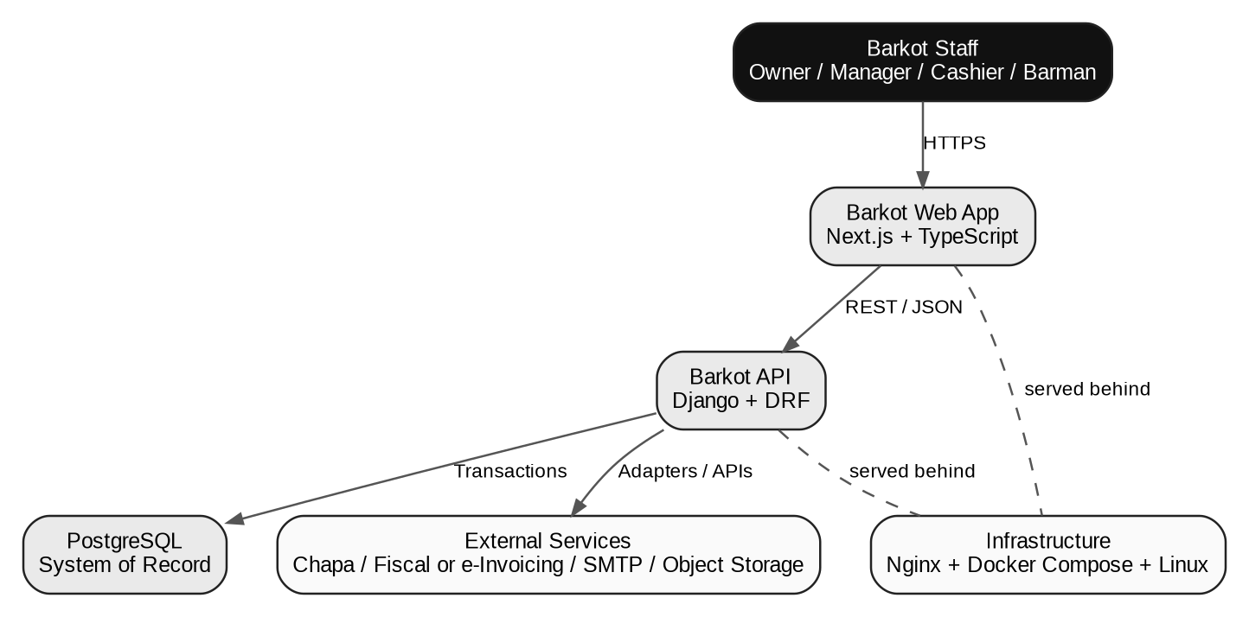
Figure 1. System context and major external boundaries.

2.1 Core business control loop
Stock received -> inventory increases
Sale -> income increases + inventory decreases
Breakage/waste -> inventory decreases through a recorded movement
Stock count -> expected vs physical quantity -> variance
Expenses -> costs increase
Payroll -> monthly employee cost is recorded
Reports -> read from authoritative transaction data
Architecture consequence
The system is not three unrelated CRUD modules. Sales, inventory, finance and payroll share financial and audit boundaries. A single business event can create multiple linked records, and those records must be committed atomically.

3. Architectural Principles
ID / Principle | Plain explanation
P01 — Modular monolith first | Keep one deployable backend with clearly separated Django domains. The system should be easy to operate on one VPS. Split services only when a demonstrated scaling or organizational requirement appears.
P02 — PostgreSQL is the system of record | Inventory, sales, expenses, payroll and audit records live in one relational database. No dashboard or cache is allowed to become the source of truth.
P03 — Ledger over overwrite | Inventory and financial values are represented as transactions/movements. Historical records are not silently overwritten to “fix” a balance.
P04 — Atomic business transactions | A sale, for example, must create its sale header, items, payment and stock movement inside one database transaction so partial records cannot survive.
P05 — Least privilege | Users are granted only the permissions necessary for their work. Frontend visibility is not a security boundary; backend permissions are authoritative.
P06 — Auditability by design | Sensitive operations record actor, timestamp, entity, action and relevant reason/context. Corrections are represented as adjustments instead of erasing evidence.
P07 — Cost-aware engineering | Prefer open-source components and a single VPS. Optional Redis/Valkey + Celery are introduced only when background processing creates real value.
P08 — Integration isolation | Payment, fiscal/e-invoice and email providers are accessed through adapters/services. Business logic must not depend directly on provider-specific payload formats.
P09 — Same-origin web security | Where practical, serve the Next.js UI and Django API from the same public origin through Nginx path routing. This reduces cross-origin complexity and supports secure cookies/CSRF patterns.
P10 — Local-time correctness | Store timestamps consistently and calculate daily/period reports using Africa/Addis_Ababa. Business-day boundaries must never depend on browser locale alone.
P11 — Connectivity resilience | Critical writes use idempotency keys and concise requests so retries do not duplicate sales or stock receipts. MVP does not silently create offline financial transactions.
P12 — Upgradeable dependencies | Pin exact production versions in lock files/images, update patch releases regularly, and document major upgrades with test evidence.
P13 — Boring operations | Use Docker Compose, Nginx, PostgreSQL, standard Linux, automated backups and a small number of processes. Avoid Kubernetes and distributed infrastructure.
P14 — Test business invariants | Tests must prove that inventory cannot go negative unexpectedly, a sale changes stock once, payroll totals reconcile and reported balance matches source transactions.

4. Architecture Decision Summary
Decision | Selected | Reason
Application style | Modular monolith | Small team, one client, shared transaction boundaries, simpler deployment and debugging.
Frontend | Next.js + TypeScript | Strong dashboard UI ecosystem, type safety, component reuse and responsive web delivery.
Backend | Django + DRF | Mature relational model support, authentication, admin tooling, ORM, security and API framework.
Database | PostgreSQL 17.x | Relational integrity, transactions, reporting capability, mature ecosystem and permissive license.
Web server | Nginx | Stable reverse proxy, TLS termination, routing and static asset handling.
Runtime isolation | Docker Compose | Repeatable local/staging/production environments without Kubernetes complexity.
Async jobs | Optional Celery 5.6.x | Use only for report generation, scheduled tasks and other non-blocking work.
Queue/cache | Optional Redis 7.2.x / alternative Valkey | Keep core MVP functional without a queue; add one when async needs become real.
Auth for web MVP | Django session + secure HttpOnly cookie + CSRF | Simple same-origin web authentication; future mobile clients can use token auth.
API | REST / JSON, /api/v1/ | Simple, explicit contract suited to the web application and future clients.
Deployment | Commercially permitted external VPS + Yegara domain | Full control and predictable architecture; Yegara current VPS terms restrict commercial use.

5. Target Technology Stack and Versions
Version targets are recommendations for a project starting in September 2026. Patch versions should be pinned to the latest secure release available when the repository is created; the table intentionally distinguishes “major/minor target” from the patch version that is actually locked in source control.
Layer | Target version | Why | Upgrade policy
OS | Ubuntu Server 24.04 LTS | Stable long-lived server base; widely supported by Docker and standard tooling. | Apply security updates monthly or sooner for critical issues.
Python | 3.13.x | Supported by Django 5.2 and long support window; conservative ecosystem choice versus jumping to every newest release. | Pin minor series; patch update regularly.
Django | 5.2.x LTS | LTS release with long security support. | Pin latest secure 5.2.x patch available at implementation time.
Django REST Framework | 3.18.x | Current 3.18 series supports modern Django releases and includes 2026 fixes. | Pin exact patch.
Node.js | 24.x LTS | Active LTS line as of the target date; suitable for production Next.js. | Track LTS patches.
Next.js | 16.3.x / 16.x | Current 2026 generation with App Router, TypeScript and modern build tooling. | Pin exact patch and update within 16.x after regression tests.
React | 19.3.x | Current React major/minor as of September 2026. | Patch updates with UI regression testing.
TypeScript | 5.9.x or compatible 5.x | Next.js 16 requires TypeScript 5.1+; 5.9 adds current compiler improvements. | Pin exact patch.
Tailwind CSS | 4.x | Current generation; efficient for the monochrome Barkot design system. | Use supported 4.x patch.
PostgreSQL | 17.x | Conservative supported version with long support window; avoids unnecessary major jump while project is new. | Patch update within 17.x.
Celery | 5.6.x | Current stable 2026 series. | Optional dependency; pin exact patch.
Redis | 7.2.x (optional) | Permissive BSD-3-Clause licensed line; extended supported Redis series. | Use only if needed; evaluate Valkey alternative if licensing preferences change.
Valkey | 9.1.x (alternative) | Open-source Redis-compatible option; current 2026 release line. | Use only after Celery integration tests pass.

Version-source notes
Django 5.2 is an LTS release and supports Python 3.14; Django 6.1 is newer but has a shorter support horizon than the 5.2 LTS branch. For a business system with a small team, this specification deliberately chooses the LTS line. PostgreSQL 17 is a currently supported major version. Celery 5.6 is the stable 2026 line. Next.js 16 requires Node 20.9+; Node 24 is the current LTS line. See the reference section for official source links.

6. System Context and Logical Architecture

6.1 Logical layers
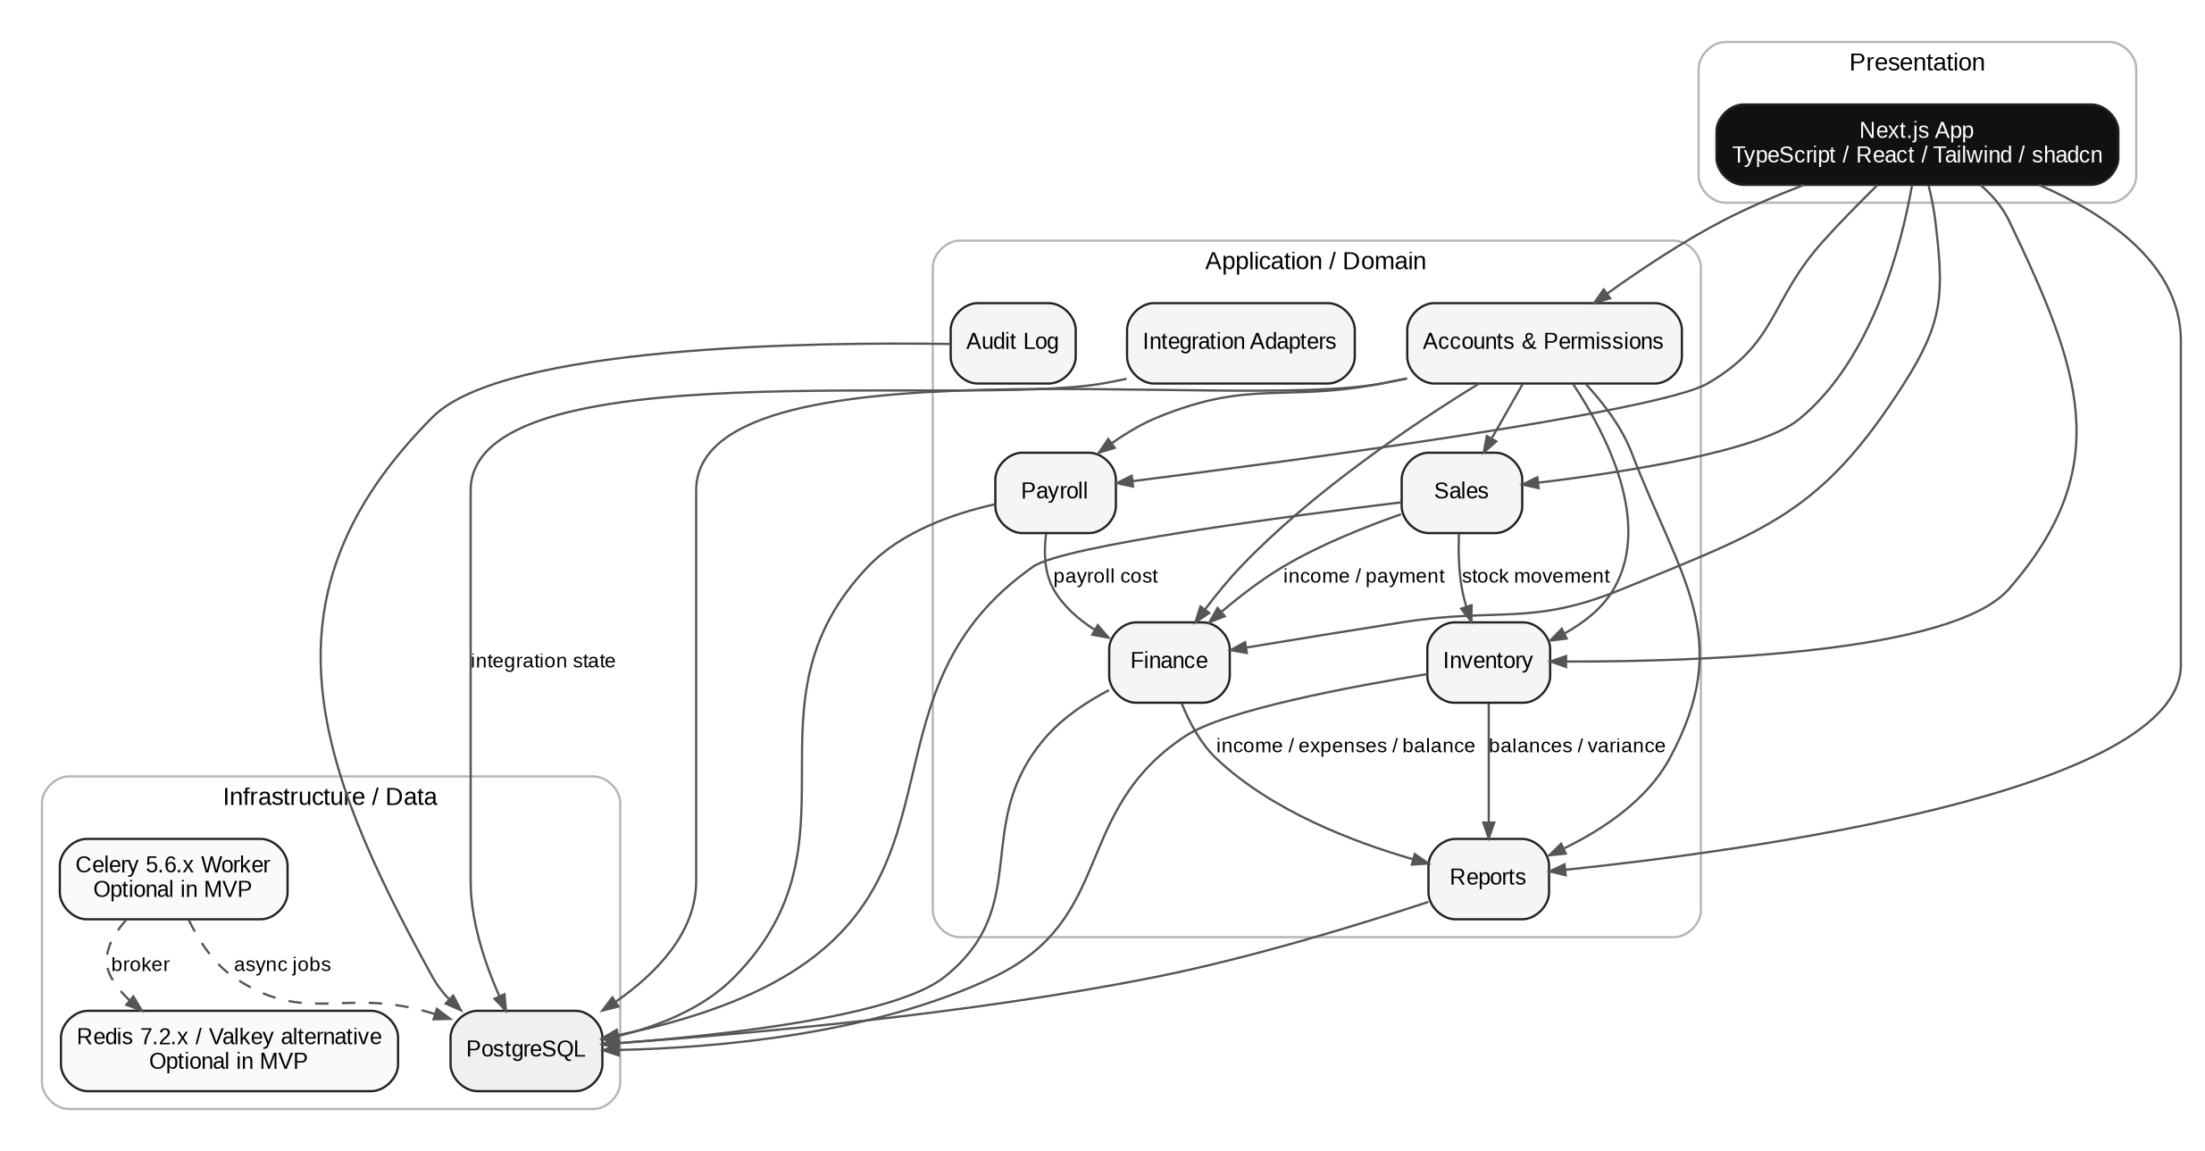
Figure 2. Logical architecture: presentation, application domains and infrastructure services.

6.2 Module boundaries
Django app/domain | Owns | May depend on
accounts | authentication, sessions, roles, permissions | core, audit
users | user profile/business role data | accounts
products | categories, products, price history | core
sales | sales, sale items, payments | products, inventory, finance, audit
inventory | stock receipts, movements, counts, adjustments | products, audit
finance | expenses, financial transaction views, balance calculations | sales, inventory, payroll
payroll | employees, payroll runs, deductions, payment status | users, finance, audit
reports | read-only report/query services and exports | all domains; never owns source truth
integrations | provider adapters and integration state | core; selected domain events
audit | immutable/append-oriented audit records | accounts, core
core | shared enums, base models, money/time utilities, errors | none

Dependency rule
Domain dependencies should flow inward toward business rules and data. Views/controllers should orchestrate use cases; they should not contain multi-step financial or inventory calculations.

7. Frontend Architecture

7.1 Technology
- Framework: Next.js 16.x with App Router.
- Language: TypeScript.
- UI: Tailwind CSS 4.x and shadcn/ui components.
- Icons: Lucide React.
- Charts: Recharts or an equivalent lightweight chart library.
- Forms: React Hook Form + Zod for client-side schema validation where useful.
- Server communication: fetch/typed API client; React Query may be introduced for client-side cache and request state.

7.2 Frontend responsibilities
- Render business workflows defined by the UX specification.
- Enforce presentation-level permissions and hide actions that the user cannot perform.
- Validate obvious input errors before sending requests.
- Never calculate authoritative balances independently of the backend.
- Handle loading, empty, success and error states explicitly.
- Provide accessible keyboard and mouse interactions for tables/forms.

7.3 Suggested feature structure
apps/web/src/
app/
components/
features/
dashboard/
sales/
inventory/
finance/
payroll/
reports/
lib/
services/
hooks/
types/
styles/

7.4 Route model
/dashboard
/sales
/sales/transactions
/inventory
/inventory/products
/inventory/receive
/inventory/counts
/inventory/movements
/inventory/breakage
/finance
/finance/expenses
/finance/balance
/payroll/employees
/payroll/runs
/payroll/deductions
/reports
/settings

8. Backend Architecture

8.1 API style
Django REST Framework provides a versioned REST API. The browser application communicates with /api/v1/... endpoints. Each endpoint maps to an explicit use case or resource. List endpoints use filtering, pagination and ordering; detail endpoints return a stable schema.
/api/v1/auth/login/
/api/v1/auth/logout/
/api/v1/auth/me/
/api/v1/dashboard/summary/
/api/v1/products/
/api/v1/sales/
/api/v1/sales/{id}/
/api/v1/inventory/receipts/
/api/v1/inventory/counts/
/api/v1/inventory/movements/
/api/v1/finance/expenses/
/api/v1/finance/balance/
/api/v1/payroll/employees/
/api/v1/payroll/runs/
/api/v1/payroll/deductions/
/api/v1/reports/...

8.2 Service/use-case layer
Complex operations such as “complete sale”, “receive stock”, “complete stock count” and “approve payroll” should be implemented as explicit service/use-case functions. The API serializer should validate input and call the service; it should not contain the full business transaction.

8.3 Production serving
- Nginx terminates TLS and routes public requests.
- Gunicorn serves Django in production.
- Next.js runs as a Node server using next start.
- Django and PostgreSQL remain on a private Docker network.
- Redis/Valkey, if used, is never publicly exposed.

9. Authentication and Authorization

9.1 Authentication strategy
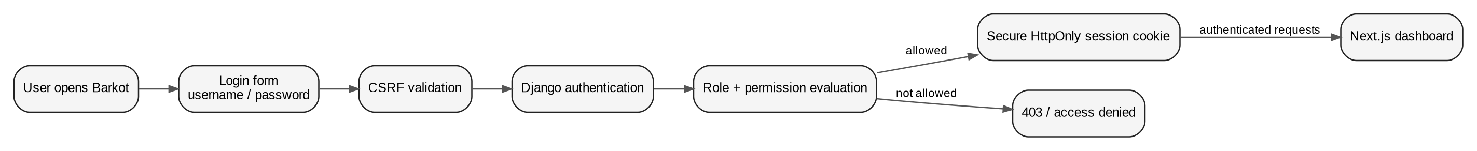
Figure 3. Recommended browser authentication flow for the web MVP.
For the browser-only MVP, use Django session authentication with secure HttpOnly cookies and CSRF protection. Because the UI and API are routed through the same public origin, this avoids storing long-lived tokens in browser localStorage and keeps the security model straightforward. A future mobile client may use DRF SimpleJWT under a separate token policy.

9.2 Roles
Role | Primary permissions
Owner/Admin | Full business visibility, configuration, approvals, reports, users and audit review.
Manager | Operational management, stock counts, expenses, payroll review/approval and reports.
Cashier | Sales, transaction view, stock counts when assigned, relevant inventory access.
Barman | Receive stock, record breakage/waste and relevant inventory view.

9.3 Security controls
- Password hashing using Django's supported password hasher.
- HttpOnly, Secure cookies; SameSite protection appropriate to deployment.
- CSRF protection for state-changing browser requests.
- Session timeout and logout/invalidation.
- Rate limiting/throttling on login and sensitive endpoints.
- Backend permission checks for every protected operation.
- No secrets committed to Git.

10. Core Domain and Transaction Architecture
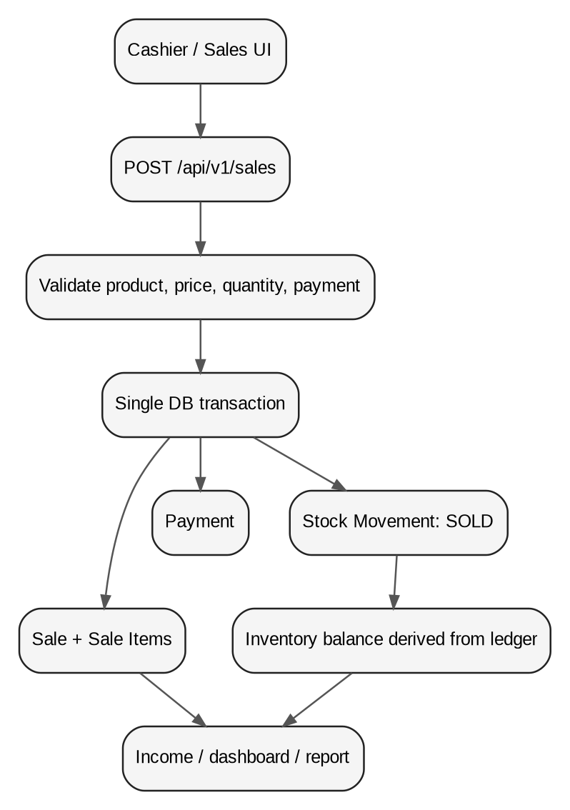
Figure 4. Example atomic sale transaction and resulting inventory/finance effects.

10.1 Business transaction pattern
Request -> validate -> begin database transaction -> create domain records -> create linked ledger movements -> commit -> return authoritative result

10.2 Idempotency
Financial and stock-creating endpoints should accept an Idempotency-Key or enforce an equivalent client-generated unique reference. This is important because a weak network or accidental double-click must not create duplicate sales or duplicate stock receipts.

10.3 Money and quantity types
- Never use floating-point values for money. Use PostgreSQL NUMERIC/Decimal.
- Store currency explicitly as ETB for the MVP.
- Use numeric quantity fields where products may have non-integer units; integer quantities remain valid for bottle-based stock.
- Persist the price used on each transaction line so historical reports remain correct after price changes.

11. Data Architecture and PostgreSQL Design
PostgreSQL is the system of record. PostgreSQL is free to use, including in commercial software, under the PostgreSQL License. The current supported major versions include 17 and 18; version 17 is selected here as a conservative production baseline.

11.1 Core entities
Entity | Purpose
User / Role / Permission | Authentication and authorization.
Employee | Monthly payroll subject.
Product / Category | Inventory and sales master data.
PriceHistory | Historical purchase/selling prices.
Sale / SaleItem / Payment | Customer transaction and payment records.
StockReceipt / StockReceiptItem | Incoming stock received by the Barman.
StockMovement | Append-oriented inventory ledger.
StockCount / StockCountItem | Physical count and variance calculation.
Expense / ExpenseCategory | Operational and inventory-related expenses.
PayrollRun / PayrollItem / Deduction | Monthly payroll and adjustments.
AuditLog | Security and business change trace.

11.2 Inventory calculation
Expected Closing Stock = Opening Stock + Received + Approved Stock-In
- Sales - Breakage/Waste - Other Stock-Out
+/- Approved Adjustments

11.3 Current balance strategy
The movement ledger is authoritative. A derived balance may be cached/materialized later for performance, but the derived balance must never become an independent source of truth. Reconciliation tools must be able to rebuild the expected balance from movements.

11.4 Time strategy
- Database timestamps: UTC.
- Business reporting timezone: Africa/Addis_Ababa.
- Convert to local time at the application/report layer.
- Do not trust a browser-provided timezone for accounting periods.

12. Inventory Architecture
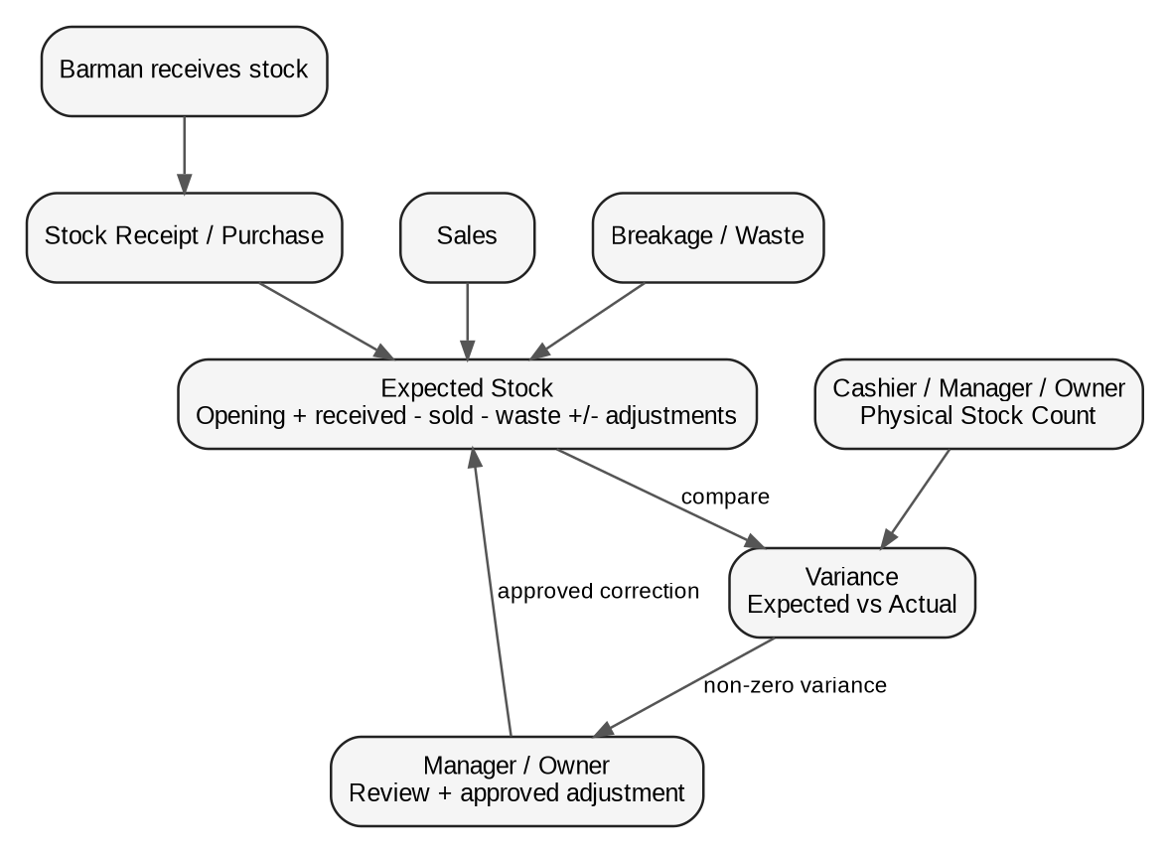
Figure 6. Inventory control loop from receiving through variance review.

12.1 Stock receiving
The Barman is the primary stock receiver. Receiving a stock delivery creates a stock receipt and corresponding stock movements. The operation must be atomic with the financial purchase record when the receipt is considered a business expense.

12.2 Stock counting
Physical counting is intentionally role-flexible. The count can be performed by the Cashier, Manager or Owner. The system records the actual quantity entered by the counter and calculates variance against the expected ledger balance.

12.3 Adjustments
- Non-zero variances are not silently overwritten.
- Adjustments require a reason and actor.
- Sensitive adjustments may require manager/owner approval.
- Historical movements remain visible after an adjustment.

13. Sales and Finance Architecture

13.1 Sales
A completed sale is the principal connection between the Sales, Inventory and Income domains. When a sale is committed, its items and payment are stored, and corresponding stock movements are created in the same database transaction.

13.2 Expenses
Expenses are categorized and recorded separately from revenue. Inventory purchases may have both an inventory effect and a financial cost effect. Payroll is treated as an expense for financial reporting while maintaining a separate payroll domain for employee detail.

13.3 Balance
Balance = Total Income - Total Expenses
The system should label this as business balance/operating balance according to the client’s terminology. It should not claim statutory accounting profit unless the client later defines accounting rules and all required cost/tax inputs are captured.

14. Payroll Architecture
Figure 7. Monthly payroll lifecycle.

14.1 Monthly cycle
Payroll period -> generate -> review -> approve -> mark paid -> report

14.2 Data model
Object | Key fields
Employee | name, position, start_date, monthly_wage, status
PayrollRun | period_start, period_end, status, created_by, approved_by
PayrollItem | employee, gross, additions, deductions, net, payment_status
PayrollDeduction | employee/payroll item, date, amount, reason, recorded_by

14.3 Regulatory configuration
Any statutory tax or payroll deduction rules must be configurable and validated with the client’s accountant before production. The architecture should not permanently hard-code an unverified tax table because Ethiopian payroll requirements can change.

15. Reporting and Analytics Architecture

15.1 Report categories
Report | Primary question | Source domains
Financial Balance | How much came in, how much went out and what is the balance? | Sales, Expenses, Payroll
Inventory Stock Balance | What stock should exist versus what was counted? | StockMovement, StockCount, Products
Inventory Variance | Where do expected and actual quantities differ? | StockMovement, StockCount
Payroll | How much is owed/paid for the month? | Employee, PayrollRun, PayrollItem, Deduction

15.2 Query architecture
Reports should use dedicated query services or read-optimized database queries. Avoid loading thousands of raw records into application memory. Filters should be pushed to PostgreSQL and results should be paginated where appropriate.

15.3 Export
- CSV for simple data exports.
- XLSX for operational report sharing when requested.
- PDF for human-readable report snapshots.

16. Integration Architecture

16.1 Integration rule
External services must be isolated behind adapters. The core business domains should speak in Barkot business concepts such as Payment, Invoice and Notification; adapters translate those concepts to provider-specific APIs.
Integration | MVP status | Architectural treatment
Chapa | Optional / requirement validation | Payment adapter + webhook verification + transaction status table. Never trust browser redirect alone.
Ethiopian fiscal/e-invoicing | Architecture boundary required; exact technical implementation to be validated | Invoice adapter. Keep fiscal fields isolated from core sale model where possible.
SMTP / email | Optional | Notification adapter for password reset/report delivery if enabled.
Object storage | Optional until receipts/uploads require it | S3-compatible adapter. Store only object metadata/URLs in PostgreSQL.

Important
Payment gateway integration and tax/fiscal invoicing are not the same thing. A successful payment does not automatically prove an invoice is fiscally compliant, and a fiscal invoice does not determine how a payment settles.

17. Optional Async Processing: Redis/Valkey + Celery

17.1 Why the system may not need it on day one
Most Barkot MVP operations are short database transactions and should execute synchronously. Adding a queue prematurely creates another service to monitor, secure and back up.

17.2 When to introduce the queue
- Large XLSX/PDF report generation.
- Scheduled daily/monthly summaries.
- Monthly payroll generation if it becomes computationally heavy.
- Email notifications and retryable outbound integrations.
- Long-running reconciliation or maintenance jobs.

17.3 Cost strategy
Cost rule
Celery itself does not create a SaaS subscription. The cost comes from the server/service that runs the worker and broker. For Barkot, run the worker and broker on the same VPS when volume is low. If the client cannot afford any additional service, keep the MVP synchronous and add the queue later.

17.4 Redis vs Valkey
Redis 7.2.x remains under the BSD-3-Clause license, while later Redis lines use source-available licensing models. Valkey is an open-source Redis-compatible project with current 9.x releases. For the initial Barkot deployment, Redis 7.2.x is the lower-risk documented choice for Celery compatibility; Valkey may be adopted after explicit integration testing.

18. Infrastructure, Deployment and Hosting Options
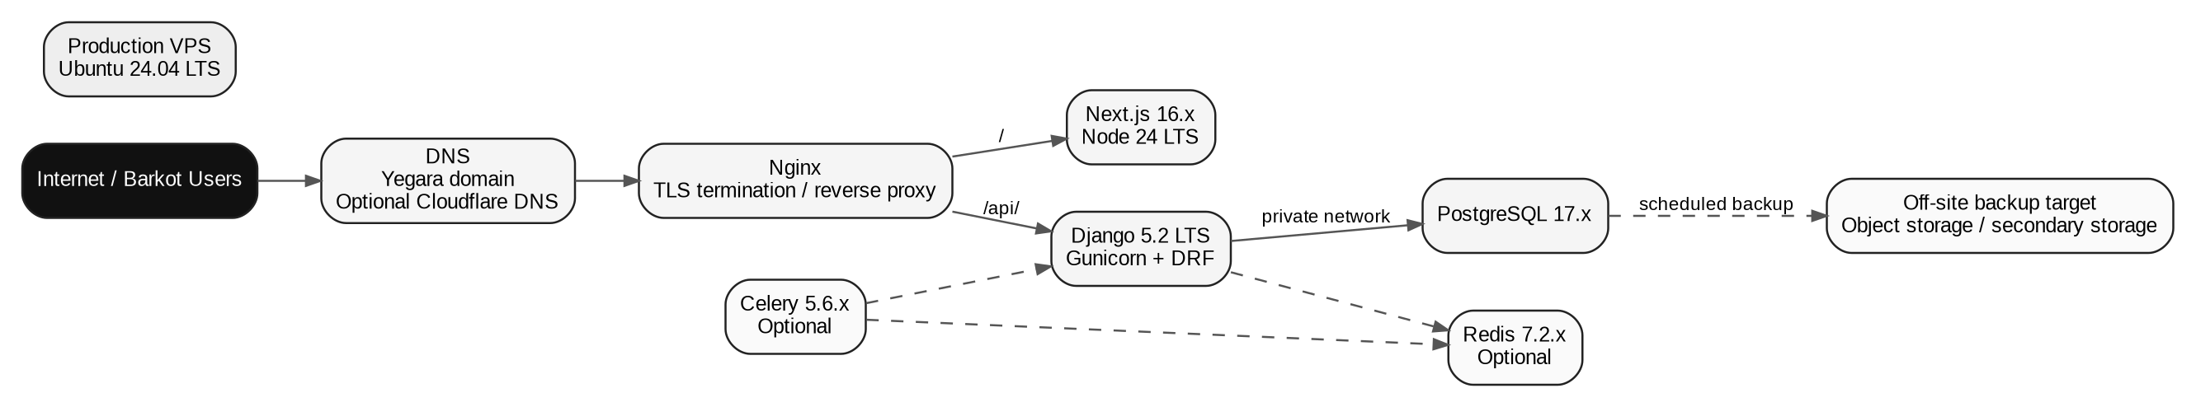
Figure 8. Recommended single-VPS production topology with Yegara domain registration.

18.1 Deployment options
Option | Suitability | Reason / caveat
A. Yegara shared hosting | Not recommended for app runtime | Yegara’s shared hosting is oriented to websites/cPanel-type workloads; the Barkot stack needs long-running Python and Node processes. Use it, if desired, for email/domain-related services only.
B. Yegara VPS | Development/staging only unless terms are changed | Current Yegara terms state that VPS service is for personal/student/developer use and is not permitted for commercial use. Do not deploy Barkot production there without written confirmation that the applicable service permits commercial use.
C. External commercial VPS + Yegara domain | RECOMMENDED | Use Yegara for the domain, then point DNS to a VPS provider whose terms allow commercial applications. One VPS can host Nginx, Next.js, Django, PostgreSQL and optional Redis/Celery.
D. PaaS / managed platforms | Possible but cost-sensitive | Less server maintenance, but multiple services can introduce recurring foreign-currency cost and vendor lock-in.
E. Large cloud (AWS/Azure/GCP) | Future option | Technically strong but unnecessary complexity and cost for a single small restaurant MVP.

18.2 Recommended production topology
- One commercially permitted VPS running Ubuntu 24.04 LTS.
- Nginx on the host for TLS and reverse proxy.
- Docker Compose for application services.
- Next.js container for the web UI.
- Django/Gunicorn container for API.
- PostgreSQL container with persistent volume, or host-managed PostgreSQL if the provider recommends it.
- Redis 7.2.x / Valkey and Celery only when needed.
- Automated external database backups.

19. Domain and DNS Strategy (Yegara Host)
The public domain should be brand-oriented rather than tied to the technology. The current Yegara price page lists .COM registration at 3,800 ETB/year on the Standard Hosting tier, with higher-priced managed/premium hosting packages. Exact availability of a candidate name must be checked at purchase time.
Candidate | Use | Recommendation
barkotbar.com | Primary brand domain | Preferred if available; short and future-proof.
barkotrestaurant.com | Alternative brand domain | Good if the shorter name is unavailable.
barkotmanagement.com | Software/product-oriented | Usable, but less natural for staff and customers.
barkotpos.com | POS-focused | Avoid as primary brand if the product will remain broader than POS.

19.1 Subdomains
https://barkotbar.com/ -> web application / public landing if needed
https://barkotbar.com/api/v1/ -> API through same origin
https://www.barkotbar.com/ -> optional redirect to apex
status.barkotbar.com -> optional status page (future)

19.2 DNS pattern
Register the domain with Yegara, then delegate DNS to a DNS provider if desired, or keep DNS with the registrar. If Cloudflare is selected only for DNS/proxy, the domain registration remains with Yegara. Do not create more subdomains than the application needs.
Domain decision
Buy the domain in the client’s name, not the developer’s personal account. Record the registrar credentials and recovery information in the client’s secure operational documentation.

20. Security Architecture

20.1 Network controls
- Public ports: 80/443; SSH only for administration and preferably restricted by key authentication.
- PostgreSQL and Redis/Valkey not exposed to the public Internet.
- Docker networks separate public-facing services from data services.
- Nginx rate/size limits for large request abuse.

20.2 Application controls
- Django security middleware enabled.
- Secure cookies and CSRF controls.
- Strict input validation and serializer validation.
- DRF pagination and throttling on public/sensitive endpoints.
- Audit log for high-value actions.
- No direct editing of historical financial records; use reversal/adjustment records.
- File upload limits and content-type validation.
- Secrets stored in server secret files/environment, never Git.

20.3 Operational security
- Disable password SSH login if key-only administration is practical.
- Keep OS and container images patched.
- Use automated TLS certificates.
- Run dependency vulnerability scans during CI where practical.
- Review administrator accounts quarterly.

21. Backup, Disaster Recovery and Business Continuity

21.1 Backup policy
Asset | Frequency | Retention target | Restore test
PostgreSQL logical backup | Daily | 7 local + 30 off-site (minimum target) | Quarterly
Uploaded files | Daily / incremental if supported | 30 days or policy | Quarterly
Application configuration | Every deployment + on change | All release versions | On deployment
Docker/image release metadata | Per release | Previous 3-5 releases | Before rollback if needed

21.2 Important rule
Hosting-provider “automatic backup” is not treated as the only backup. Yegara explicitly states in its terms that customers remain responsible for their own backups; the production design therefore creates independent database backups and verifies that a restore is possible.
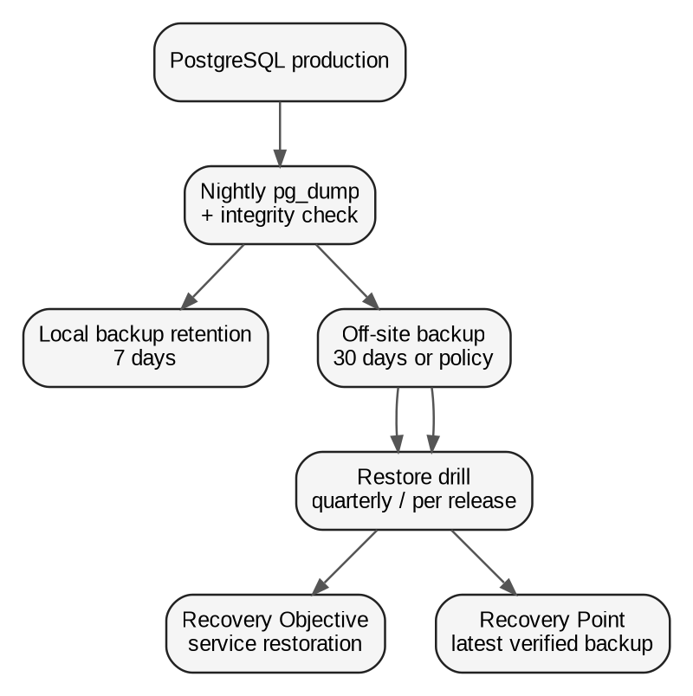
Figure 9. Backup and restore flow.

22. CI/CD and Release Management
Figure 10. Recommended source-control and deployment workflow.

22.1 Branching
main -> production-ready
staging -> release candidate / staging
feature/* -> individual changes

22.2 CI gates
- Backend lint/type checks where adopted.
- Django test suite.
- Database migration check.
- Frontend typecheck/lint.
- Frontend unit/component tests.
- Production build for Next.js.
- API contract/OpenAPI validation where applicable.

22.3 Release
1. Merge approved changes.
2. Build versioned Docker images.
3. Run tests in CI.
4. Deploy to staging.
5. Smoke test login, sale, stock receiving, stock count, expense and payroll.
6. Back up production database before high-risk schema changes.
7. Deploy production.
8. Run migrations.
9. Run health checks and verify key workflows.

23. Testing Strategy
Layer | Examples | Priority
Unit tests | Money calculations, payroll calculations, variance calculations, permission helpers | Critical
Domain/service tests | Complete sale, receive stock, complete stock count, approve payroll | Critical
API tests | Authentication, permissions, filtering, pagination, idempotency | Critical
Database tests | Constraints, transaction atomicity, unique references | Critical
Frontend tests | Forms, table interactions, permission rendering | High
E2E tests | Login -> sale -> stock movement -> dashboard; receive -> count -> variance; payroll cycle | Critical
Security tests | Unauthenticated access, role bypass, file upload limits | High

23.1 Minimum E2E scenarios
- Cashier creates a sale; inventory reduces exactly once; income increases.
- Barman receives stock; inventory increases; purchase cost is recorded.
- Manager completes stock count; variance is calculated; adjustment requires permission.
- Manager generates monthly payroll; deduction reason is captured; net pay reconciles.
- Cashier cannot approve payroll or change product price unless explicitly permitted.

24. Observability and Operations

24.1 MVP baseline
- Application logs with timestamp, level, request ID and user ID where appropriate.
- Nginx access/error logs.
- Docker health checks.
- A simple /health/live and /health/ready endpoint.
- Server disk/CPU/RAM monitoring.
- Optional Sentry integration if an affordable/free plan meets the client’s needs.

24.2 What to alert on
- Application unavailable.
- Database unavailable.
- Disk usage above threshold.
- Backup failure.
- Repeated 5xx errors.
- TLS certificate approaching expiry.

25. Repository and Project Structure
barkot/
apps/
web/ # Next.js
api/ # Django
infra/
docker/
nginx/
scripts/
docs/
architecture/
api/
runbooks/
.github/
workflows/
.env.example
docker-compose.yml
docker-compose.prod.yml
README.md

25.1 Backend internal layout
apps/api/
config/
apps/
accounts/
users/
products/
sales/
inventory/
finance/
payroll/
reports/
integrations/
audit/
core/
manage.py
requirements/

26. Complete Dependency Inventory

26.1 Frontend runtime/development dependencies
Dependency | Target | Purpose | Required
next | 16.x | Web framework / server rendering / routing | Yes
react / react-dom | 19.3.x | UI runtime | Yes
typescript | 5.9.x | Static typing | Yes
tailwindcss / @tailwindcss/postcss | 4.x | Styling system | Yes
lucide-react | Current compatible 0.x | Consistent icon set | Yes
recharts | Current compatible 3.x | Dashboard charts | Yes
react-hook-form | Current compatible 7.x | Form state | Recommended
zod | Current compatible 4.x | Input/schema validation | Recommended
@tanstack/react-query | Current compatible 5.x | Client cache/request state | Recommended
date-fns | Current compatible 4.x | Date formatting/manipulation | Recommended
eslint / eslint-config-next | Next.js 16-compatible | Linting and CI quality gate | Yes
prettier | Current compatible 3.x | Formatting consistency | Recommended
vitest | Current compatible 4.x | Frontend unit/component tests | Recommended
playwright | Current compatible 1.x | End-to-end browser tests | Recommended

26.2 Backend runtime/development dependencies
Dependency | Target | Purpose | Required
Django | 5.2.x LTS | Web framework / ORM / security / admin | Yes
djangorestframework | 3.18.x | REST API | Yes
psycopg[binary] | 3.x | PostgreSQL driver | Yes
django-filter | Current compatible 25.x+ | Filtering API lists | Recommended
drf-spectacular | Current compatible 0.29.x | OpenAPI schema/documentation | Recommended
gunicorn | Current compatible 23.x | Production WSGI server | Yes
whitenoise | Current compatible 6.x | Optional static-file middleware | Optional
Pillow | Current compatible 11.x/12.x | Image processing for logo/product assets | Optional
openpyxl | Current compatible 3.1.x | XLSX report generation | Optional
reportlab | Current compatible 4.x | PDF report generation | Optional
Celery | 5.6.x | Background jobs | Optional
django-celery-beat | Current compatible 2.x | Scheduled Celery tasks | Optional
redis-py | Current compatible 6.x+ | Redis/Valkey protocol client | Optional
pytest / pytest-django | Current compatible releases | Backend unit/integration tests | Recommended
ruff | Current compatible 0.x | Linting and formatting | Recommended
mypy / django-stubs | Current compatible releases | Static type checking where adopted | Recommended

26.3 Infrastructure dependencies
Component | Target | Purpose | Required
Ubuntu Server | 24.04 LTS | Server OS | Yes
Docker Engine + Compose v2 | Current supported release | Application packaging/deployment | Recommended
Nginx | Current stable/security-supported line | Reverse proxy / TLS / routing | Yes
Certbot or equivalent ACME client | Current supported release | TLS certificate automation | Recommended
PostgreSQL | 17.x | Persistent database | Yes
Redis | 7.2.x | Cache/broker if selected | Optional
Valkey | 9.1.x | Redis-compatible alternative if selected/tested | Optional
Celery worker | 5.6.x | Async processing | Optional
Git + GitHub | Current supported client/platform | Source control / CI | Recommended
S3-compatible object storage | Provider dependent | Receipts/uploads when server storage is no longer appropriate | Optional

27. Cost-Control Strategy
Cost area | MVP strategy | Why
Database license | PostgreSQL, self-hosted | No software license fee; client pays only infrastructure.
Backend/frontend license | Django, DRF, Next.js, TypeScript, Tailwind, React | Open-source ecosystem.
Queue | Do not deploy until needed | Avoid unnecessary broker/worker operational cost.
Monitoring | Logs + health checks initially | Avoid mandatory SaaS monitoring fees.
Hosting | Single commercial VPS | One predictable infrastructure bill.
Domain | Yegara .COM registration | ETB-based registrar option; keep ownership with client.
File storage | Start on server only for low-volume assets; move to object storage when needed | Avoid unnecessary storage billing during MVP.
Email | Use existing domain mailbox/SMTP if available | Avoid adding another provider until email automation is necessary.

Important trade-off
“Cheap” does not mean “no operational responsibility.” Self-hosting eliminates many recurring service fees but transfers backup, patching, monitoring and recovery responsibility to the project team.

28. Phased Implementation Plan
Phase | Architecture scope | Key output
Phase 0 | Environment + design baseline | UI spec, repo, Docker Compose, DB schema, auth skeleton
Phase 1 | Auth + users + products | Login, roles, permissions, products and categories
Phase 2 | Sales + inventory | Sales, stock receiving, movements, counts, breakage and variance
Phase 3 | Finance | Expenses, balance, dashboard and financial reports
Phase 4 | Payroll | Employees, monthly payroll, deductions and payment status
Phase 5 | Hardening | Audit, backups, E2E tests, rate limits, monitoring, production runbook
Phase 6 | Optional integrations | Chapa, fiscal/e-invoice, email, object storage, async jobs

29. Architecture Risks and Mitigations
Risk | Impact | Mitigation
Duplicate sales due to retries/double-click | High | Idempotency keys + unique client reference + atomic transaction.
Inventory silently edited | High | Movement ledger + stock counts + adjustment approval + audit log.
Weak network at restaurant | High | Small payloads, server-side retry safety, concise UI, no silent offline financial writes in MVP.
Client cannot pay USD services | High | Self-host core services on one fixed-cost VPS; use Yegara domain/ETB purchasing where practical.
Hosting provider terms change | Medium | Keep portable Docker images + database dumps + documented deployment; own domain in client account.
Tax/e-invoice requirements change | High | Integration adapter + configurable rules; validate with accountant/provider before compliance claim.
Single server failure | High | Independent backups + restore tests + documented rebuild process.
Overengineering for a small restaurant | Medium | Modular monolith, one VPS, optional async services only when needed.
Dependency security issue | High | Pinned versions + periodic patching + CI update checks.

30. Open Decisions / Validation Items
1. Confirm the exact customer sales recording workflow and whether all sales are entered individually.
2. Confirm all payment methods currently used at Barkot.
3. Confirm whether food ingredients are included in inventory MVP or beverages are the first controlled stock class.
4. Confirm the physical stock count frequency and whether a formal closing time exists.
5. Confirm payroll additions/overtime/absence rules, if any.
6. Confirm payroll deduction approval policy and required statutory calculations with the client’s accountant.
7. Confirm whether receipts/documents need file uploads in MVP.
8. Validate fiscal/e-invoicing technical requirements before production sales invoicing is declared compliant.
9. Check live availability of the chosen Barkot domain before purchase.
10. Confirm a commercially permitted production VPS provider and payment method in ETB or otherwise acceptable to the client.
Architecture gate
Do not freeze the production deployment or fiscal integration until the open items that affect legal compliance, commercial hosting terms and payment flows have been validated.

31. References and Source Notes
Ref | Source | URL | Use in this document
R1 | Django 5.2 release notes / LTS | https://docs.djangoproject.com/en/5.2/releases/5.2/ | Used for LTS status and Python compatibility.
R2 | Django 6.1 release notes | https://docs.djangoproject.com/en/6.1/releases/6.1/ | Used to compare current release/support horizon.
R3 | Django 5.2 release notes index | https://docs.djangoproject.com/en/5.2/releases/ | Used to verify current 5.2 patch-release series.
R4 | Django REST Framework release notes | https://www.django-rest-framework.org/community/release-notes/ | Used for current 3.18.x series and compatibility notes.
R5 | Next.js installation/system requirements | https://nextjs.org/docs/app/getting-started/installation | Used for Node.js minimum and current setup guidance.
R6 | Next.js version 16 guide | https://nextjs.org/docs/app/guides/upgrading/version-16 | Used for Node and TypeScript minimums for Next.js 16.
R7 | React 19.3 announcement | https://react.dev/blog/2026/09/09/react-19-3 | Used for current React 19.3 status.
R8 | Python versions / support | https://devguide.python.org/versions/ | Used for Python support horizon.
R9 | PostgreSQL versioning policy | https://www.postgresql.org/support/versioning/ | Used for supported PostgreSQL major versions and lifecycle.
R10 | PostgreSQL license | https://www.postgresql.org/about/licence/ | Used for license/free commercial-use statement.
R11 | Celery 5.6 documentation | https://docs.celeryq.dev/en/latest/ | Used for current stable Celery series and task-queue architecture.
R12 | Valkey downloads/releases | https://valkey.io/download/ | Used for current Valkey 9.1.x release status.
R13 | Redis version management | https://redis.io/docs/latest/operate/oss_and_stack/install/version-mgmt/ | Used for supported Redis version families.
R14 | Redis licensing | https://redis.io/legal/licenses/ | Used for Redis version/licensing distinctions.
R15 | Yegara pricing | https://yegara.com/price | Used for current .COM/domain pricing and hosting options.
R16 | Yegara VPS | https://yegara.com/vps | Used for current VPS resources, prices, locations and deployment characteristics.
R17 | Yegara terms & conditions | https://mail.yegara.com/terms | Used for commercial-use restriction on VPS and backup responsibility.
R18 | Yegara .ET domain guide | https://yegara.com/en/guide/how-to-register-et-domain-name/ | Used to distinguish .ET registration route from Yegara .COM registration.

Source validation date: 28 September 2026. Current versions and pricing should be rechecked at implementation time because software releases, security patches, hosting terms and domain availability can change.

Architecture Baseline Summary
Recommended baseline
Next.js 16.x + TypeScript + React 19.3 + Tailwind 4.x on the frontend; Django 5.2.x LTS + DRF 3.18.x on the backend; PostgreSQL 17.x as the system of record; Nginx + Docker Compose on a commercially permitted VPS; Yegara as the domain registrar; Redis/Celery optional and delayed until there is a real asynchronous workload.

Primary domain candidate
barkotbar.com (subject to live availability). Register the domain in the client’s own Yegara account and route the DNS to the production infrastructure.

Most important technical rule
Treat sales, inventory, expenses and payroll as authoritative transactions in PostgreSQL. Dashboards are views over those transactions, never a second source of truth.

