ENTERPRISE WORKFORCE MANAGEMENT PLATFORM
Production Technical Blueprint & Operational Flow Documentary
Application Version: 2.4.0-ENTERPRISE | Target Audience: CTO, Lead Architects, SecOps, Auditors
Core Stack: Spring Boot 3.2.3 (Java 21 LTS) • PostgreSQL 18 • React 18 SPA • Redux Toolkit • Docker
DOCUMENT EXECUTIVE SUMMARY
This master reference document provides the complete end-to-end operational blueprint of the HRMS application. It integrates all 21 modular domains, concrete visual flowcharts, step-by-step numbered walkthroughs, exact mathematical formulations for biometric time-tracking and statutory payroll, and code-level failure defenses.

1. High-Level System Architecture & Ingress Flow
EXECUTIVE SUMMARY (IN PLAIN ENGLISH)
The HRMS platform runs as a high-scale Modular Monolith. When an employee or manager accesses the platform via browser, their request hits an Nginx reverse proxy and an IP rate limiter before reaching the Spring Boot 3 core. Every company's data is strictly isolated in PostgreSQL 18 using a discriminator column (tenant_id), ensuring complete multi-tenant privacy.

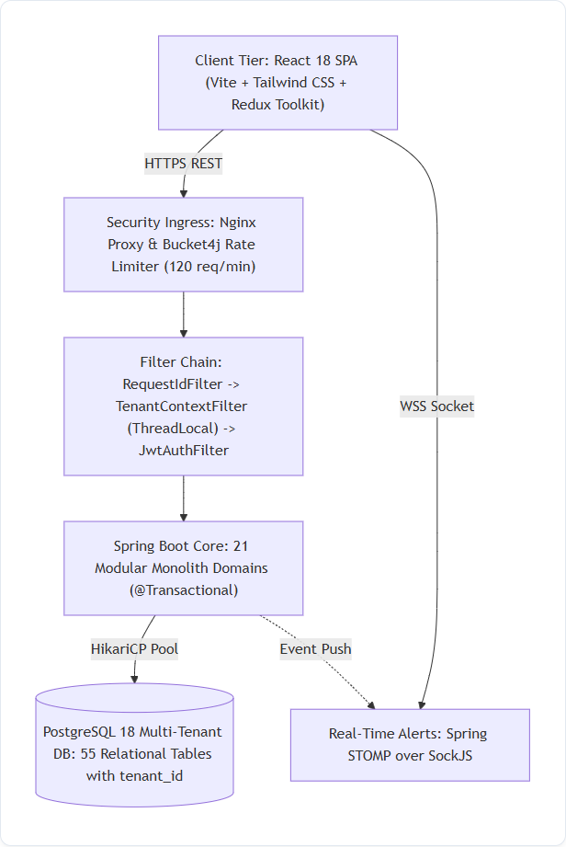
Figure 1.1 — End-to-End System Ingress, Security Filters, Monolith Core, and PostgreSQL 18 Multi-Tenant Layer

Step-by-Step Architectural Ingress Trace
Step 1: Client Action (React 18 SPA) — User performs an action in the frontend. Axios injects the HMAC-SHA256 JWT Bearer token and the organization header (X-Tenant-ID: eoxys).
Step 2: Rate Limiting Ingress (Bucket4j) — RateLimitFilter checks the client IP against an in-memory token bucket (120 req/min limit) to prevent brute-force and DoS attacks.
Step 3: Correlation ID Injection — RequestIdFilter creates a unique UUID (X-Request-ID) and binds it to Logback's MDC for distributed logging across micro-operations.
Step 4: ThreadLocal Multi-Tenant Binding — TenantContextFilter extracts X-Tenant-ID and stores it in Java's ThreadLocal storage, guaranteeing isolation on Tomcat worker threads.
Step 5: JWT Security & Role Evaluation — JwtAuthenticationFilter validates the cryptographic token signature and injects role permissions (e.g. ROLE_HR, ROLE_EMPLOYEE) into Spring's SecurityContext.
Step 6: Transactional Domain Execution — The matching Spring @Transactional service executes business logic, performs mathematical calculations, and accesses PostgreSQL 18 via HikariCP.
Step 7: Memory Sanitization (Mandatory Finally Block) — Upon request completion, TenantContext.clear() executes to prevent ThreadLocal memory leaks in Tomcat's pooled threads.
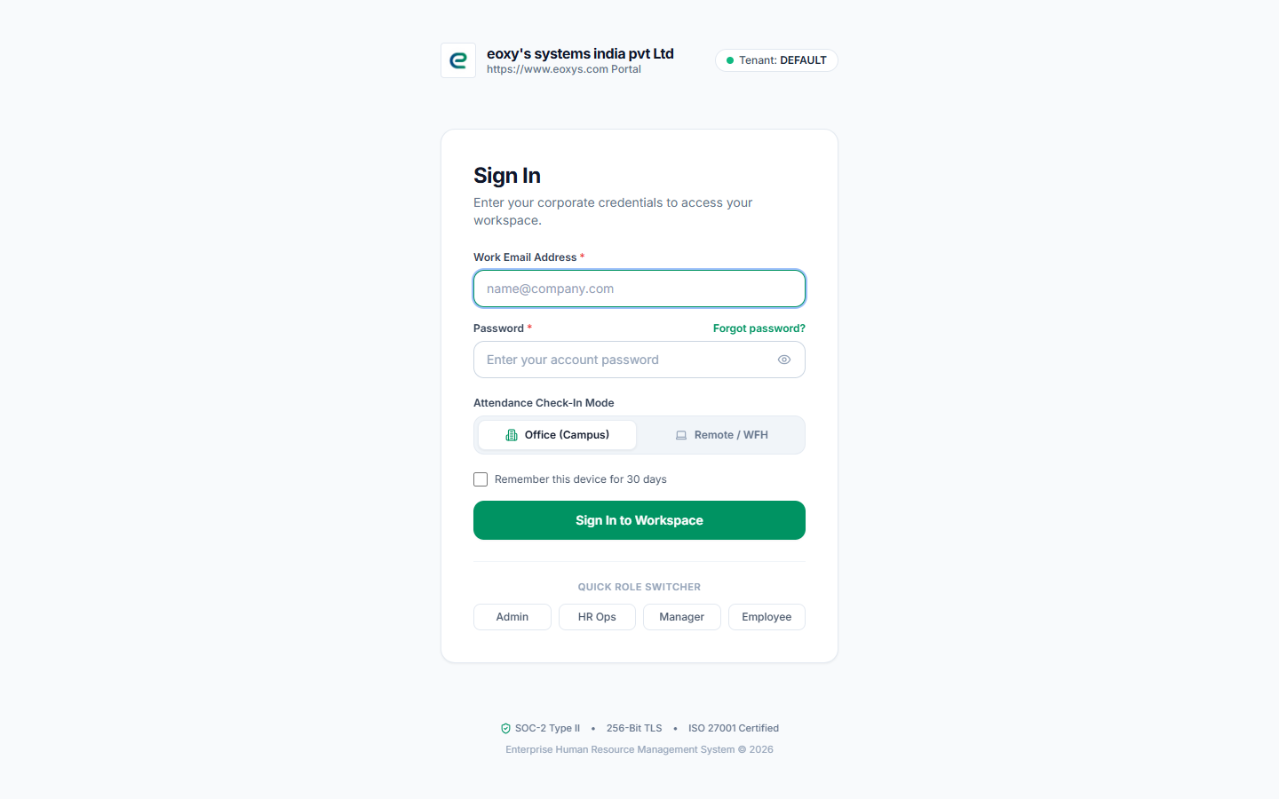
Figure 1.2 — Corporate SaaS Ingress & 2FA TOTP Authentication Screen

2. Role-Based Actions Matrix: HR Manager vs. Employee vs. Admin
EXECUTIVE SUMMARY (IN PLAIN ENGLISH)
The system enforces strict permission boundaries. Regular employees are sandboxed in their Employee Self-Service (ESS) portal, allowing them to view and manage only their own attendance, leaves, and payslips. HR Managers have company-wide authority over talent acquisition, employee directory CRUD, and payroll execution. System Admins govern multi-tenant security and audit logs.

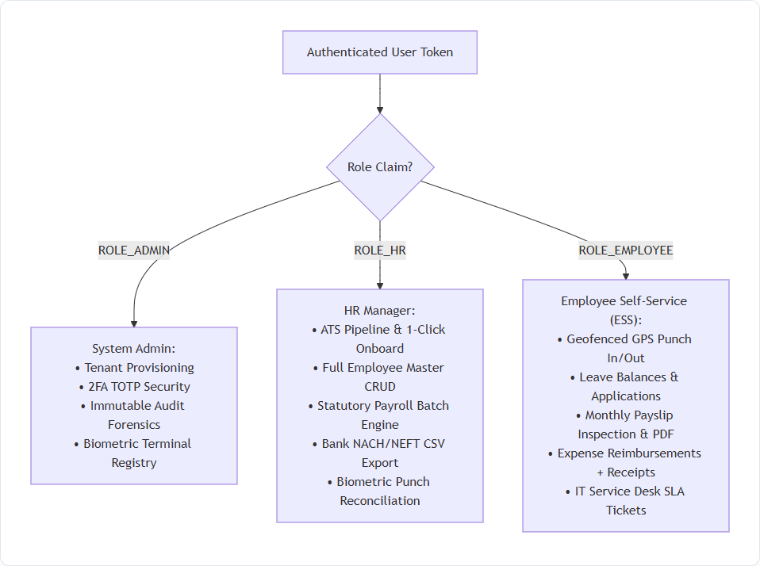
Figure 2.1 — Three-Tier Operational Authorization Matrix

Detailed Functional Permissions Comparison
Module Capability | System Admin | HR Manager | Employee (Self-Service)
White-Label Tenant Customization | Full Access | No Access | No Access
2FA Reset & Audit Log Forensics | Full Control | No Access | No Access
ATS Pipeline & 1-Click Onboard | View Only | Full Execution | No Access
Employee Directory Master CRUD | Full Access | Full Control | View Own Profile Only
Biometric Turnstile Hardware Config | Full Control | Full Control | No Access
Daily Attendance Punch In / Out | Optional | Optional | Mandatory Clock In/Out
Leave Quota Application & Review | Allowed | Full Approval | Submit Own Requests
Statutory Payroll Batch Run | View Only | Full Execution | No Access
Monthly Payslip PDF Access | All Slips | All Slips | Download Own Slip Only
Expense Reimbursement Approval | Allowed | Tier-2 Finance Sign-Off | Submit Own Claims + Receipts
IT Hardware Asset Inventory | Full Control | Full Control | View Assigned Assets
Exit Resignation & Relieving Letter | Full Control | HR Clearance Sign-Off | Submit Own Resignation

3. System Admin Setup, Security & Tenant Isolation
EXECUTIVE SUMMARY (IN PLAIN ENGLISH)
System Admins manage the platform's multi-tenant isolation, cryptographic 2FA tokens, and denial-of-service protections. Every single administrative configuration change is recorded in an immutable, append-only database log for compliance auditing.

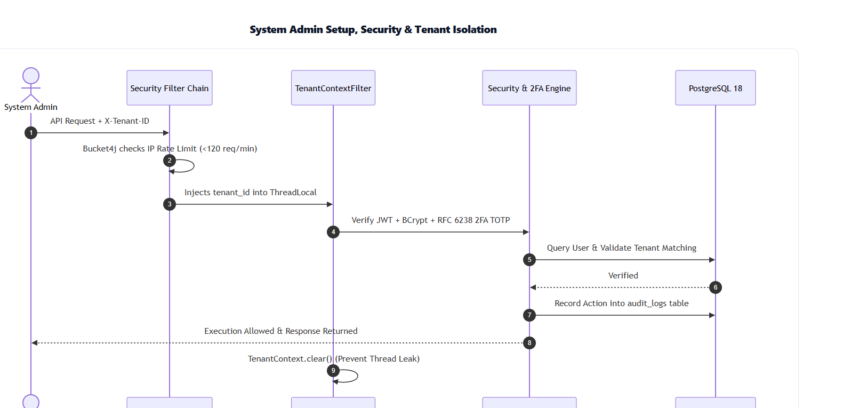
Figure 3.1 — Administrative Setup Execution Sequence & Security Forensics

Core System Admin Pillars
Step 1: Multi-Tenant Data Partitioning — Enforces tenant_id scoping across 55 database tables. Tomcat filter intercepts X-Tenant-ID header and ensures strict thread-local separation.
Step 2: Bank-Grade 2FA TOTP (RFC 6238) — Supports Google Authenticator, Microsoft Authenticator, and Authy with 8 single-use emergency backup recovery keys.
Step 3: Brute-Force Account Lockout — Monitors login_history; accounts are automatically locked for 30 minutes after 5 consecutive failed login attempts.
Step 4: Physical Biometric Terminal Registry — Maintains IP address, listening ports, serial numbers, and heartbeat pings for all physical attendance scanners in biometric_devices.

4. Complete Employee Lifecycle (Day-1 Joining to Exit Relieving)
EXECUTIVE SUMMARY (IN PLAIN ENGLISH)
Governs an individual's journey through three phases: (1) Onboarding from ATS with mandatory initial password reset; (2) Active Employment via daily attendance, break timers, leave balances, and expense claims; and (3) Offboarding with 4-department clearance sign-offs, statutory Gratuity calculation, and official digital Relieving Letter issuance.

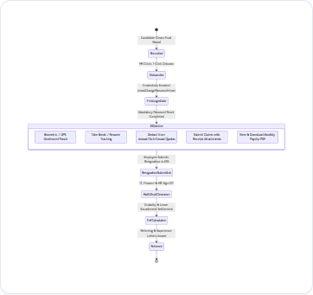
Figure 4.1 — Complete Employee Employment State Machine

Lifecycle Phase Breakdown
Step 1: First-Time Login Security Gate — New hires log in with Hrms@XXXX. The backend detects mustChangePassword: true and locks all portal features until a compliant permanent password is created.
Step 2: Daily Self-Service Attendance — Employee punches in with GPS geofencing. Punches after 09:30 AM flag LATE_ARRIVAL. The break tracker records lunch/break minutes.
Step 3: Leave & Time-Off Management — Employees submit leave requests against pre-seeded Annual (24), Sick (12), and Casual (8) quotas.
Step 4: Separation & 4-Department Clearance NOC — Resignation triggers clearance checklists across IT (hardware return), Finance (dues/loans), and HR before F&F settlement.
Step 5: Statutory Gratuity & Settlement — Engine computes gratuity ((15 * Basic * Tenure) / 26) and unavailed leave encashment, generating the official Relieving Letter PDF.

5. Profile Generation & Deterministic Employee ID Logic
EXECUTIVE SUMMARY (IN PLAIN ENGLISH)
When an HR Manager clicks '1-Click Onboard' on an accepted candidate, the platform automatically generates their permanent ID (EMP-YYYY-XXXX), creates user login credentials, seeds statutory leave balances, and emails them their welcome package.

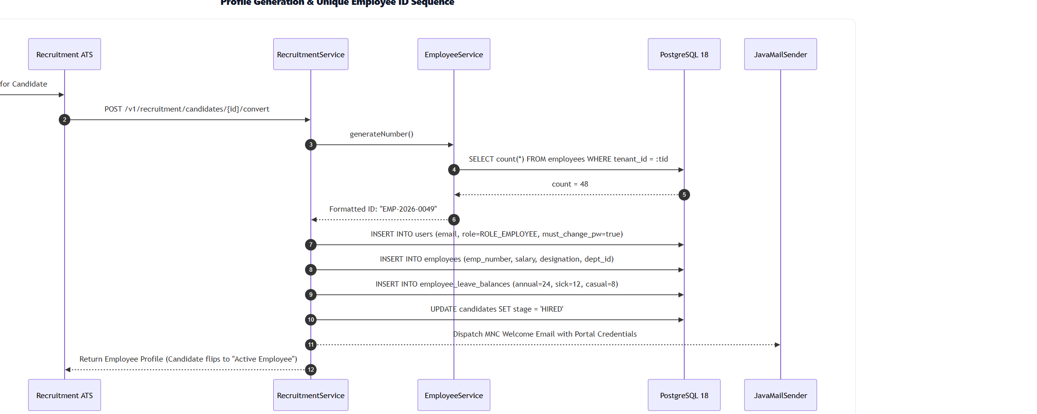
Figure 5.1 — 1-Click Onboarding & Credential Generation Sequence

Mathematical Sequence & Execution Flow
Step 1: Deterministic ID Calculation — ID is minted via: String.format('EMP-%d-%04d', Year, count + 1). For example, with 48 active staff in 2026, the generated ID is EMP-2026-0049.
Step 2: User Credential Provisioning — Creates User record with ROLE_EMPLOYEE, temporary bcrypt password Hrms@<4-random-digits>, and mustChangePassword = true.
Step 3: Statutory Quota Seeding — Automatically seeds employee_leave_balances with 24 Annual Leaves, 12 Sick Leaves, and 8 Casual Leaves.
Step 4: Asynchronous Welcome Email — Dispatches branded HTML email via JavaMailSender containing credentials and login URL.
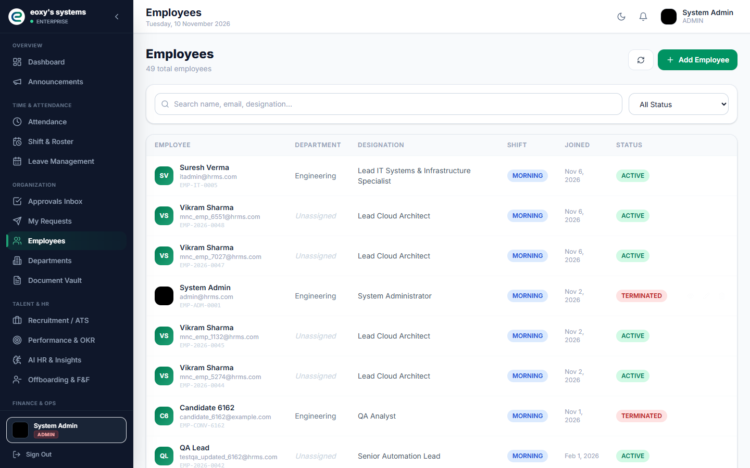
Figure 5.2 — Corporate Employee Master Directory with Generated Codes

6. Biometric Terminal Ingestion & Time Tracking Rules
EXECUTIVE SUMMARY (IN PLAIN ENGLISH)
Physical biometric hardware (ZKTeco/eSSL) pushes punch logs to the server. The first punch is check-in; punches after 09:30 AM are marked Late. Subsequent punches update check-out. If worked time minus breaks is under 4 hours, it automatically becomes Half Day.

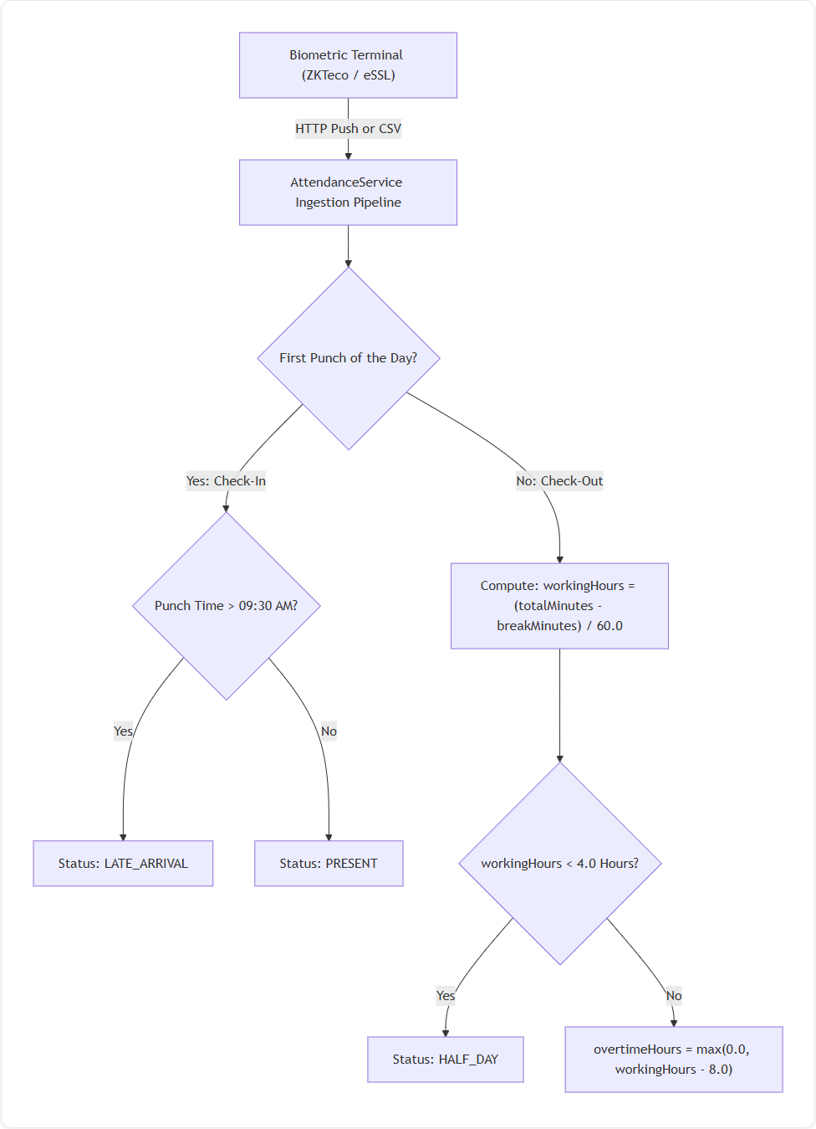
Figure 6.1 — Attendance Ingestion, Punctuality & Overtime Decision Tree

Precise Mathematical Rules
Step 1: First Punch of the Day — Recorded as checkInTime. If punch time is after 09:30 AM, status is flagged as LATE_ARRIVAL.
Step 2: Net Working Hours Calculation — workingHours = Math.max(0.0, (totalMinutes - breakMinutes) / 60.0). Break minutes are dynamically subtracted.
Step 3: Half-Day Penalty Trigger — If workingHours < 4.00, status is automatically overridden to HALF_DAY.
Step 4: Overtime Calculation — overtimeHours = Math.max(0.0, workingHours - 8.00). Standard 8-hour workday threshold.
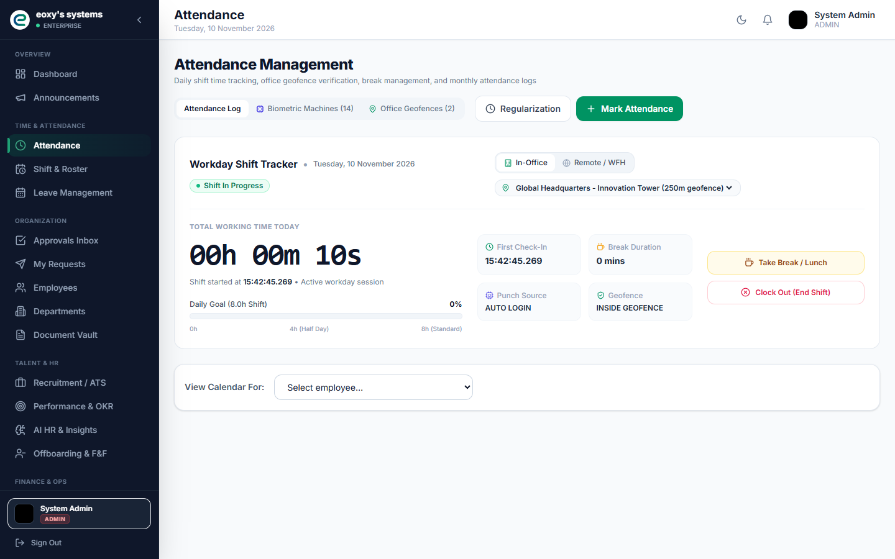
Figure 6.2 — Biometric Stopwatch, Break Timer & Daily Attendance Hub

7. Statutory Payroll Engine, Salary Templates & Bank Disbursements
EXECUTIVE SUMMARY (IN PLAIN ENGLISH)
The payroll engine calculates salaries in one click. It determines earned gross pay from present days, decomposes it into Basic (50%), HRA (20%), and Special Allowance (30%), deducts PF (12%), PT, and TDS, adds approved expense reimbursements, and exports an RBI-compliant bank transfer file.

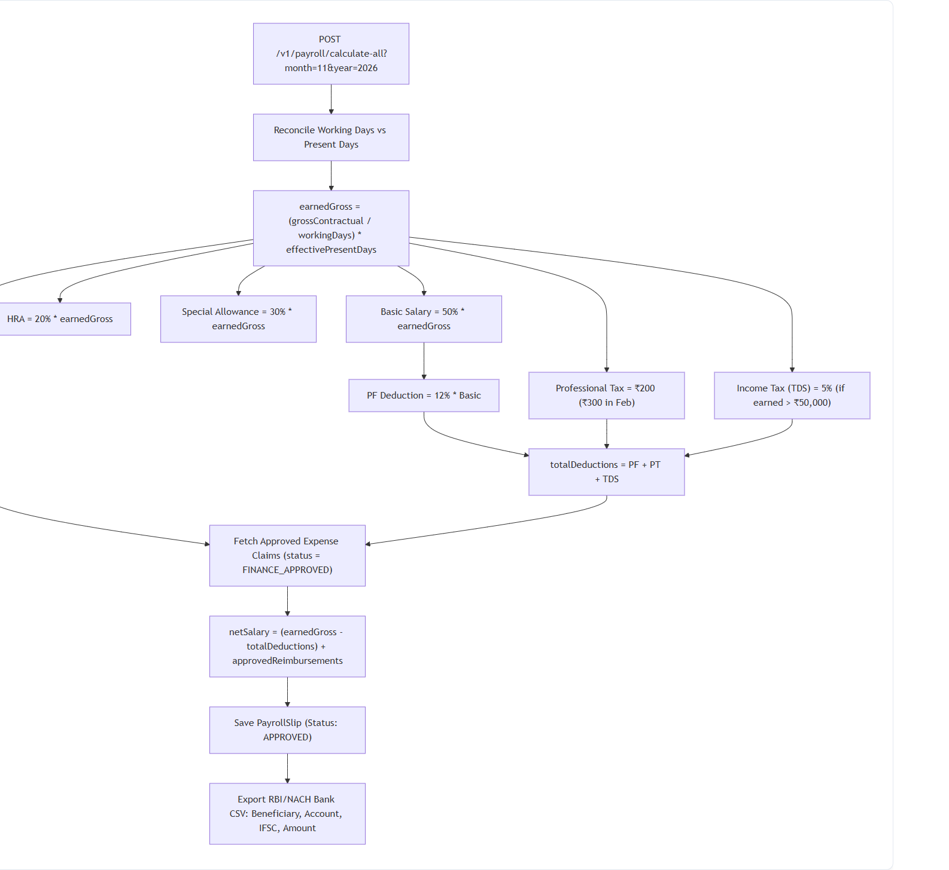
Figure 7.1 — Payroll Batch Reconciliation, Component Splitting & Bank Payout Flow

Mathematical Formulation of Salary Engine
Step 1: Prorated Earned Gross — perDaySalary = grossContractual / calendarWorkingDays. earnedGross = perDaySalary * effectivePresentDays.
Step 2: MNC Component Split — Basic Salary = 50% * earnedGross. HRA = 20% * earnedGross. Special Allowance = 30% * earnedGross.
Step 3: Statutory Deductions — Provident Fund (PF) = 12% * Basic. Professional Tax (PT) = ₹200 (₹300 in Feb). TDS = 5% if earnedGross > ₹50,000.
Step 4: Approved Expense Reimbursement Bridge — Queries claims where status = FINANCE_APPROVED and disburses them directly into net pay total.
Step 5: Bank Transfer CSV Export — Outputs RBI/NACH-compliant CSV: BeneficiaryName, AccountNumber, IFSC, Amount, Narration.
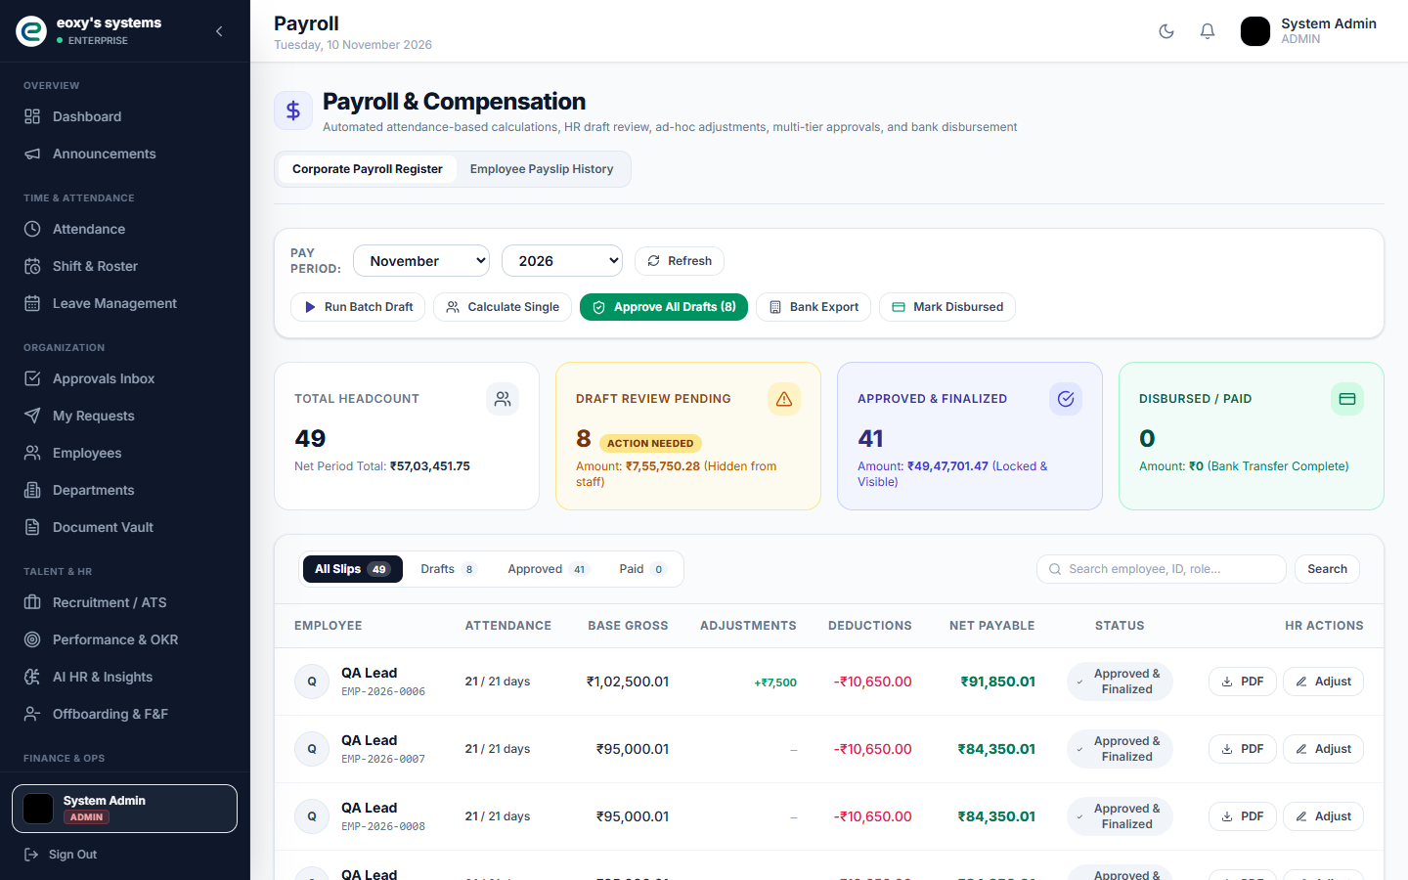
Figure 7.2 — Monthly Payroll Register Console with Component Breakdown

8. Automated Offer Letter Generation & Candidate Dispatch
EXECUTIVE SUMMARY (IN PLAIN ENGLISH)
When a candidate passes final interviews, HR triggers the offer workflow. The system compiles their CTC breakdown, designation, and joining date into an official employment contract with a cryptographic verification hash, emailing it to the candidate with an acceptance button.

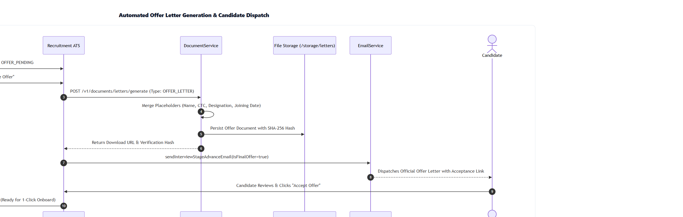
Figure 8.1 — Automated Offer Letter Pipeline & Cryptographic Verification

Offer Letter Pipeline Steps
Step 1: Interview Panel Clearance — Interviewers submit scorecards recommending STRONG_HIRE. Candidate stage advances to OFFER_PENDING.
Step 2: Dynamic Template Merging — DocumentService injects candidate name, CTC breakdown, designation, and reporting manager into official template.
Step 3: Cryptographic Hash & Vault Storage — Calculates SHA-256 integrity hash and stores contract PDF in /storage/tenants/{tid}/letters/.
Step 4: Candidate Digital Acceptance — Candidate receives email with offer letter PDF and acceptance link. Clicking accept flips stage to OFFER_ACCEPTED, unlocking 1-Click Onboard.

9. Talent Acquisition ATS & Native WebRTC Live Interviews
EXECUTIVE SUMMARY (IN PLAIN ENGLISH)
The ATS manages candidate progression across 6 stages. Includes native peer-to-peer WebRTC video interview rooms with an embedded collaborative code compiler and structured candidate evaluation scorecards.

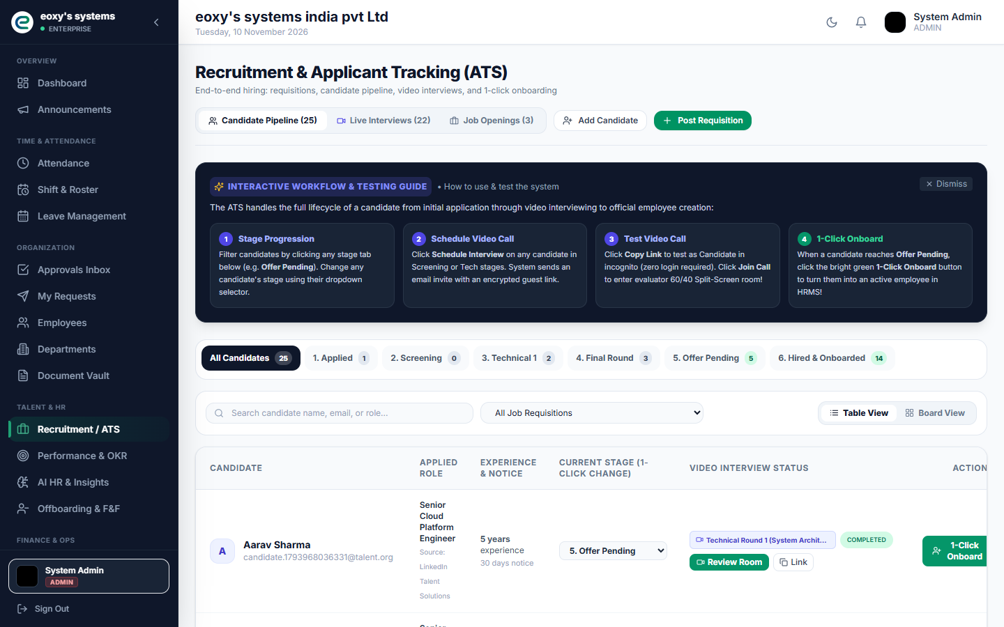
Figure 9.1 — Corporate ATS Candidate Pipeline & Video Interview Hub
Step 1: 6-Stage Pipeline — Applied -> Screening -> Technical Round 1 -> Technical Round 2 (Final) -> Offer Pending -> Hired.
Step 2: In-Browser WebRTC Live Interviews — Peer-to-peer video rooms with LiveKit integration, live chat, shared whiteboard, and interactive code compiler.
Step 3: Objective Scoring Rubrics — Evaluates technical skills, problem solving, and culture fit, recording audit verdicts into interview_scorecards.

10. Leave Quotas & Multi-Stage Expense Workflows
EXECUTIVE SUMMARY (IN PLAIN ENGLISH)
Employees apply for leaves against dedicated Annual, Sick, and Casual balances. Expense claims support receipt uploads and a 2-stage approval workflow (Reporting Manager Review -> Finance Audit) that flows directly into monthly salary disbursement.

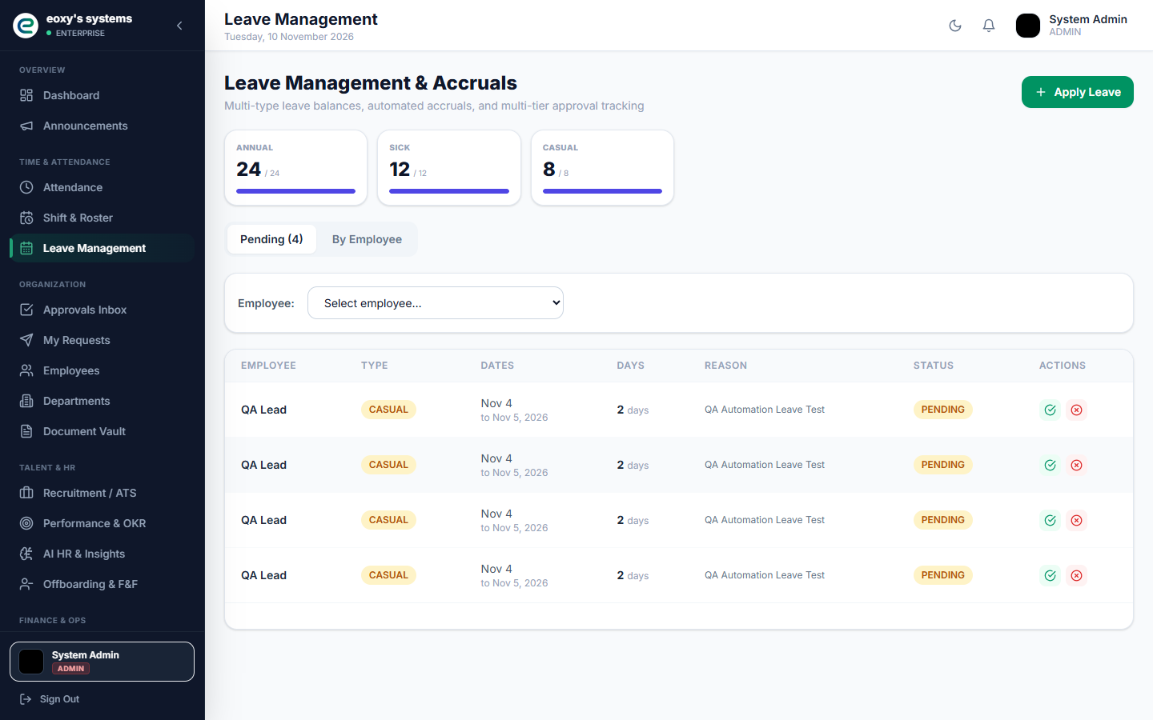
Figure 10.1 — Statutory Leave Balance Tracker & Approval Queue
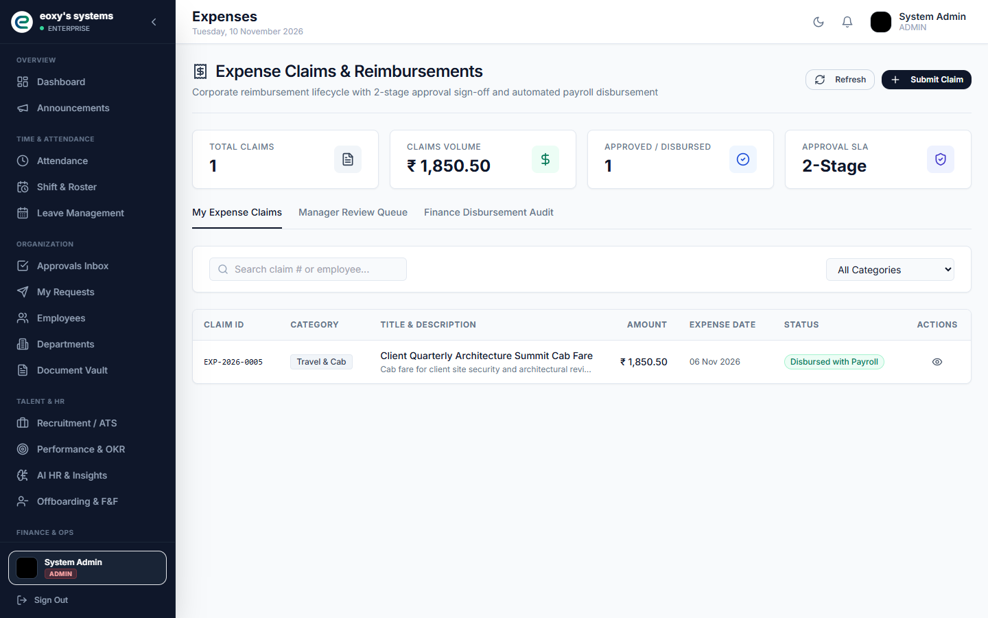
Figure 10.2 — Corporate Expense Reimbursement Claims & Receipt Vault

11. Critical Production Edge Cases & Architectural Defenses
SYSTEM RESILIENCE SUMMARY
The following catalog details real-world operational edge cases, concurrency challenges, and failure modes, along with the code-level mechanisms that prevent system breakdowns.

■ Cross-Midnight Night Shifts (22:00 to 06:00 next day)
Problem: Checkout punches occurring on the next calendar day could be treated as a new check-in.
Defense: The system checks shift.is_night_shift == true. Checkouts occurring before shift end + grace period are retroactively bound to the previous day's check-in record.
■ Single Punch Anomaly (Forgotten Checkout)
Problem: An employee clocks in at 09:00 AM but leaves without clocking out, resulting in null working hours.
Defense: A nightly Spring cron (0 30 23 * * *) marks unclosed check-ins as INCOMPLETE_PUNCH. The employee submits an Attendance Regularization Ticket in ESS for manager sign-off, which retroactively recalculates hours.
■ Rapid Duplicate Hardware Punches (< 60s Debounce)
Problem: Multiple thumb scans within seconds due to hardware sensor uncertainty.
Defense: If Duration.between(lastPunch, currentPunch).getSeconds() < 60, subsequent scans are discarded as hardware bounce artifacts.
■ Loss of Pay (LOP) Salary Prorations
Problem: Unapproved absences must not receive contractual compensation.
Defense: earnedGross = (grossContractual / calendarWorkingDays) * effectivePresentDays. All statutory components (Basic, HRA, PF) scale strictly off earnedGross.
■ Negative Net Salary Prevention
Problem: Heavy statutory deductions or unpaid leave could mathematically result in negative net pay.
Defense: netSalary = Math.max(0.00, earnedGross - totalDeductions). Any unrecovered deduction balance rolls over into employee_salary_arrears.
■ Async Thread Pool Context Loss (@Async)
Problem: Spring background mailer and PDF worker threads lose ThreadLocal tenant_id.
Defense: Configured TenantAwareTaskDecorator copies tenant_id from the HTTP request thread into the worker thread before execution and clears it in a finally block.
■ Concurrent 1-Click Onboard ID Collisions
Problem: Multiple HR managers onboarding candidates simultaneously could receive identical sequential IDs.
Defense: Protected via database sequence allocation and a composite unique constraint UNIQUE(tenant_id, employee_number) on PostgreSQL.

